Journal of Geophysical Research: Planets
Supporting Information for
Equation of State, Structure, and Transport Properties of Iron Hydride Melts at Planetary Interior Conditions
Emma R. Stoutenburg¹, Razvan Caracas², Natalia V. Solomatova³, and Andrew J. Campbell¹
¹Department of the Geophysical Sciences, University of Chicago, Chicago, IL, USA, ² Université Paris Cité, Institut de Physique du Globe de Paris, CNRS, 1 rue Jussieu, Paris, France, ³CNRS, Ecole Normale Supérieure de Lyon, Laboratoire de Géologie de Lyon LGLTPE UMR5276, Centre Blaise Pascal, Lyon, France
Contents of this file

Figure S1
Figure S2
Figure S3
Figure S4
Introduction
Here we include Figure S1-4. Figure S1 shows validation for our chosen interatomic potentials. Figure S2 contains the linear fit for the pressure correction due to spin-polarization in pure, liquid iron at 3000 K. Figure S3 shows the estimated pressure correction due to magnetism at ambient pressure. Figure S4 compares the diffusivity of iron and hydrogen at 100 GPa to those calculated based on extrapolated Arrhenius laws from the literature.

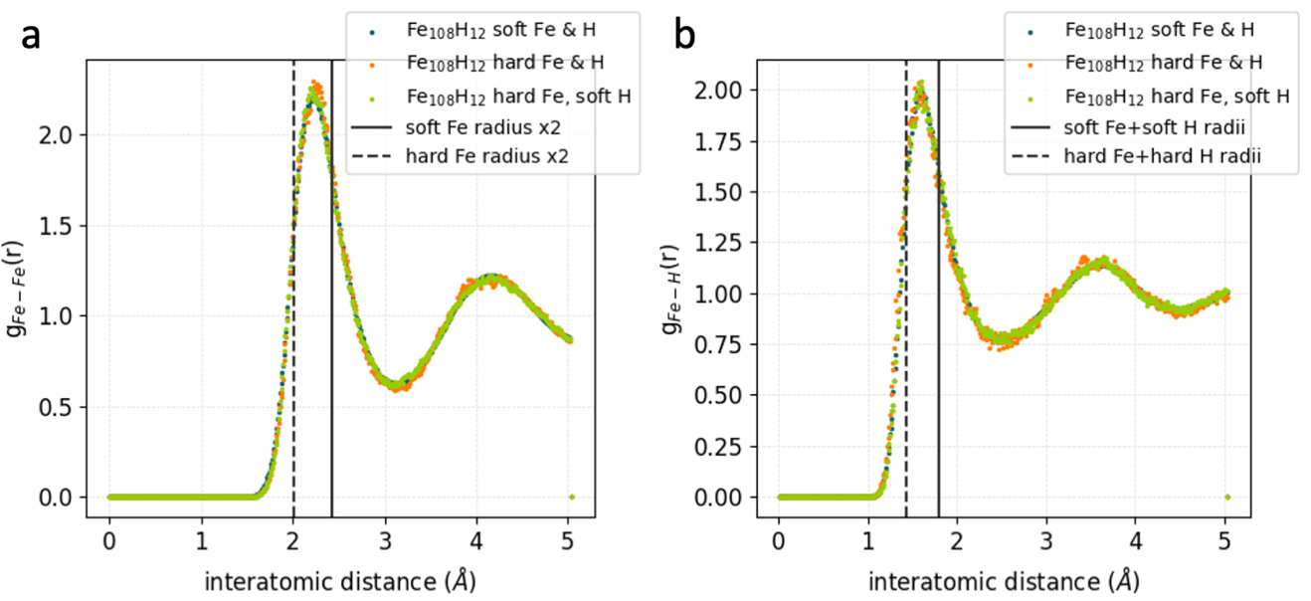
Figure S1. Comparisons of the g_{Fe-Fe}(r) and g_{Fe-H}(r) in Fe_{0.9}H_{0.1} at P_{NSP} = 100 GPa and 5000 K using different core radii (different pseudopotentials) for the atoms. We test an iron pseudopotential with a core radius of 1.9 Bohr (1 Angstrom) (“hard Fe”) and a hydrogen pseudopotential with a core radius of 0.8 Bohr (0.4 Angstrom) (“hard H”), whereas the simulations discussed in our study used an iron core radius of 2.3 Bohr (1.2 Angstrom) (“soft Fe”) and a hydrogen core radius of 1.1 Bohr (0.58 Angstrom) (“soft H”). The three types of simulations, soft iron and hydrogen, hard iron and soft hydrogen, and hard iron and hydrogen result in nearly identical distributions despite the different potentials; therefore, the choice of pseudopotential core radius does not strongly affect the behavior of the atoms in the melts. Hard pseudopotentials are typically only used in studies with pressures in excess of 100 GPa, therefore our choice of soft pseudopotentials for our study is typical and the test here shows that they are appropriate. We use Fe_{0.9}H_{0.1} because at this pressure, temperature, and composition, we expect the iron atoms to be closer to one another than at other more hydrogen-rich conditions or less high-pressure conditions.

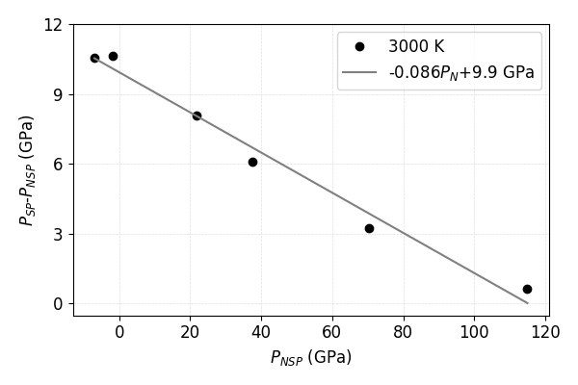
Figure S2. Difference between the pressure in spin-polarized (SP) and non-spin-polarized (NSP) iron from this study, ∆P=P_{SP}-P_{NSP}, at 3000 K. A linear fit ∆P=-0.086P_{N-SP} + 9.9 GPa can be used to estimate the pressure correction for non-spin-polarized iron.

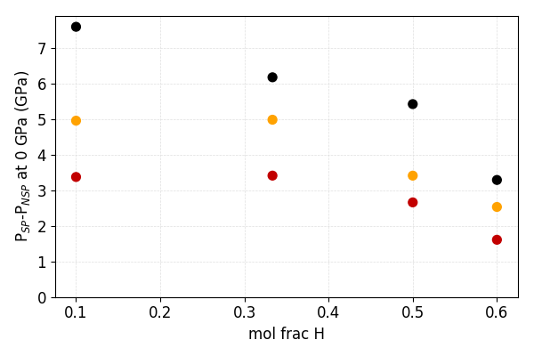

Figure S3. Estimated pressure difference due to magnetism at ambient pressure in iron hydrides from this study as a function of hydrogen concentration (black: 3000 K, gold: 4000 K, scarlet: 5000 K). Based on SP and NSP simulations performed between 0-1.7 GPa for each composition at each temperature and assuming ∆P is linear and goes to zero at 115 GPa as in pure iron (Figure S2). Magnetism diminishes as hydrogen concentration increases and at high temperatures, and consequently ∆P falls.

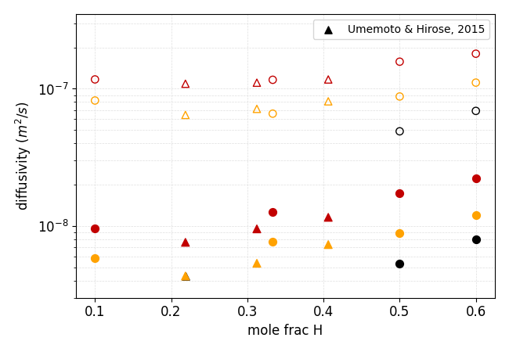

Figure S4. Diffusivity of iron (solid symbols) and hydrogen (hollow symbols) at 100 GPa from our study (circles) and based on the Arrhenius relationships provided in Umemoto & Hirose (2015) for melts of compositions Fe_{0.78}H_{0.22}, Fe_{0.69}H_{0.31}, and Fe_{0.59}H_{0.41} (triangles), as a function of hydrogen concentration (black: 3000 K, gold: 4000 K, scarlet: 5000 K). Both studies agree very well on the trend in diffusivity, especially for hydrogen. The small disagreement in iron trend could be due to a combination of (1) the fact that the minimum pressures simulated by Umemoto & Hirose were 112 GPa at 4000 K and 125 GPa at 5000 K, therefore these diffusivities are significantly extrapolated and (2) the smaller system size in Umemoto & Hirose, as they only had between 76-100 iron atoms to our 108 iron atoms.

