Supplemental Material

- Supplemental Methods and Materials
1.1 Isolation of DNA
At Oslo University Hospital (OUH), 10-20µm thick tissue sections (2-5 per patient) from formalin-fixed paraffin-embedded (FFPE) tumor tissue were incubated over night at 45ºC before deparaffinization in limonene and rehydration in a series of graded alcohol solutions. Areas of tumor cells were carefully scraped off the slides with a scalpel using adjacent HE-stained sections as guides and transferred to lysis buffer in Eppendorf Safe-Lock tubes. DNA and RNA were then extracted on a Qiacube Connect (Qiagen), using the Qiagen AllPrep DNA/RNA FFPE protocol. The first 15 DNA samples were eluted in ATE-buffer, according to the protocol. These were subsequently cleaned by addition of ice-cold ethanol and 3M sodium acetate pH 5.2, precipitated by centrifugation and re-suspended in EB-buffer. The remaining 15 DNA samples were eluted directly in EB-buffer.
Similarly at University of Texas MD Anderson Cancer Center (MDACC), 10-20µm thick tissue sections (2-5 per case) from FFPE tumor tissue underwent deparaffinization per Qiagen AllPrep DNA/RNA FFPE Kit protocol. From the subset of patients included at the University of Texas MD Anderson Cancer Center, DNA and RNA was extracted also from FFPE-sections of normal endometrial tissue from the same patients.
The isolated DNA was quantified using the QubitdsDNA HS Assay Kit (ThermoFisher).

1.2 Whole exome sequencing (WES) of DNA
Tumor DNA from the patients from OUH was sequenced at the OUH Genomics Core Facility using the Twist Library Preparation Enzymatic fragmentation Kit 2.0 and the Human Comprehensive Exome Panel (Twist Bioscience). Tumor and normal DNA obtained from the patients from MDACC was sequenced using the Twist Universal Adapter System and Twist Human Exome Core kit. 100ng DNA was used as input (for four cases input was lower; 49 ng, 63 ng, 85ng and 94ng), and further processed according to the manufacture’s recommendations. Libraries were sequenced paired-end 2x150bp on the NovaSeq6000 System (Illumina) at each institution. The average coverage was 409.86 for the OUH tumor samples, 413.15 for the MDACC tumor samples and 360.93 for the MDACC normal samples.

  - Variant Calling
Variant calling and analysis were performed with Illumina Dragen Bio-IT v. 3.7 for the data arising from the OUH patients and v. 3.9 for the MDACC data. The human reference genome GRCh38 (patch p12) (obtained from the UCSC database) was used for mapping and alignment. For the OUH tumor-only data, the single nucleotide variant (SNV) calling was performed with Twist Exome BED target file (target BED padding 250). For the MDACC tumor-normal paired data, the Twist Human Core Exome plus RefSeq BED target file was used (Bed padding 20). For the OUH tumor-only data, a dbSNP file from NCBI was used to reference potential germline variants and annotations for the matches were added (https://ftp.ncbi.nih.gov/snp/organisms/human_9606_b151_GRCh38p7/VCF/.).

1.4 Variant annotation and filtration
The open-source software package Personal Cancer Genome Reporter¹⁴ (PCGR) was used for somatic variant annotation. For each individual sample, a report summarizing the detected SNVs and InDels, in addition to computed tumor mutational burden (TMB), microsatellite instability (MSI) status and the estimated mutational signatures, was generated.
For the OUH data, vcf files were used and settings “tumor-only, uterus samples”. Tumor reading depth (tdb) was set as >1 and tumor allele frequency (taf) were set as >0. SNVs with known relevance to endometrial cancer was extracted, and filtered first for coding mutations, then for tumor reading depth ≥ 30 and tumor allele frequency ≥ 0.05. Specifically for the OUH data, mutations with allele frequencies close to 0.5 or 1 were ignored, assuming these represent germ line variation. For the MDACC data, vcf-files were analyzed using settings: “tumor-control, uterus samples”. Filtering thresholds and criteria were otherwise the same as for the OUH data.

1.5 Mutational signatures
The contribution of COSMIC Single Base Substitution (SBS) mutational signatures ¹¹ were generated for each tumor sample using the PCGR workflow ¹⁴ (with settings tdb ≥ 30 and allele frequency ≥ 0.5), if the total number of SNVs in the exome data exceeded 200. To generate the SBS signatures from the OUH tumor-only data, variants found in the dbSNP database were removed prior to running the PCGR workflow (with settings tdb ≥ 30 and allele frequency ≥ 0.1).
The mutational signature reconstruction was limited to the subset of SBS signatures relevant for the uterus category: SBS1 Aging, SBS2 AID/POBEC, SBS5 Unknown, SBS10a POLE mutant, SBS10b POLE mutant, SBS13 AID/APOBEC, SBS14 POLE/MMR deficiency, SBS15 MMR deficiency, SBS28 Unknown, SBS40 Unknown and SBS44 MMR deficiency An accuracy of fitting is calculated that reflects how well the mutation profile can be reconstructed based on the available signatures. Of note, the signature that contributed the most in each tumor is reported.

- Supplemental References

[1] Illumina (2021) Dragen bio-it platform v3.7 user guide. https://support.illumina.com/
content/dam/illumina-support/documents/documentation/software_documentation/
dragen-bio-it/Illumina-DRAGEN-Bio-IT-Platform-User-Guide-1000000141465-00.pdf.

[2] Illumina (2021) Dragen bio-it platform v3.9 user guide. https://support-docs.illumina.com/
SW/DRAGEN_v39/Content/SW/FrontPages/DRAGEN.htm.

[3] NCBI (2021) dbsnp file source. https://ftp.ncbi.nih.gov/snp/organisms/human_9606_
b151_GRCh38p7/VCF/.

[3] NCBI (2021) dbsnp website: Discrimating somatic and germline variants. https://www.ncbi.nlm.nih.gov/snp/docs/analysis/somatic/.

- Supplemental Figures and Tables
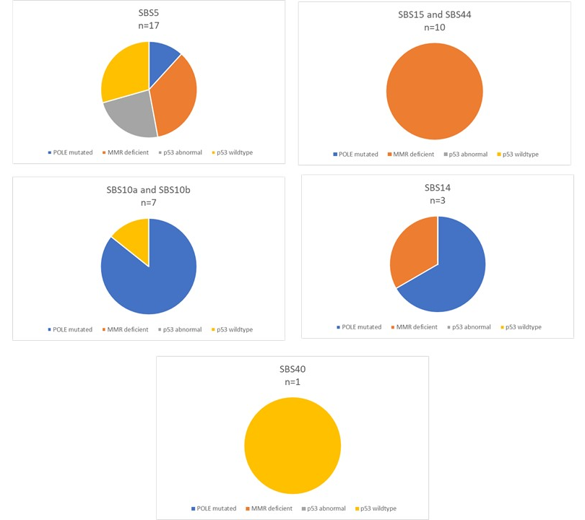
Supplemental Figure 1. ProMisE Subgroup Variability within Mutational Signatures. Mutational signatures demonstrated molecular diversity amongst ProMisE classification subgroups.

Supplemental Table 1: Mutations Evaluated
ARID1A | KRAS | ZFHX3 | HNFB1 | MTOR
ARID5B | MUC16 | ATR | KLF | NRAS
BRCA1 | POLE | CTCF | EIF2AK | SMAD4
BRCA2 | PTEN | CHD4 | CYP19A1 | MLH1
CTNNB1 | PIK3CA | CSMD3 | MYC | MLH3
ERBB2 | PIK3R1 | COLA11 | ALK | MSH2
FAT1 | PPP2R1A | JAK1 | ESR1 | MSH6
FAT4 | RB1 | RNF43 | GNAS | PMS2
FBXW7 | RPL22 | SPOP | MET | TGFBR2
FGFR2 | TP53 | TAF1 | SOX4 | EPCAM

Supplemental Table 2: Mutational Signature Profiles
Mutational Signature | Proposed Etiology | Comments
SBS5 | Unknown | Clock-like in that the number of mutations in most cancers and normal cells correlates with the age of the individual
SBS10a | Polymerase epsilon exonuclease domain mutations. | Generate large numbers of somatic mutations (>100 mutations per MB) and samples with these signatures have been termed hypermutators
SBS10b | Polymerase epsilon exonuclease domain mutations. | Generate large numbers of somatic mutations (>100 mutations per MB) and samples with these signatures have been termed hypermutators.
SBS14 | Concurrent polymerase epsilon mutation and defective DNA mismatch repair. | One of seven mutational signatures associated with defective DNA mismatch repair and microsatellite instability (MSI) and is often found in the same samples as other MSI associated signatures: SBS6, SBS15, SBS20, SBS21, SBS26 and SBS44.
SBS15 | Defective DNA mismatch repair. | One of seven mutational signatures associated with defective DNA mismatch repair and microsatellite instability (MSI) and is often found in the same samples as other MSI associated signatures: SBS6, SBS14, SBS20, SBS21, SBS26, and SBS44.
SBS40 | Unknown | Correlated with patients’ ages for some types of human cancer.
SBS44 | Defective DNA mismatch repair. | One of seven mutational signatures associated with defective DNA mismatch repair and microsatellite instability (MSI) and is often found in the same samples as other MSI associated signatures: SBS6, SBS14, SBS15, SBS20, SBS21, and SBS26

Supplemental Table 3: Patients with recurrence
ID | Location of recurrence | Time to recurrence (months) | Adjuvant Treatment | ProMisE Classification | Mutational Signature
1 | Ascites and peritoneal disease | 21.9 | Chemo with EBRT +/- VBT | p53 WT | n/a
2 | Lung and pelvic mass | 10.2 | None | P53 abnormal | n/a
3 | Ascites and peritoneal disease | 11.4 | Chemo +/- VBT | p53 WT | SBS 5
4 | Right Fibula | 4.0 | VBT only | MMR deficient | SBS 5
5 | Vaginal cuff | 19.5 | VBT only | p53 WT | SBS 5
6 | Para-anal or perineum | 21.3 | Chemo +/- VBT | P53 abnormal | SBS 5
7 | Para-aortic lymph nodes | 26.2 | Chemo +/- VBT | MMR deficient | SBS 5
8 | Lung | 36.7 | Chemo +/- VBT | MMR deficient | SBS 5
9 | Lung | 35.9 | Chemo +/- VBT | MMR deficient | n/a

