Supplemental Material
Supplemental Text. Detailed description of short-read analyses to verify gene absences.
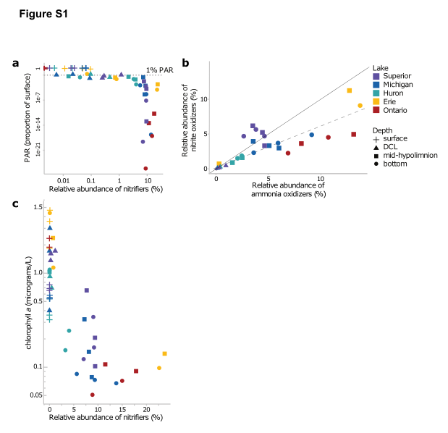
Figure S2.1 Relationships between environmental factors and relative abundance of nitrifiers in the Great Lakes. Relative abundance based on 16S rRNA V4-V5 region amplicon sequencing from Summer 2012. Nitrifier abundance includes sequences assigned to the families Nitrosopumilaceae (AOA), Nitrosomonadaceae (AOB), Nitrospiraceae (NOB), and Gallionellaceae (NOB). (a) Relative abundance of nitrifiers (% of total community) compared to photosynthetically active radiation (PAR). (b) Correlation between the relative abundances of nitrite oxidizers and ammonia oxidizers in each sample. A 1:1 line (solid) and linear regression fit (dashed) are shown for reference. (c) Relative abundance of nitrifiers (% of total community) compared to chlorophyll a concentration. PAR and chlorophyll data from the EPA Great Lakes Environmental Database (https://cdx.epa.gov/). Values are presented in Supplemental Dataset S2.1.
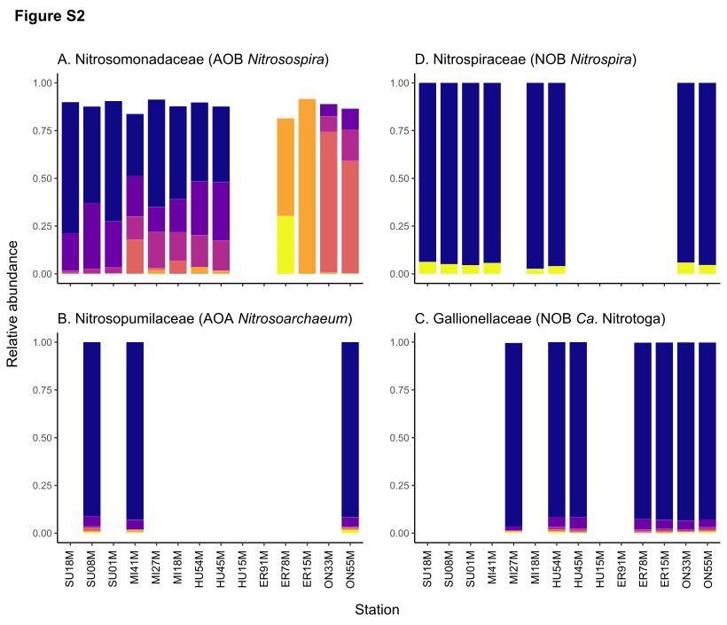
Figure S2.2 Oligotype composition of nitrifiers across the Great Lakes. Each color represents a different 16S rRNA oligotype.
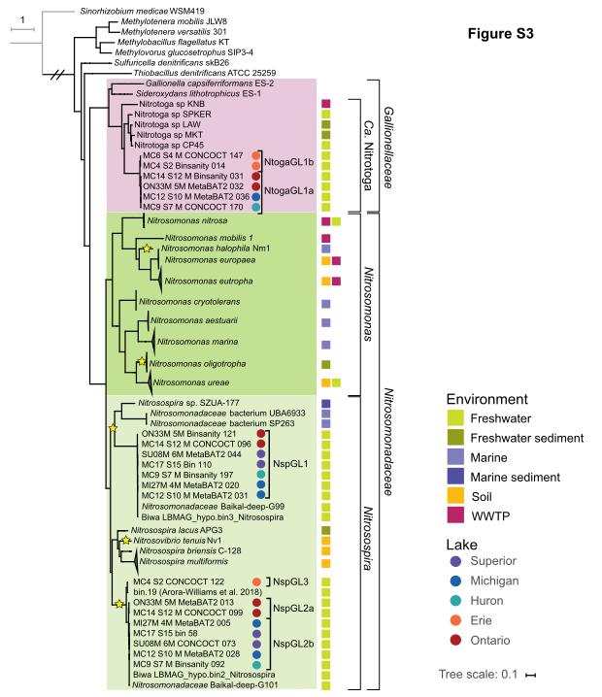
Figure S2.3 Phylogenomic tree of the Nitrosomonadales order of Betaproteobacteria, focusing on the Nitrosomonadaceae and Gallionellaceae families. Tree was constructed using 139 concatenated single-copy core genes (B.J. Campbell, L. Yu, J.F. Heidelberg, and D.L. Kirchman, PNAS 108:12776-12781, 2011). Colored squares indicate the environment of origin; colored circles denote the lake of origin for genomes from the Laurentian Great Lakes; yellow stars indicate clades containing strains that lack nitrosocyanin.
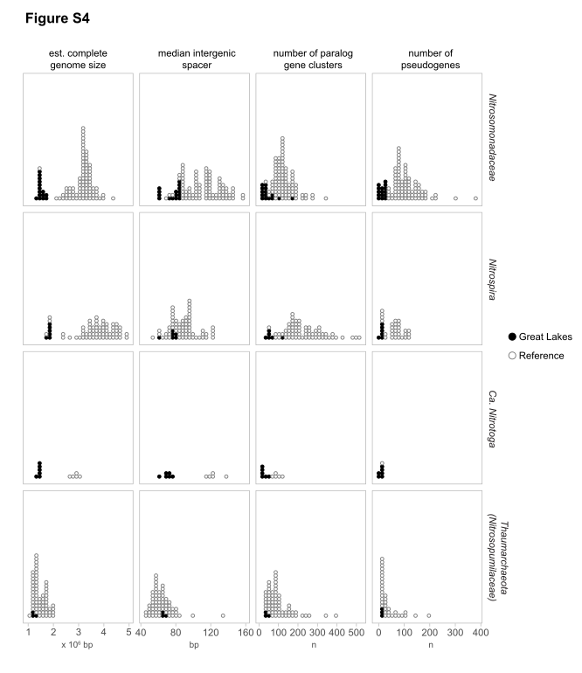
Figure S2.4 Histograms of nitrifier genome properties. Rows show each taxonomic group and columns show genome properties. Each circle represents a single genome/MAG. Great Lakes MAGs shown as filled circles.
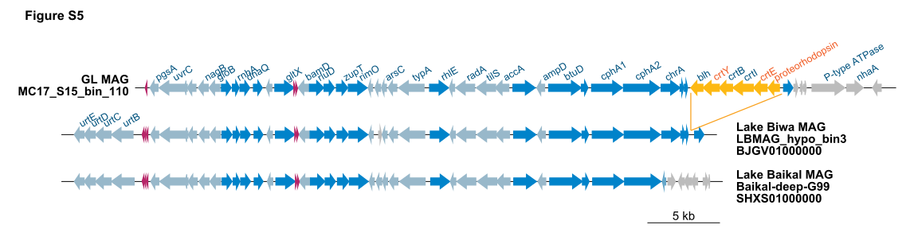
Figure S2.5 Gene neighborhood surrounding proteorhodopsin in Nitrosospira draft genomes from deep lakes. Light blue, shared genes on reverse strand; dark blue, shared genes on forward strand; pink, tRNA genes; orange, PR module in NspGL1 MAG; gray, genes unique to one MAG.
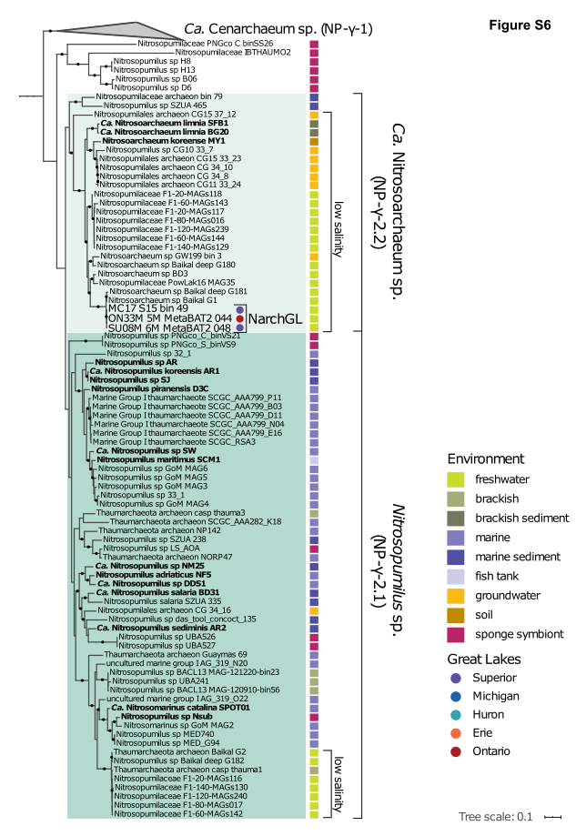
Figure S2.6 Phylogenomic tree of Nitrosopumilaceae and Cenarchaeum. Tree was constructed using concatenated single-copy core genes as defined in (C. Rinke et al., Nature 499:431-437, 2013). Colored boxes correspond to the environment of origin; genomes from the Laurentian Great Lakes are indicated by colored circles. Names in bold indicate cultured isolates or enrichments.
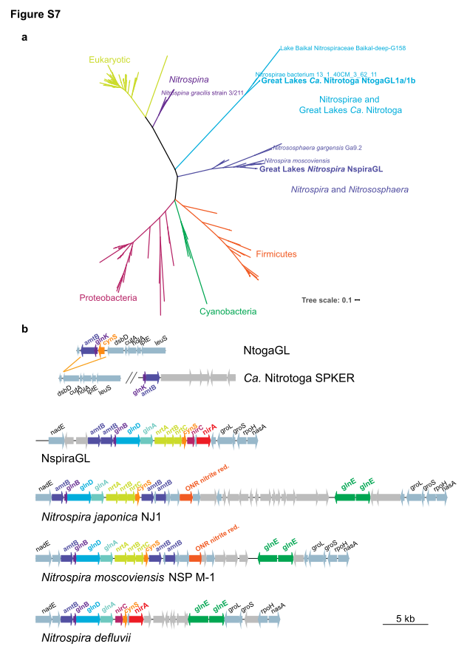
Figure S2.7 Cyanase diversity and distribution among nitrite oxidizing bacteria. a) Phylogenetic tree showing distinct clades of cyanase, highlighting Great Lakes Nitrospira and Ca. Nitrotoga. b) Gene synteny surrounding the cyanase gene in NspiraGL and reference Nitrospira, and a cyanase insertion in NtogaGL compared to reference Ca. Nitrotoga.
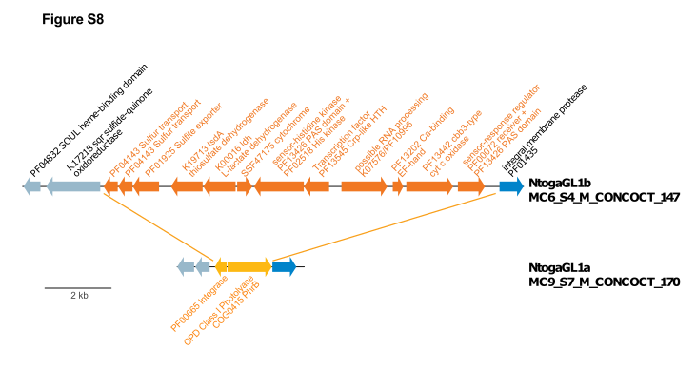
Figure S2.8 Gene content distinguishing NtogaGL1a and NtogaGL1b. Genes colored in blue are shared between both genomes; orange colored genes are unique to either genome.
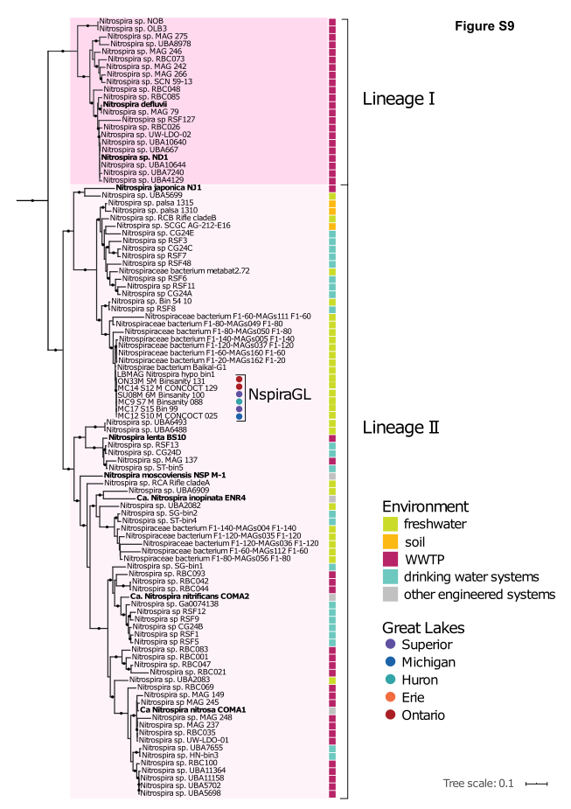
Figure S2.9 Phylogenomic tree of Lineage I and II Nitrospira. Tree was constructed using concatenated single-copy core genes (B.J. Campbell, L. Yu, J.F. Heidelberg, and D.L. Kirchman, PNAS 108:12776-12781, 2011). Colored boxes correspond to the environment of origin; genomes from the Laurentian Great Lakes are indicated by circles color coded by lake of origin.
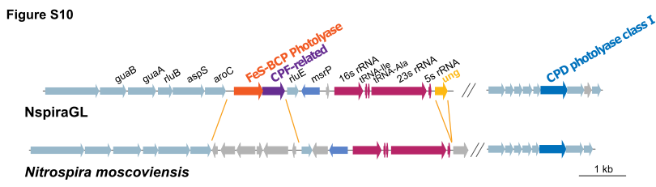
Figure S2.10 Gene neighborhood surrounding photolyase genes in NspiraGL, compared to reference N. moscoviensis. Genes shared between the two genomes are colored light blue (protein coding) or magenta (rRNA, tRNA); non-shared genes are gray; photolyase genes are colored to match the tree in Figure 5.

Dataset S2.1. Relative abundance of nitrifiers based on 16S rRNA amplicons, and associated environmental parameters. Relative abundance is reported as proportion of total community reads. The full 16S rRNA dataset is presented in Paver et al. (2020) Environ Microbiol 22(1): 433-446. Chlorophyll-a concentrations and irradiance values are from the US EPA Water Quality Survey (available from https://cdx.epa.gov/).

Dataset S2.2. Nitrate (NOx), ammonium, and urea concentrations compiled from literature, EPA Water Quality Survey (available from https://cdx.epa.gov/) or measured in this study. NA, not available; n.d., not detected

Dataset S2.3. Assembly statistics and taxonomic information for metagenome-assembled genomes (MAGs) of nitrifiers in the Great Lakes.

Dataset S2.4. Genome properties for newly assembled MAGs and reference genomes included in this study.

Dataset S2.5. Protein functions differentiating genomes of Great Lakes nitrifiers from previously published genomes. Genome averages are calculated for reference genomes and GL MAGs. Genome-level counts for each individual GL MAG and for selected reference genomes are also shown.

Dataset S2.6. Detailed list of presence/absence of key nitrification genes in MAGs presented in this study. NCBI Protein IDs listed when a MAG contains the target gene. 0 indicates the gene was not recovered in the MAG.

Dataset S2.7. Short read analysis for verifying gene loss. Each target gene was searched in unassembled short reads as described in Materials & Methods. Values indicate the number of mapped reads, normalized to gene length. n.d., not detected.

Dataset S2.8. Stations are from the US EPA Water Quality Survey (available from https://cdx.epa.gov/).

