4.7 Supplemental Material

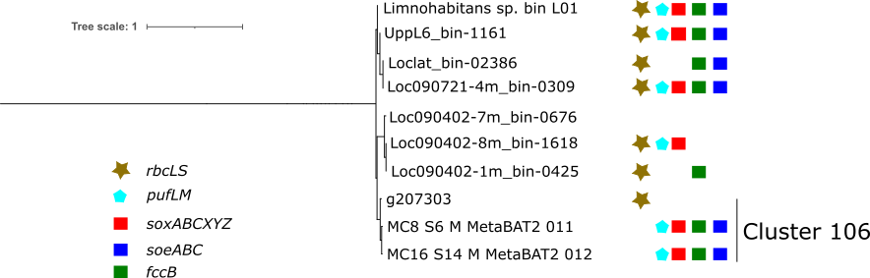
Figure S4.1a Pruned subset of phylogenomic tree of all 971 references used in pangenomic analysis. Shown here are the phylogenetically closest to cluster 106. Key gene content summarized here based on KO presence or absence as determined by pangenomic analysis. At least 50% of the presented pathway must be present to be represented as contained in a genome in this figure.
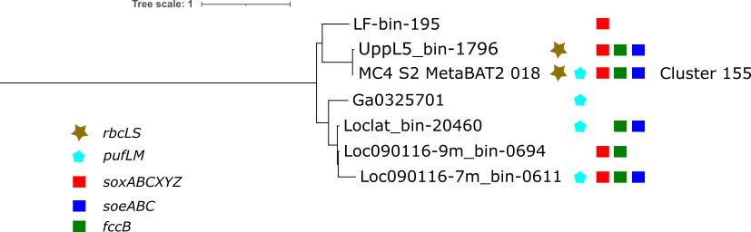
Figure S4.1b Pruned subset of phylogenomic tree of all 971 references used in pangenomic analysis. Shown here are the phylogenetically closest to cluster 155. Key gene content summarized here based on KO presence or absence as determined by pangenomic analysis. At least 50% of the presented pathway must be present to be represented as contained in a genome in this figure.

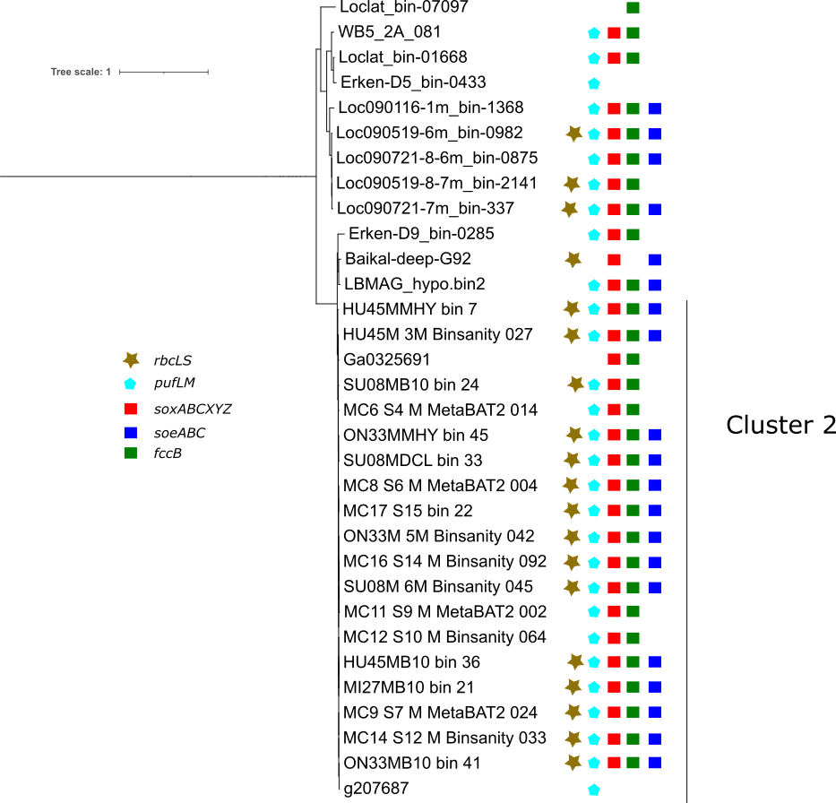
Figure S4.1c Pruned subset of phylogenomic tree of all 971 references used in pangenomic analysis. Shown here are the phylogenetically closest to cluster 2. Key gene content summarized here based on KO presence or absence as determined by pangenomic analysis. At least 50% of the presented pathway must be present to be represented as contained in a genome in this figure.

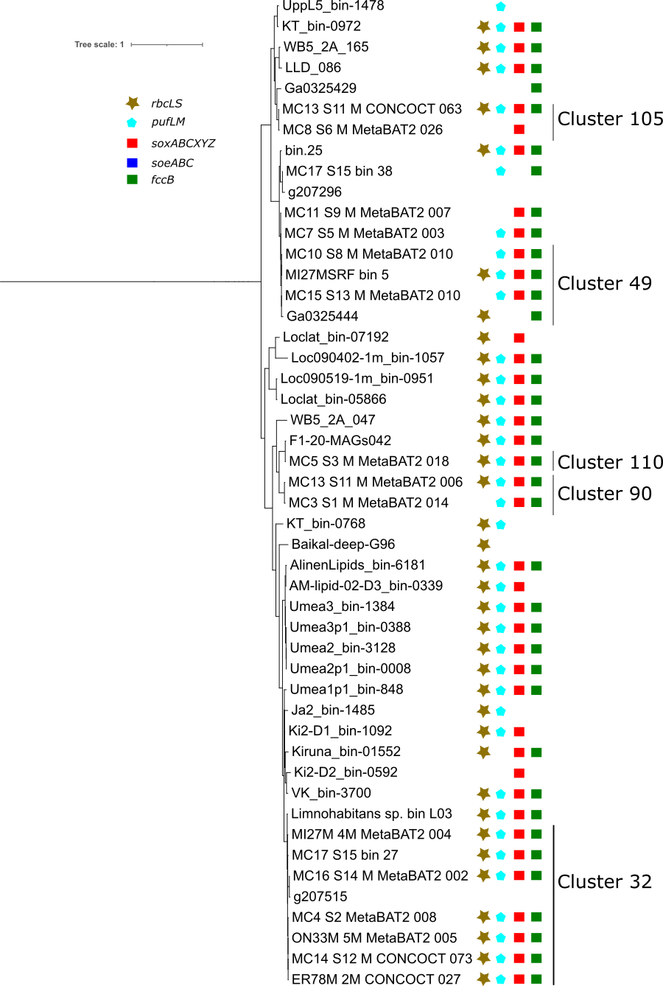
Figure S4.1d Pruned subset of phylogenomic tree of all 971 references used in pangenomic analysis. Shown here are the phylogenetically closest to cluster 32, 90, 110, 49 and 105. Key gene content summarized here based on KO presence or absence as determined by pangenomic analysis. At least 50% of the presented pathway must be present to be represented as contained in a genome in this figure.

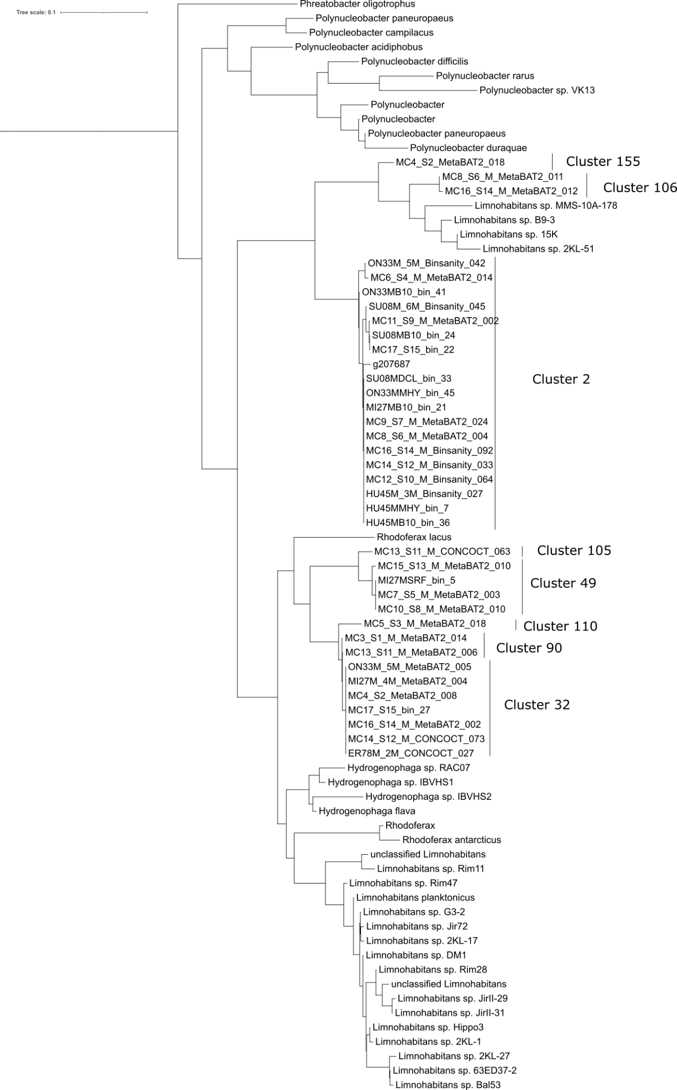
Figure S4.2 Phylogenetic tree of pufL (K08928) sequences from MAGs in relevant MAG clusters as well as closest relatives in RefSeq Microbial Genomes database.

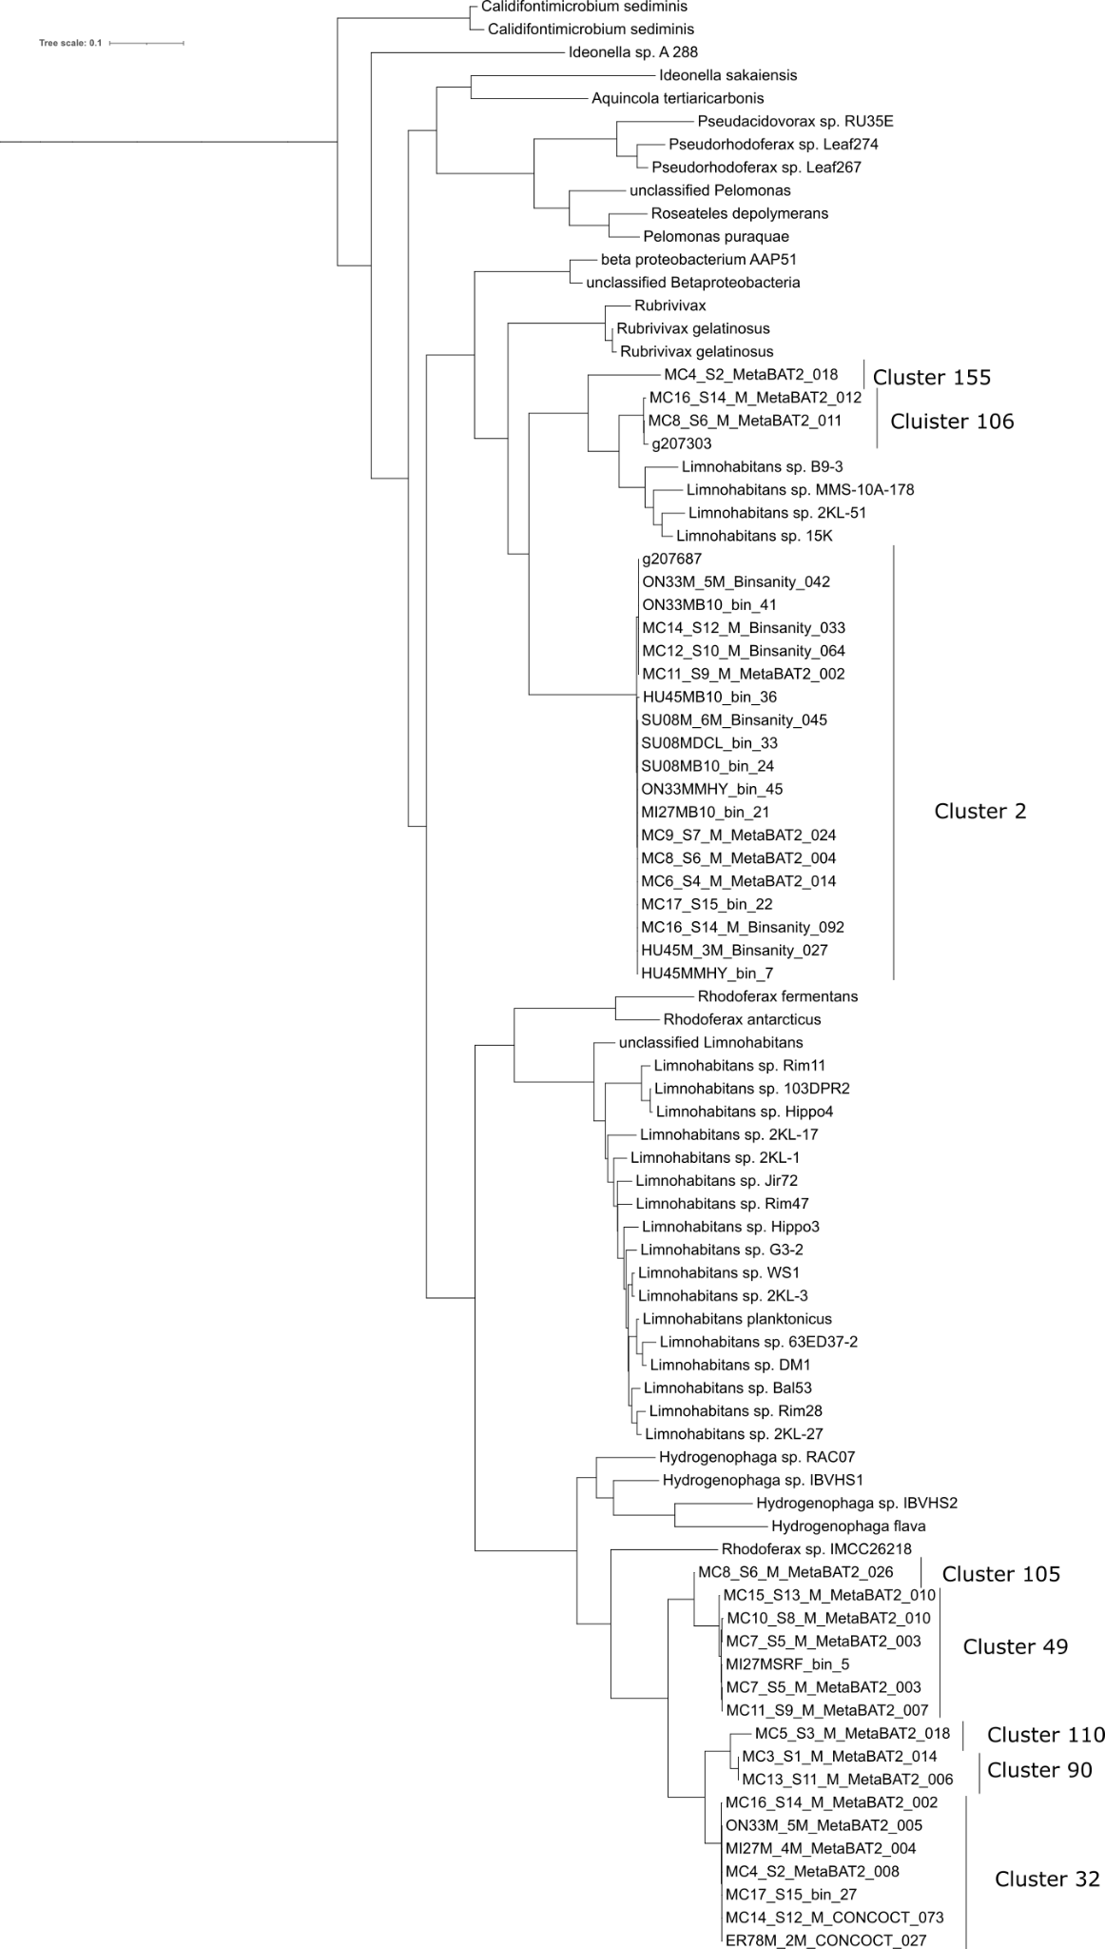
Figure S4.3 Phylogenetic tree of acsF (K04035) sequences from MAGs in relevant MAG clusters as well as closest relatives in RefSeq Microbial Genomes database.

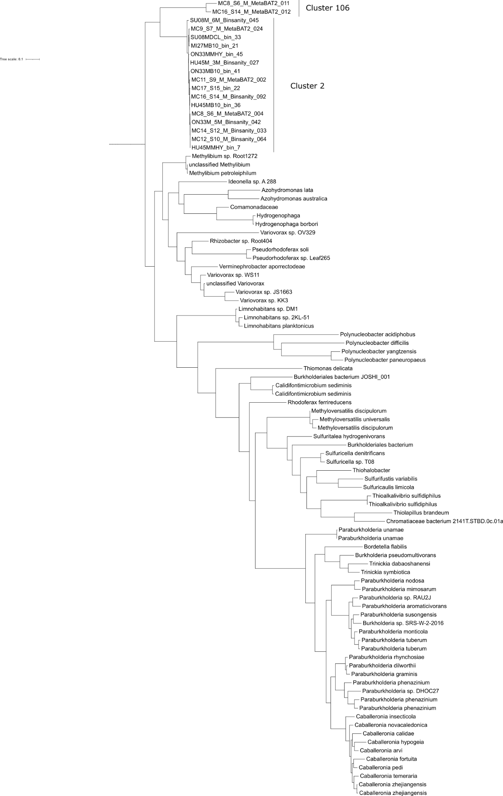
Figure S4.4 Phylogenetic tree of soeC (K21309) sequences from MAGs in relevant MAG clusters as well as closest relatives in RefSeq Microbial Genomes database.

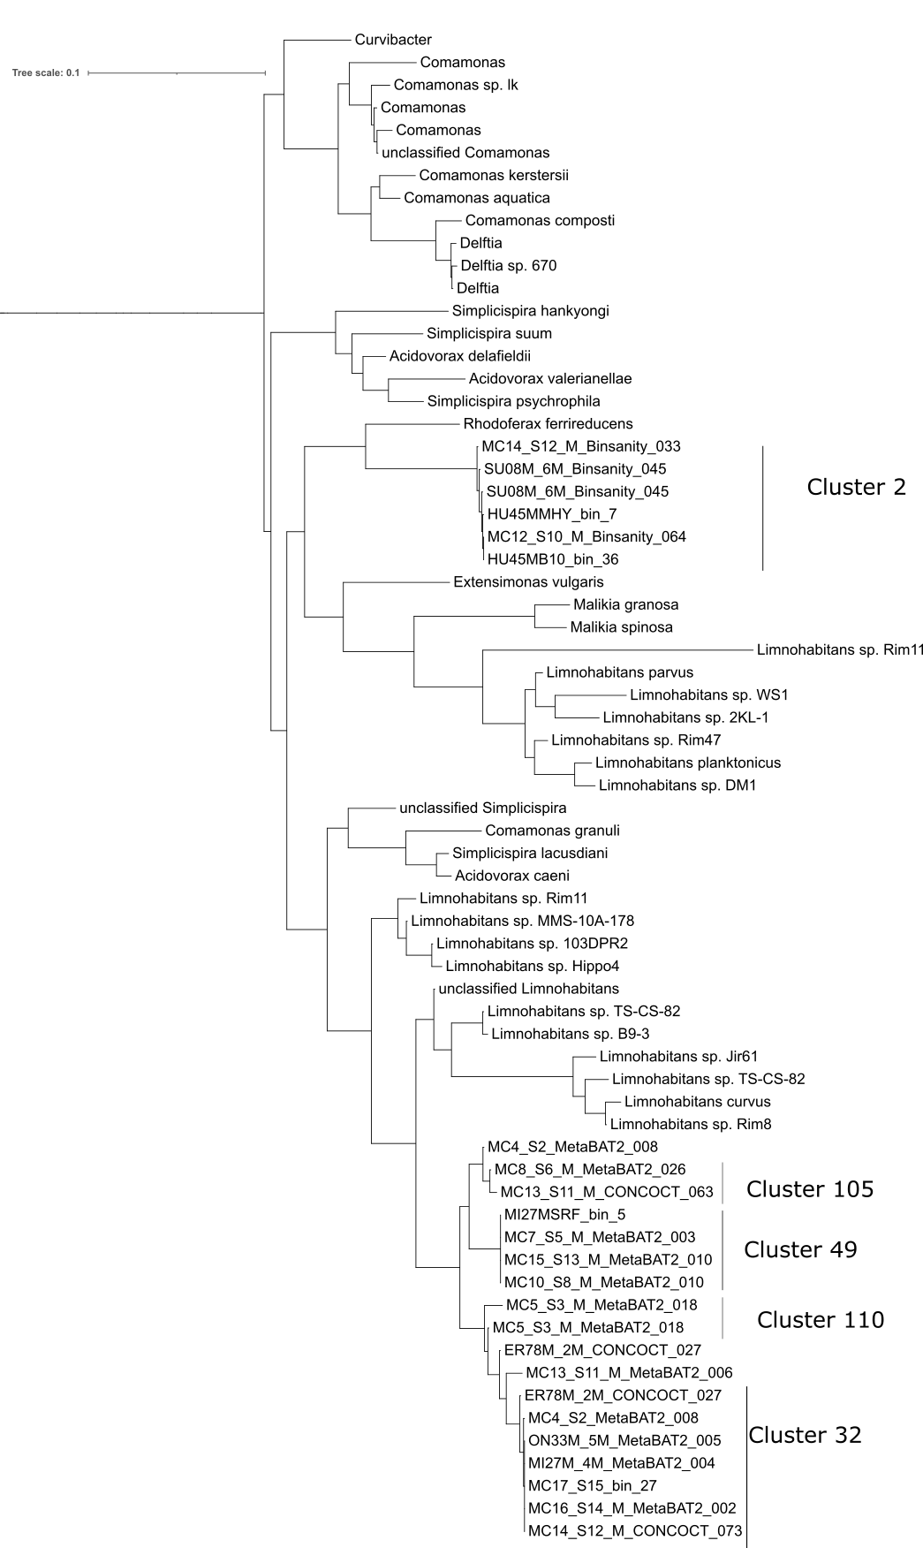
Figure S4.5 Pruned section of phylogenetic tree of gapA (K00134) sequences from MAGs in relevant MAG clusters as well as closest relatives in RefSeq Microbial Genomes database. Pruned section displays cluster 2, 32, 49, 105 and 110.

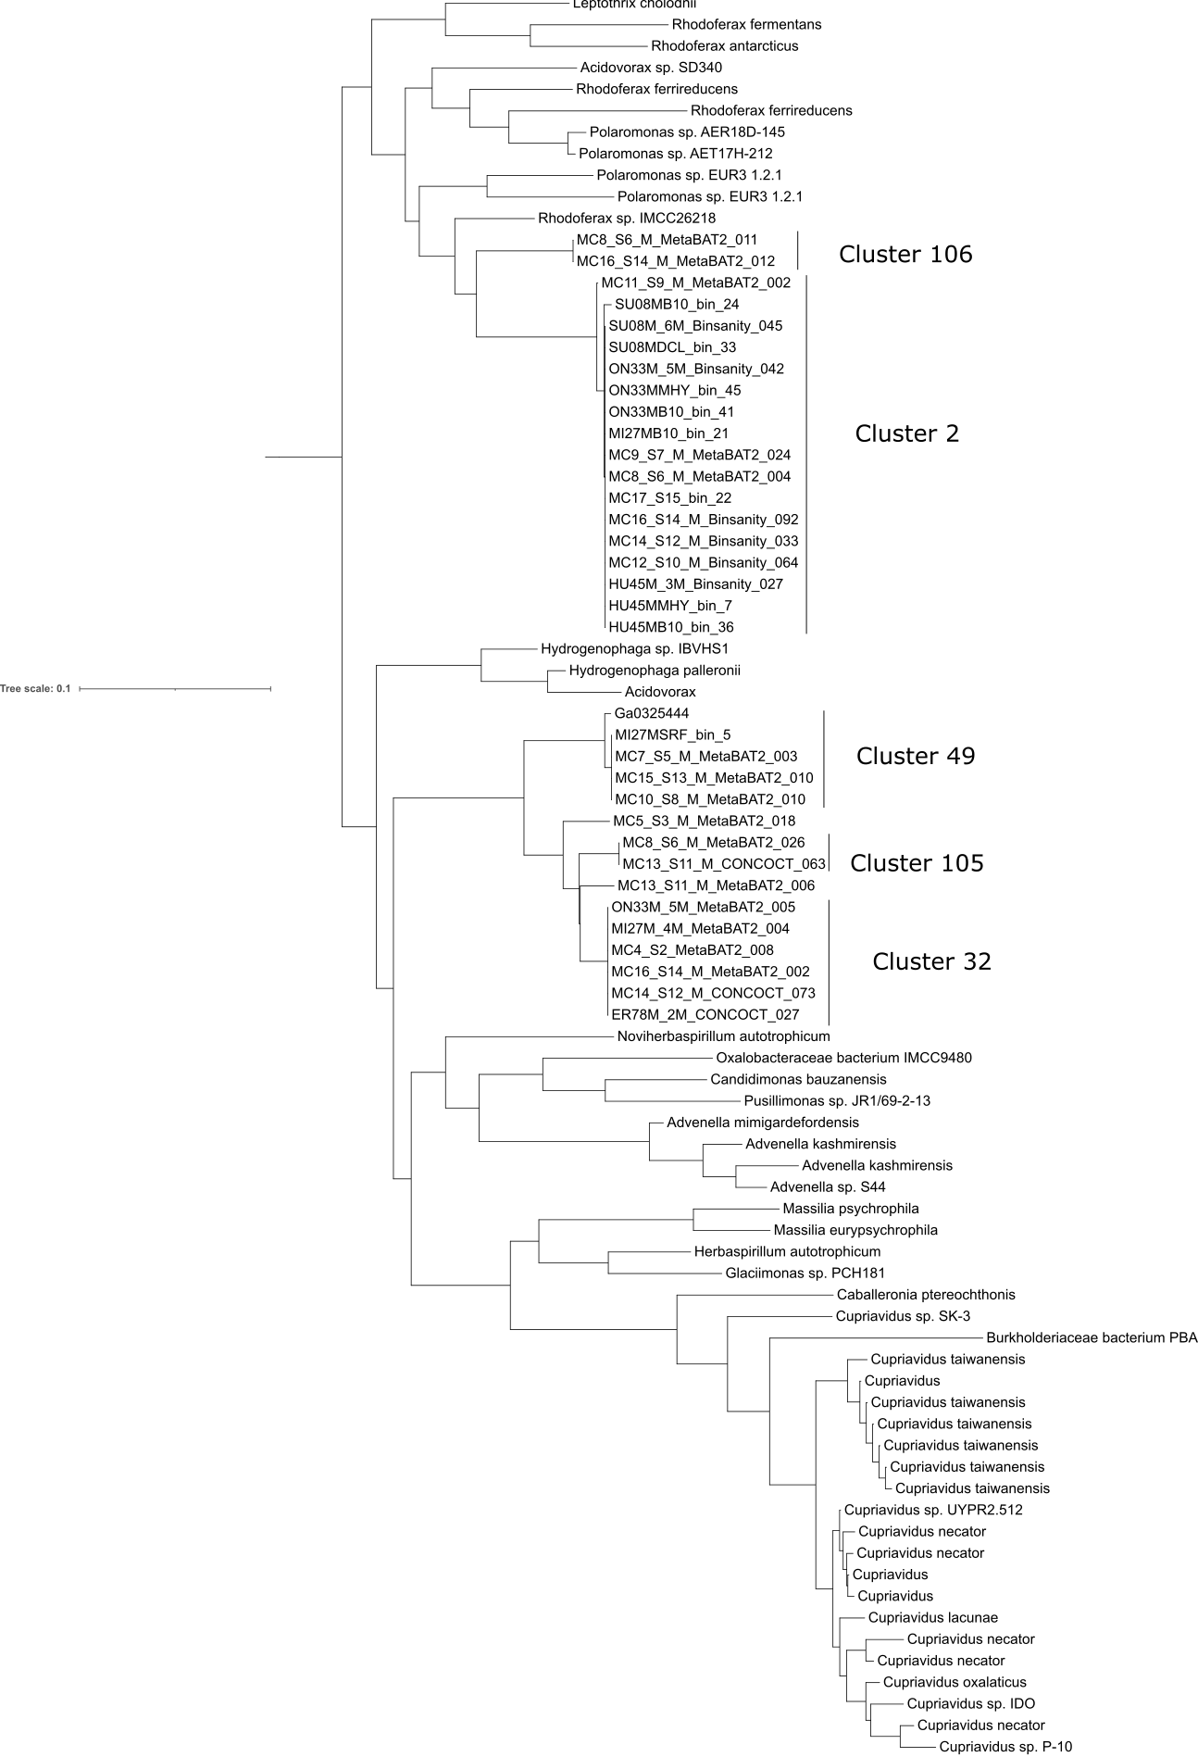
Figure S4.6 Pruned section of phylogenetic tree of prkB (K00855) sequences from MAGs in relevant MAG clusters as well as closest relatives in RefSeq Microbial Genomes database. Pruned section displays cluster 2, 32, 49, 105 and 105 and 106.

Table S4.1 Values of KO reads per Kb and Transcript Reads per DNA read for all KOs present in analysis of expression of Burkholderiales transcripts

Table S4.2 Inventory of key genes as summarize by KOs present in all MAGs present in clusters in which rbcL and pufLM were found

Table S4.3 Inventory of key genes rbcL and pufLM in identified references

Table S4.4 Inventory of pathways in and their completion in all MAGs present in clusters in which rbcL and pufLM was found, as well as completion of those MAGs and which cluster in which they were present.

