Supplementary Material
Theoretical approaches for developing hepatitis C virus controlled human infection models

Zhenzhen Shi^{1#}, Adquate Mhlanga^{1#}, Yuji Ishida^{2#}, Ari Josephson¹, Nicholson T. Collier³, Hiromi Abe-Chayama⁴, Chise Tateno-Mukaidani², Scott J Cotler¹, Jonathan Ozik³, Marian Major⁵, Jordan J. Feld⁶, Kazuaki Chayama ^{7,8*}, Harel Dahari^{1*}
¹ The Program for Experimental & Theoretical Modeling, Division of Hepatology, Department of Medicine, Stritch School of Medicine, Loyola University Chicago, Maywood, IL, USA;
² PhoenixBio Co., Ltd., Higashi-Hiroshima, Japan;
³ Decision and Infrastructure Sciences Division, Argonne National Laboratory, Lemont, IL and Consortium for Advanced Science and Engineering, University of Chicago, Chicago, IL;
⁴ Center for Medical Specialist Graduate Education and Research, Hiroshima University, Hiroshima, Japan;
⁵ Division of Viral Products, Center for Biologics Evaluation and Research, Food and Drug Administration, Silver Spring, Maryland, USA
⁶Toronto Centre for Liver Disease, Toronto, ON, Canada;
⁷ Hiroshima Institute of Life Sciences, Hiroshima, Japan;
⁸ RIKEN Center for Integrative Medical Sciences, Yokohama, Japan.
# Equally contributed.

* Correspondence:
Harel Dahari: hdahari@luc.edu
Kazuaki Chayama: chayama@mba.ocn.ne.jp

A: Basic Model
The initial ODE model consisted of the following three equations, adapted from a previous mathematical model of acute HCV in chimpanzees (Gastroenterology 2005;128:1056-66)
$\frac{dT}{dt}=-dT-βVT\left(1-η\left(t\right)\right)$
$\frac{dI}{dt}=βVT\left(1-η\left(t\right)\right)-δ_{0}I$ (Eq. S1)
$\frac{dV}{dt}=pI\left(1-ϵ\left(t\right)\right)-cV$
The variables and parameters are the same in Eq. S1) as described for the two-equation model (Eq.1) in the main manuscript except for variable V in Eq. S1 that represents both inoculated virus ,Ve, and produced virus from infected cells ,Vm , in Eq. 1.
Although this model captures the biphasic increase, transient decline, and plateau, it did not reproduce well the magnitude of HCV drop at 6 hr post infection (p.i.), i.e., two orders of magnitude above the measured data (Fig. S1A).
B: Basic Model with Eclipse Phase
To try to capture the magnitude of viral drop by 6 hr p.i., an eclipse phase during which infected cells are not productive thus allowing a time delay in producing virions by infected cells while inoculated virus is cleared from blood was assumed. This was included in Eq. S2 as described below:
$\frac{dT}{dt}=-dT-βVT\left(1-η\left(t\right)\right)$
$\frac{dI_{e}}{dt}=βVT\left(1-η\left(t\right)\right)-{}_{e}I_{e}$ (Eq. S2)
$\frac{dI_{m}}{dt}={}_{e}I_{e}-δ_{0}I_{m}$
$\frac{dV}{dt}=pI_{m}\left(1-ϵ\left(t\right)\right)-cV$
where I_{e} represents infected cells in the eclipse phase before they become productively infected cells, I_{m}, at a rate of ${}_{e}$. We performed sensitivity analysis on Ω_{e} and found nearly identical model curves under eclipse phase durations ranged from 7 to 80 hours (not shown). Since Ωe and β parameters are highly correlated, resulting in a coupling effect that made it challenging to estimate both parameters accurately, ${}_{e}$ was fixed at 2.4 day⁻¹ (i.e., eclipse phase duration of 10 hours) based on the in vitro findings of Lindenbach et al. (PMID: 15947137) which aligns well within the eclipse duration range (1-52 hours) estimated by the ABM model (Table 2).
The model was improved by 7 points (based on Akaike Information Criterion, AIC) compared to Eq. S1 but was still an order of magnitude above observed data (Fig. S1B).
C: Necessity of Two Populations of Virus with Different Infection Rates
We explored another model which is used in the main manuscript (Eq. 1). It consists of splitting the virus into two populations: inoculated virus and virions produced by infected human hepatocytes. We assume that the difference between these two populations is in their infectivity, with the inoculated virus having a lower infection rate, $β_{e}$, potentially due to damage to the viral envelope from being frozen for an extended period. This allows for a time delay in producing virions by infected cells while inoculated virus is cleared from blood. $β_{e}$ had to be held fixed due to identifiability issues with $β_{m}$. We explored a range of values from $1×{10}^{-12}$ to $1×{10}^{-10}$ mL/virions/day in Berkeley Madonna, and found that $1×{10}^{-11}$ mL/virions/day ($4.17 ×{10}^{-13}$ mL/virions/hour) provided the best fits to the data for the remaining parameters. The results of fitting the two-population model (Eq. 1) with the measured data (Fig. S1C) had the lowest AIC (4 point lower than Eq. S2).
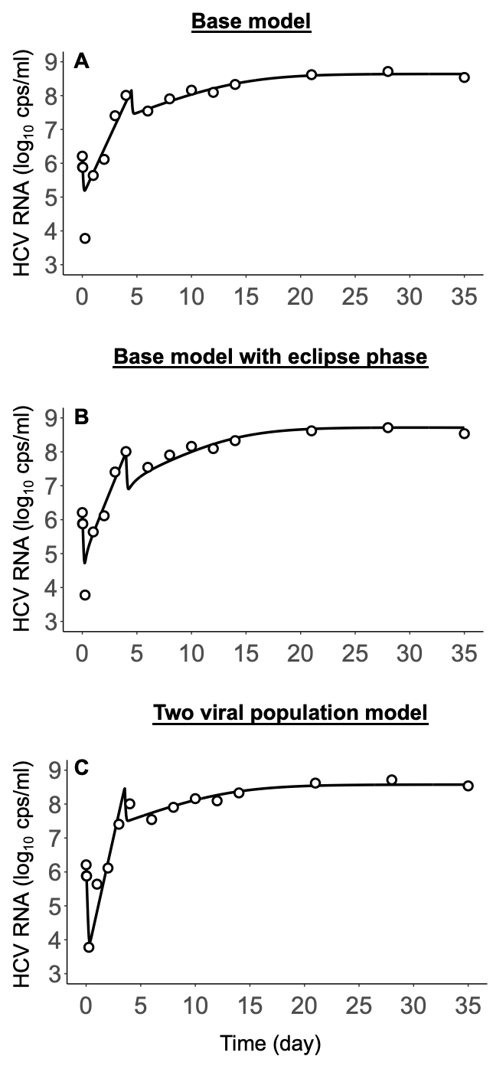
Fig. S1. Measured serum HCV-RNA kinetics (open circles) for mouse 1 (M1) and corresponding models’ fit curves (solid lines) using Eq. S1 (A) Eq. S2 (B) and Eq. 1 (C). The estimated models’ parameters are: (A) $β=2.87×{10}^{-11}$ mL/virions/hour, $ϵ=82$%, $p$= 7.74 virions/cell/hr, (B) $β=3.10×{10}^{-11}$ mL/virions/hour, $ϵ=87$%, $p$= 13.65 virions/cell/hr, and (C)$β=3.20 ×{10}^{-11}$ mL/virions/hour, $ϵ=92$%, $p$= 15.37 virions/cell/hr. In (A), (B) and (C), we set parameters $δ_{0}=d=0$ , η=0, and c=22.2 day⁻¹. Parameter tir was fixed to 4.2, 4.0 and 3.5 days in (A), (B) and (C), respectively. AIC values for the evaluate models: Base model (A) = -24, base model with eclipse phase (B) = -31, and the two-viral population model, i.e., Eq. 1 in the main manuscript (C) = -35. The remaining parameters in each model were fixed as provided in the above respective modeling sections and in the main manuscript for Eq. 1.

D: Blocking of Viral Production vs. Blocking of Viral Infection
Mice 3 (M3) and 4 (M4) did not exhibit a transient decline, instead they switched from a rapid increase phase to a slower increase phase around day 5. Because a transient decline is cause by a blocking of production (ε) in model, we explored using only blocking of infection ($η$) for these two mice to explain the decreasing slope of the viral load. The results of that fit are shown in the top row of Fig. S2.
The results clearly indicate that for M3 and M4, using only blocking of infection results in a poorer fit compared to using only blocking of production. For both mice, the AIC and MSE of the models indicate that blocking of production produces better agreement with the data, as shown in Table S1.

Table S1. Goodness-of-fit comparison for blocking of viral production ($ε$) or infection ($η$). Akaike Information Criterion (AIC) as calculated by lmfit for ODE and mean squared error (MSE) was calculated for ABM using mean function in R.
 | AIC* |  | MSE*
 | Only Blocking of Infection ($η$) | Only Blocking of Production ($ε)$ | Only Blocking of Infection ($η$) | Only Blocking of Production ($ε)$
M1 | -29 | -35 | 0.146 | 0.0775
M2 | -30 | -36 | 0.0799 | 0.0480
M3 | -28 | -34 | 0.129 | 0.0737
M4 | -32 | -47 | 0.0607 | 0.0372
M5 | -31 | -34 | 0.270 | 0.135
*A lower AIC or MSE means better agreement with the data.

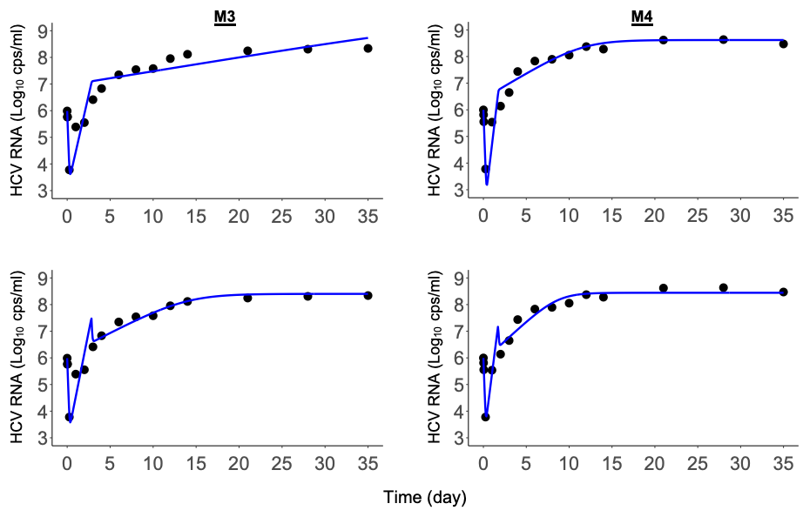
Fig. S2. A comparison of fitting the model with only blocking of infection (top row) and blocking of production (bottom row). The kinetics of serum HCV-RNA are depicted by solid black circles, while the model fit is represented by blue solid lines.

Fig. S3. HCV virion production profile for each mouse from the initial inoculation to 7 days p. i. Individual cells had randomized eclipse phases (black-shaded “E”) followed by a consistent virion production pattern. Left panel shows the production rate under minimal eclipse (Ω_{min}) phase and right panel shows the production rate under maximal eclipse phase (Ω_{max}). M1-M4 initially started with ~ 25 virions/cell/hr, and M5 had a substantial production rate of ~150 virions/cell/hr. This may be related to the high HCV RNA level observed around 5 days p.i. in M5 as shown in Fig. 4. After virion production drops, all five mice produced 1 virion/cell/hr from ~5 days p.i. to 35 days p.i. The virion production rate was calculated using Eq. 2 and Eq. 3. The parameter values (vpaf, α, P_{st}, γ, δ, ω) used in Eq. 2 and Eq. 3 were the parameter values estimated in Table 2.
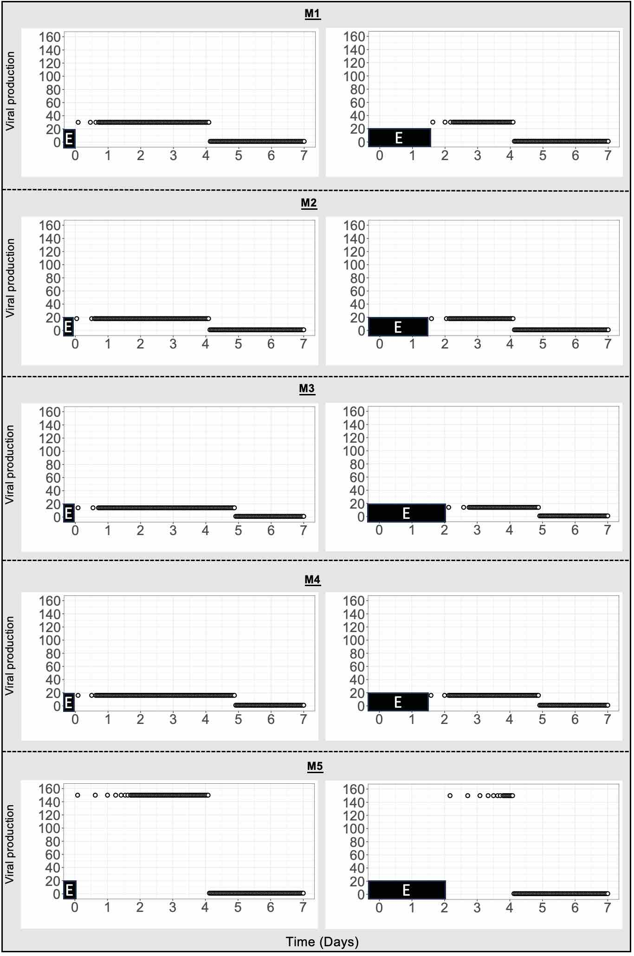
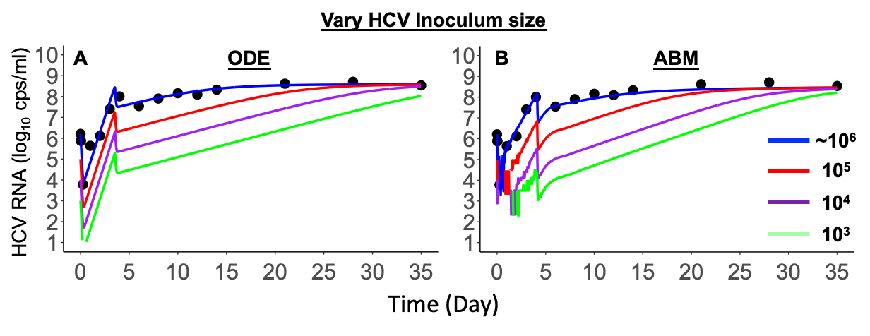
Fig. S4. Varying the HCV inoculum size using the ODE (A) and ABM (B) models.

Table S2. Comparison between ODE and ABM features for modeling acute HCV infection kinetics.
ODE | ABM | Comment (comparison)
- In efforts to explain the fast decline observed at early stage of HCV dynamics (Fig. 3), modeling (Eq. 1) assumed two virion populations without assuming eclipse phase (see Supplementary Materials why the basic model (Eq. S1) and the basic model that accounts for ecplise phase (Eq. S2) were not able to fit well the data). The two-virion population includes:  - A 60 to 260-fold less infectious inoculated virion population (V_{e}), (see, Table 1)  - Virion population that was produced by infected human hepatocytes (V_{m}) | Only one viral population was assumed with a random eclipse phase (Ω_{min} ~ Ω_{max}) assumption (Fig. 2 and Table 2) to mimic the progression of acute HCV infection in the ABM | From a biological perspective, viruses need an eclipse phase to produce virions. But including the eclipse phase in ODE did not capture the minimal viral load. By using a large range (7-80 hours) of eclipse phase duration, the model resulted in nearly identical curves across the tested values (not shown). This was due to identifiability issues, since Ω_{e} and β are highly correlated, resulting in a coupling effect that made it challenging to estimate the Ω_{e} accurately using the ODE model. (see Supplementary Materials Model B (Eq. S2) and Fig. S1B in detail). The specific dynamics and timing of the eclipse phase may not be well represented in ODE due to the assumption of homogeneity and averaging. In ODE, two virion population needs to be assumed to capture the minimal viral load (see Supplementary Materials Model C (Eq. 1) and Fig. S1C in detail). However, ABM can capture the minimal viral level (i.e., HCV RNA level lower than quantifiable limit) by assuming only one virion population, probably due to the eclipse phase assigned to each infected cell and the linearized clearance rate for each simulation step. ABM estimates that the eclipse phase can range from 1 to 52 hours
- Once the cells were infected, they immediately started producing virions | - After passing the eclipse phase, the infected cells gradually released virions based on the predefined production cycle (Fig. 2) | ABM can simulate heterogeneity with cells at different stages of production, which makes sense in a biological way. Initially, all mice started with a long production cycle (9-12 hours) for producing more than 10 virions (i.e., vpaf in Table 2). Within 3 days p.i. the time interval between each production cycle dropped to 1 hr with a low production rate of 1 virion/cell.
- Five unknown model parameters needed to be estimated, which includes:  - Time at viral production drops (t_{ir})  - Infection rate of virions produced by the mouse (β_{m})  - Virion production rate before t_{ir} (p)  - Efficacy in blocking viral production (ε)  - Virion clearance rate (c) | - Eleven unknown model parameters needed to be estimated, which includes:  - Time at viral production drops (t_{ir})  - Infection rate (β)  - Virion production rate at steady state after t_{ir} (P_{st})  - Efficacy in blocking viral production (ε)  - Virion clearance rate (c)  - Min eclipse phase (Ω_{min})  - Max eclipse phase (Ω_{max})  - Initial production cycle length (δ)  - Decay constant (ω)  - Number of cycles to reach 50% of P_{st} (α)  - Steepness of the production curve (γ) | Five parameters in ABM are comparable to the parameters in ODE (highlighted in red) (Table 1 and Table 2). Six more parameters related to virion production cycle (highlighted in in blue) were needed in ABM (also see Table 2). Compared to ODE, estimating those parameters in ABM could be more computationally challenging (cost) when fit to experimental data. In ODE, model calibration using LMFIT module in Python took 10-15 minutes on an HP Pavilion x360 model 15-br095ms. In the ABM, it took approximately 4.8 hours using full concurrency on 6 nodes (with 36 cores per node), or about 1037 core hours to calibrate model parameters using the HPC workflow (see Materials and methods in detail).
- Suggests an infection rate (denoted as β_{m} in Table 1) of 5.1 ± 3.3 x 10⁻¹¹ mL/virions/hr | - Suggests an infection rate (denoted as β in Table 2) of 18.5 ± 3.5 x 10⁻¹¹ cell/hr | ODE suggests a ~10-fold higher infection rate compared to that estimated in ABM. This may be associated with a more rapid ascension phase predicted by ODE compared to that was predicted by ABM (Fig. 4).
- Suggests a constant production rate (p) of (11.2 ± 7.9) virion/cell/hr before t_{ir} (i.e., time at virion production drops, see Table 1) and (1.0 ± 0.3) virion/cell/hr after t_{ir} | - Suggests a high production rate with different production cycles before t_{ir} (Fig. S3) and a constant production rate (denoted as P_{st} in Table 2) of 1 virion/cell/hr for all five mice at the steady state (after t_{ir}) | In the ABM, because a simulation agent needs to be an integer rather than a fraction, an infected cell at a productive stage needs to produce at least one virion per cell (Table 2). In the ODE, an infected cell can produce less than 1 virion on average (Table 1).
- Suggests that efficacy in blocking viral production (denoted as ε in Table 1) is (92.1% ± 0.02%). This event occurred at (2.8 ± 0.7 days) p.i. when viral production drops (denoted as t_{ir} in Table 1) | - Suggests that efficacy in blocking viral production (denoted as ε in Table 2) is (94.3% ± 2.7%). This event occurred at (4.1 ± 0.4 days) p.i. when viral production drops (denoted as t_{ir} in Table 2) | Compared to ODE, ABM suggests a ~5% higher efficacy in blocking viral production that maybe associated with a later t_{ir}, which is the estimated time when viral production drops (Table 1, Table 2, and Fig. 4). More frequent sampling around this time event would help provide a more precise estimation regarding the transit decline in the HCV RNA level.

Table S3. Measured HCV RNA data in both SCID-M (Mice 6-10) and SCID-MhL (Mice 1-5) mice.
Time (p.i.)/Mice | 1 | 2 | 3 | 4 | 5 | 6 | 7 | 8 | 9 | 10
1min | 1620333.98 | 1519823.29 | 973672.632 | 991898.071 | 1310160.21 | 845324.194 | 1203191.31 | 1369576.9 | 1122448.1 | 1058850.44
0.5h | 769177.002 | 585486.694 | 574809.521 | 649546.582 | 719972.021 | 135896.265 | 94085.2844 | 162316.058 | 129241.937 | 111957.596
1h | 756126.563 | 332997.253 | 591131.543 | 358227.136 | 652202.71 | +/-* | - | +/-* | +/-* | -
6h | - | +/-* | +/-* | - | - | - | - | - | - | +/-*
d1 | 435798.34 | 405844.849 | 245160.919 | 344586.584 | 815321.265 | - | - | - | +/-* | -
d2 | 1302902.93 | 1706398.24 | 357422.314 | 1376503.27 | 4582372.85 | - | - | +/-* | - | +/-*
d3 | 25420954.7 | 7605481.05 | 2594397.36 | 4467554 | 58506164.1 | - | - | - | - | -
d4 | 101816555 | 32965289.1 | 6783955.08 | 27349640.6 | 155379070 | - | - | - | - | -
d6 | 34945306.6 | 70991648.4 | 22246541 | 67650562.5 | 25723552.7 | - | - | - | - | -
d8 | 80298873 | 49668796.9 | 34757926.8 | 78814839.8 | 78008478.5 | - | - | - | +/-** | -
d10 | 144696586 | 111306703 | 38121679.7 | 112946297 | 87377156.3 | - | - | - | +/-** | -
d12 | 124569492 | 141328207 | 90207750 | 235572539 | 150661313 | - | - | - | - | -
d14 | 213685313 | 196068281 | 131103164 | 189603164 | 200032828 | - | - | - | - | -
d21 | 415643109 | 368923336 | 176226574 | 416330109 | 484920328 | - | +/-** | - | - | -
d28 | 516544219 | 267963838 | 203702109 | 432011162 | 454498242 | - | - | +/- | - | -
d35 | 343850801 | 274085947 | 217851431 | 296425840 | 403998223 | - | - | - | - | -
Note: +/-*: lower than quantification limit (< 6000 copies/ml); +/-**: lower than quantification limit (< 60000 copies/ml); -: lower than detection limit

