Supplementary information for

How status of research papers affects the way they are read and cited

Contents
Survey materials
Nonresponse analysis
Status signal experiment
Bias in self-reporting of influence
First vs. second reference
Descriptive statistics
Figs. S1 to S4
Tables S1 to S8

Survey materials
The full survey is available as a PDF at the following link [link provided during proofing]. The following text and figures highlight key features of the survey flow. Figure S1 displays the (anonymized) recruitment email.
[ Figure S1 about here ]
After clicking on the link, respondents proceeded to confirm that the paper was indeed theirs and read IRB information. Next, they proceeded to a randomized page, the two versions of which are displayed in Figure S2. The control (panel A) and treatment (panel B) versions are identical except that treatment includes the reference’s citation information.
[ Figure S2 about here ]
Next, respondents answered questions about their knowledge of the reference, how much it influenced them, which aspects of their work were influenced (Figure 3 in Main document). To account for ordering effects in answer choices, respondents were randomized into two forms with identical questions but reversed answer choice order. Form A’s answer choices ranged from smallest/least to biggest/most, while form B had the opposite ordering. Next, respondents rated the reference on various dimensions of quality (Figure S3). Lastly, respondents provided their gender and academic position..
[ Figure S3 about here ]

Nonresponse analysis
A response was defined as clicking on the personalized Qualtrics link (opened.survey=True). Completing the survey was defined as exiting out of the last page (completed.survey=True). To investigate response rates by impact factor of the respondent’s journal, gender, and assignment to status signal condition, we estimate a logistic regression with opened.survey as the outcome regressed on the Web of Science 2015 impact factor, a 3-level gender variable {“Unknown”, “Male”, “Female”}, and status signal indicator. The model was specified as follows:
$\log{{Y_{ij}}/{1-Y_{ij}}=β_{0}+β_{1}author.female+β_{2}author.male+β_{3}source.impact.factor+β_{4}status.signal+ϵ_{ij}}$ (1)
Where Y_{ij} is either opened.survey or completed.survey. Estimates from this regression are displayed in Table S2, model 1 and average marginal effects are displayed in Table S2, model 1. Author gender was inferred using Genderize.io (https://genderize.io/). Average marginal effects indicate that authors of papers in high impact journals were somewhat less likely to respond, with response rate decreasing by 0.73% per unit impact factor, while “Female” and “Male” authors were 2.2% and 5.7%, respectively, more likely to respond than “Unknown.” As expected, the randomly assigned status signal did not significantly affect response rates.
[ Table S2 about here ]
[ Table S3 about here ]
Of more concern is whether the status signal affected survey completion rates. Estimates from a logistic regression predicting completed.survey=True are displayed in Table S2: Model 2. The point estimate for the average marginal effect of status.signal on completion is 0.0071 (0.71%, SE = 0.004, p = 0.071). Thus we conclude that exposing status signals increased completion rates by a very small, if any, amount.

Status signal experiment

Average treatment effect
Citation can be high or low, and we expect high status signals to improve perceptions of quality, and low signals to harm them. The expected heterogeneity of the treatment makes the average treatment effect (ATE) a poor summary of it. For completeness, we provide the ATE in Table S3 below, estimated with the following regression specifications.
$$attribute_{ij}=β_{0}+β_{1}reach.signal_{i}+β_{2}X_{ij}+ϵ_{ij}$$
(2)
In this specification, attribute_{ij} is the rating of a quality attribute by author i of reference j, status.signal_{i} is an indicator of whether author i received a status signal (assignment to treatment was done at the respondent, not reference, level)and $β_{1}$ measures the ATE, and X_{ij} is a set of control variables describing author i and reference j. Control variables are indicators for the author’s gender and academic position, and indicators for the reference’s discipline, publication year, whether it was added by the responding author or a co-author, and whether it appeared first or second in the survey.
[ Table S4 about here ]
Most columns (attributes) in Table S4 show the ATE of status.signal to be negative, with effects on perceived validity and generalizability citationing significance.

Heterogeneous treatment effects
We model attribute ratings as linear functions of citation percentile (field-year specific), with a separate intercept and slope for control and treatments observations. The specification takes the same form as (3) with above.median_{ij} replaced by percentile_{ij}. Estimates from this regression are displayed in Tables S5.
[ Table S5 about here ]
The estimates show a consistent pattern: the status signal exaggerates the underlying (control) relationship. The status signal harms the perception of low-cited papers (coefficients of status.signal are negative and, with the exception of “validity,” statistically significant. However the penalty gets smaller as citation counts, and therefore the nature of the signal, improve - coefficients of the interaction effect are positive and, with the exception of “validity,” statistically significant.
To locate the approximate point in the citation distribution at which the status signal becomes a net positive for perceptions, we locate the percentile at which the control and citation-signal lines intersect. For “overall quality” that percentile is $p^{*}=4.579/0.054=89.8≈90$. Thus, for all but approximately top 10% highest cited references, the status signal had a negative effect on perceived quality.

Bias in self-reporting of influence
Responses to survey questions may be affected by social desirability bias. This bias may affect our key measure – influence – because respondents may believe that highly cited works are “better” than low cited ones, and so it would be socially undesirable to be strongly influenced by low cited, i.e. low quality, works. If this bias is present, showing respondents the work’s citation count should intensify it, because doing so a) raises the salience of citations, b) makes the citation count more accessible, and c) indicates the audience, in this case the researchers conducting the study, are aware of the citation count. On the other hand, if showing respondents citation counts has no effect on their reporting of influence, it is likely the bias is either absent or small.
To test the effect of citation information on reporting of influence, we repeat the analysis above, substituting influence as the dependent variable. Figure S4 plots the resulting coefficients and Table S6 shows the corresponding regression table.
[ Figure S4 about here ]
[ Table S6 about here ]
The estimated treatment effects are statistically indistinguishable from zero, suggesting that social desirability bias is substantively small or absent altogether.

First vs. second reference
The sampling strategy was to stratify all papers in a particular field in a particular year by citation percentile, sample at random papers from each percentile (“first reference”), and sample at random from the set of papers citing each of these references (“source papers”). Then, for each of these source papers, we chose a “second reference” to enable precise comparisons with the first. The second reference was chosen from the reference list at random, constraining it whenever possible to be in same field and year of publication as the first. Figure S6 shows the resulting number of responses by percentile, for first (blue) and second (orange) references separately. Responses on the first references were approximately equally distributed across percentiles, as expected. However, the second references were much more often very highly cited (99th percentile). Some of this difference is due to random sampling rather than stratified-by-percentile random sampling. Secondly, some of these second references were published substantially before than the oldest first references (year 2000), and have had much more time to accrue citations. Yet in these cases, for each of presentation, their citation percentile was calculated using the year-field-specific citation distribution of their corresponding first reference.
[Figure S4 about here ]

Descriptive statistics
Tables S7 and S8 display the descriptive statistics and correlation table, respectively, for quantitative variables used in the analysis.
[ Table S7 about here ]
[ Table S8 about here ]

Supplementary figures
Fig. S1. Sample recruitment email.
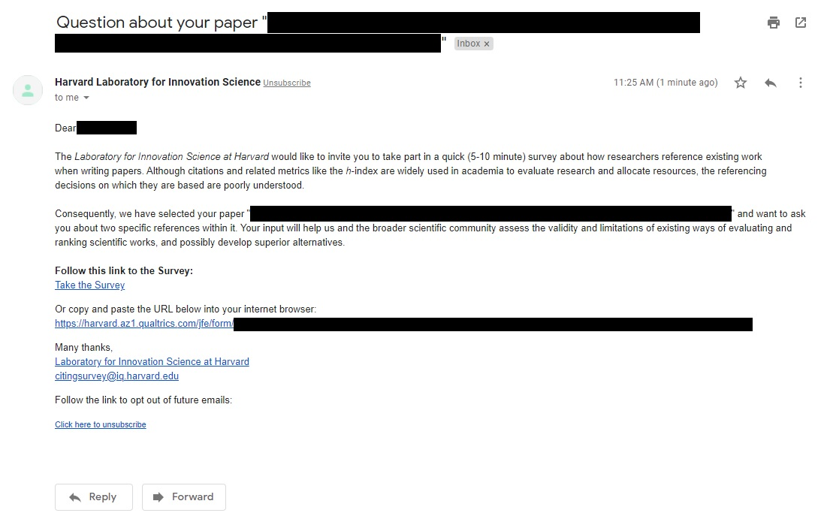

Fig. S2. Two forms used for the status signal experiment. 85% of randomly assigned respondents saw the control form (Panel A), which does not show any citation information, and 15% saw the treatment form (Panel B), which displays the true citation count and percentile.
A | B
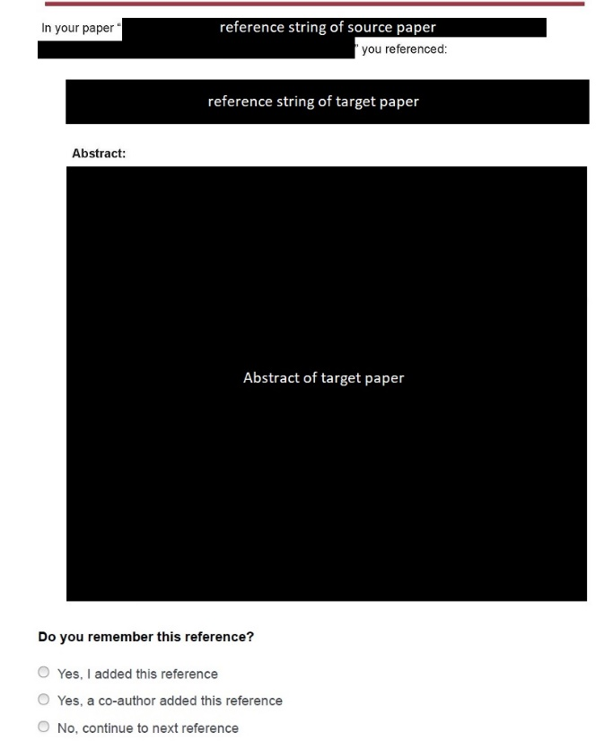 | 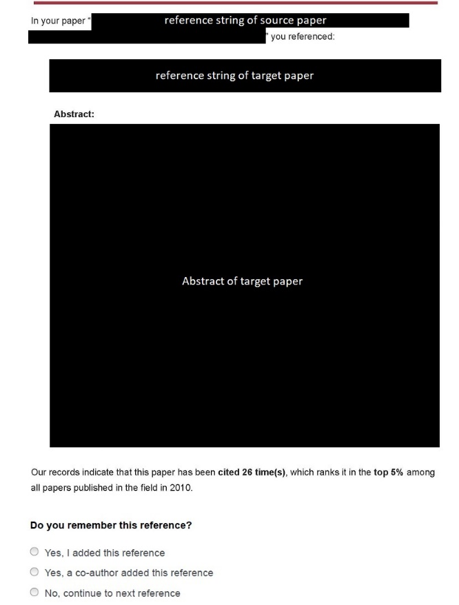

Fig. S3. Panel of questions about perceived quality of the reference. The attribute in the last position was randomized to be “Canonical” or “Prominent.” Data from this last position is not included in the present analyses due to its only indirect relationship with quality, but is available from the authors upon request.
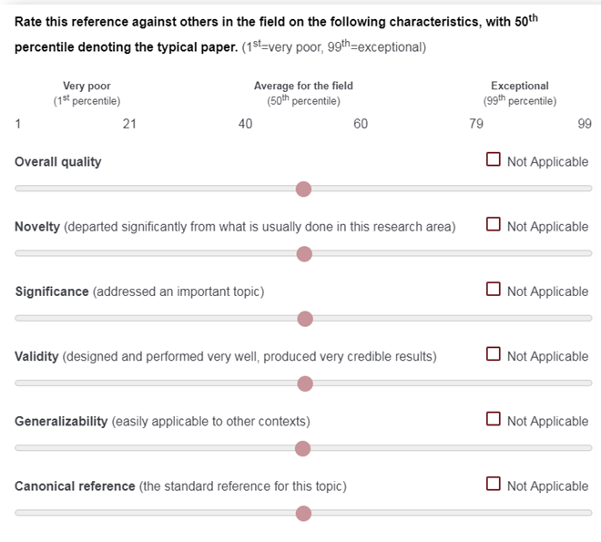

Fig S4. Treatment effects of status signal (coefficient of the status.signal variable in Appendix, Eq (3)) on reported influence. Treatment effects are shown separately for references below the median in discipline-year citation distribution (“Bottom 50%”) and above it (“Top 50%”), using only references published in the 15 focal fields in the 3 focal years. Standard errors are clustered on the respondent.
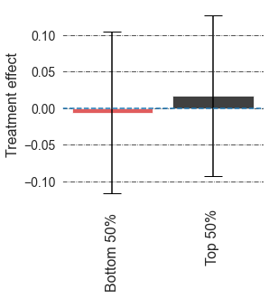

Fig. S4. Number of observations by citation percentile for first (blue) and second (orange) references. The sampling was designed around the first reference, with the second reference chosen at random from the same reference list, constraining it to be in similar year of publication and field as the first reference when available. The percentile for all second references is based on the field-year citation distribution of the first reference. The relatively few observations for very low percentiles reflect fields in which the lowest-cited papers are completely uncited.
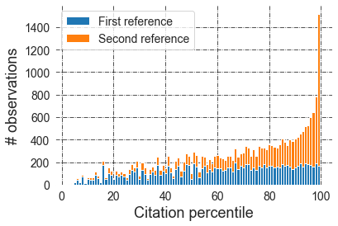

Supplementary tables
Table S1. Disciplines from which the first reference in each survey was chosen and their rank according to the mean CiteScore of the top 5 journals in 2016.

Major subject | Field | CiteScore in 2016 of top 5 journals | Rank
Arts & Humanities | Linguistics | 3.598 | 1
Arts & Humanities | History & philosophy of science | 2.098 | 3
Clinical, Pre-Clinical & Health | Oncology | 28.312 | 1
Clinical, Pre-Clinical & Health | Pharmacology & pharmacy | 13.732 | 2
Clinical, Pre-Clinical & Health | Endocrinology & metabolish | 10.736 | 4
Engineering & Technology | Energy & fuels | 13.0222 | 2
Engineering & Technology | Telecommunications | 12.194 | 3
Engineering & Technology | Engineering, electrical & electronic | 10.742 | 5
Life Sciences | Oncology | 28.312 | 1
Life Sciences | Immunology | 17.96 | 2
Life Sciences | Biochemistry & molecular biology | 17.313 | 3
Physical Sciences | Physics, applied | 21.274 | 2
Physical Sciences | Chemistry, physical | 16.294 | 5
Physical Sciences | Nanoscience & nanotechnology | 15.79 | 6
Social Sciences | Psychology | 14.864 | 1
Social Sciences | Economics | 6.542 | 8

Table S2. Estimates from logistic regressions predicting opening (Model 1) and completing (Model 2) the survey. The reference category for author.gender is “Unknown.” *p<0.1; **p<0.05; ***p<0.01 for 2-sided Wald tests. Average marginal effects are displayed in Table S2.
 | (1)  opened_survey | (2)  completed_survey
Intercept | -1.444***  (0.0228) | -1.868***  (0.0260)
author.gender = female | 0.134***  (0.0270) | 0.135***  (0.0328)
author.gender = male | 0.355***  (0.0240) | 0.427***  (0.0271)
source.impact.factor | -0.0458***  (0.0050) | -0.0388***  (0.0055)
status.signal | -0.0119  (0.0280) | 0.0560  (0.0310)
Observations | 62550 | 62550
df model | 4 | 4
pseudo-R | 0.00518 | 0.00629
LLR p-value | 2.698e-69 | 9.528e-71

Table S3. Average marginal effects from logistic regression tables of Table S2. The reference category for author.gender is “Unknown.” *p<0.1; **p<0.05; ***p<0.01 for 2-sided Wald tests.
 | (1)  opened_survey | (2)  completed_survey
author.gender = female | 0.0215***  (0.004) | 0.0171***  (0.004)
author.gender = male | 0.0569***  (0.004) | 0.0541***  (0.003)
source.impact.factor | -0.0073***  (0.001) | -0.0049***  (0.001)
status.signal | -0.0019  (0.004) | 0.0071  (0.004)

Table S4. Estimates from OLS regressions of quality attribute ratings on status signal. Robust standard errors clustered at respondent level. + p<0.1; * p<0.05; ** p<0.01; *** p<0.001 for two-sided t-tests. Constant and controls not shown.
 | Dependent variable:
 | overall.quality | novelty | validity | generalizability | significance
 | (1) | (2) | (3) | (4) | (5)
status.signal | -1.192* | -0.936 | -1.379* | -2.209** | -0.633
 | (0.607) | (0.741) | (0.678) | (0.756) | (0.631)
Controls | Y | Y | Y | Y | Y
Observations | 7,376 | 6,848 | 6,866 | 6,715 | 7,359
R² | 0.063 | 0.035 | 0.036 | 0.036 | 0.057
Adjusted R² | 0.060 | 0.031 | 0.032 | 0.032 | 0.053
Residual Std. Error | 16.972 (df = 7345) | 19.502 (df = 6817) | 17.799 (df = 6866) | 19.602 (df = 6684) | 17.768 (df = 7328)

Table S5. Estimates from OLS regressions of quality attribute ratings on status signal and percentile. Robust standard errors clustered at respondent level. + p<0.1; * p<0.05; ** p<0.01; *** p<0.001 for two-sided t-tests. Constant and controls not shown.
 | Dependent variable:
 | overall.quality | novelty | validity | generalizability | significance
 | (1) | (2) | (3) | (4) | (5)
percentile | 0.109*** | 0.103*** | 0.082*** | 0.109*** | 0.120***
 | (0.010) | (0.011) | (0.010) | (0.011) | (0.010)
status.signal | -5.035** | -5.505** | -3.504⁺ | -6.722** | -5.865**
 | (1.712) | (2.091) | (1.887) | (2.043) | (1.842)
percentile X status.signal | 0.059*  (0.023) | 0.071*  (0.028) | 0.033  (0.026) | 0.070*  (0.028) | 0.079**  (0.025)
Controls | Y | Y | Y | Y | Y
Observations | 7,376 | 6,848 | 6,866 | 6,715 | 7,359
R² | 0.087 | 0.047 | 0.045 | 0.048 | 0.079
Adjusted R² | 0.083 | 0.043 | 0.041 | 0.044 | 0.075
Residual Std. Error | 16.757 (df = 7343) | 19.382 (df = 6816) | 17.715 (df = 6834) | 19.476 (df = 6683) | 17.559 (df = 7327)

Table S6. Estimates from OLS regressions of quality attribute ratings on status signal and percentile. Robust standard errors clustered at respondent level. + p<0.1; * p<0.05; ** p<0.01; *** p<0.001 for two-sided t-tests. Constant and controls not shown.

 | Dependent variable:
 | influence
above.median | 0.097***
 | (0.027)
status.signal | -0.006
 | (0.056)
above.median X status.signal | 0.023
 | (0.066)
Observations | 9,635
R² | 0.040
Adjusted R² | 0.037
Residual Std. Error | 1.020 (df = 9603)

Table S7. Descriptive statistics of quantitative variables used in the dataset. Qualitative variables like discipline are excluded.
 | count | mean | std | min | 25% | 50% | 75% | max
percentile | 23618.0 | 68.36 | 25.23 | 2.0 | 50.00 | 74.00 | 91.0 | 99.00
citation.count | 23618.0 | 85.47 | 825.33 | 1.0 | 9.00 | 21.00 | 50.0 | 77275.00
log.citations | 23618.0 | 1.34 | 0.59 | 0.0 | 0.95 | 1.32 | 1.7 | 4.89
influence | 15320.0 | 2.47 | 1.07 | 1.0 | 2.00 | 2.00 | 3.0 | 5.00
major.influence | 15320.0 | 0.18 | 0.38 | 0.0 | 0.00 | 0.00 | 0.0 | 1.00
knowledge | 15563.0 | 2.93 | 1.10 | 1.0 | 2.00 | 3.00 | 4.0 | 5.00
overall_quality | 11680.0 | 68.74 | 17.36 | 1.0 | 60.00 | 70.00 | 80.0 | 99.00
significance | 11589.0 | 69.91 | 18.06 | 1.0 | 60.00 | 71.00 | 82.0 | 99.00
novelty | 10811.0 | 65.63 | 19.67 | 1.0 | 55.00 | 69.00 | 80.0 | 99.00
validity | 10884.0 | 70.97 | 17.88 | 1.0 | 60.00 | 74.00 | 83.0 | 99.00
generalizability | 10562.0 | 64.95 | 19.83 | 1.0 | 53.00 | 68.00 | 80.0 | 99.00
gender | 16357.0 | 1.31 | 0.47 | 1.0 | 1.00 | 1.00 | 2.0 | 3.00
position | 16428.0 | 4.32 | 2.71 | 1.0 | 2.00 | 3.00 | 7.0 | 9.00
status.signal | 23618.0 | 0.15 | 0.35 | 0.0 | 0.00 | 0.00 | 0.0 | 1.00
first.paper | 23618.0 | 0.50 | 0.50 | 0.0 | 0.00 | 0.00 | 1.0 | 1.00
added.by.coauthor | 17676.0 | 1.10 | 0.30 | 1.0 | 1.00 | 1.00 | 1.0 | 2.00
when.discovered | 11458.0 | 2.43 | 1.24 | 1.0 | 1.00 | 2.00 | 3.0 | 5.00
discovered.social.contact | 15371.0 | 0.15 | 0.36 | 0.0 | 0.00 | 0.00 | 0.0 | 1.00
discovered.database.search | 15371.0 | 0.62 | 0.48 | 0.0 | 0.00 | 1.00 | 1.0 | 1.00

Table S8. Correlation table for numeric variables, with self-citations excluded. Qualitative variables like discipline are also excluded.
