Supplemental Figure S1-1: Case 1 patient data as presented to the panel of experts.
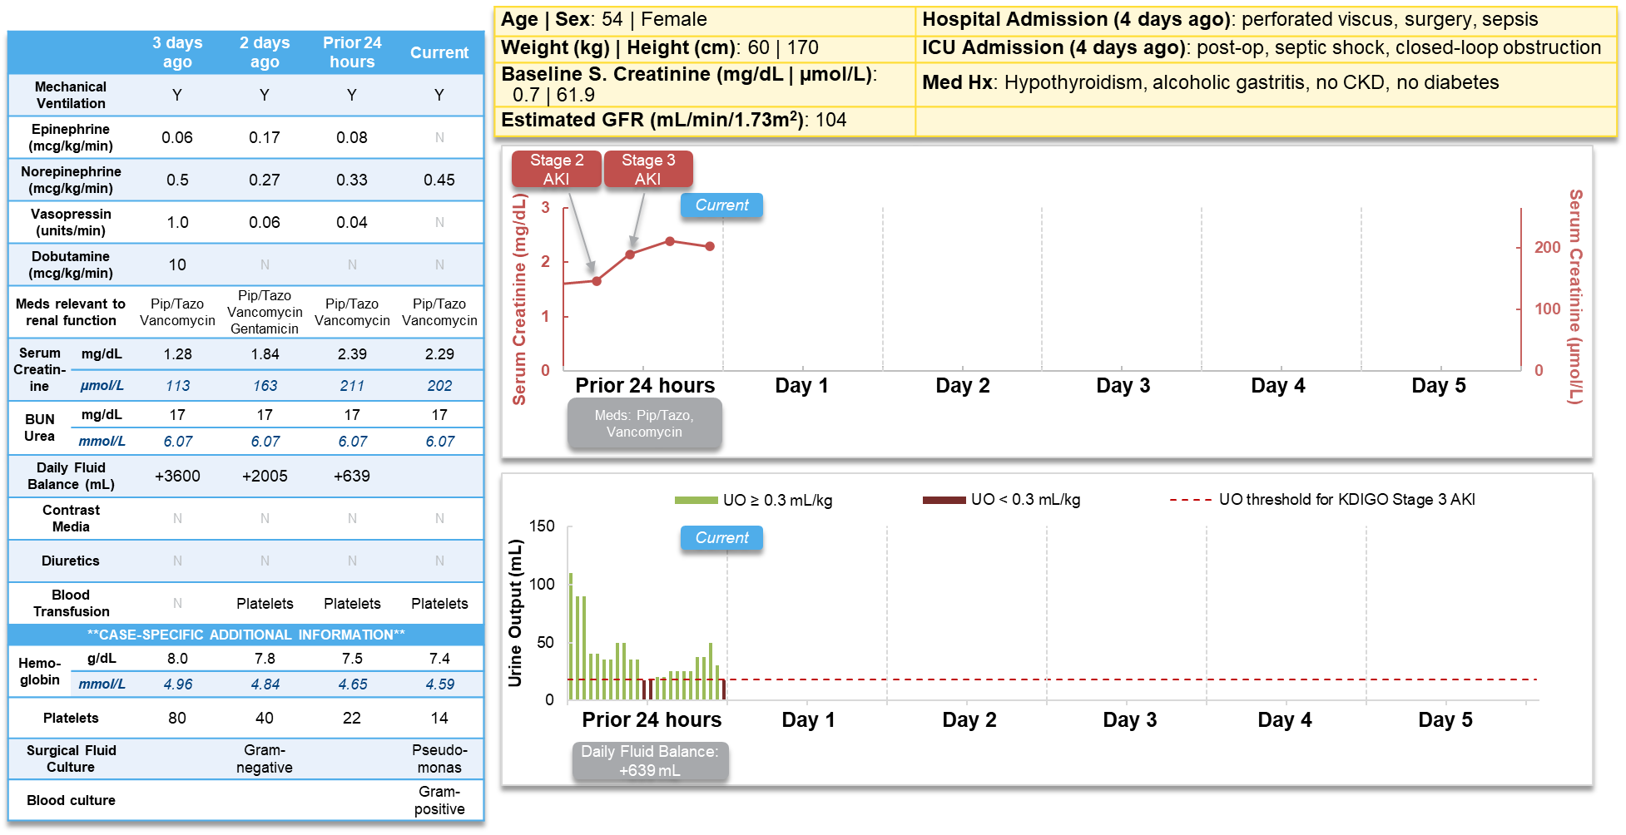

Supplemental Figure S1-2: Case 1 with additional patient data after CCL14 measurement. CCL14 values and additional clinical data after ‘current’ (time of the CCL14 urine sample collection) were not made avaible to the expert panel.
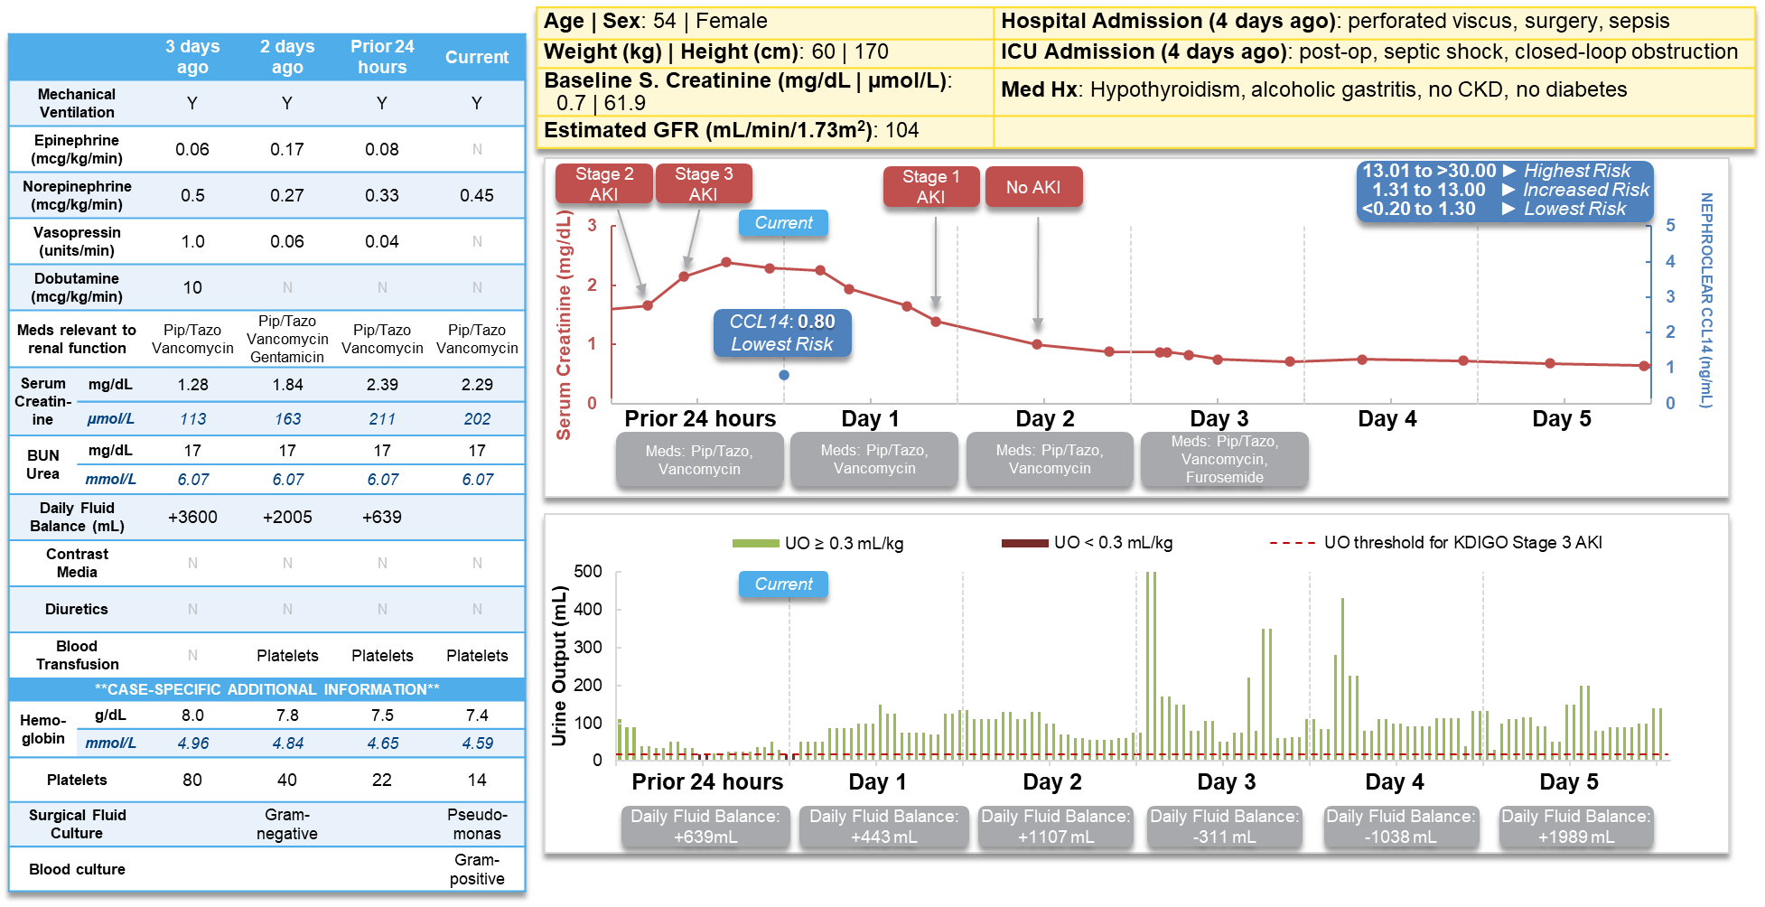

Supplemental Figure S1-3: Case 2 patient data as presented to the panel of experts.
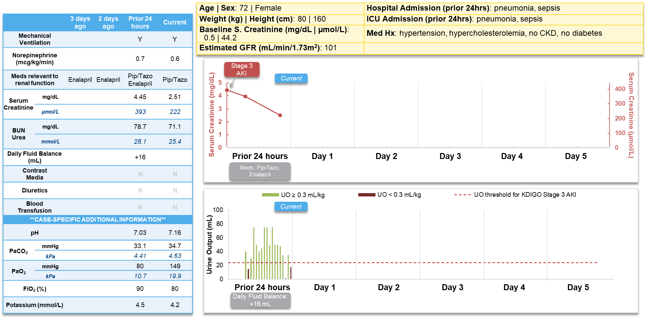

Supplemental Figure S1-4: Case 2 with additional patient data after CCL14 measurement. CCL14 values and additional clinical data after ‘current’ (time of the CCL14 urine sample collection) were not made avaible to the expert panel.
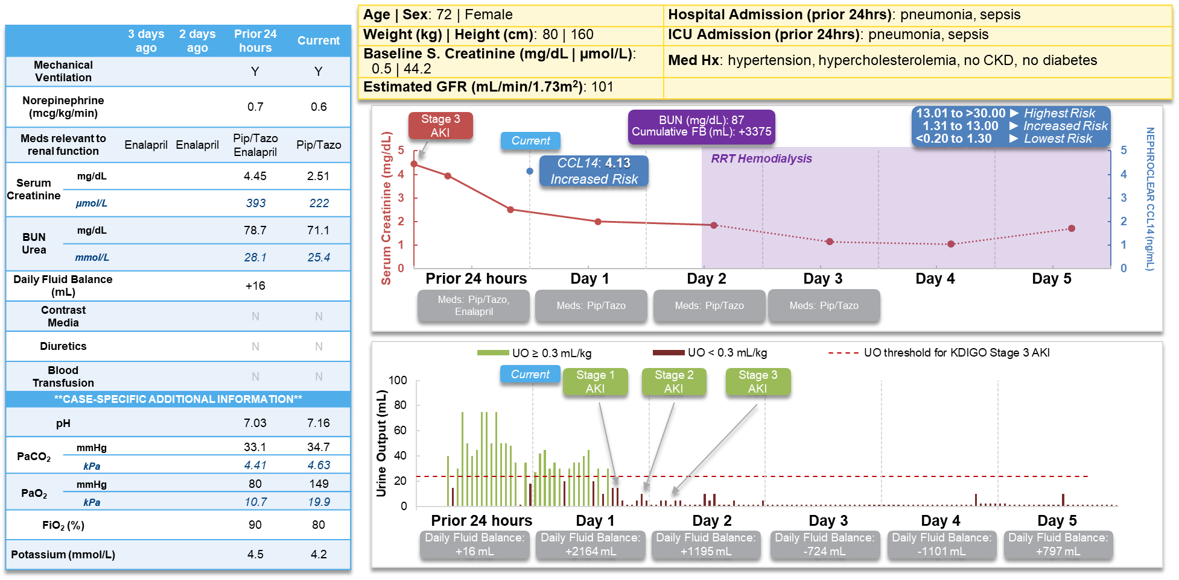

Supplemental Figure S1-5: Case 3 patient data as presented to the panel of experts.
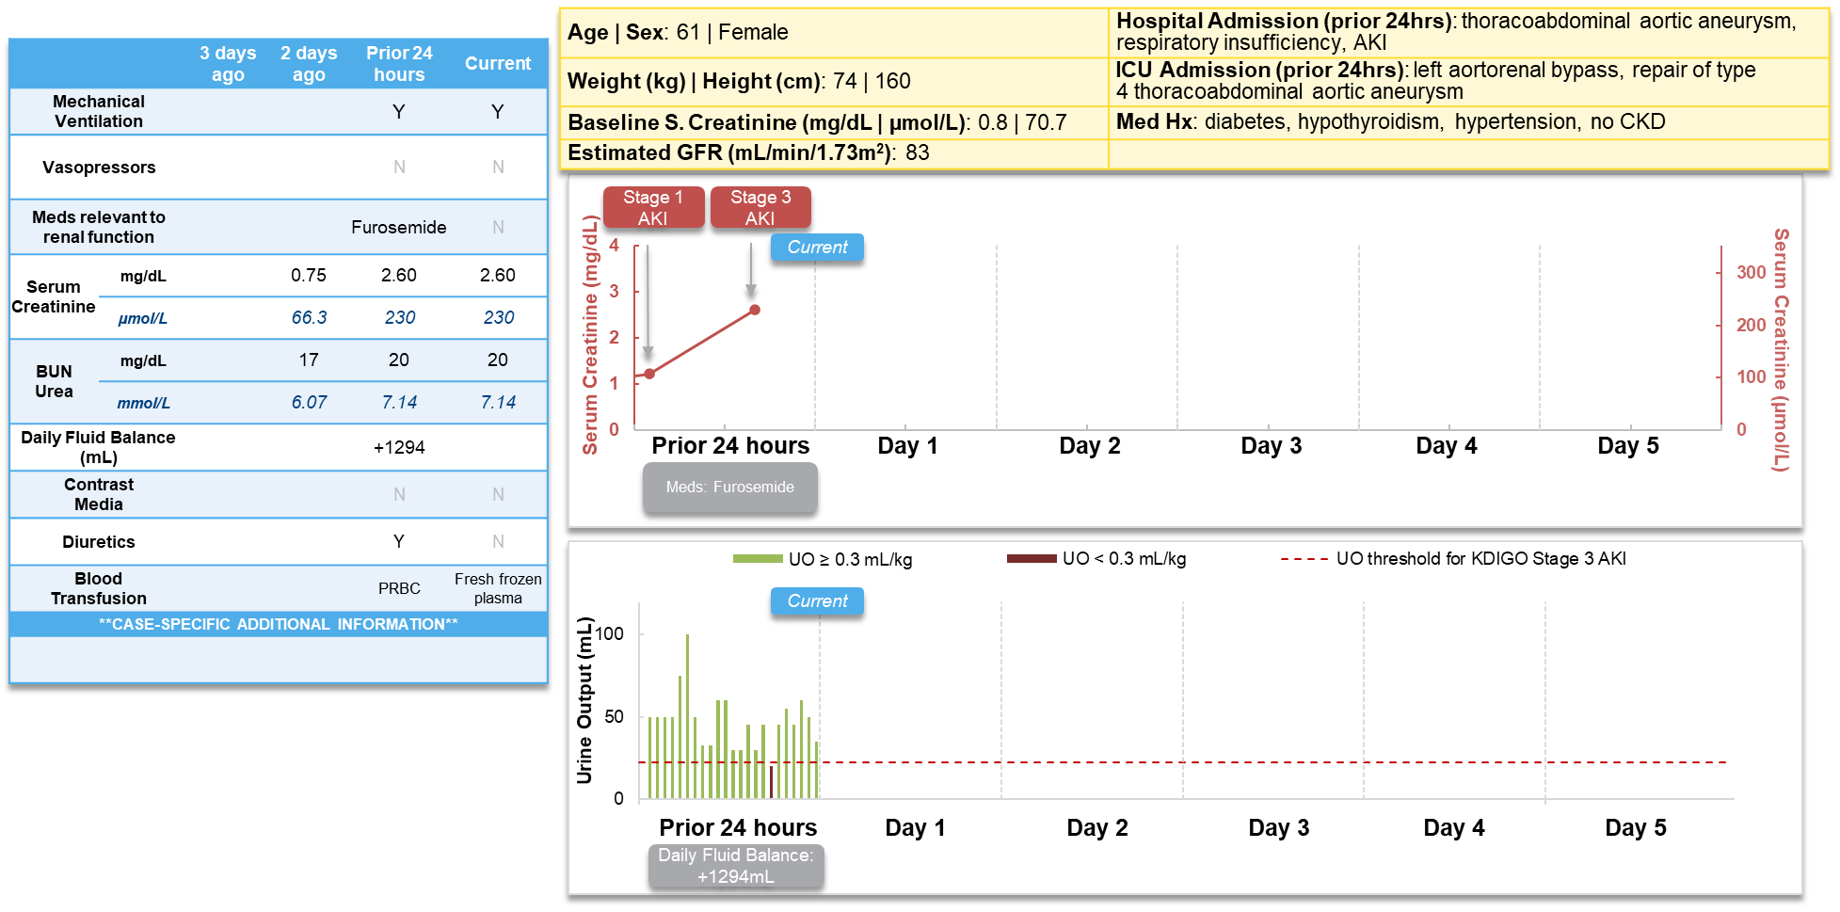

Supplemental Figure S1-6: Case 3 with additional patient data after CCL14 measurement. CCL14 values and additional clinical data after ‘current’ (time of the CCL14 urine sample collection) were not made avaible to the expert panel.
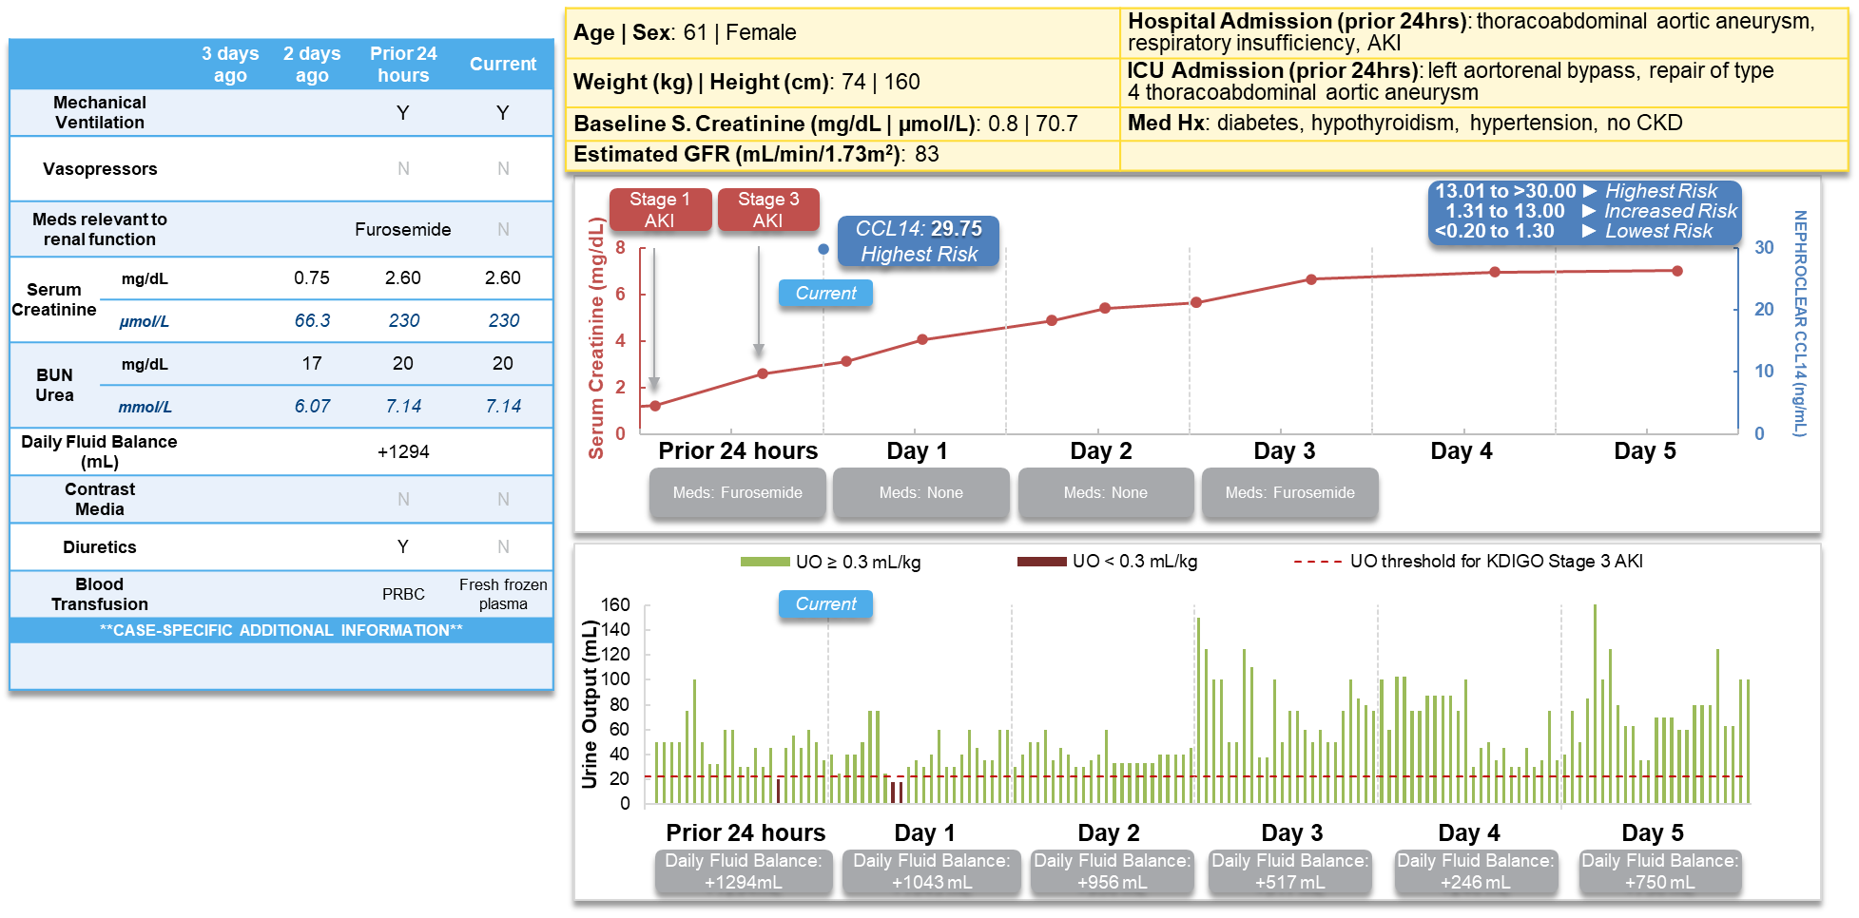

Supplemental Figure S1-7: Case 4 patient data as presented to the panel of experts.
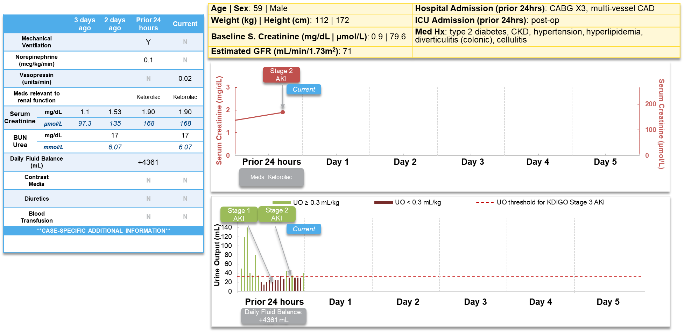

Supplemental Figure S1-8: Case 4 with additional patient data after CCL14 measurement. CCL14 values and additional clinical data after ‘current’ (time of the CCL14 urine sample collection) were not made avaible to the expert panel.
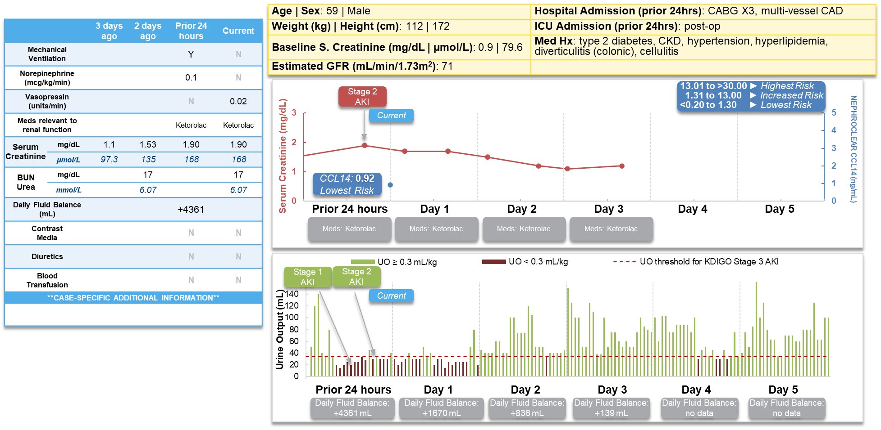

Supplemental Figure S1-9: Case 5 patient data as presented to the panel of experts.
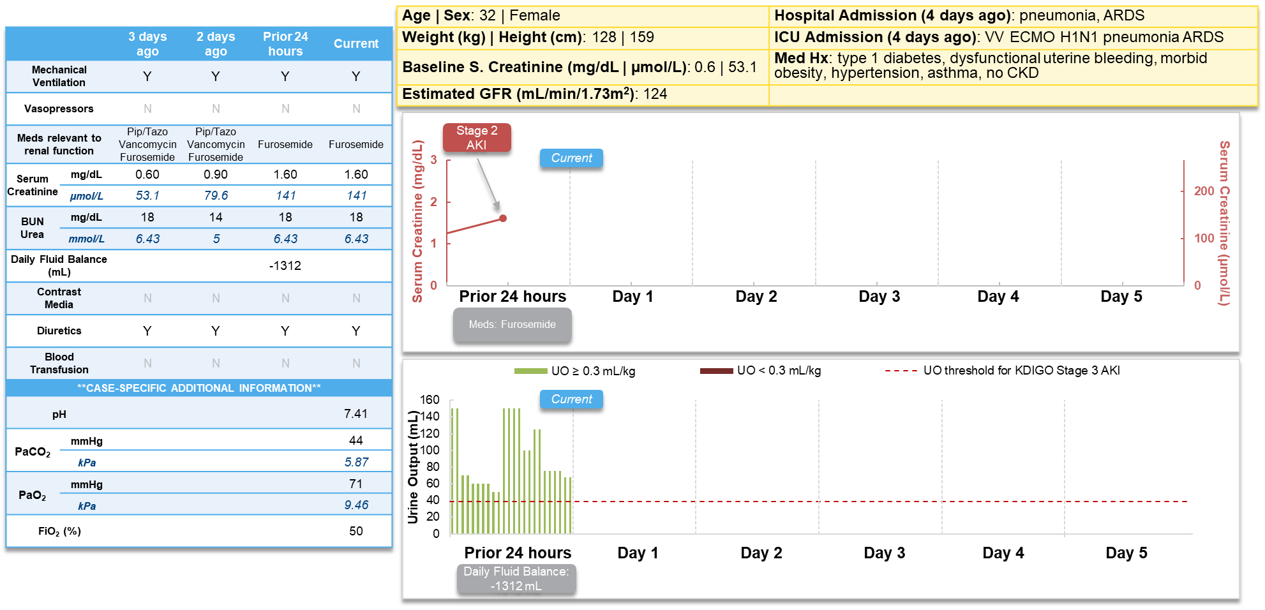

Supplemental Figure S1-10: Case 5 with additional patient data after CCL14 measurement. CCL14 values and additional clinical data after ‘current’ (time of the CCL14 urine sample collection) were not made avaible to the expert panel.
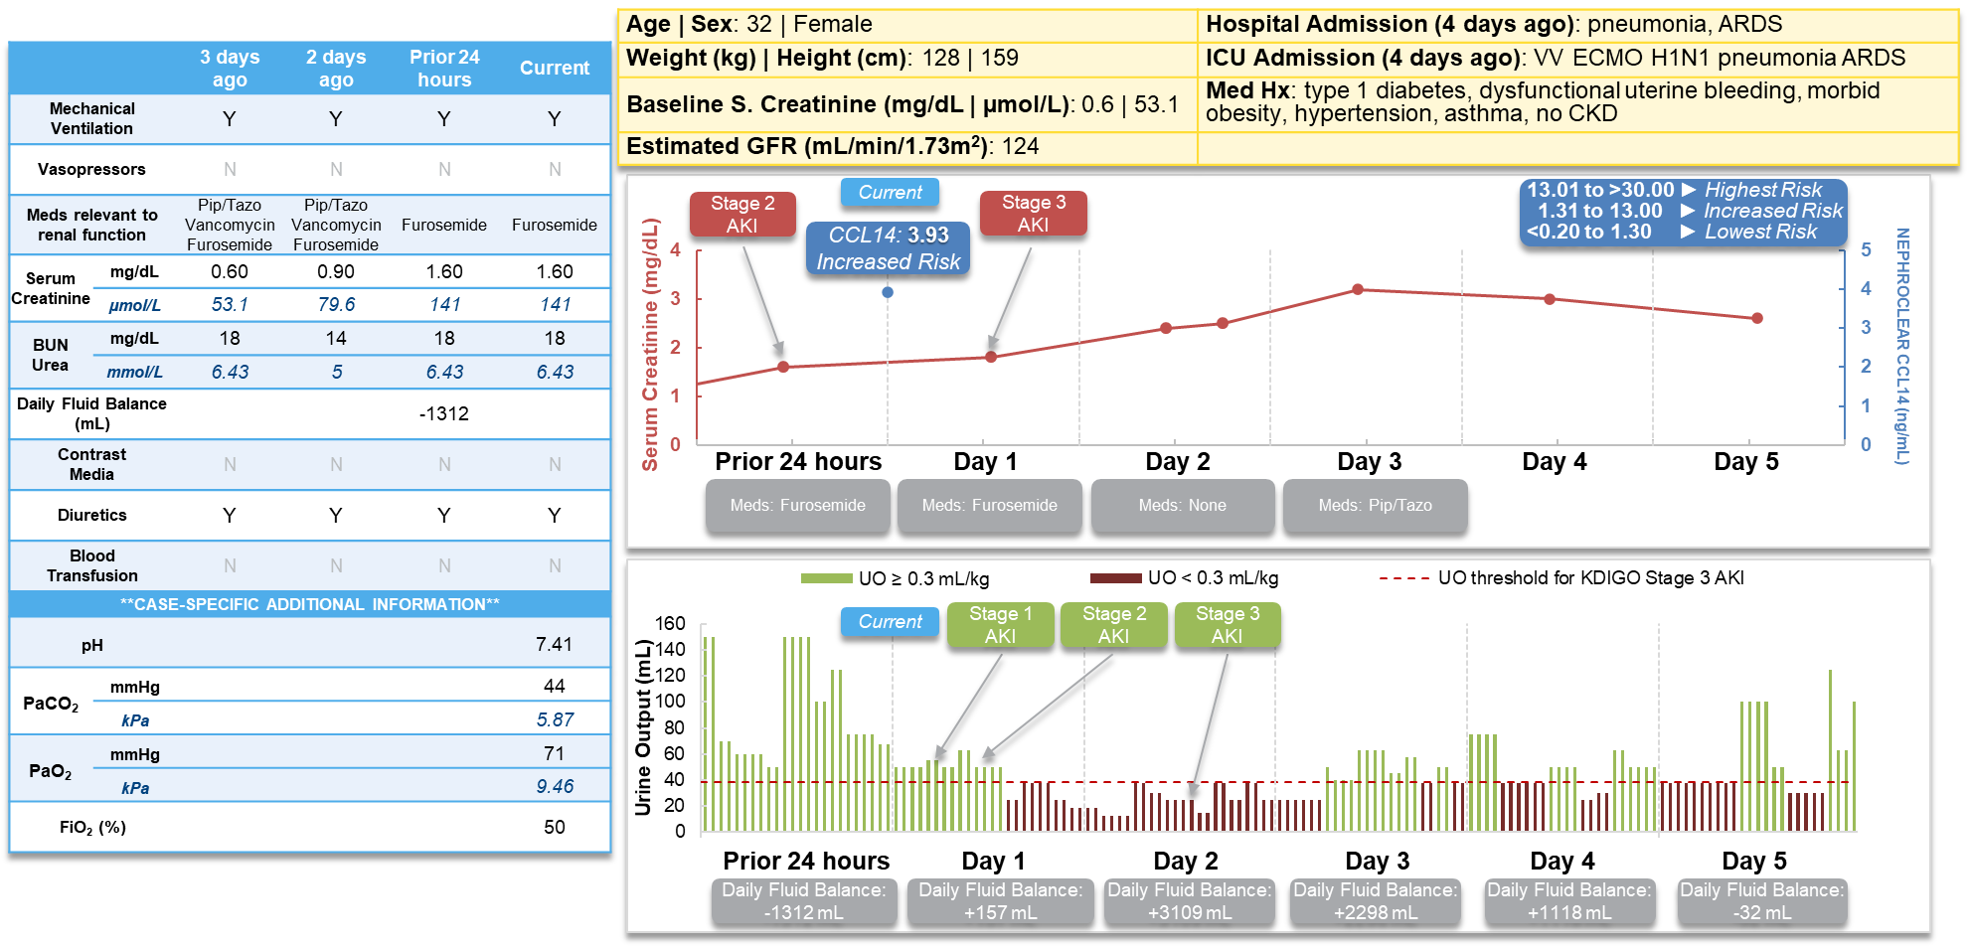

Supplemental Figure S1-11: Case 6 patient data as presented to the panel of experts.
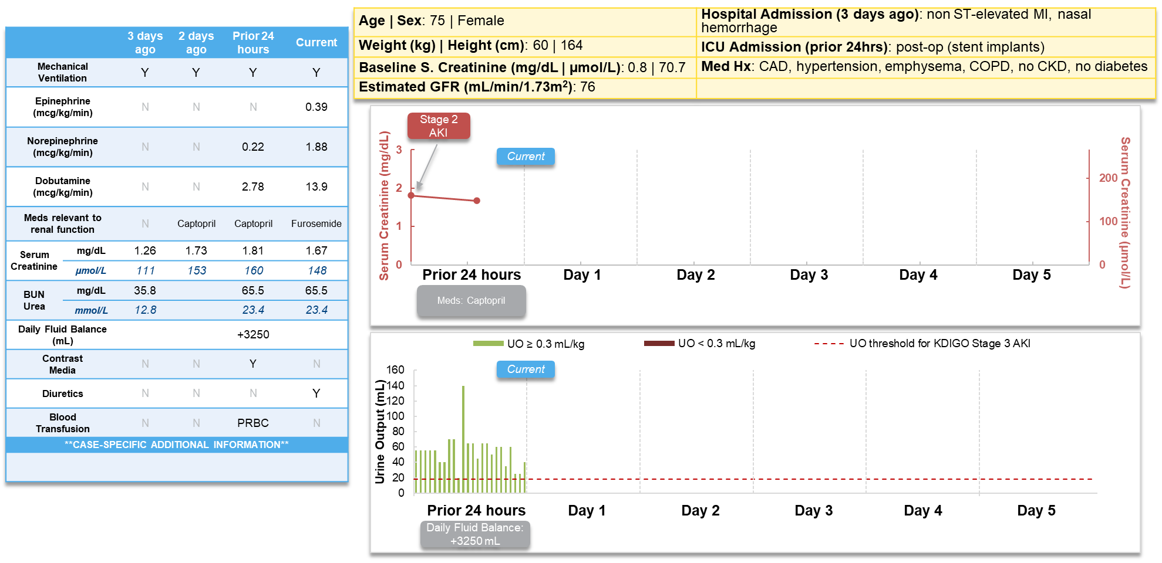

Supplemental Figure S1-12: Case 6 with additional patient data after CCL14 measurement. CCL14 values and additional clinical data after ‘current’ (time of the CCL14 urine sample collection) were not made avaible to the expert panel.
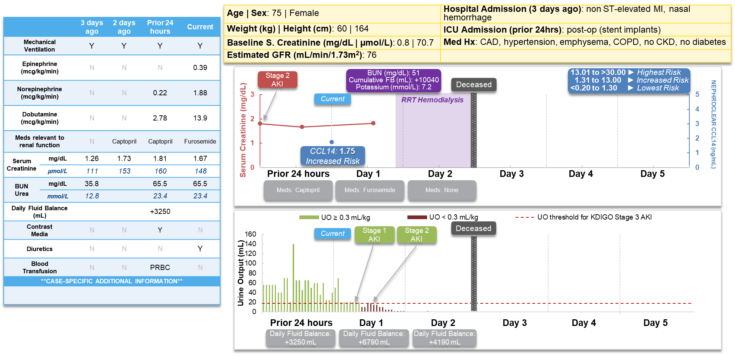

Supplemental Figure S2-1: Case 1, Clinical action: Change Piperacillin/Tazobactam to Cefepime. The bottom and top boxes are the 1st and 3rd quartiles, respectively. The bottom and top whiskers are the minimum and maximum, respectively. The middle bars within the boxes are the medians. The dots are the individual responses from the experts.
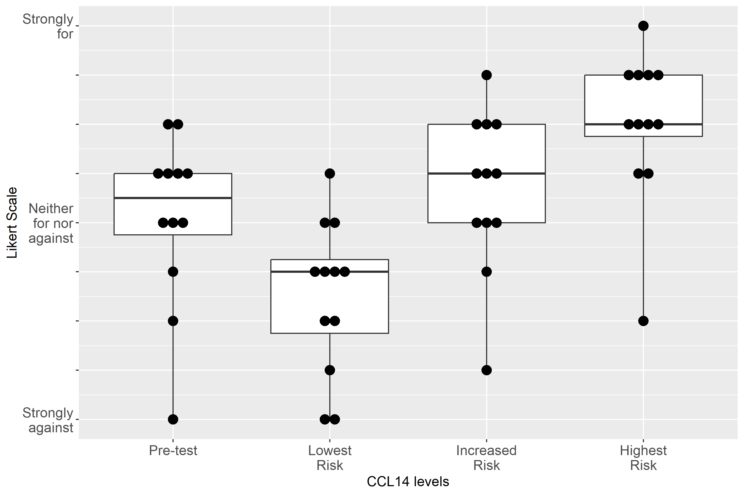

Supplemental Figure S2-2: Case 1, Clinical action: Stop Vancomycin
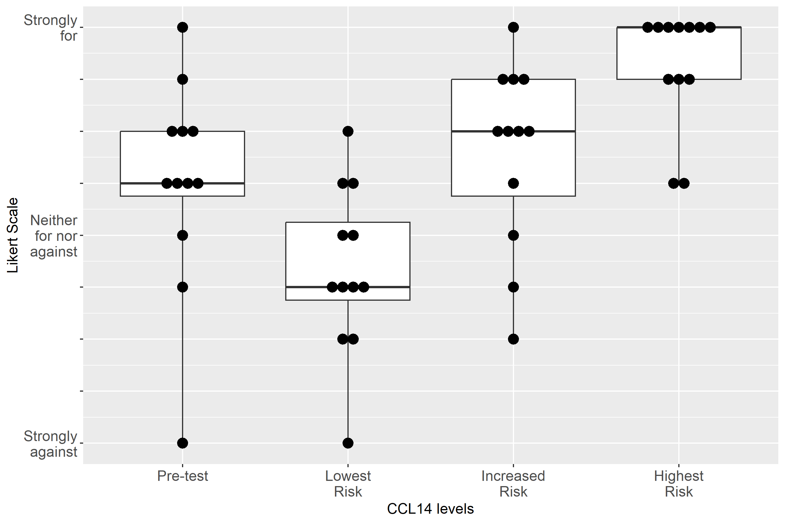

Supplemental Figure S2-3: Case 1, Clinical action: Adjust non-nephrotoxic, renally cleared medication
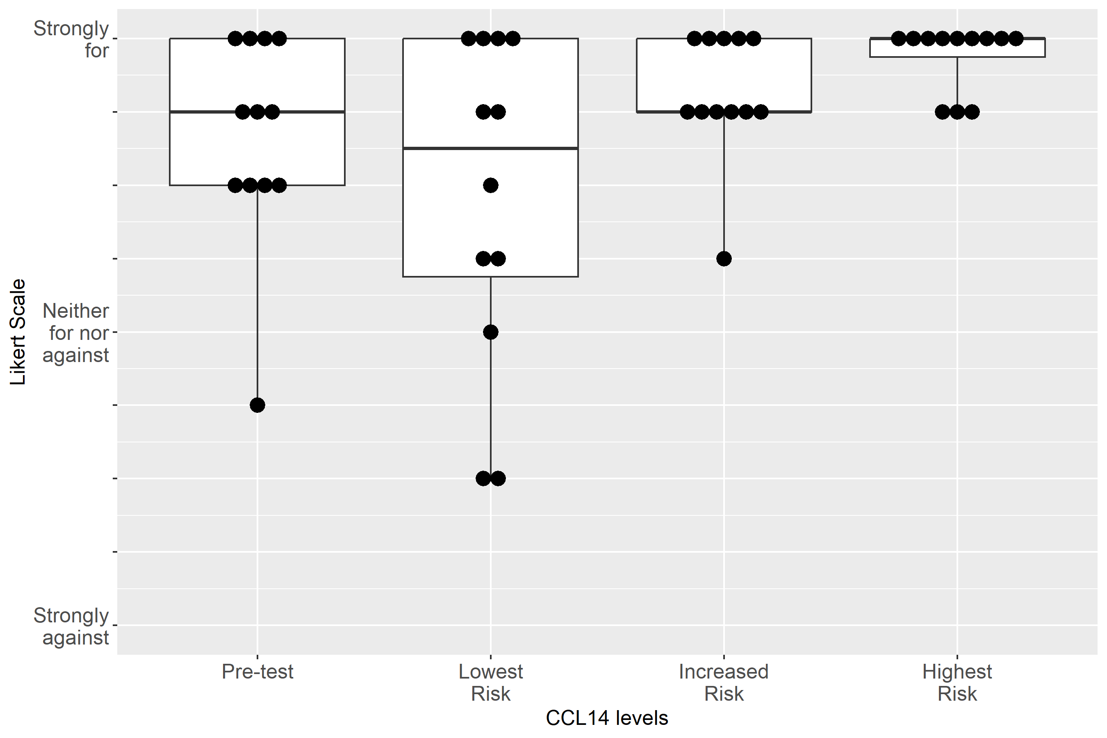

Supplemental Figure S2-4: Case 1, Clinical action: Use functional hemodynamic monitoring
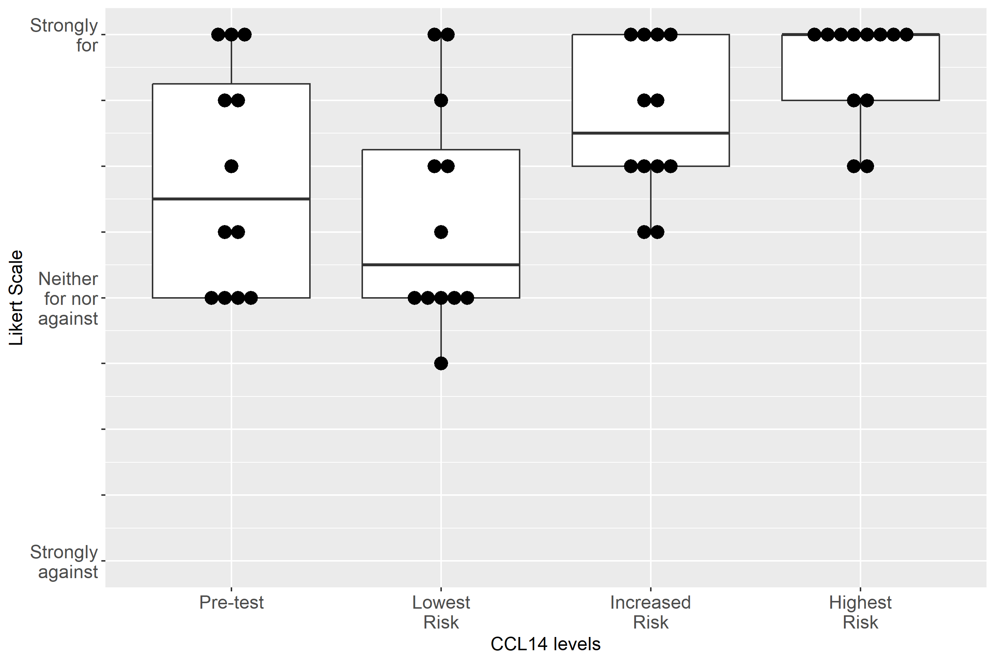

Supplemental Figure S2-5: Case 1, Clinical action: Perform renal ultrasound
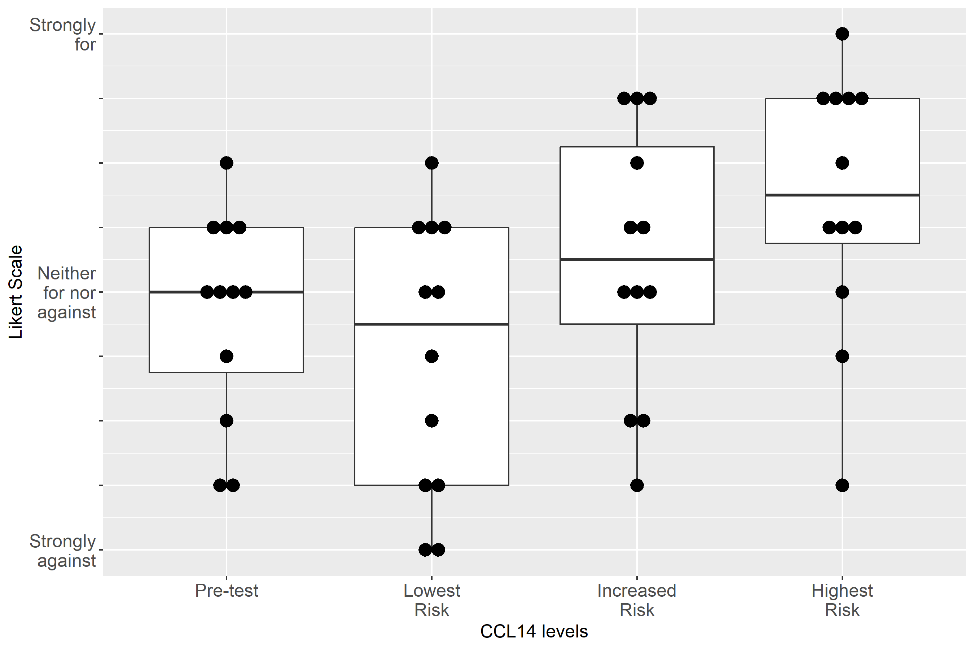

Supplemental Figure S2-6: Case 1, Clinical action: Keep foley catheter, 1-2 hourly Urine Output
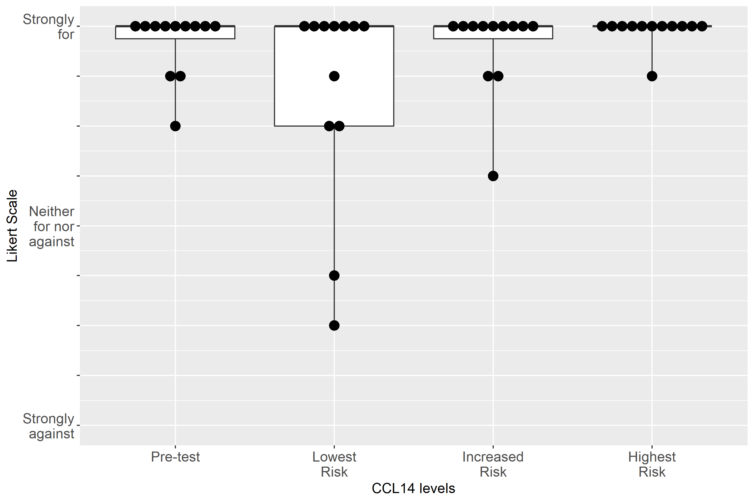

Supplemental Figure S2-7: Case 1, Clinical action: Measure serum creatinine at least daily
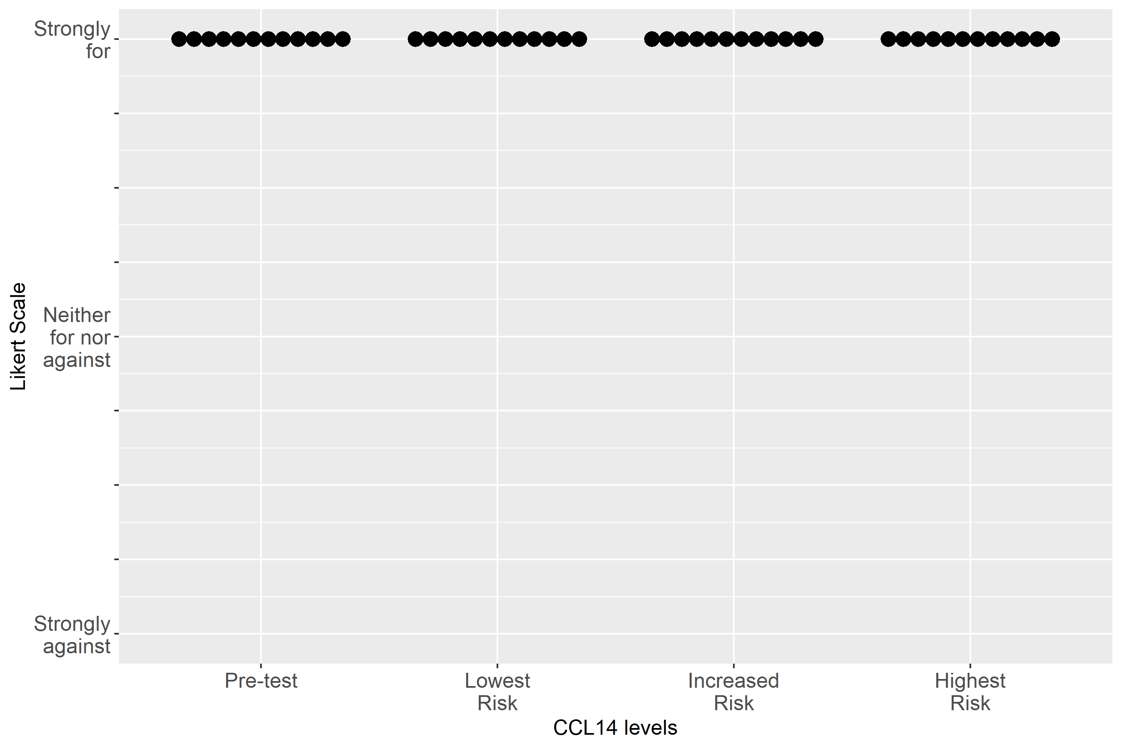

Supplemental Figure S2-8: Case 1, Clinical action: Consult nephrology
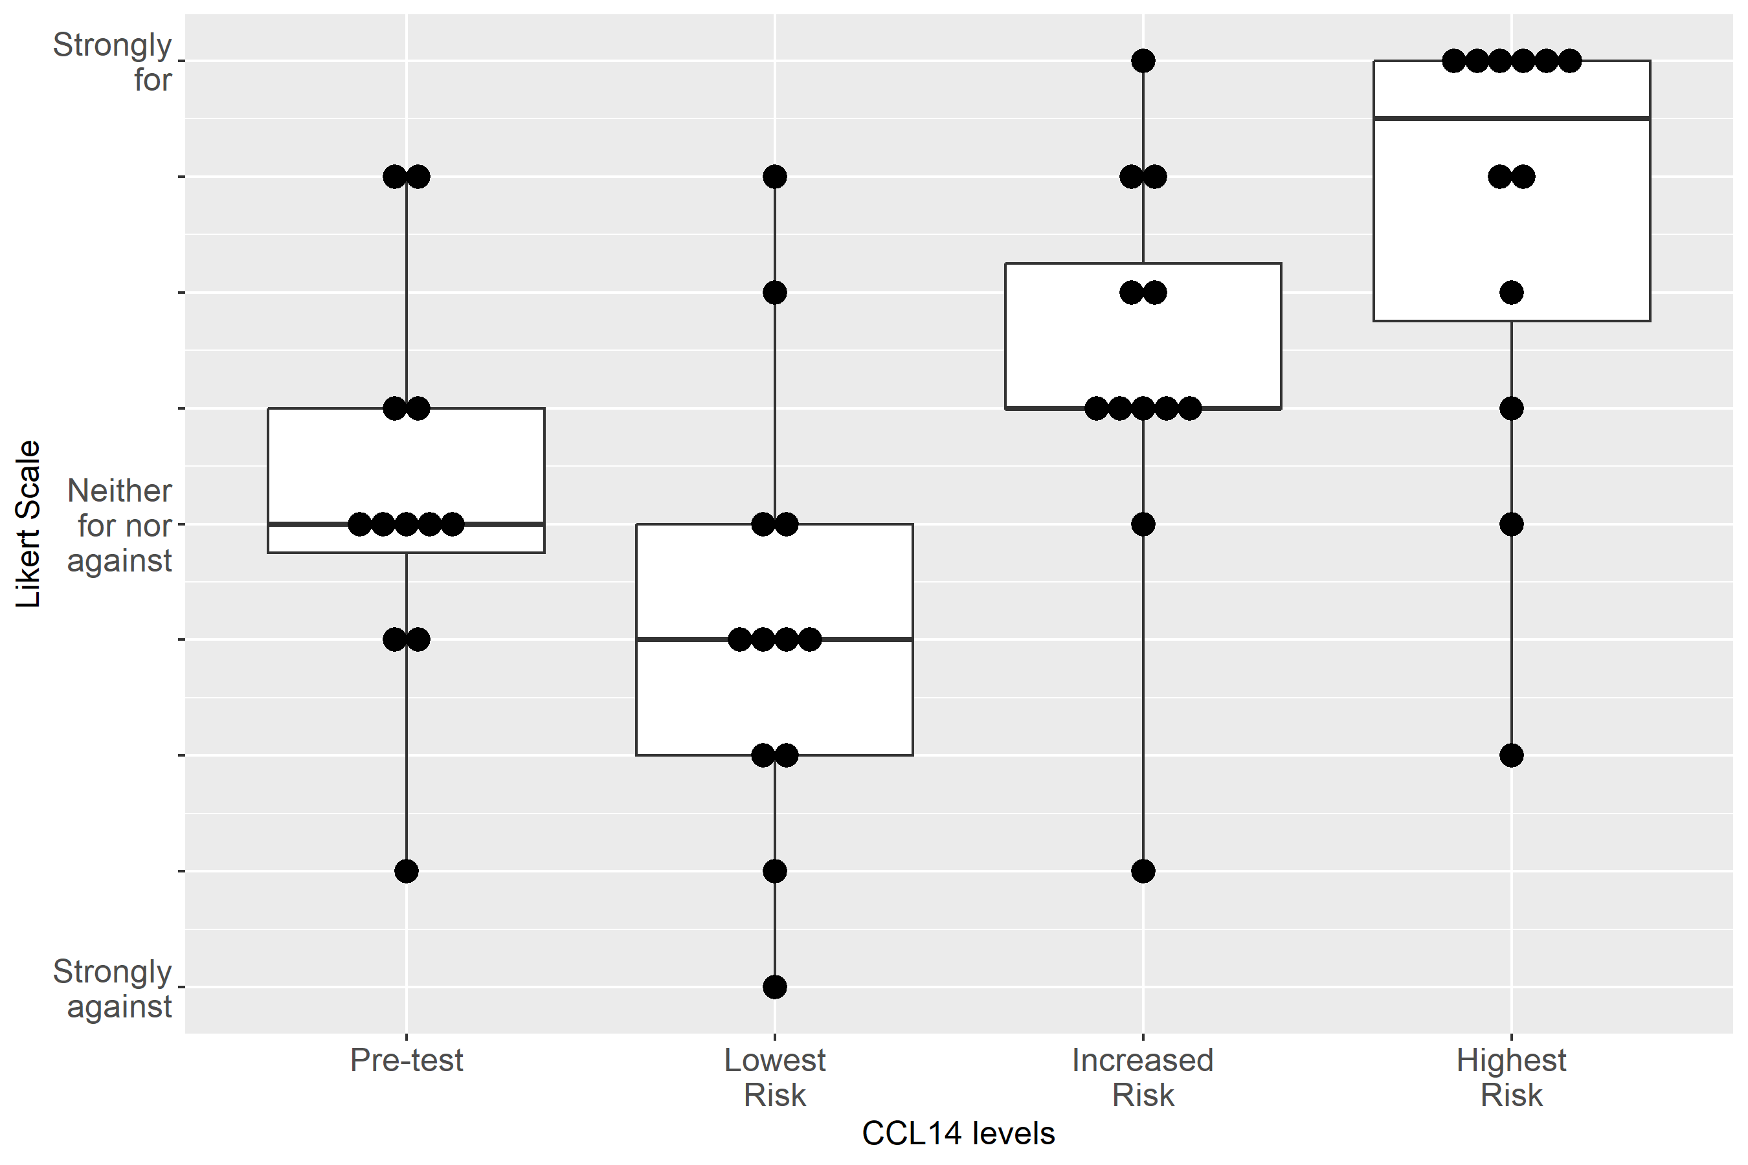

Supplemental Figure S2-9: Case 1, Clinical action: Order CT with contrast
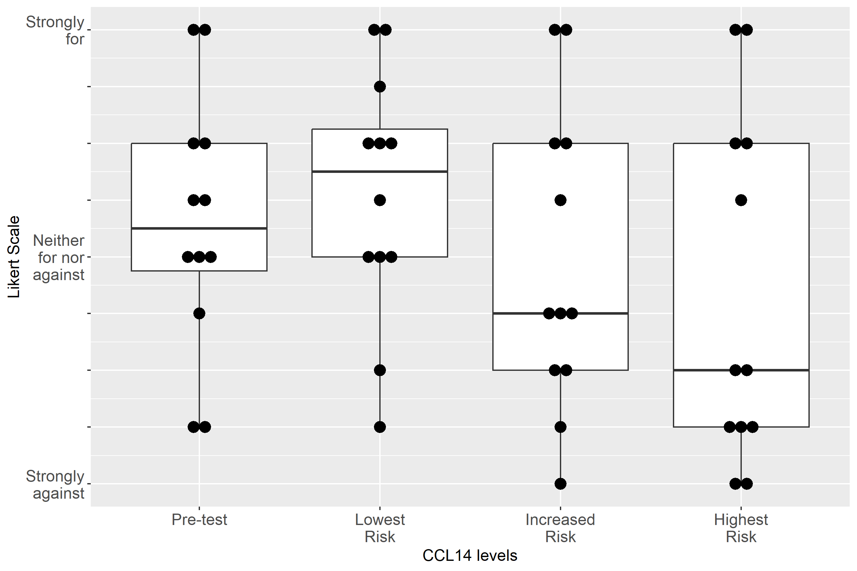

Supplemental Figure S2-10: Case 1, Clinical action: Give fluid
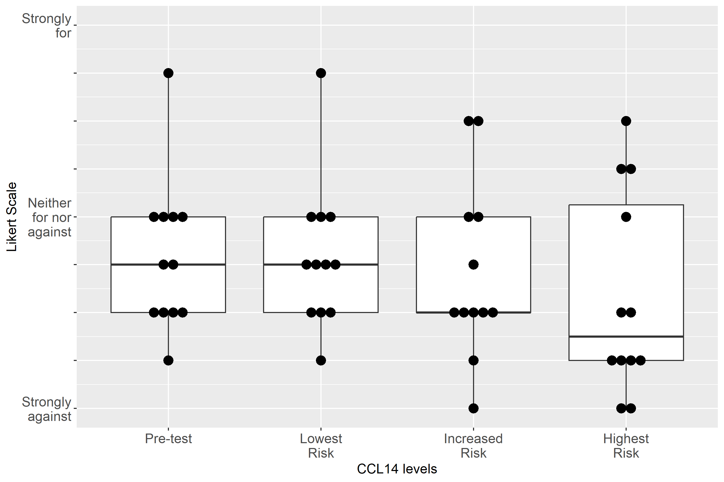

Supplemental Figure S2-11: Case 1, Clinical action: Administer Lasix
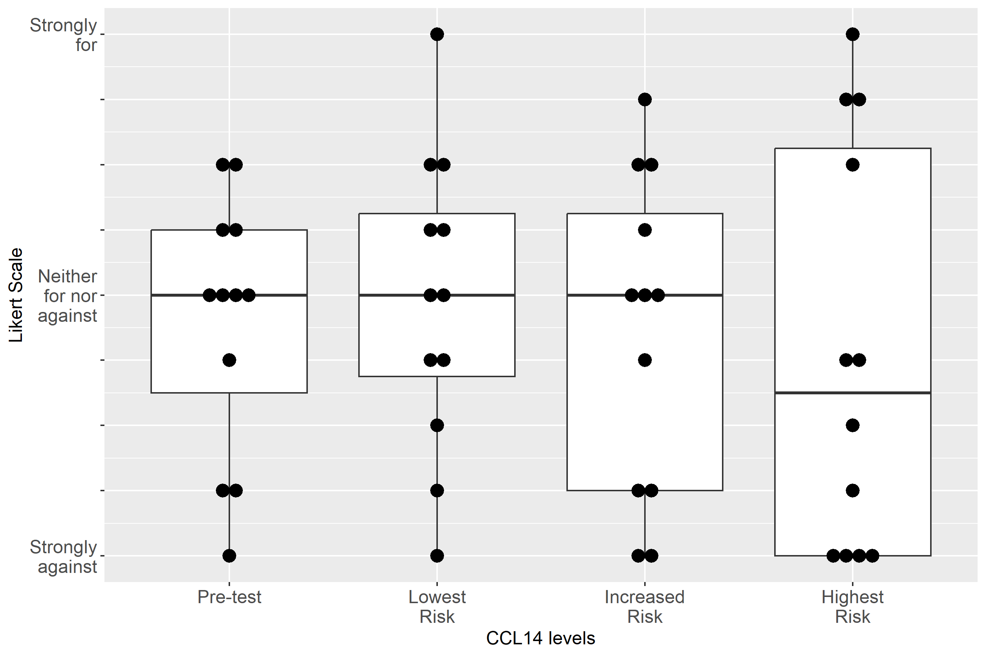

Supplemental Figure S2-12: Case 1, Clinical action: Discuss RRT with patient/family
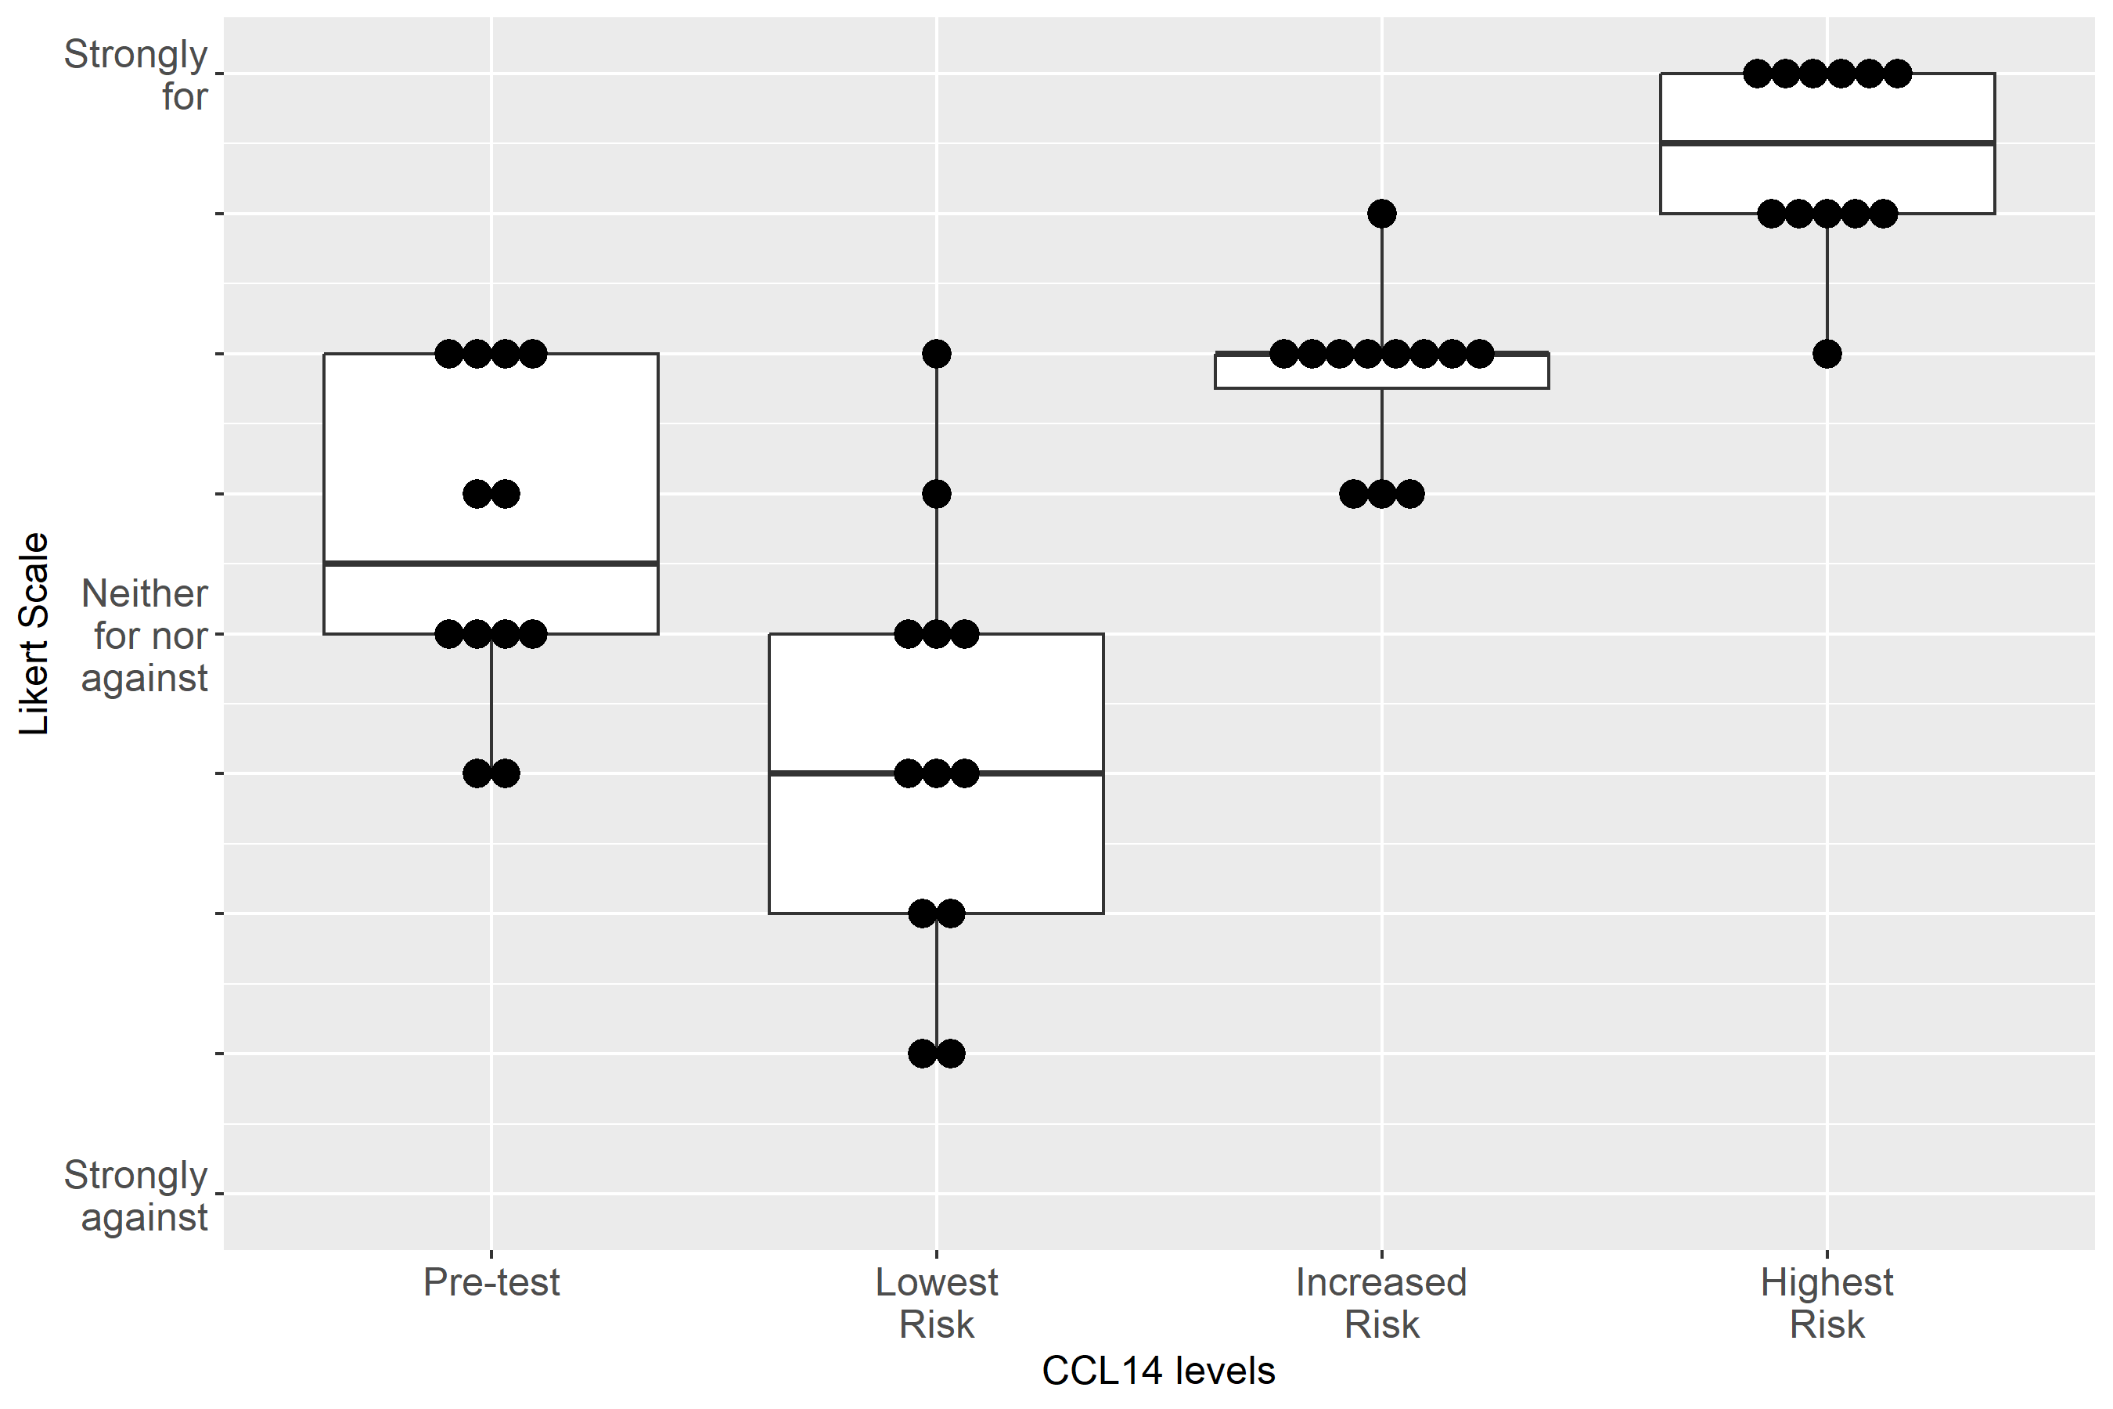

Supplemental Figure S2-13: Case 2, Clinical action: Change Piperacillin/Tazobactam to Cefepime
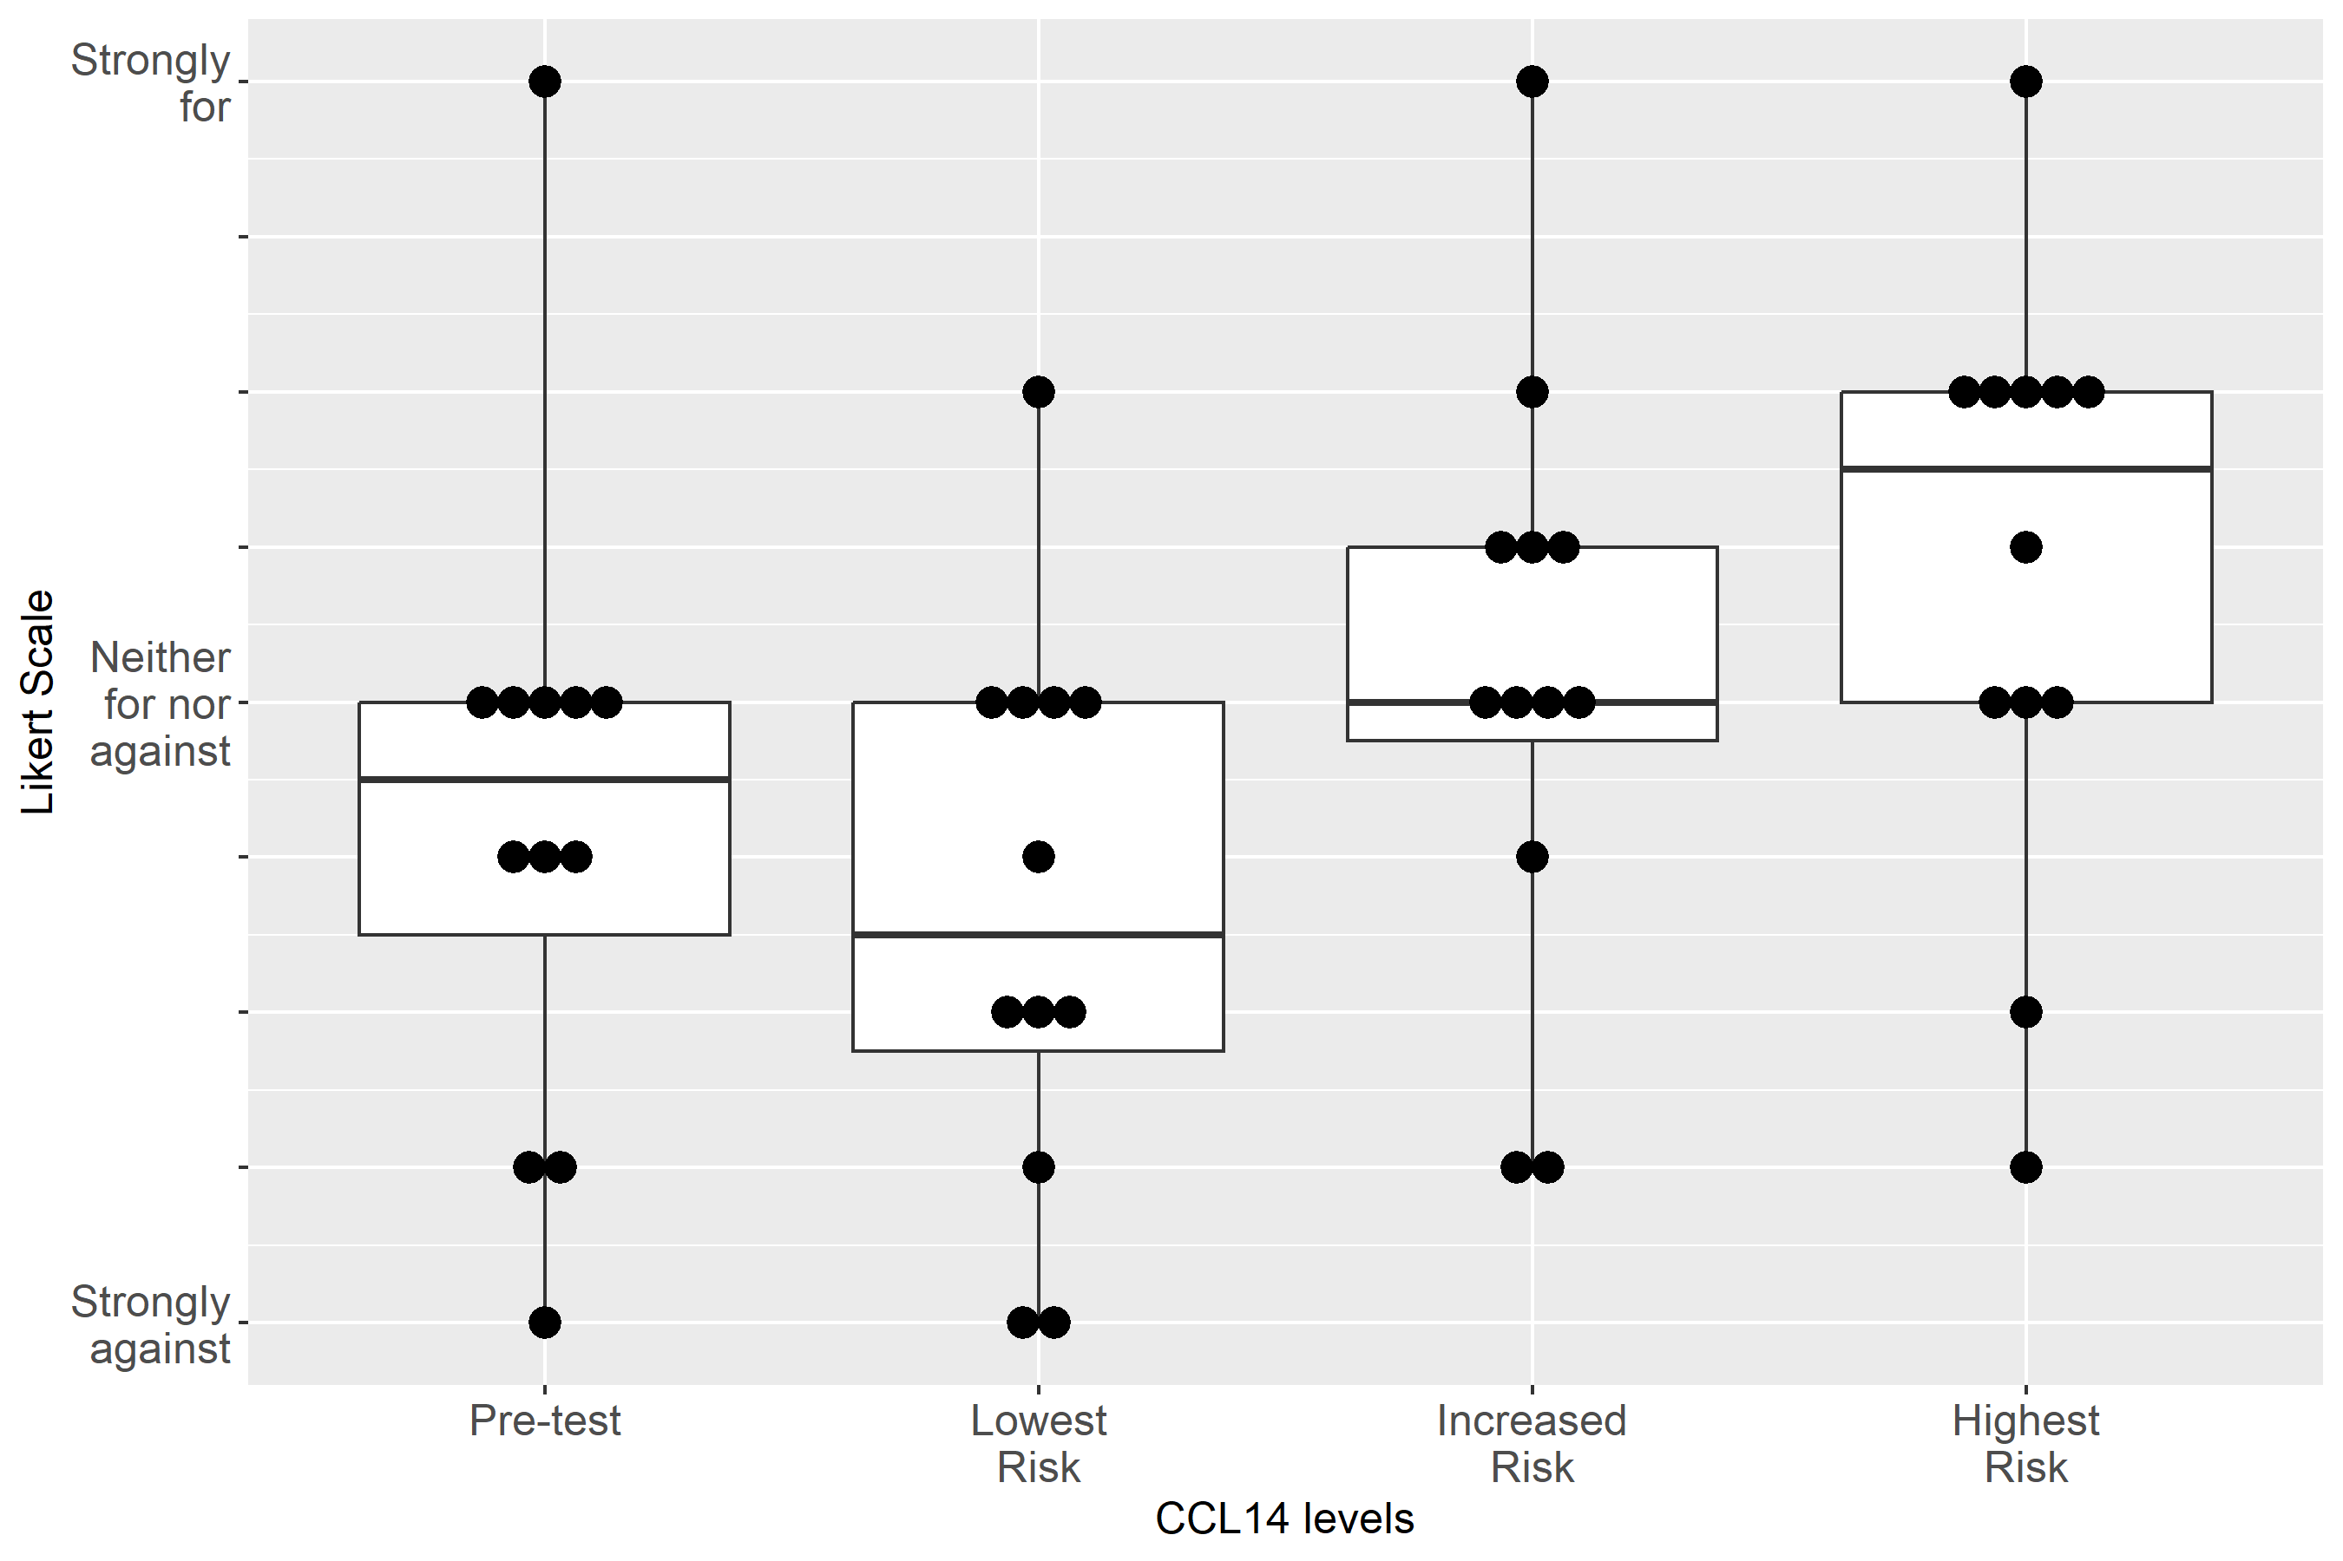

Supplemental Figure S2-14: Case 2, Clinical action: Adjust non-nephrotoxic, renally cleared medication
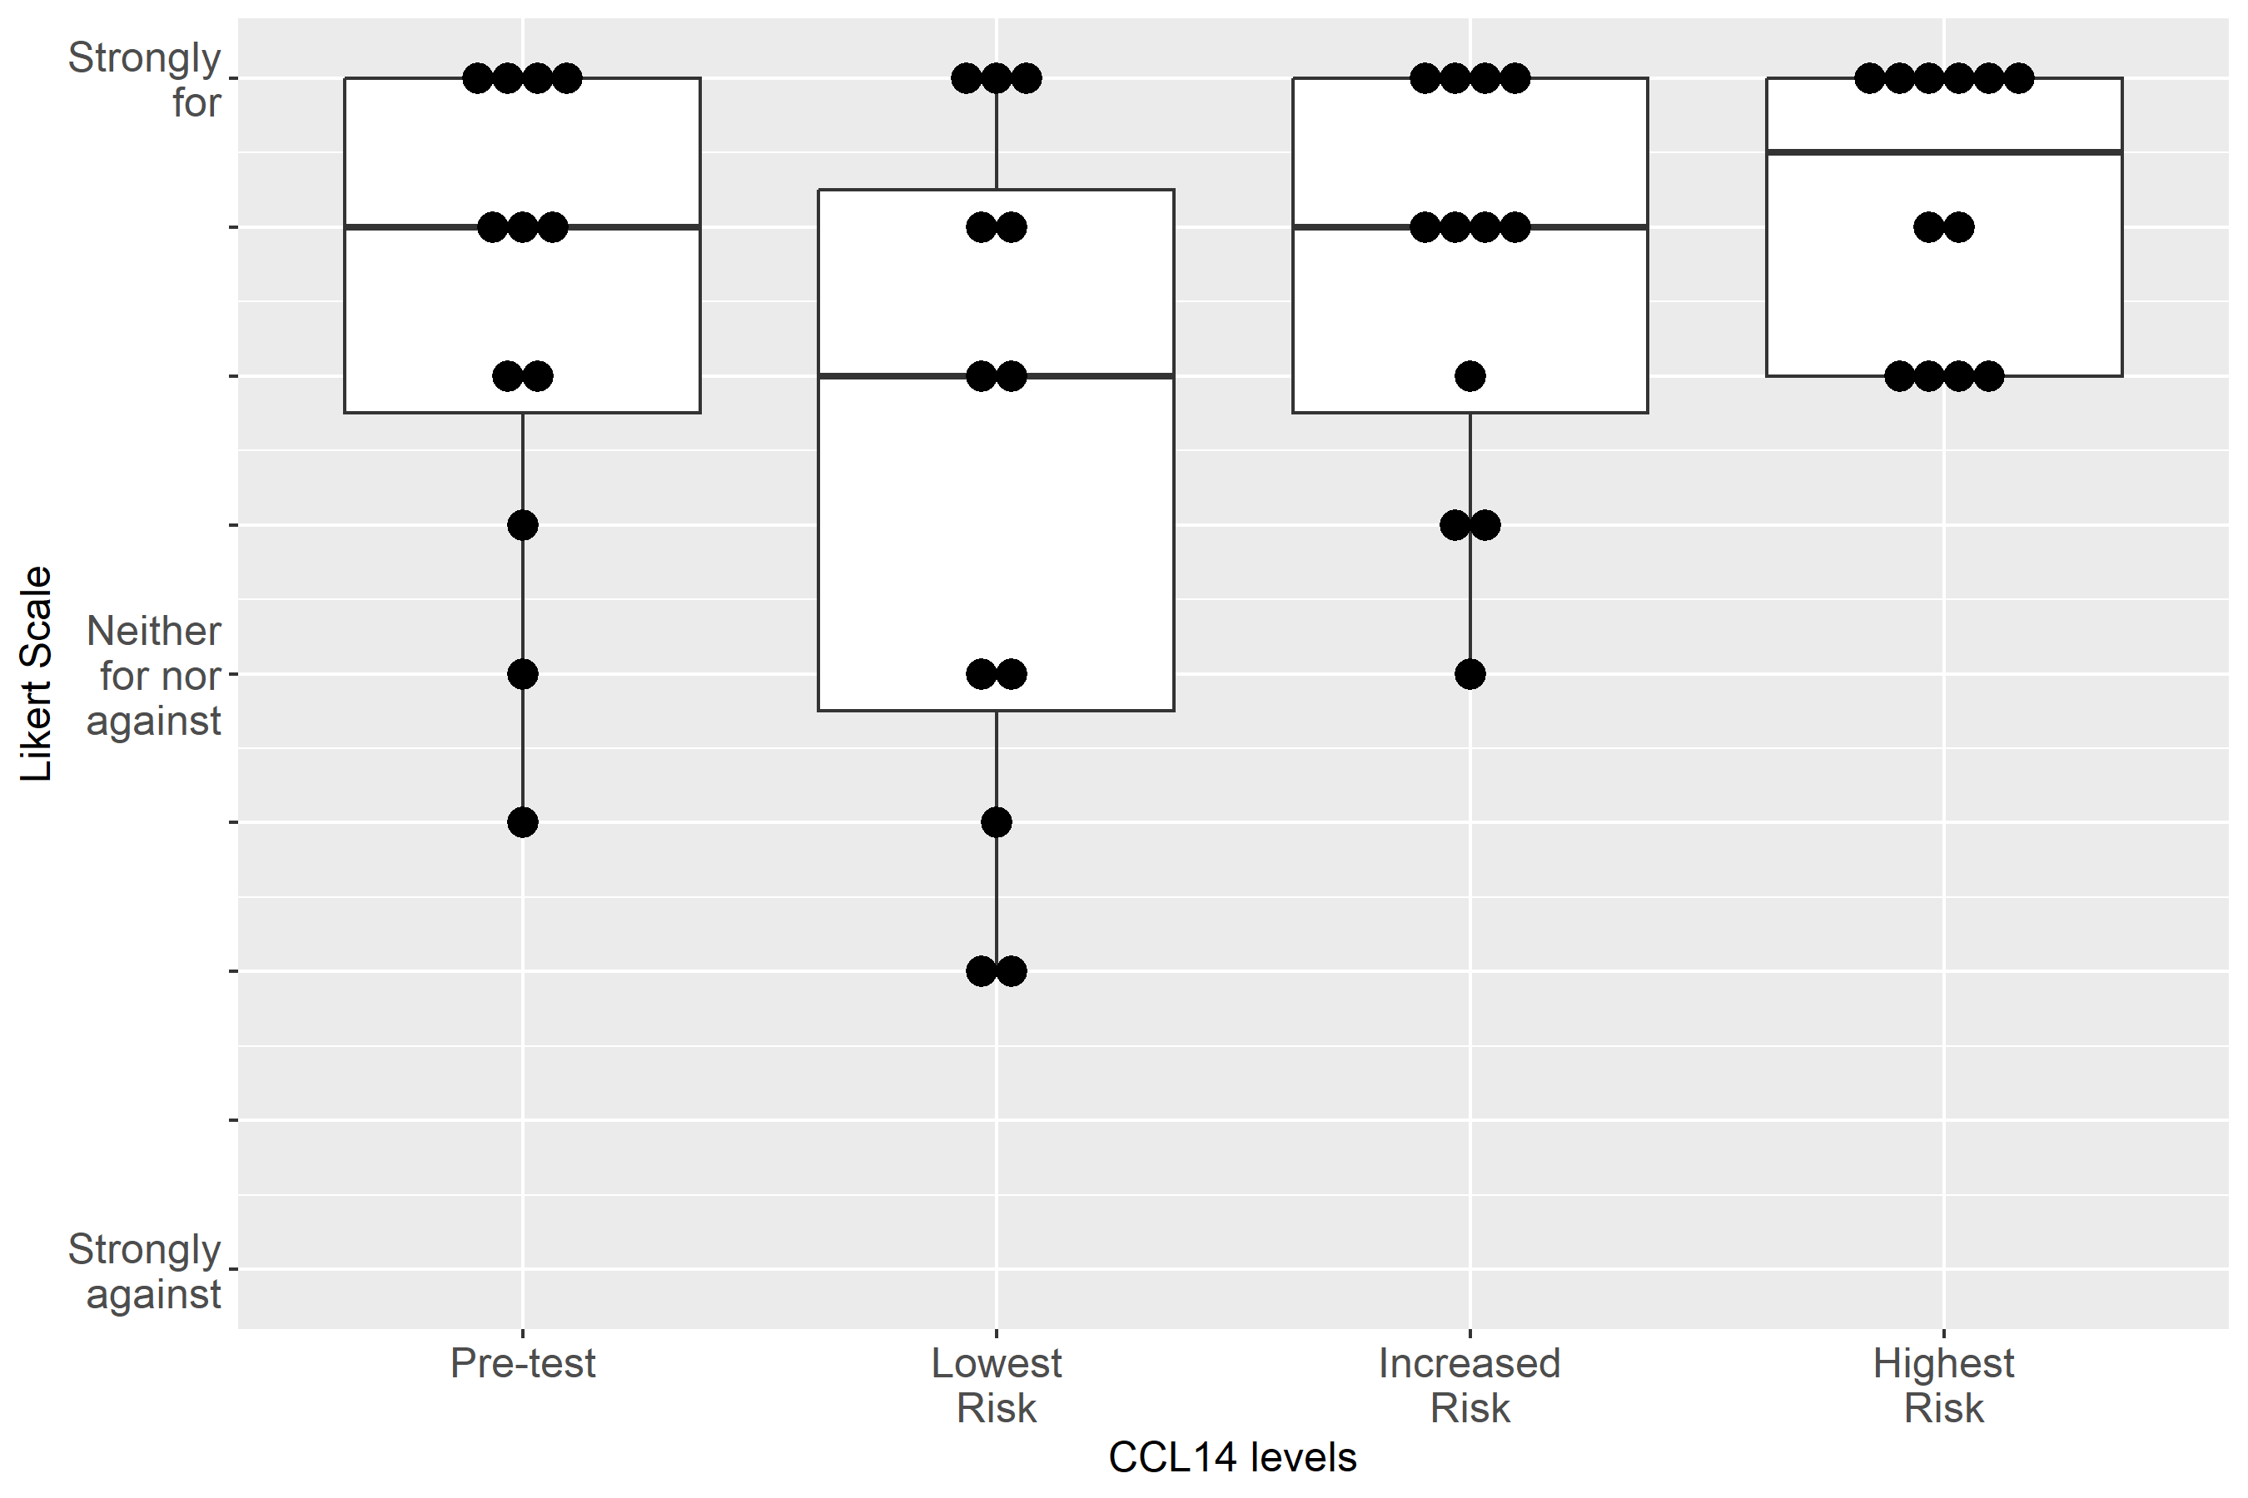

Supplemental Figure S2-15: Case 2, Clinical action: Use functional hemodynamic monitoring
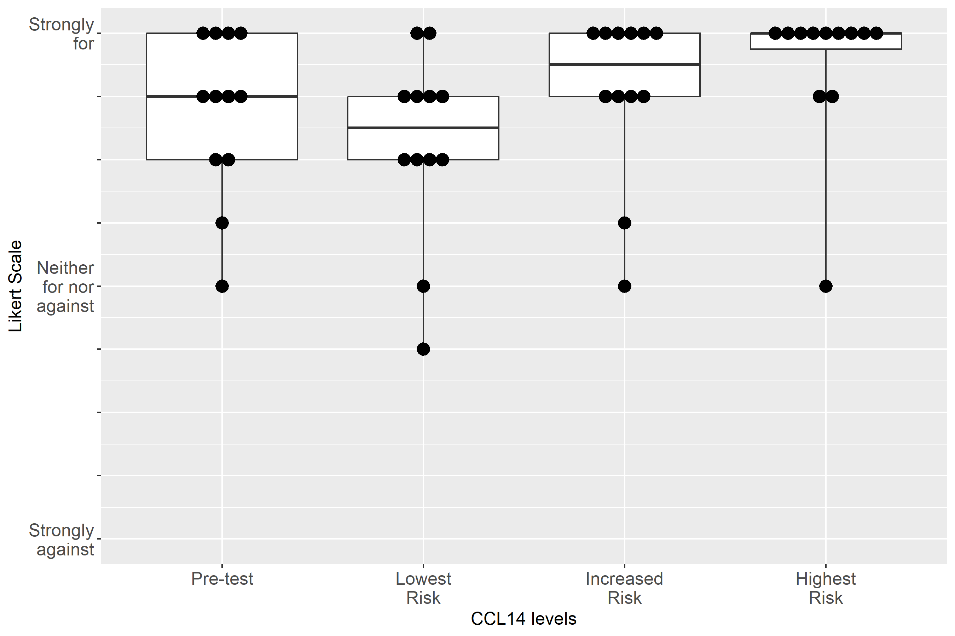

Supplemental Figure S2-16: Case 2, Clinical action: Perform renal ultrasound
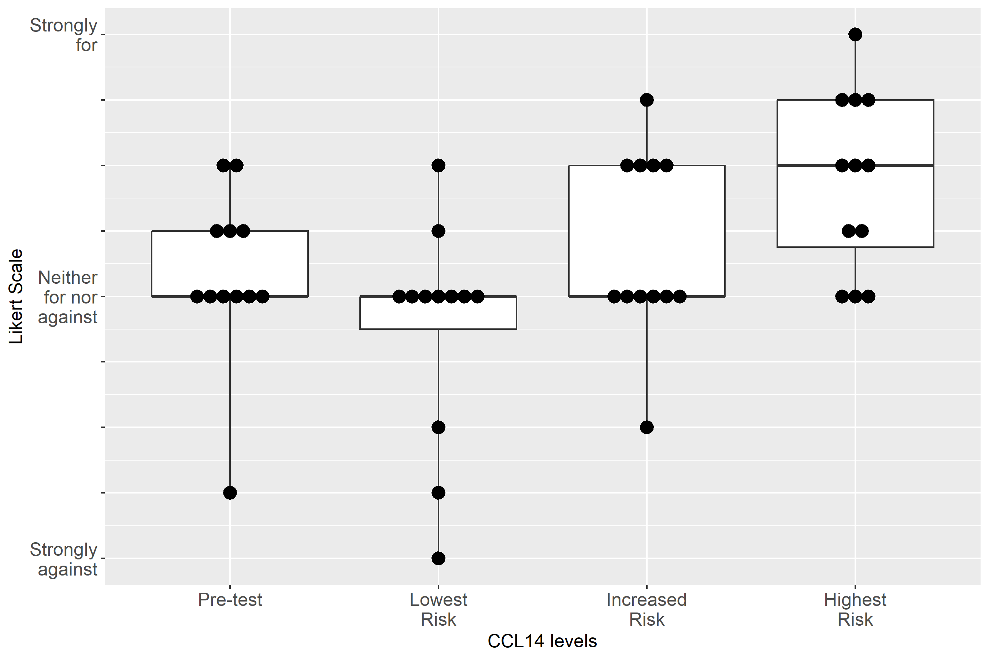

Supplemental Figure S2-17: Case 2, Clinical action: Keep foley catheter, 1-2 hourly Urine Output
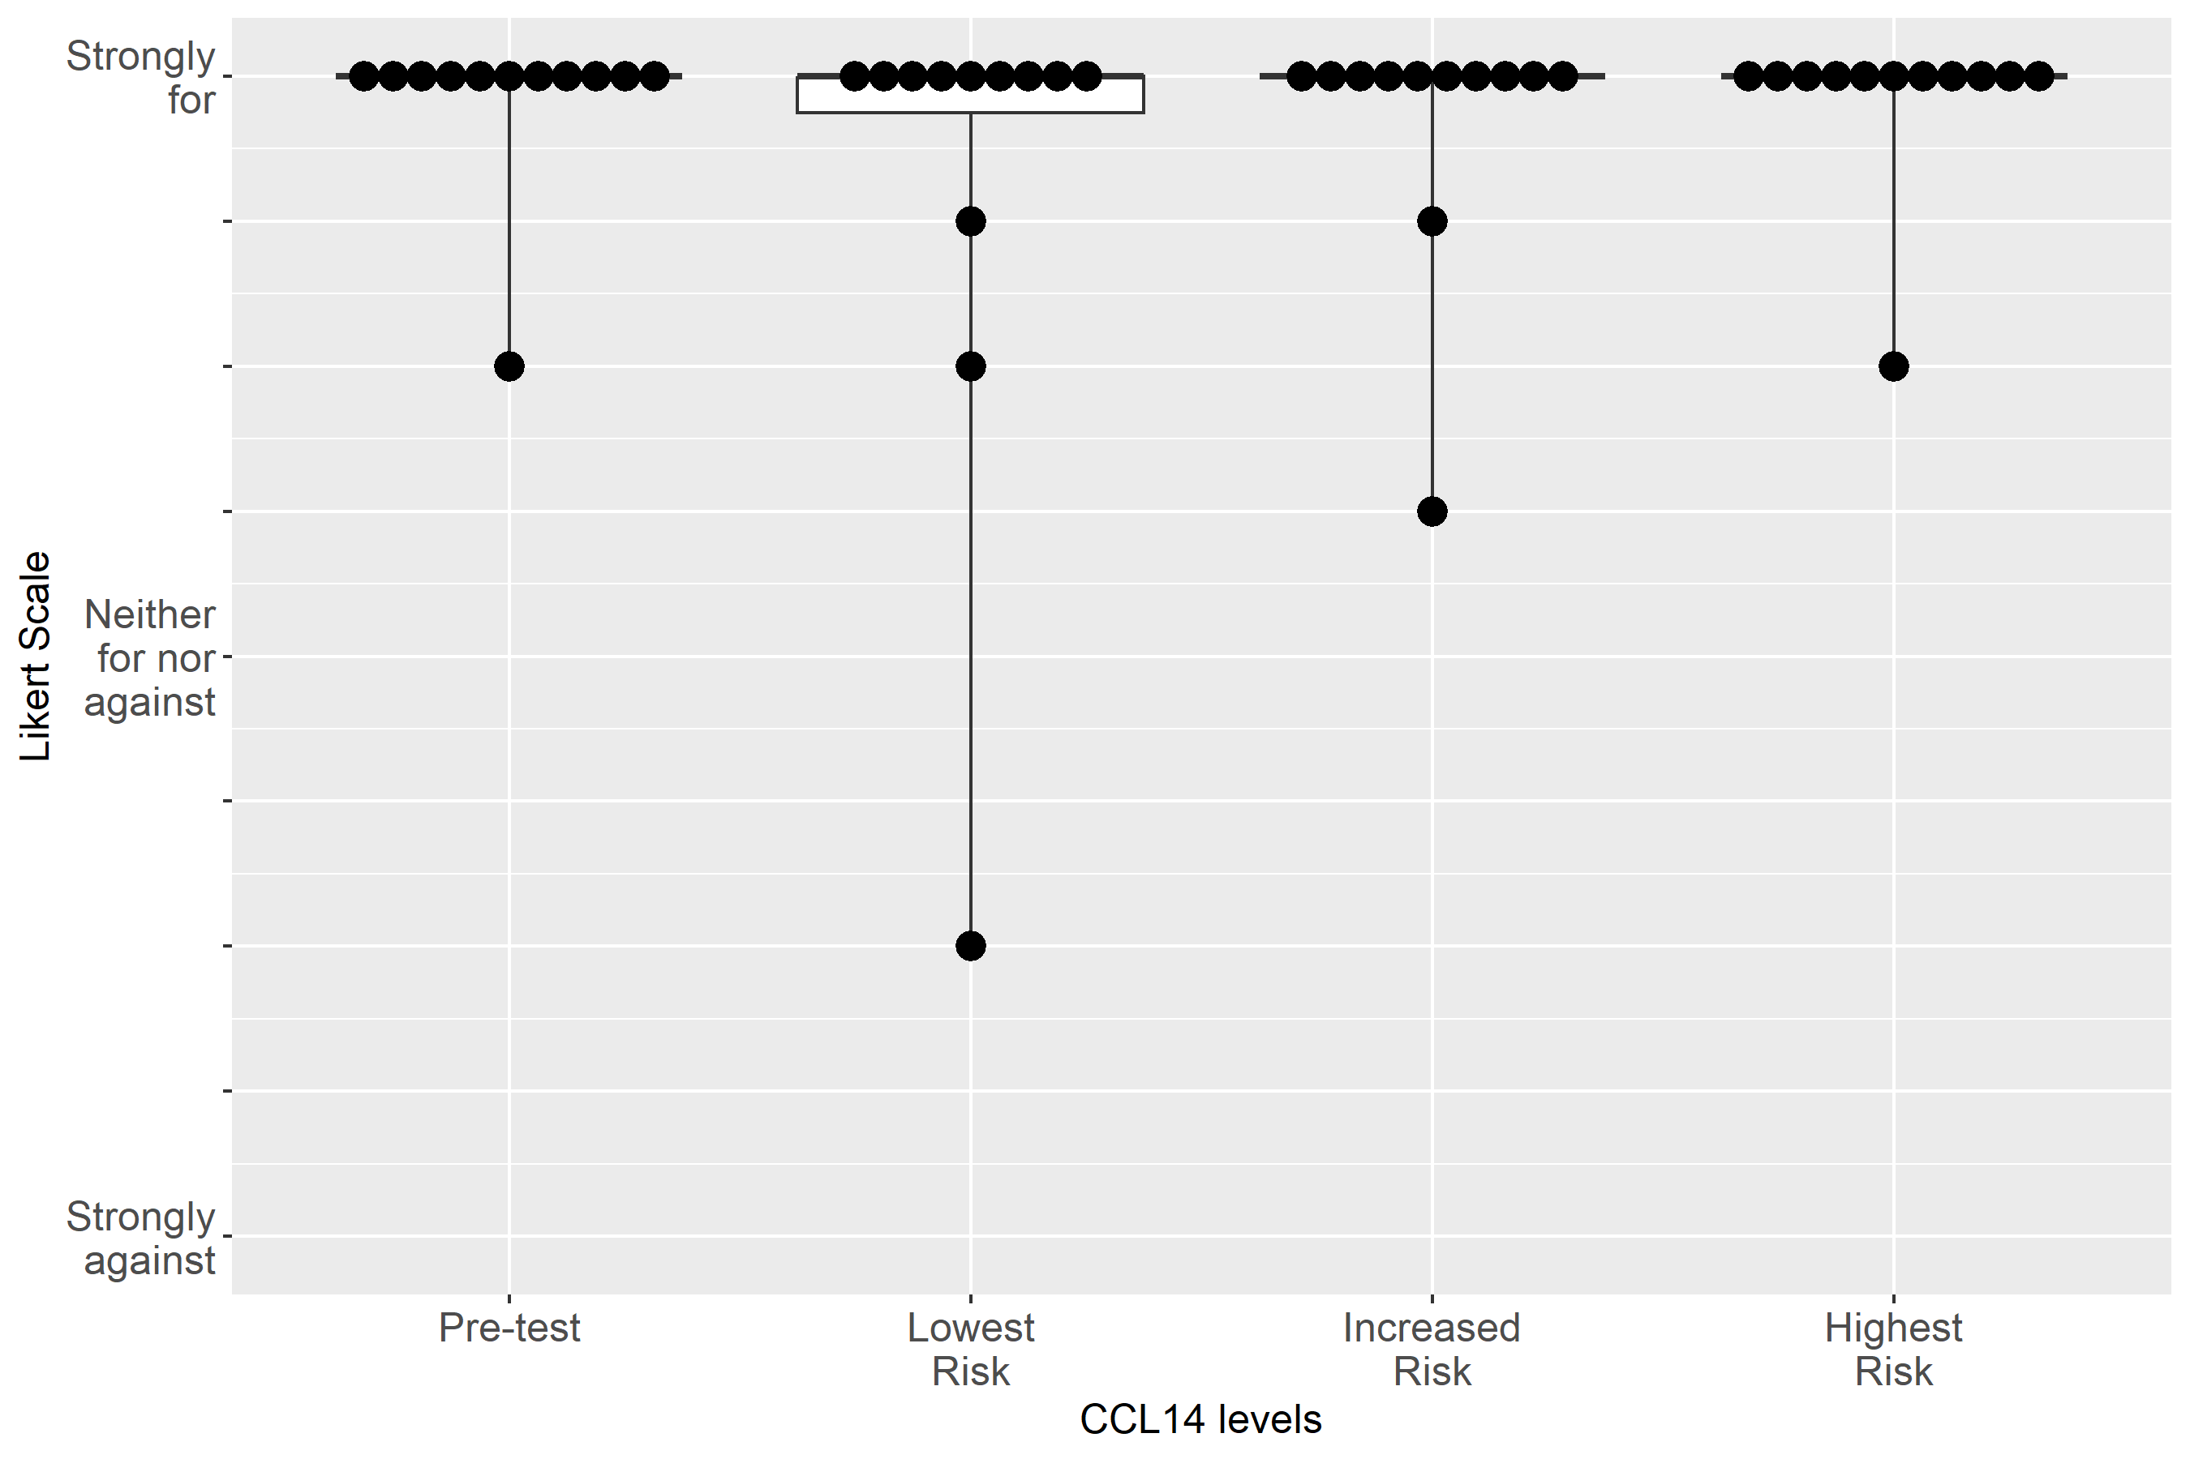

Supplemental Figure S2-18: Case 2, Clinical action: Measure serum creatinine at least daily

Supplemental Figure S2-19: Case 2, Clinical action: Consult nephrology
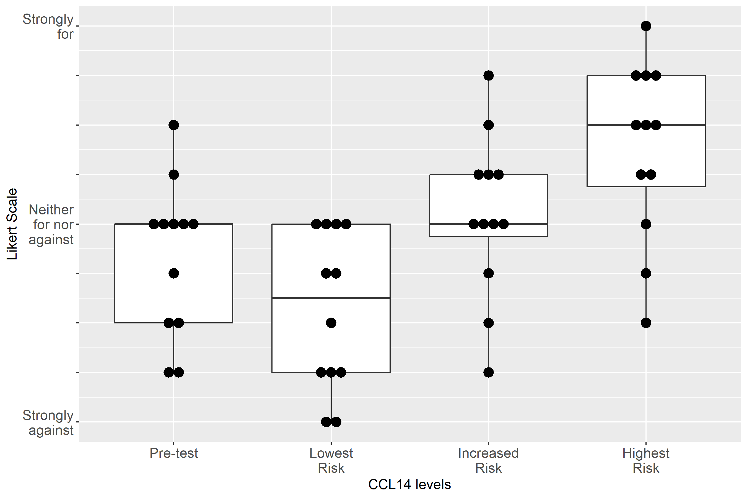

Supplemental Figure S2-20: Case 2, Clinical action: Give fluid
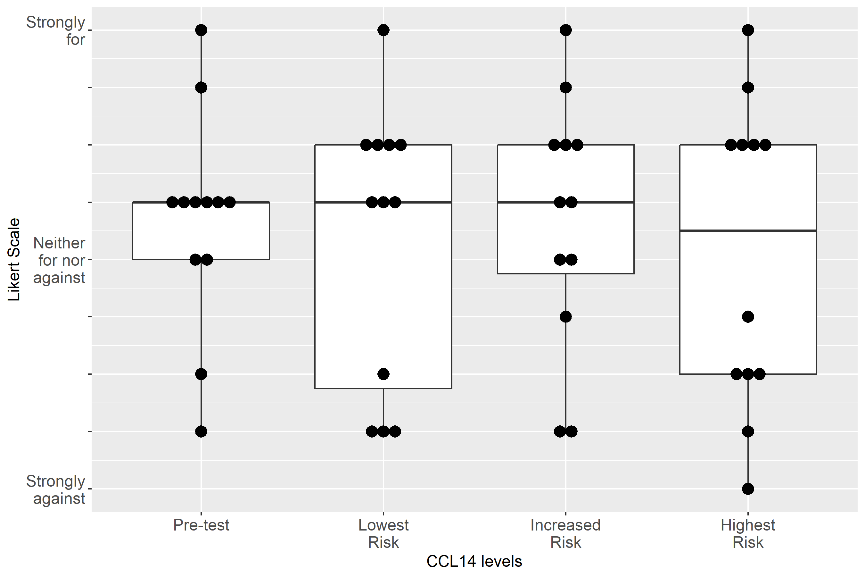

Supplemental Figure S2-21: Case 2, Clinical action: Administer Lasix
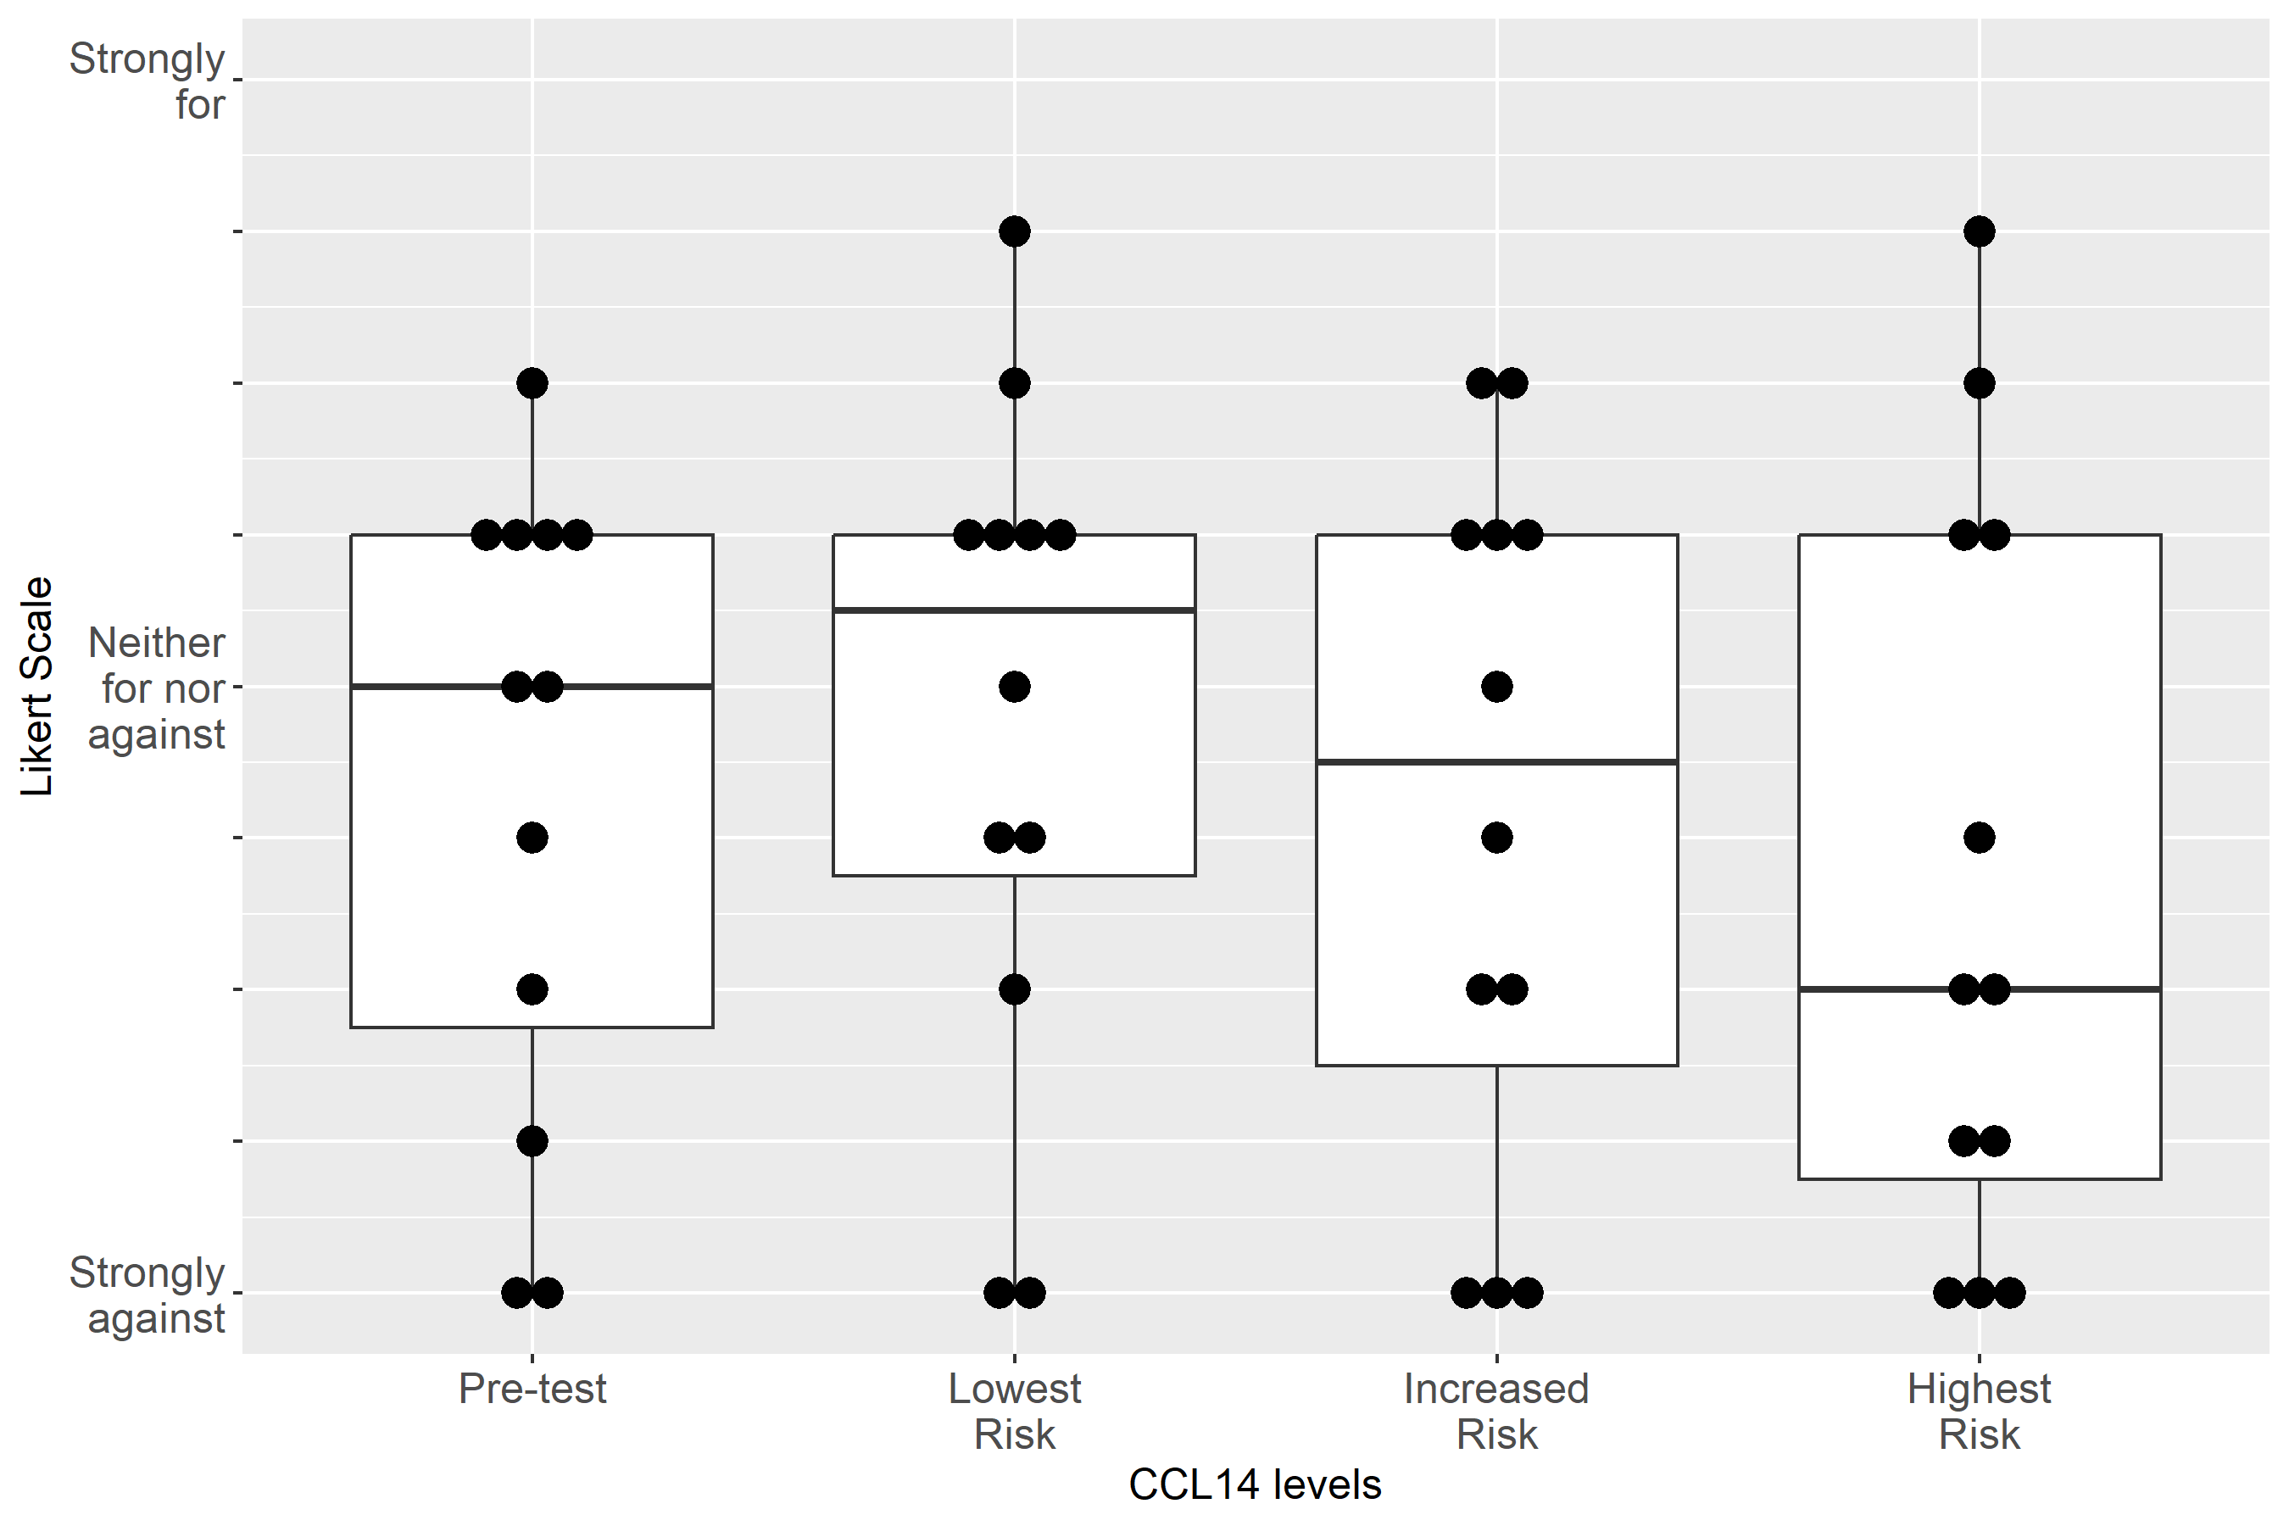

Supplemental Figure S2-22: Case 2, Clinical action: Order CT with contrast
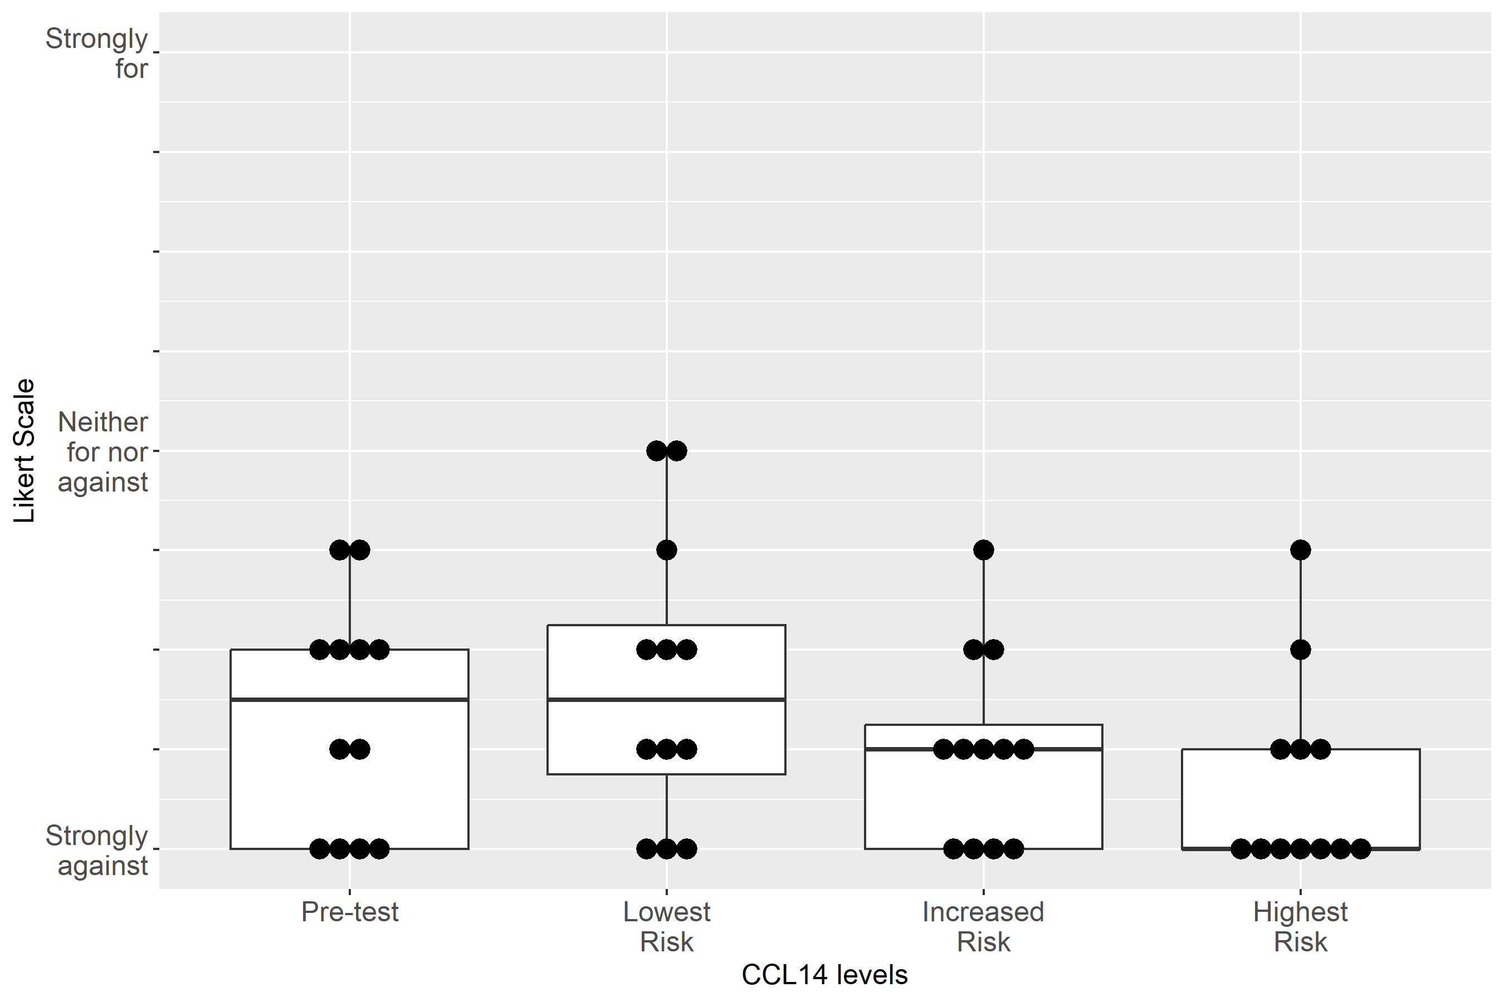

Supplemental Figure S2-23: Case 2, Clinical action: Discuss RRT with patient/family
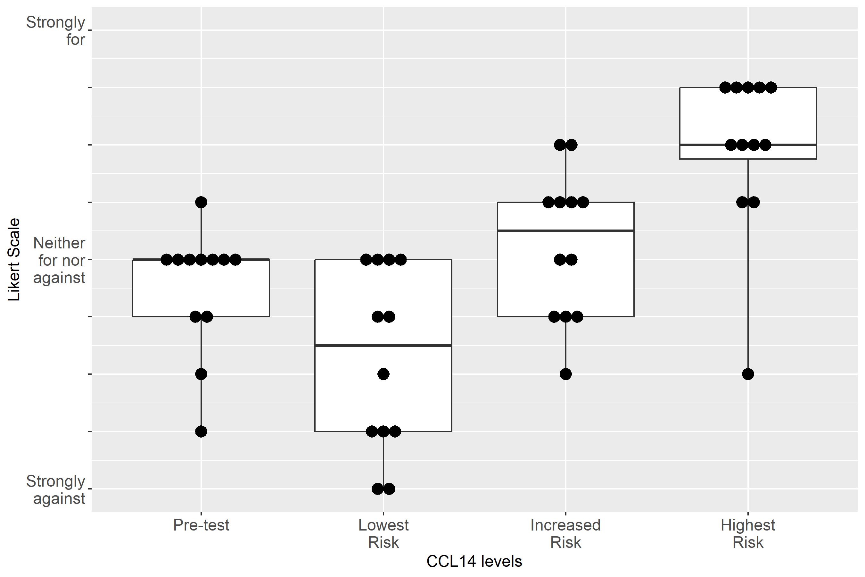

Supplemental Figure S2-24: Case 3, Clinical action: Avoid NSAIDs
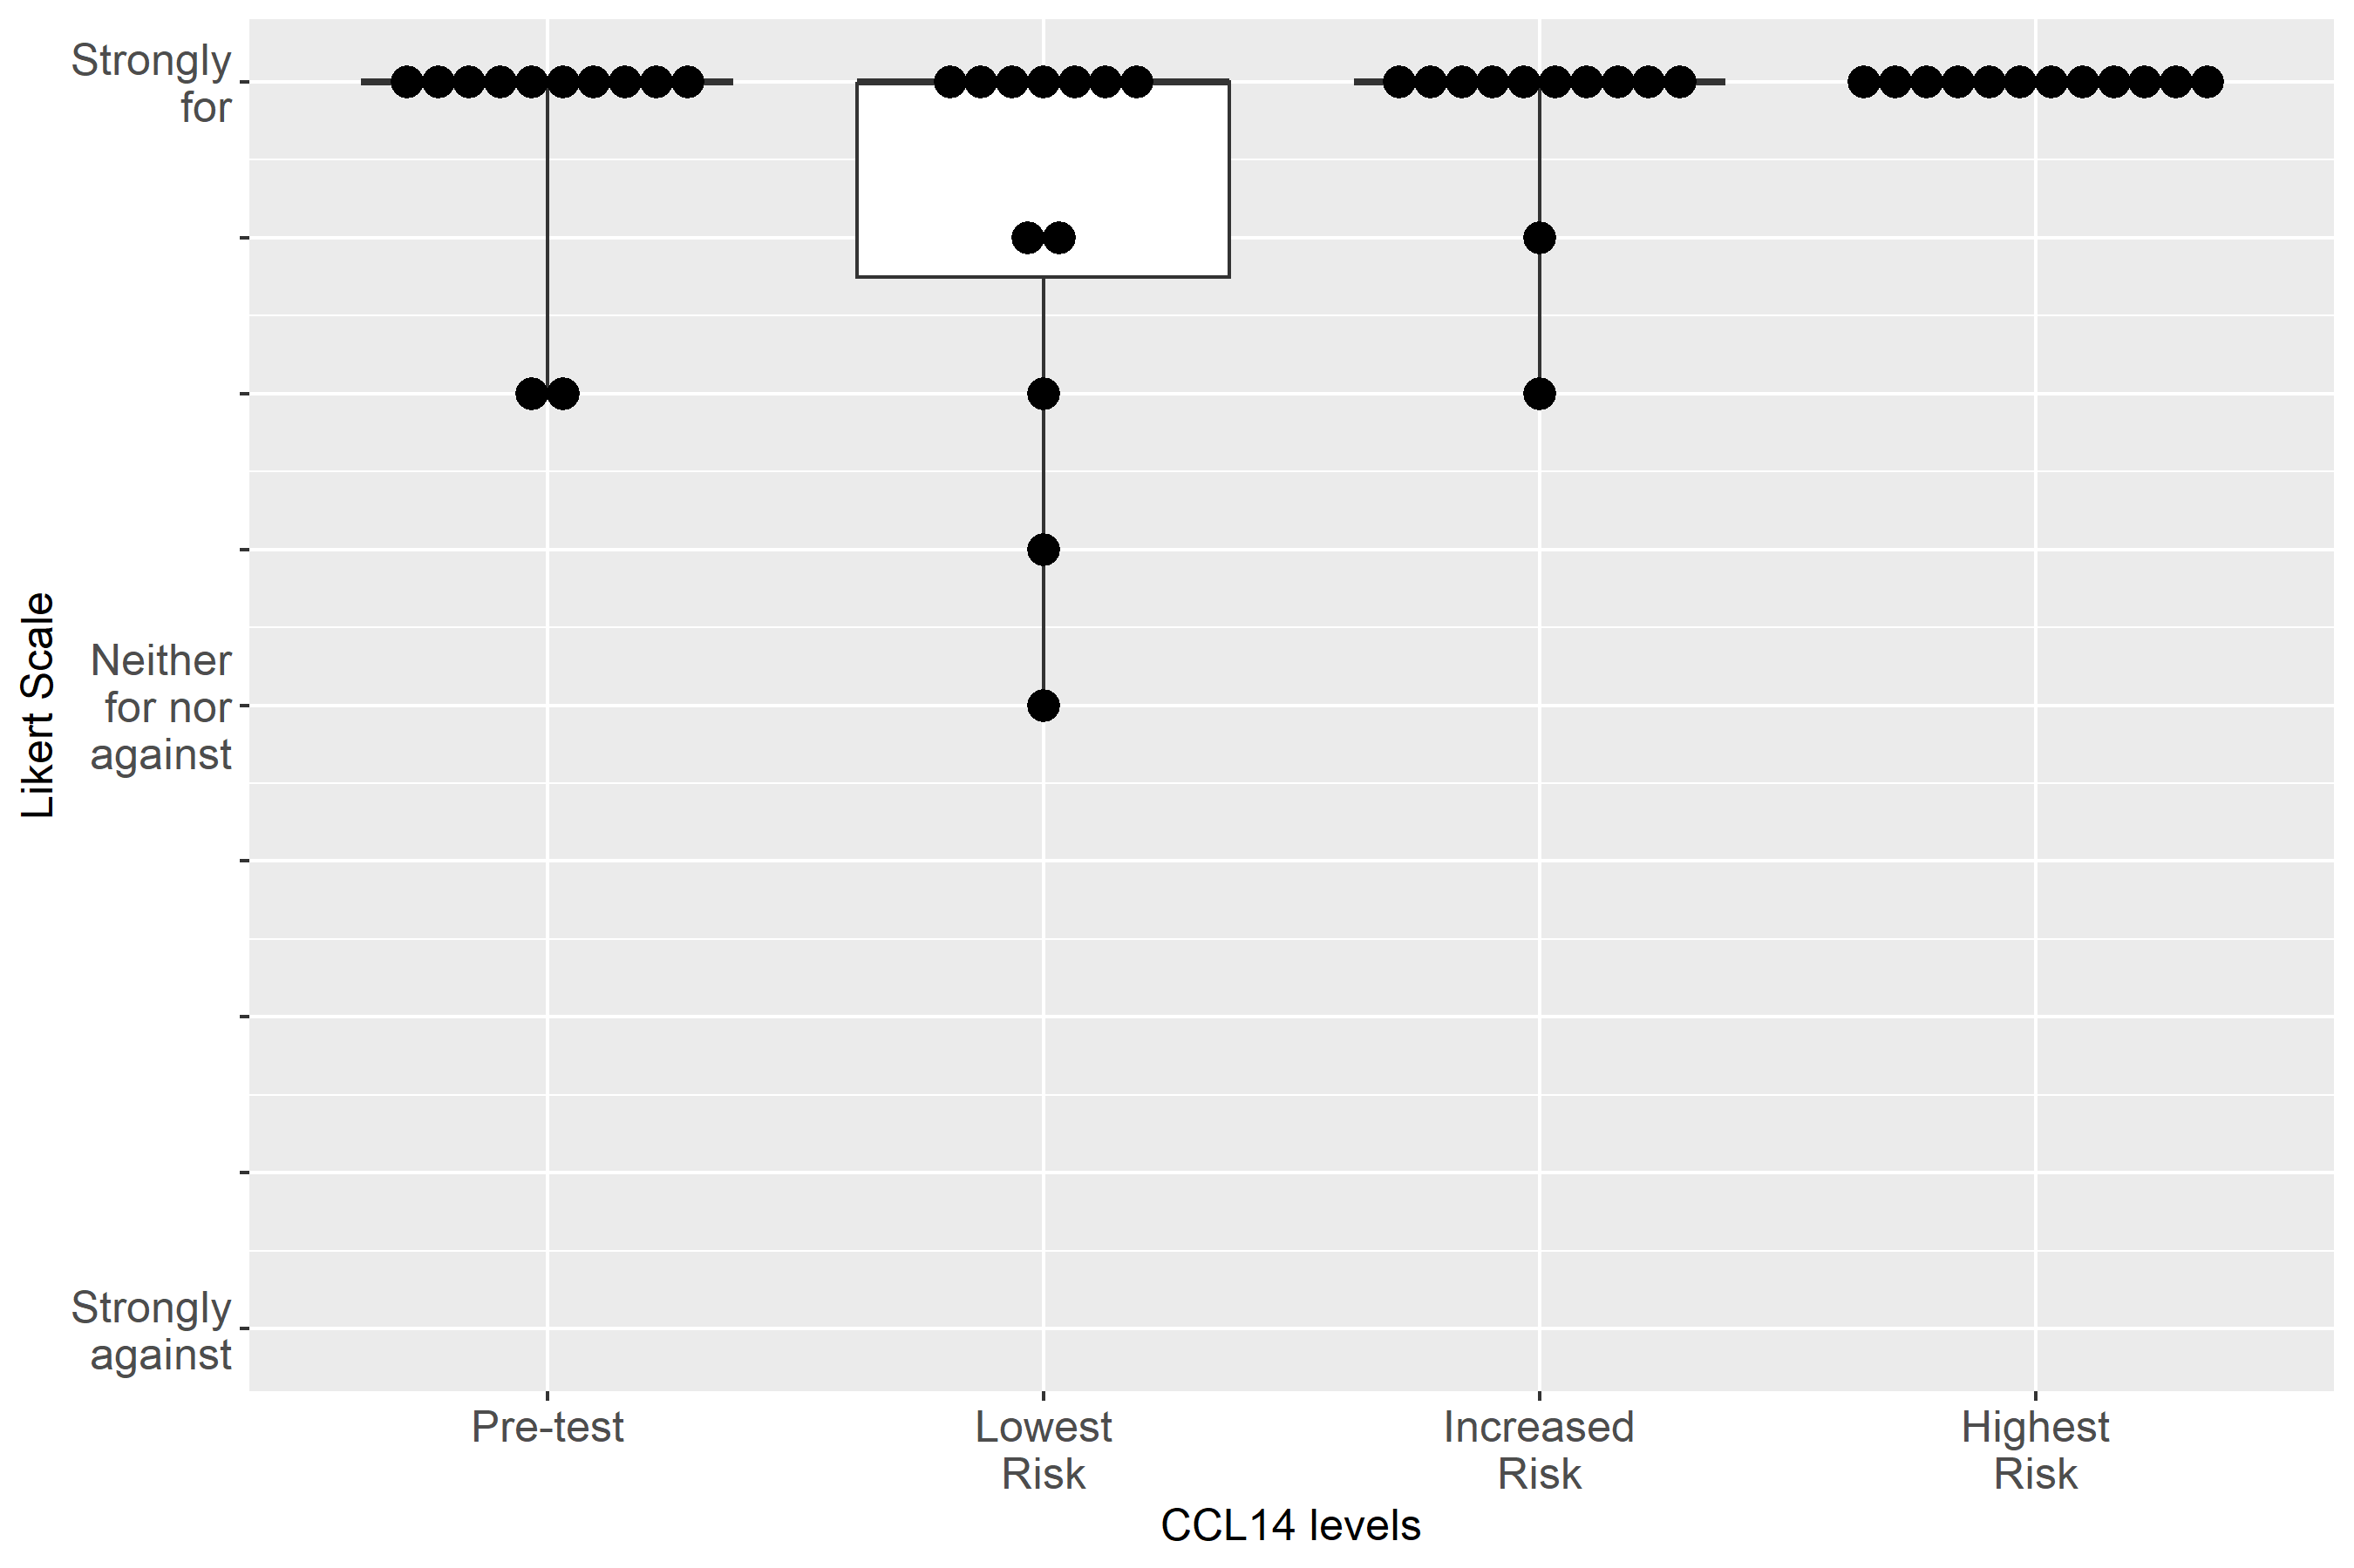

Supplemental Figure S2-25: Case 3, Clinical action: Adjust non-nephrotoxic, renally cleared medication
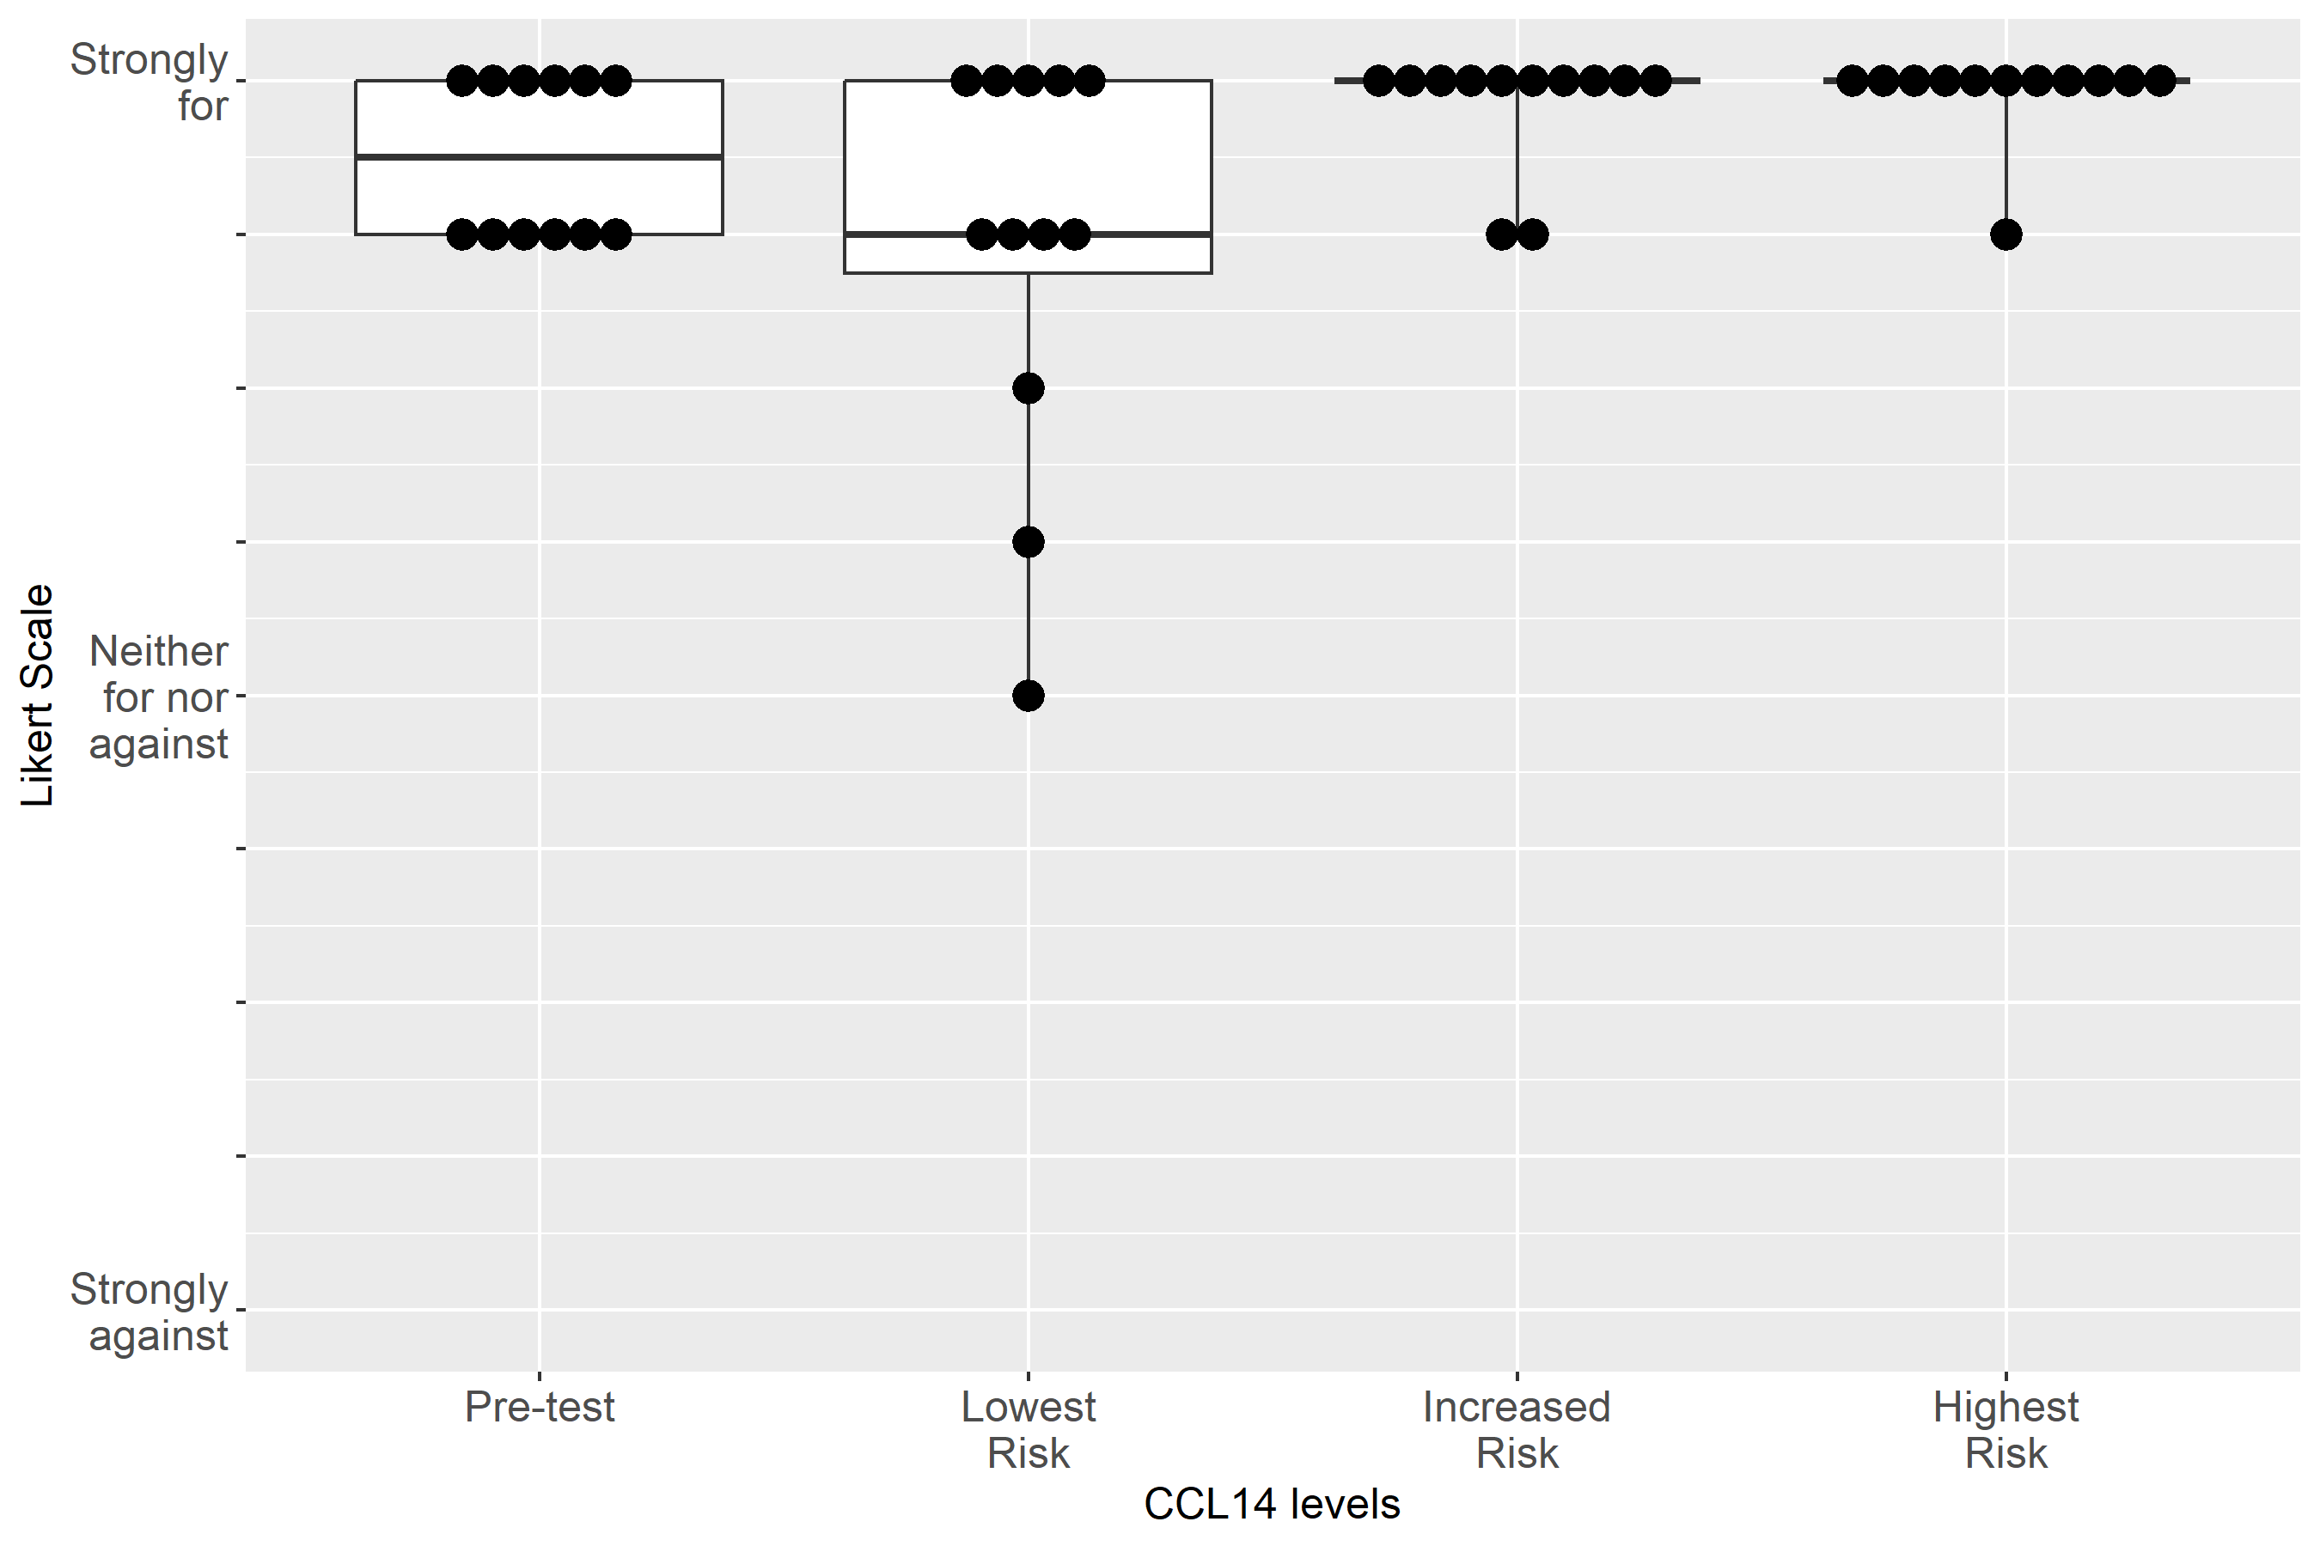

Supplemental Figure S2-26: Case 3, Clinical action: Use functional hemodynamic monitoring
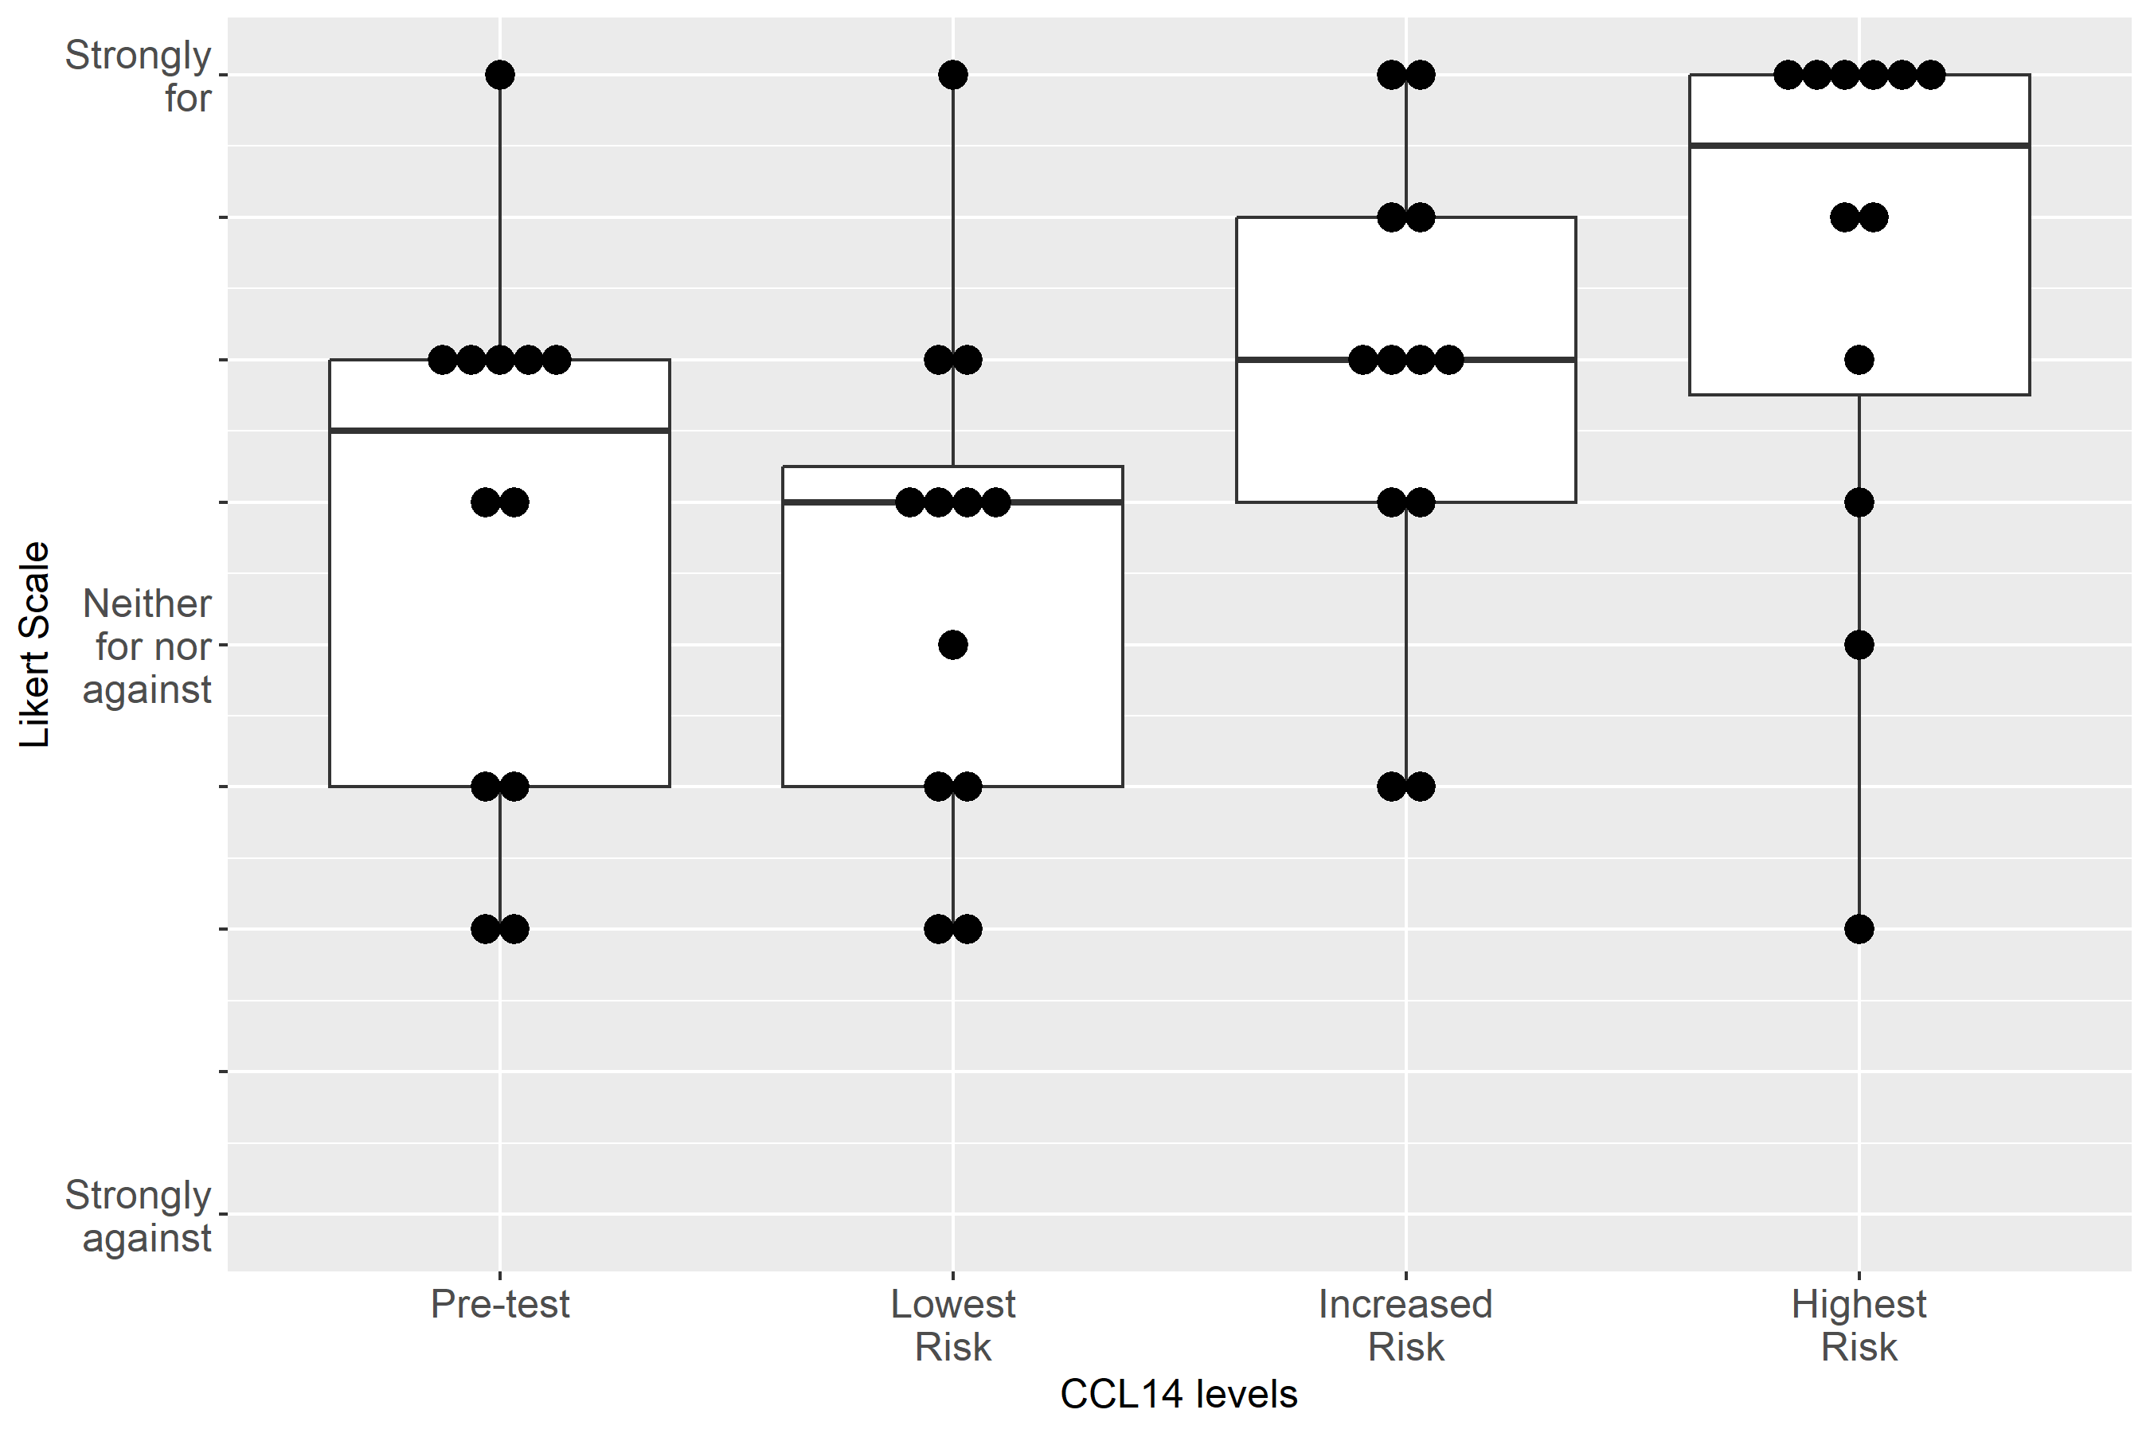

Supplemental Figure S2-27: Case 3, Clinical action: Perform renal ultrasound
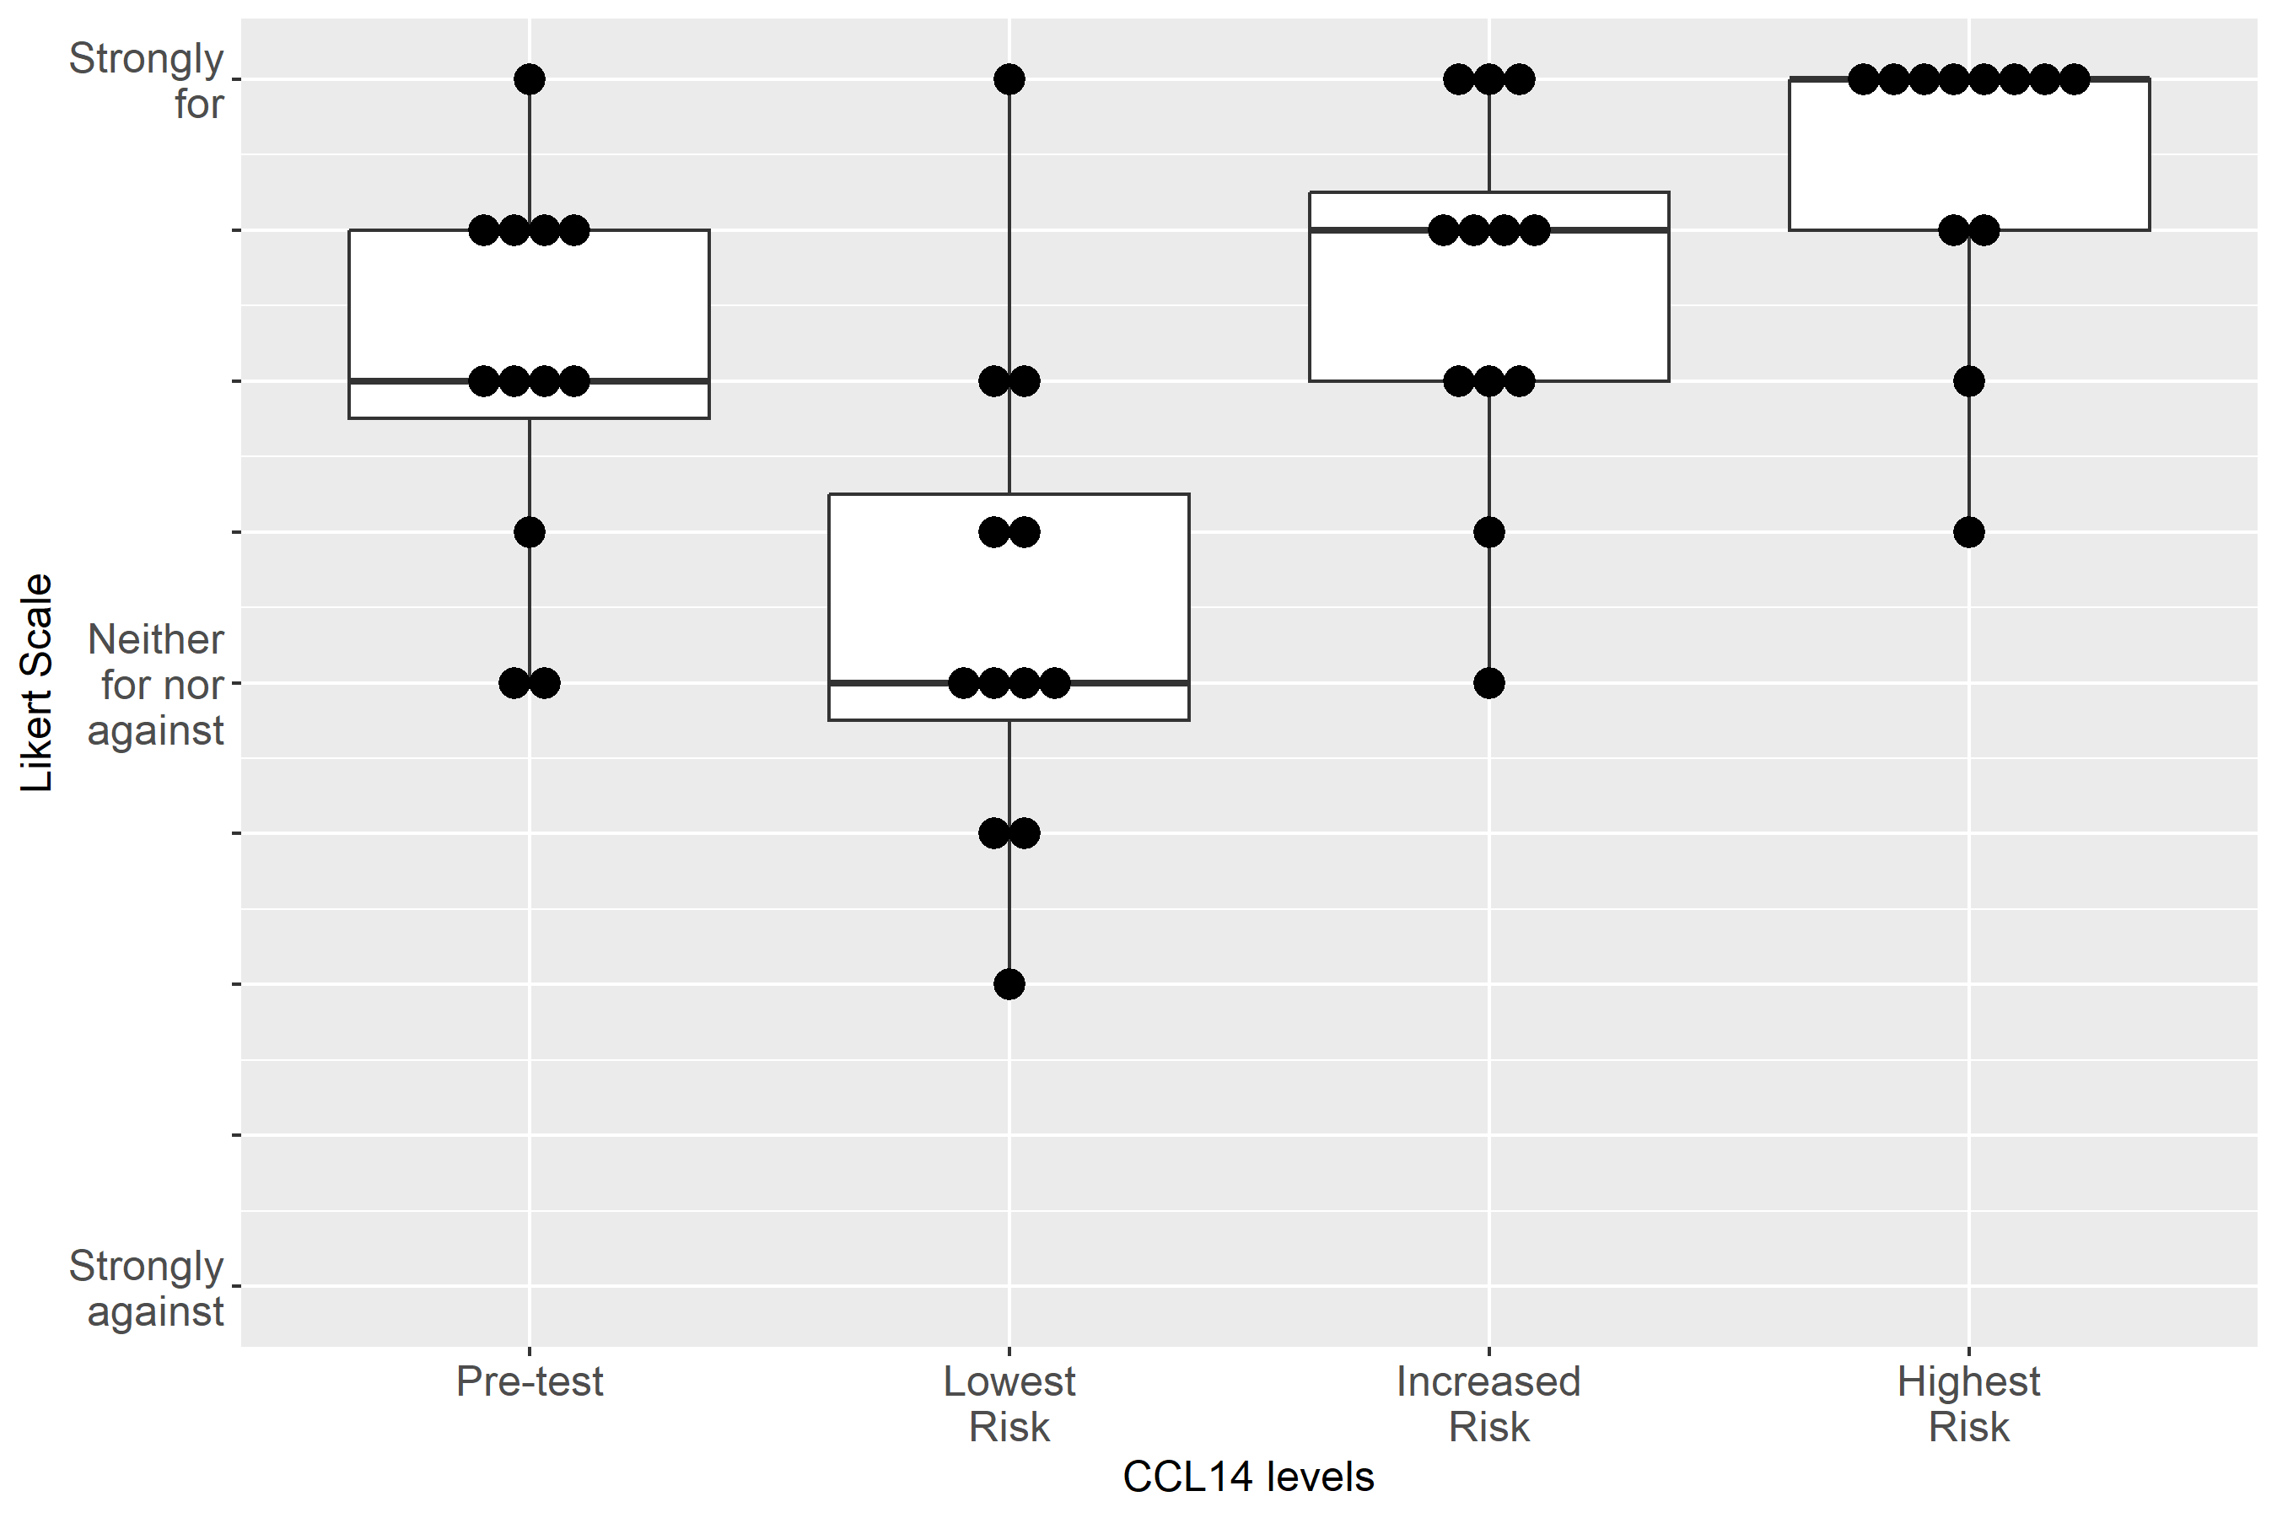

Supplemental Figure S2-28: Case 3, Clinical action: Keep foley catheter, 1-2 hourly Urine Output
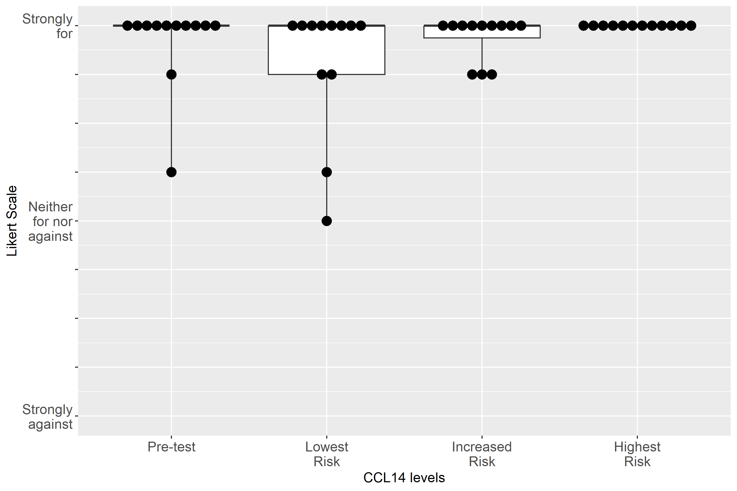

Supplemental Figure S2-29: Case 3, Clinical action: Measure serum creatinine at least daily

Supplemental Figure S2-30: Case 3, Clinical action: Consult nephrology
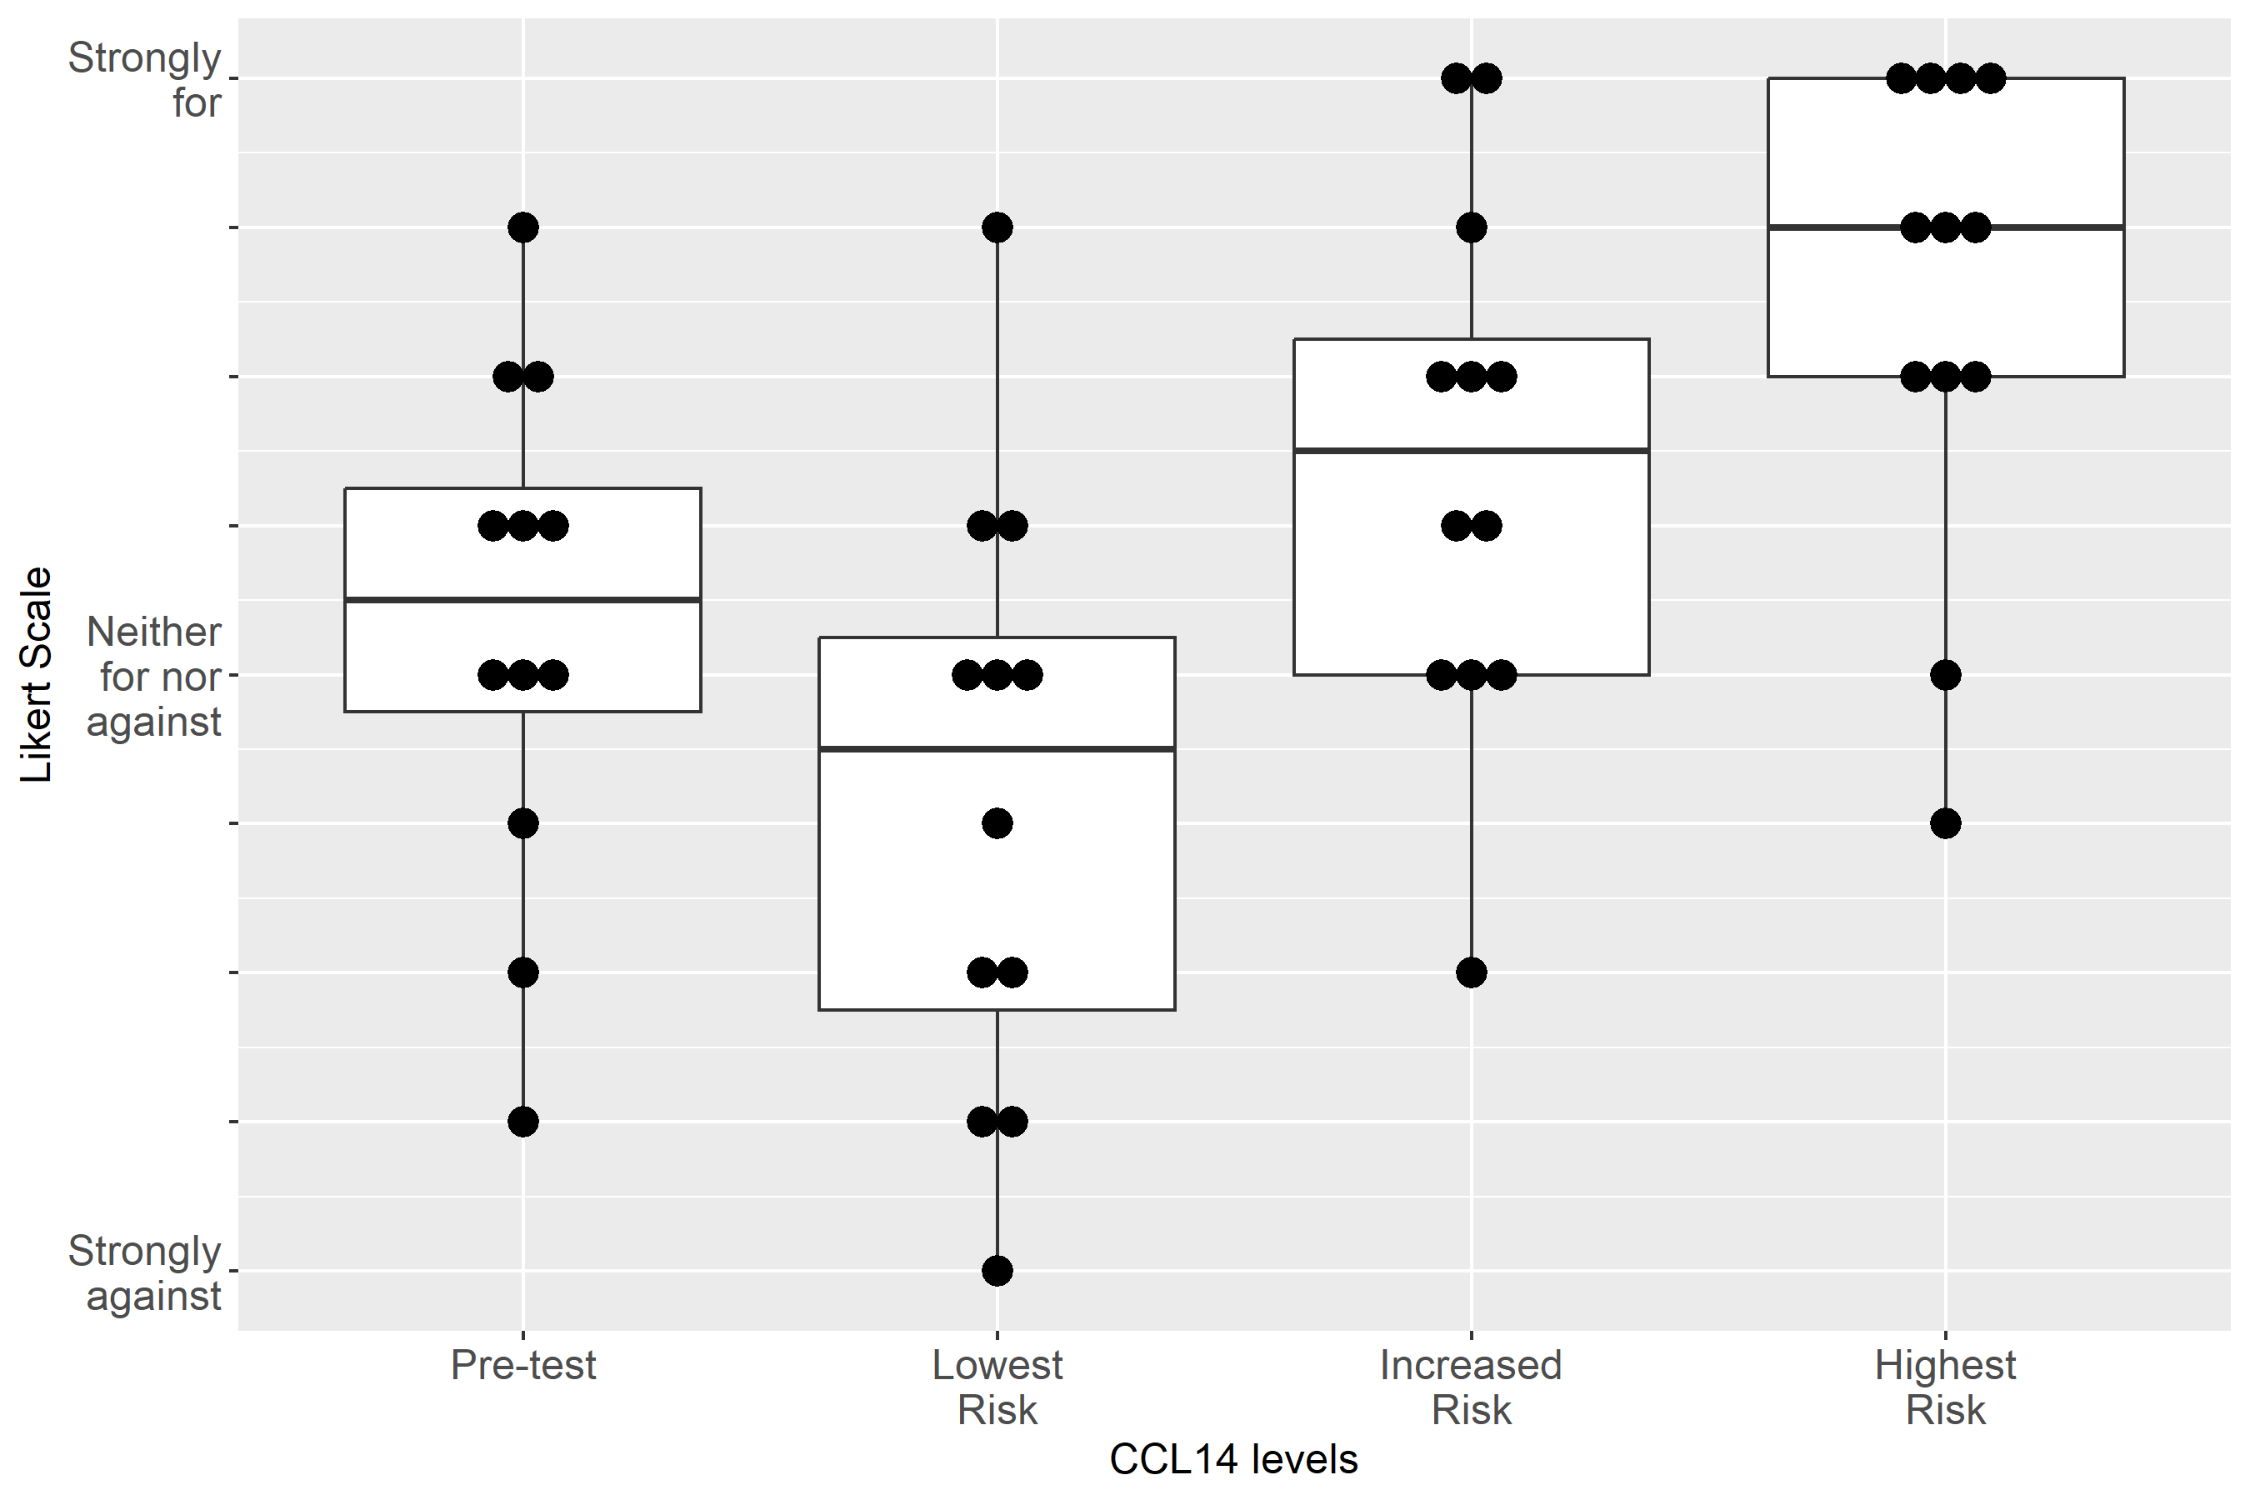

Supplemental Figure S2-31: Case 3, Clinical action: Order CT with contrast
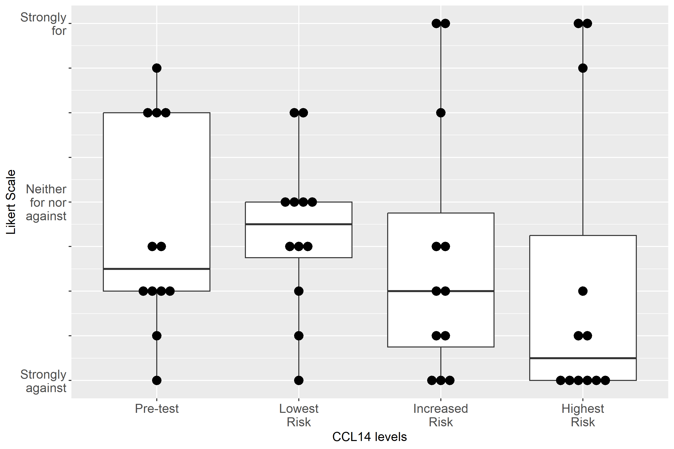

Supplemental Figure S2-32: Case 3, Clinical action: Give fluid
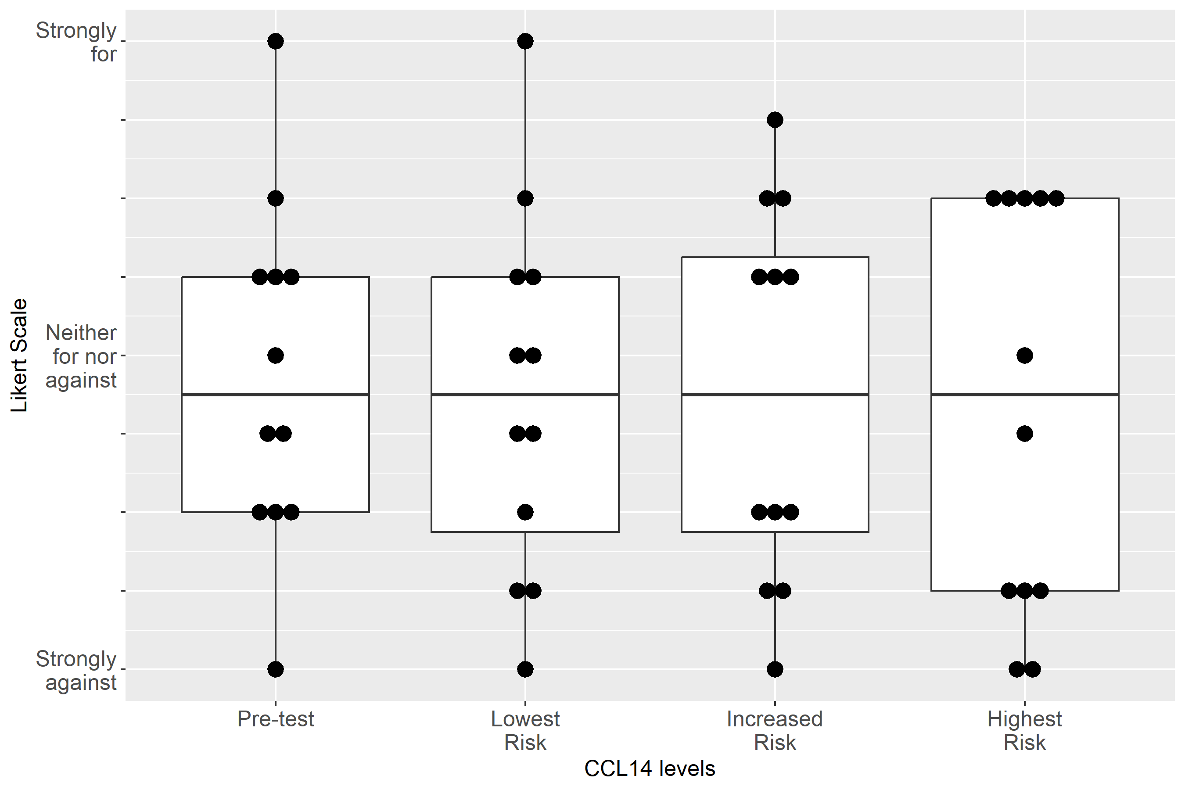

Supplemental Figure S2-33: Case 3, Clinical action: Administer Lasix
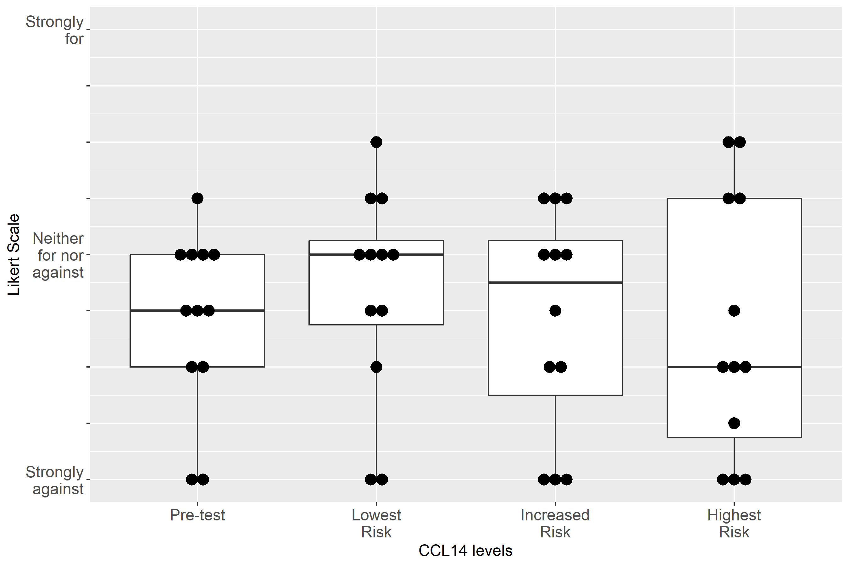

Supplemental Figure S2-34: Case 3, Clinical action: Discuss RRT with patient/family
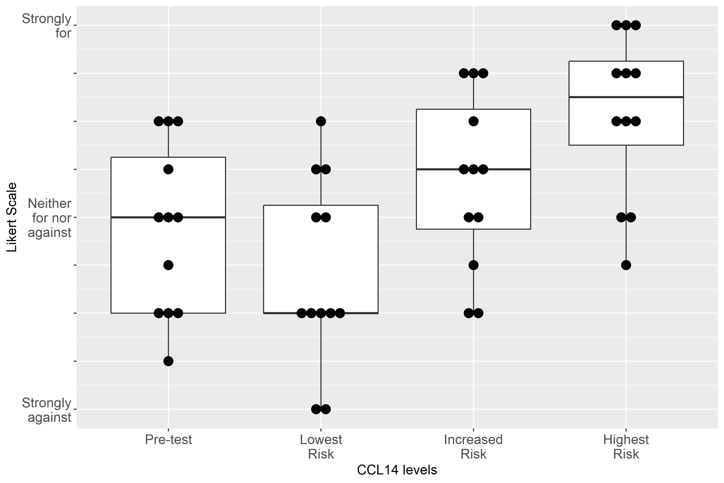

Supplemental Figure S2-35: Case 4, Clinical action: Avoid NSAIDs
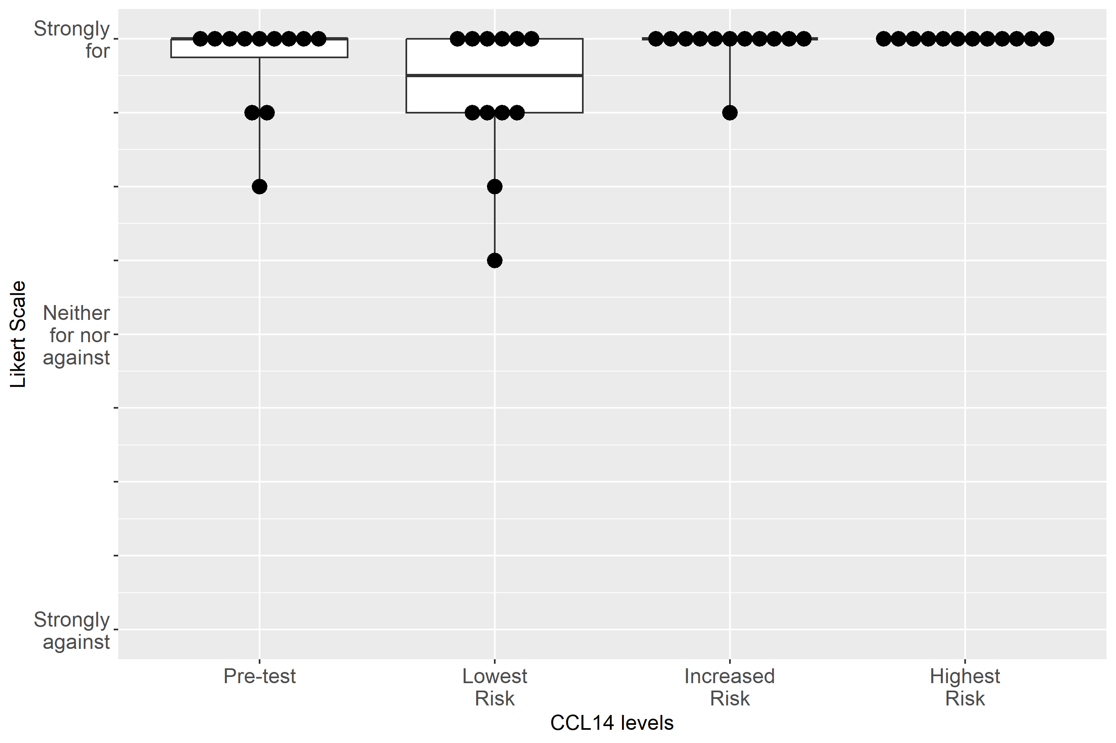

Supplemental Figure S2-36: Case 4, Clinical action: Adjust non-nephrotoxic, renally cleared medication
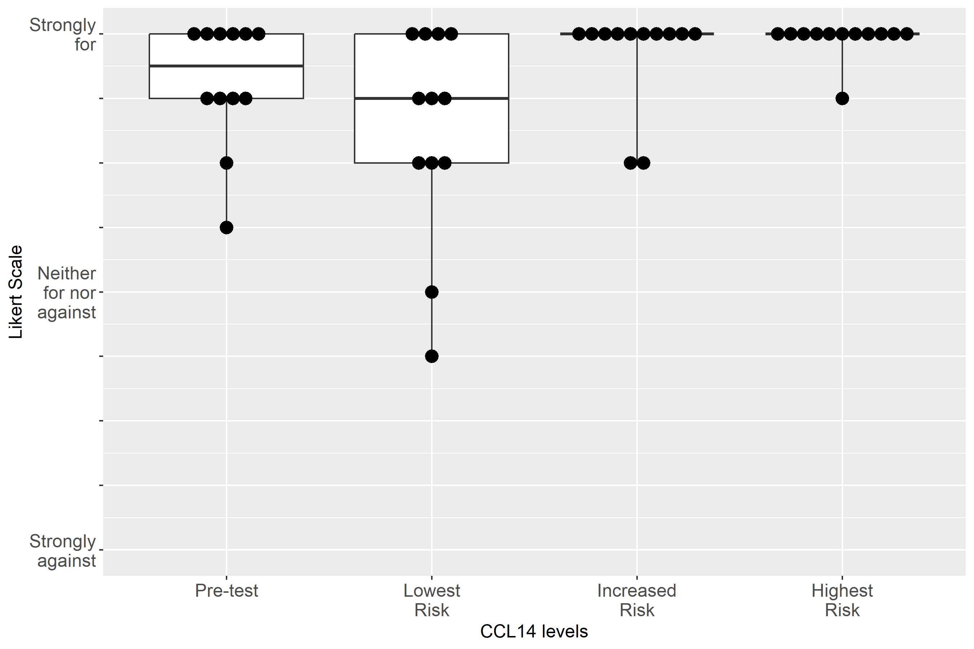

Supplemental Figure S2-37: Case 4, Clinical action: Use functional hemodynamic monitoring
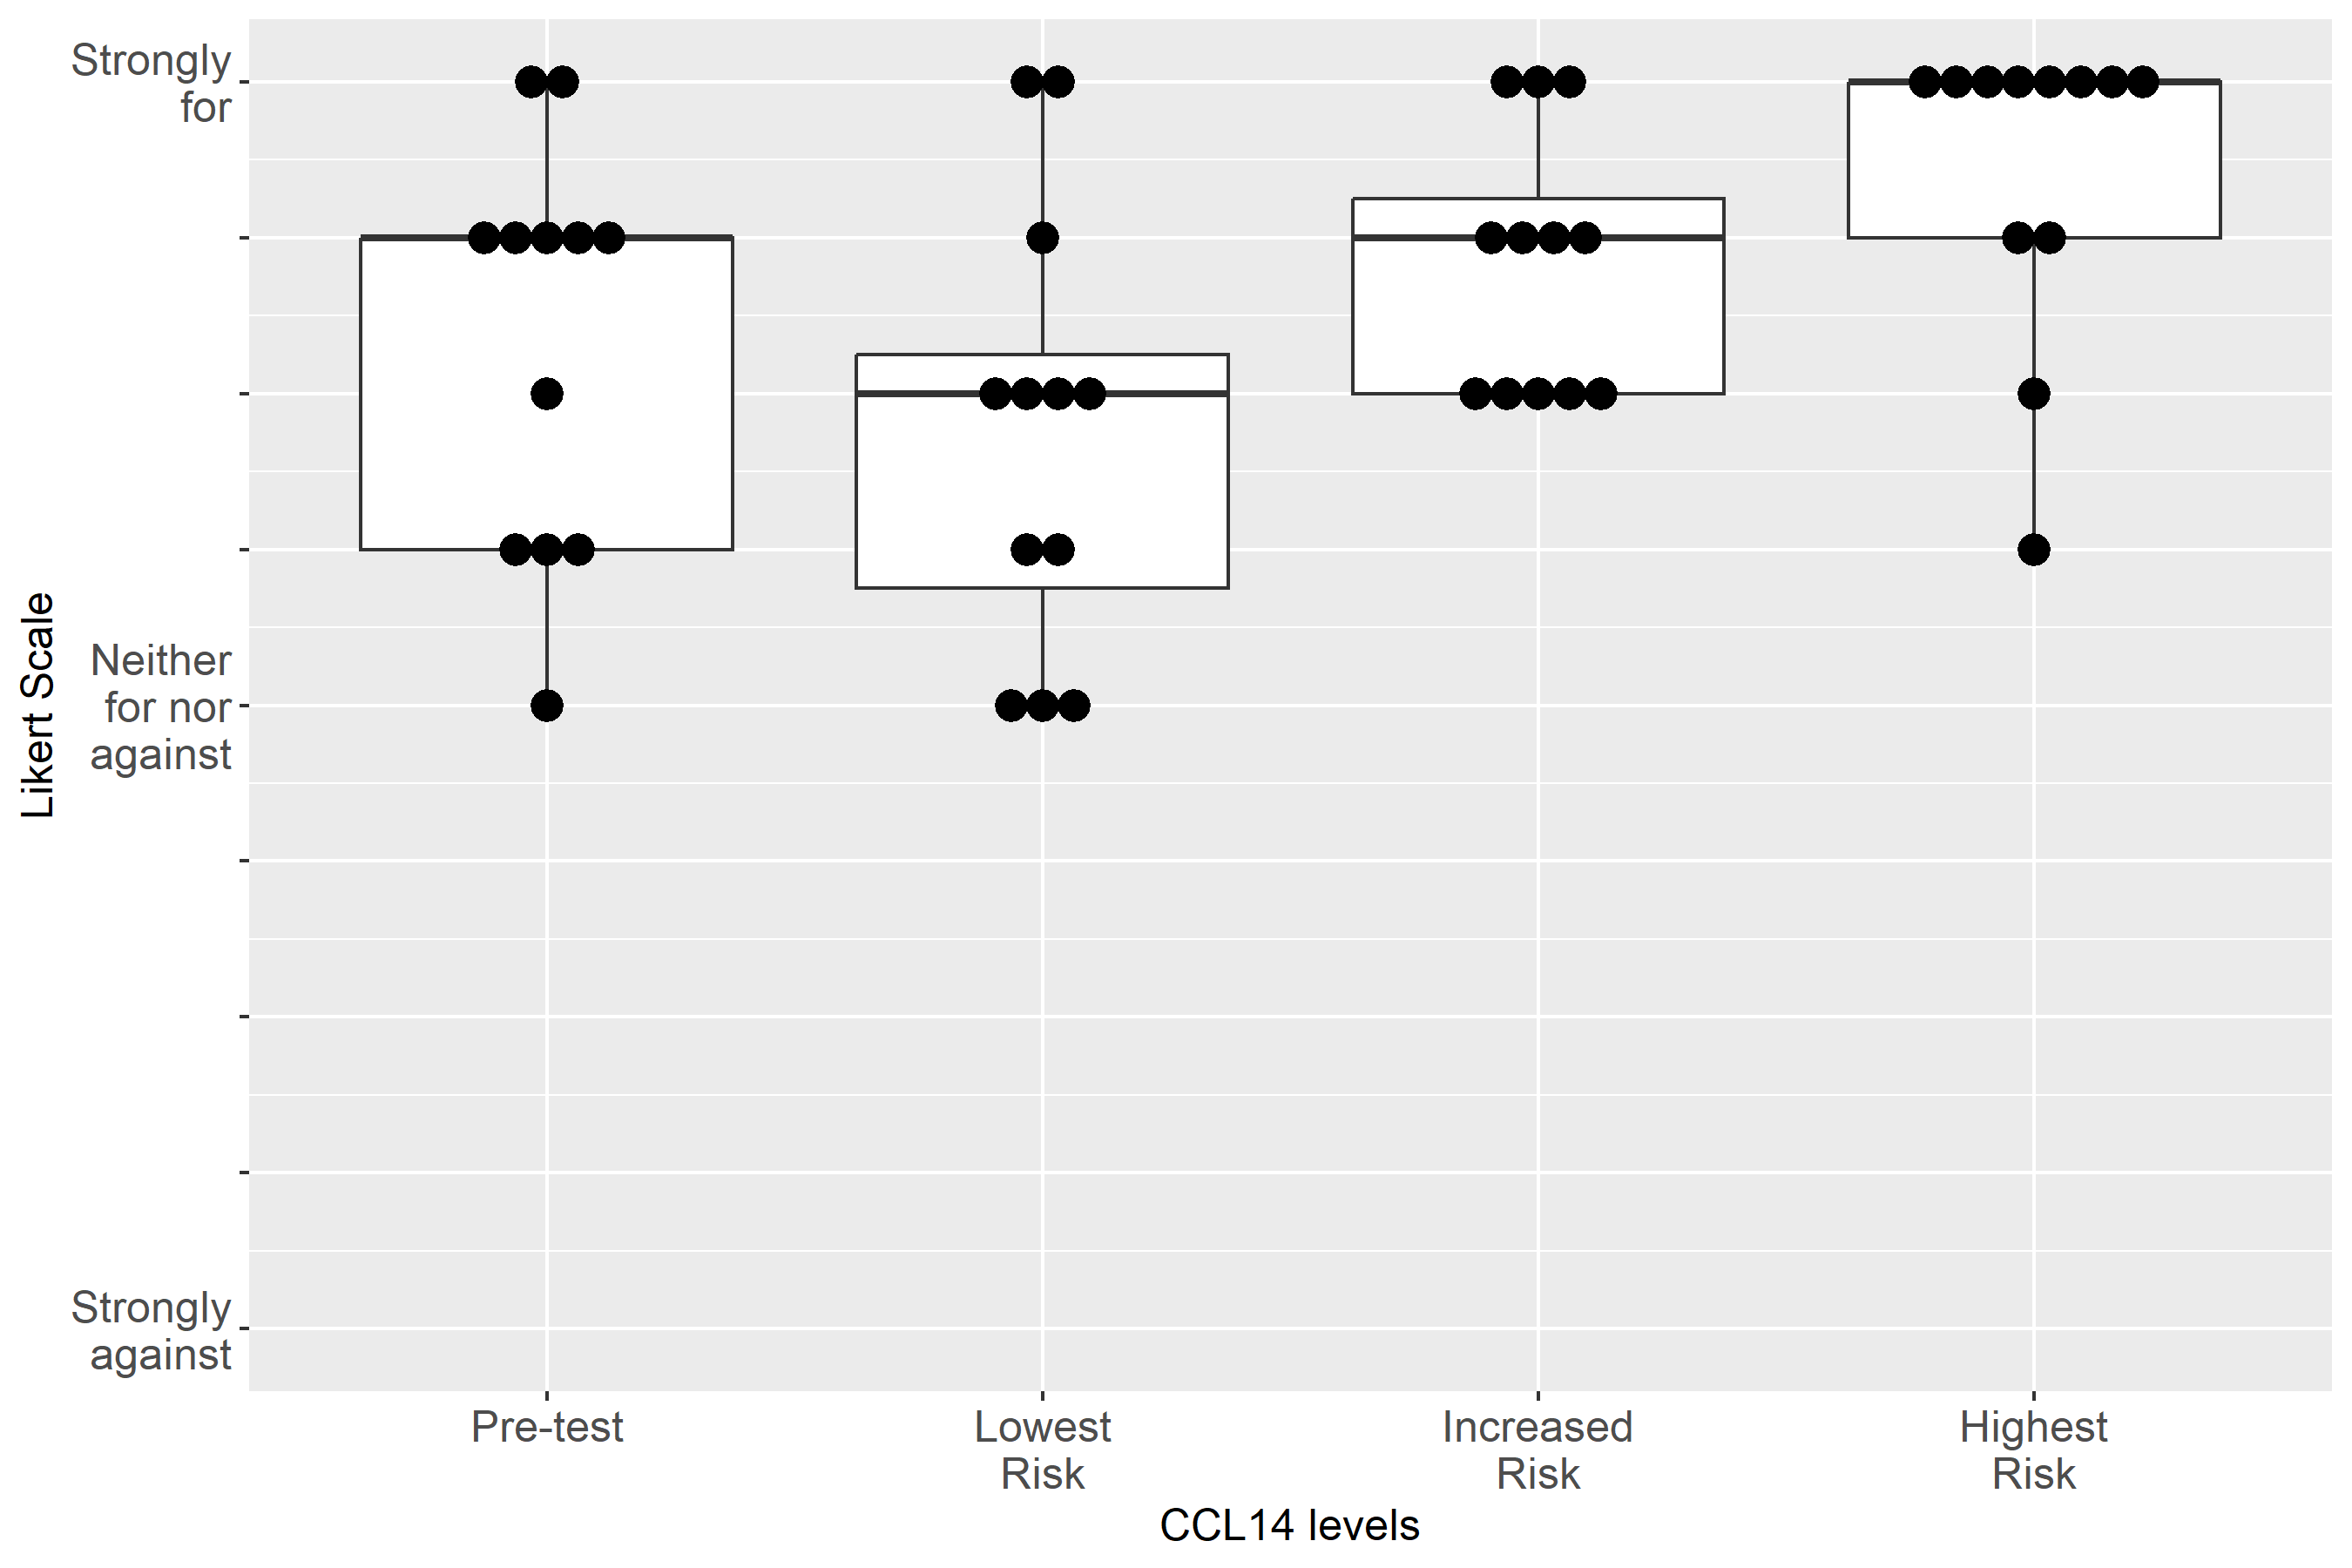

Supplemental Figure S2-38: Case 4, Clinical action: Perform renal ultrasound
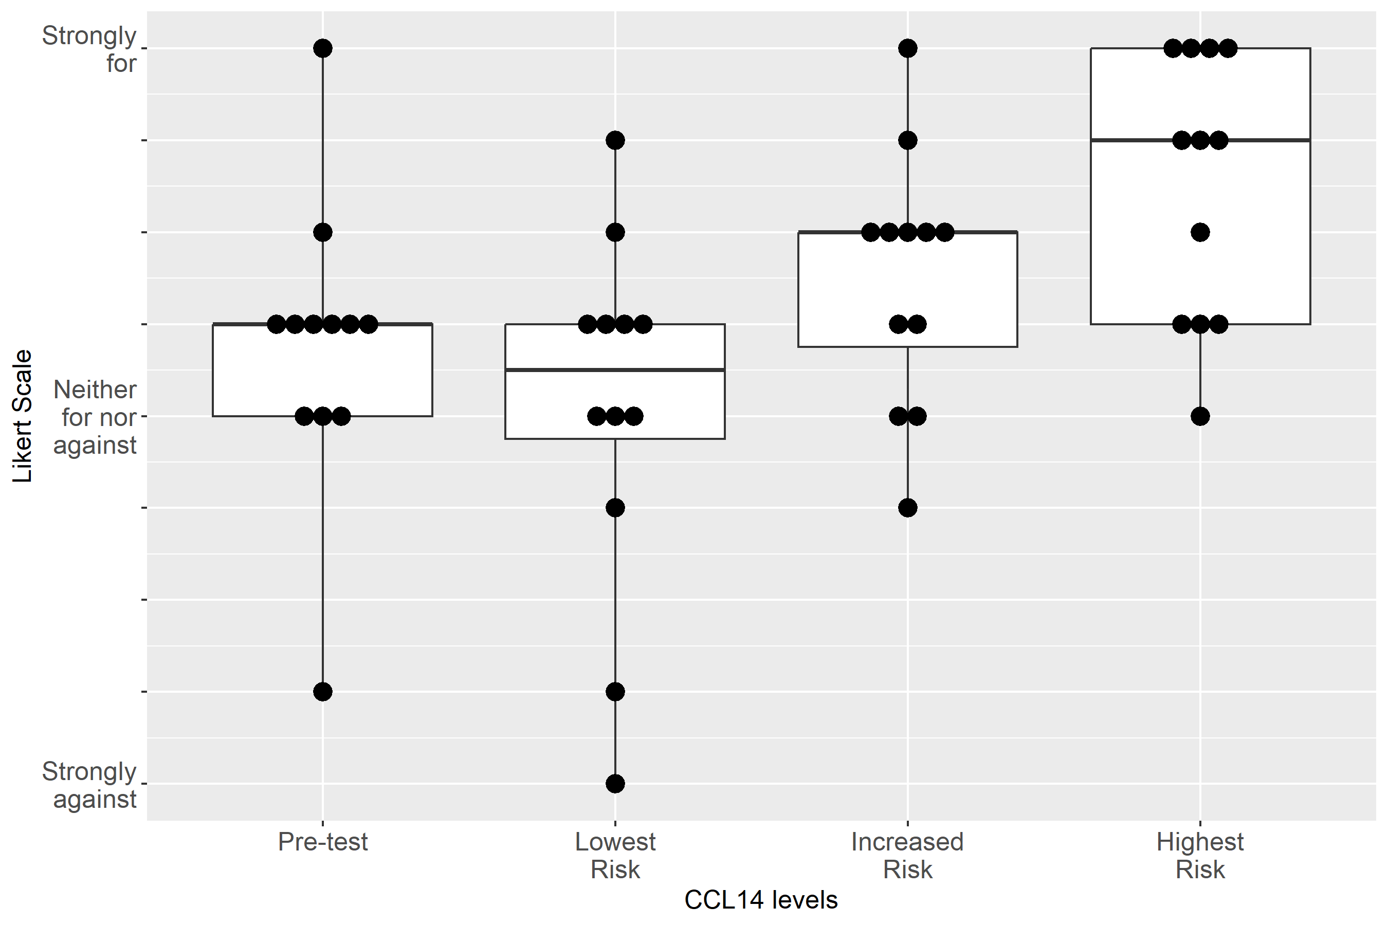

Supplemental Figure S2-39: Case 4, Clinical action: Keep foley catheter, 1-2 hourly Urine Output
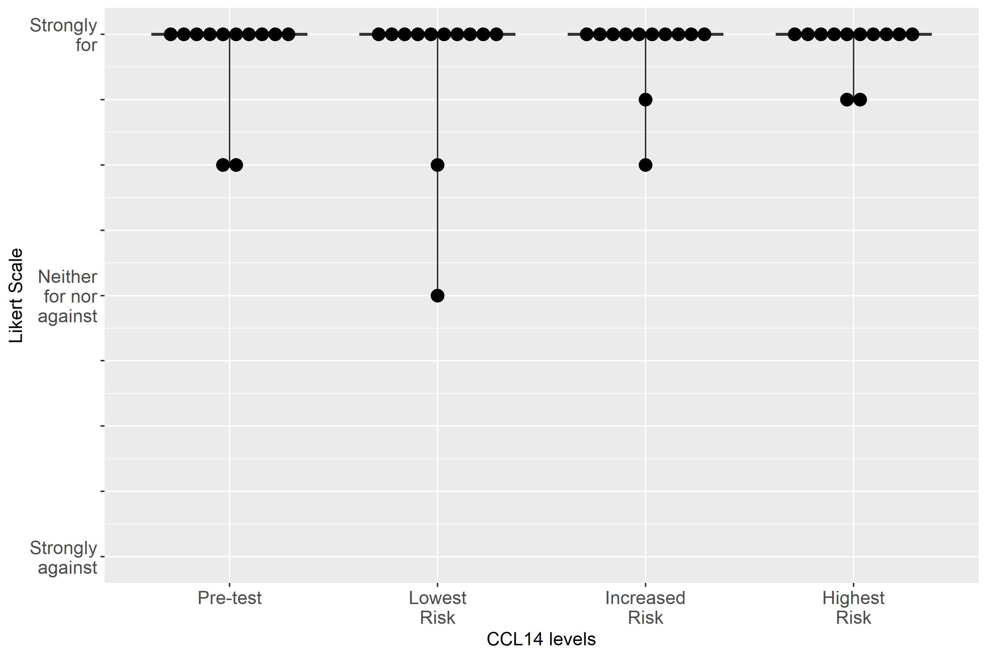

Supplemental Figure S2-40: Case 4, Clinical action: Measure serum creatinine at least daily

Supplemental Figure S2-41: Case 4, Clinical action: Consult nephrology
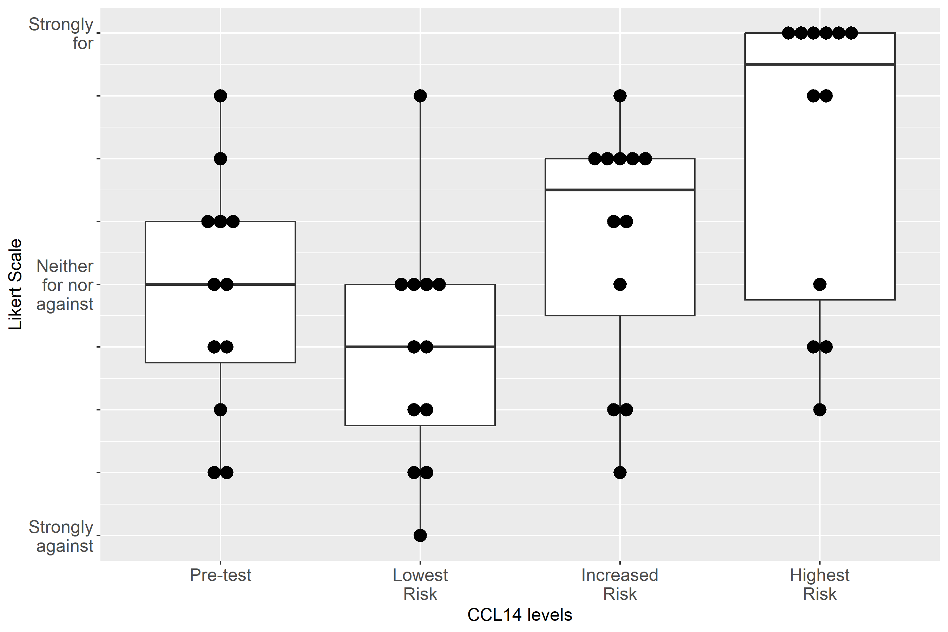

Supplemental Figure S2-42: Case 4, Clinical action: Give fluid
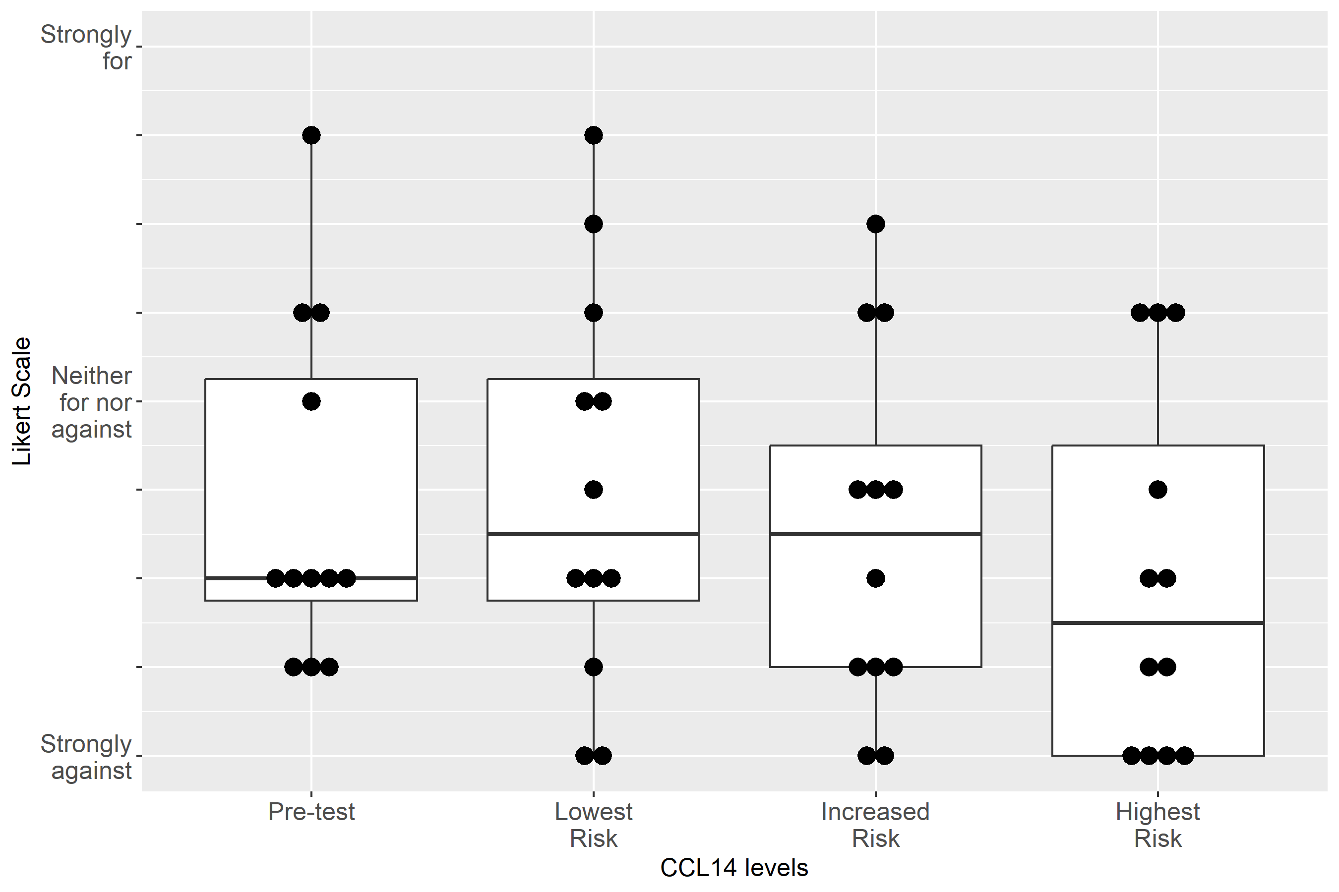

Supplemental Figure S2-43: Case 4, Clinical action: Administer Lasix
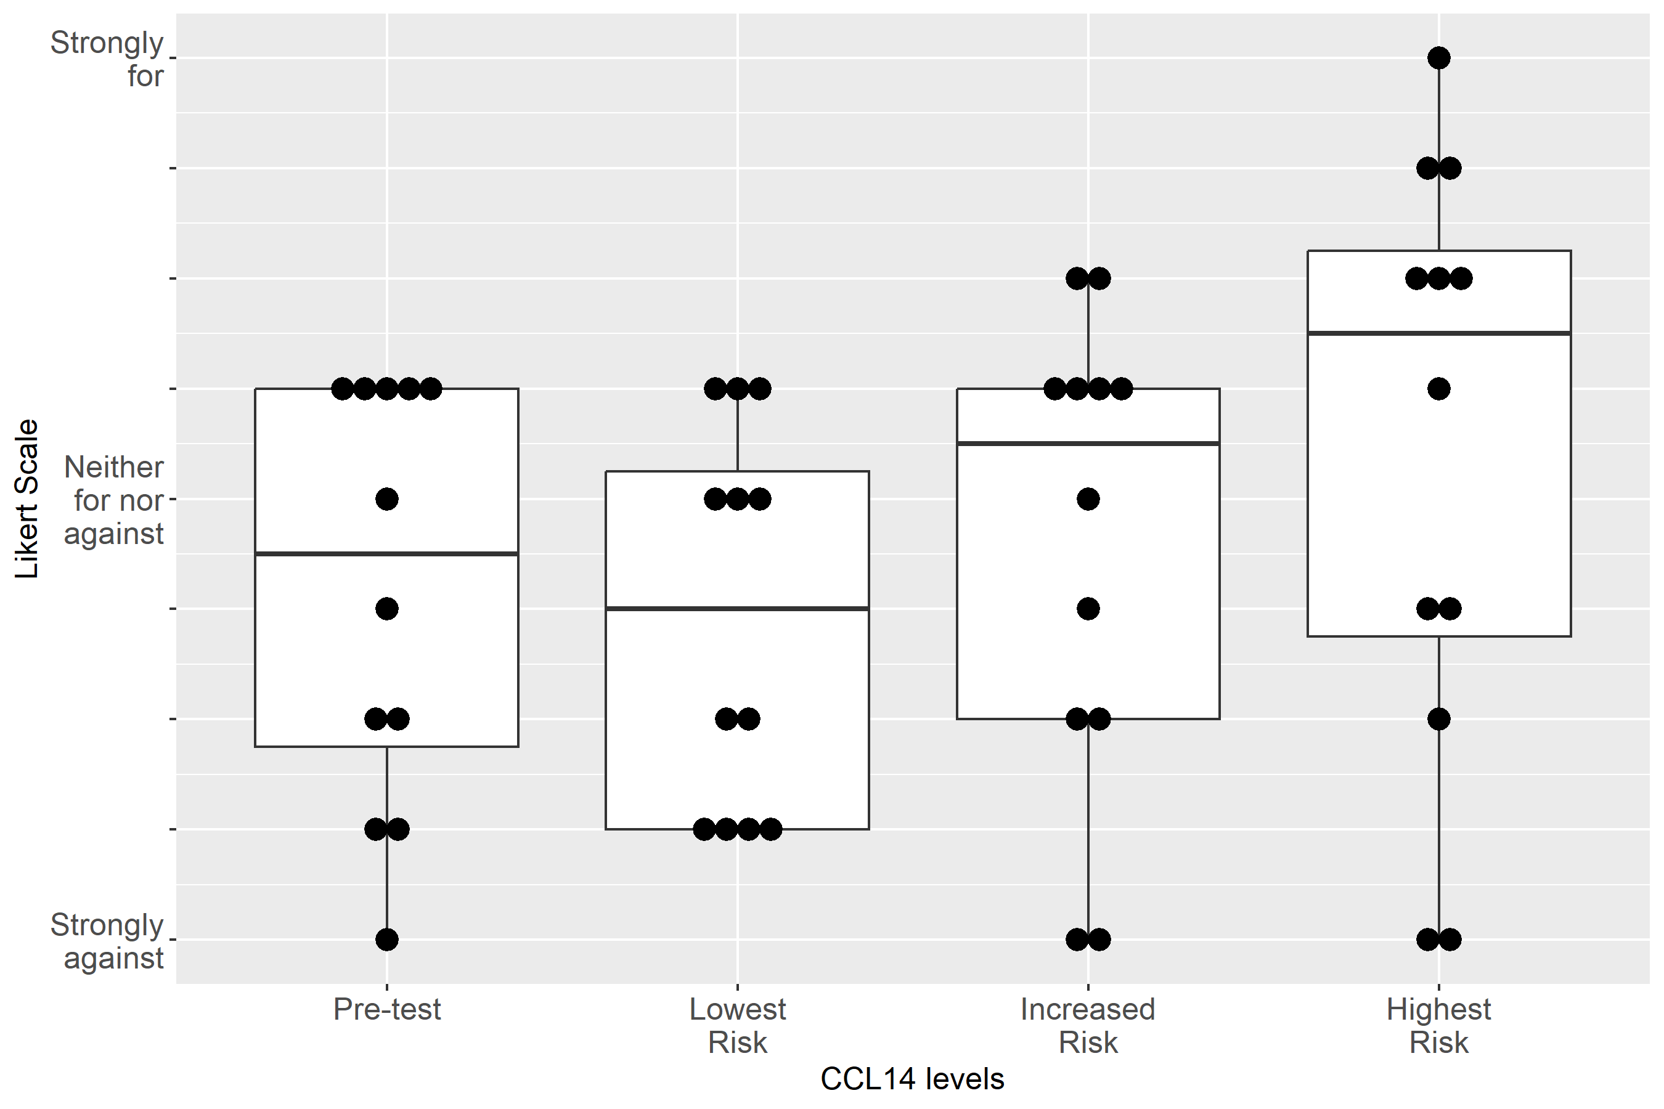

Supplemental Figure S2-44: Case 4, Clinical action: Order CT with contrast
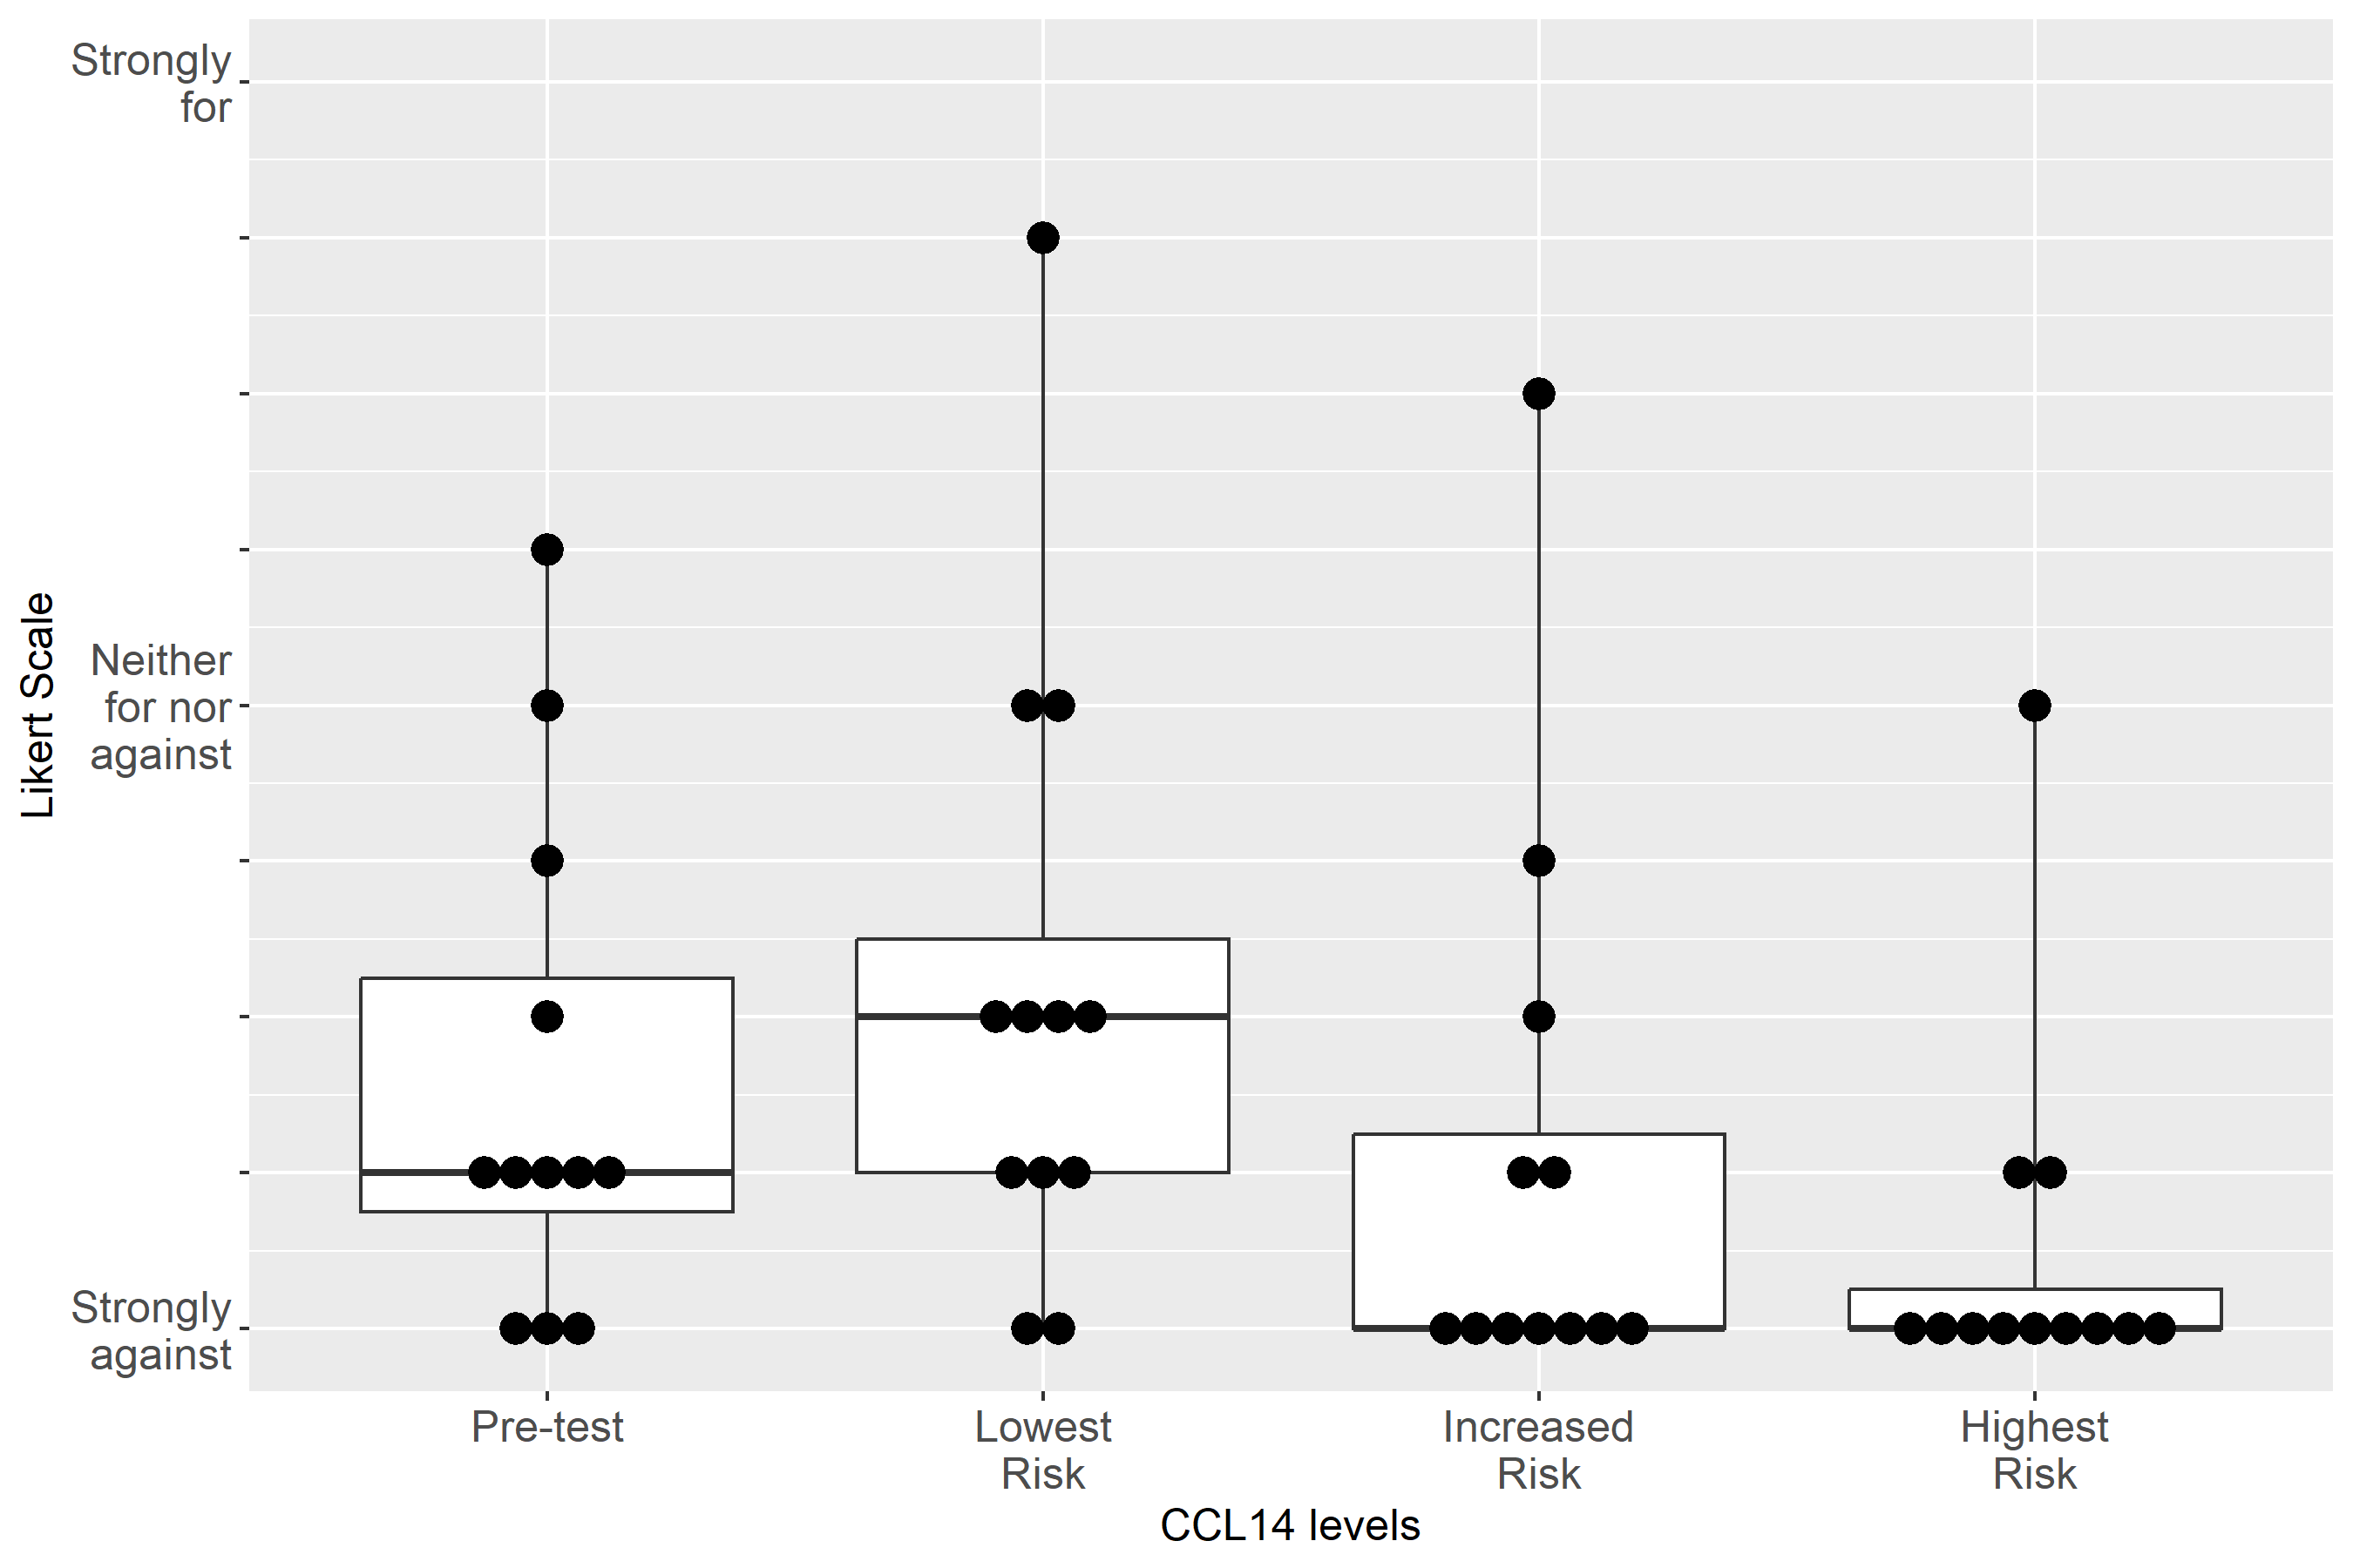

Supplemental Figure S2-45: Case 4, Clinical action: Discuss RRT with patient/family
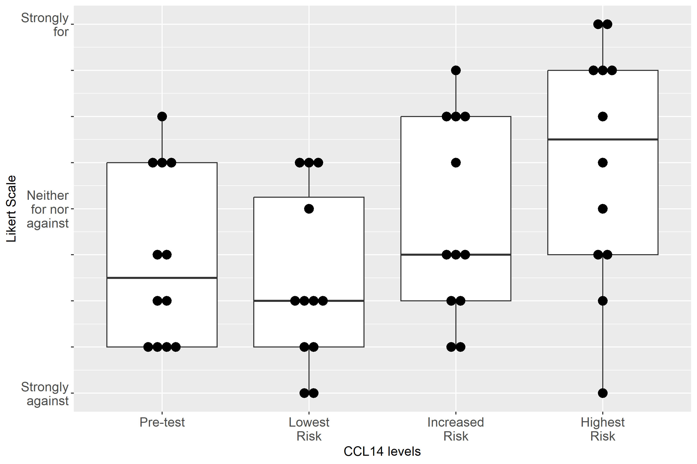

Supplemental Figure S2-46: Case 5, Clinical action: Resume Piperacillin/Tazobactam
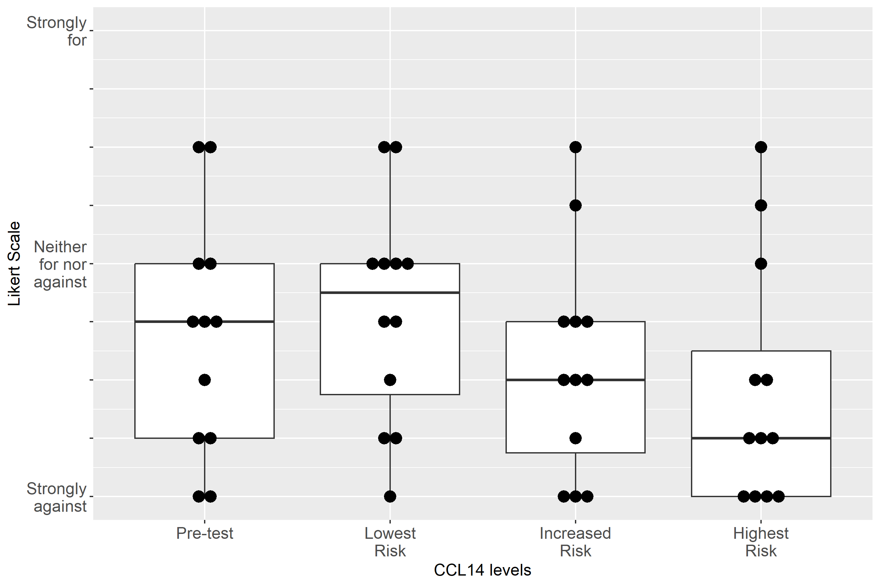

Supplemental Figure S2-47: Case 5, Clinical action: Resume Vancomycin
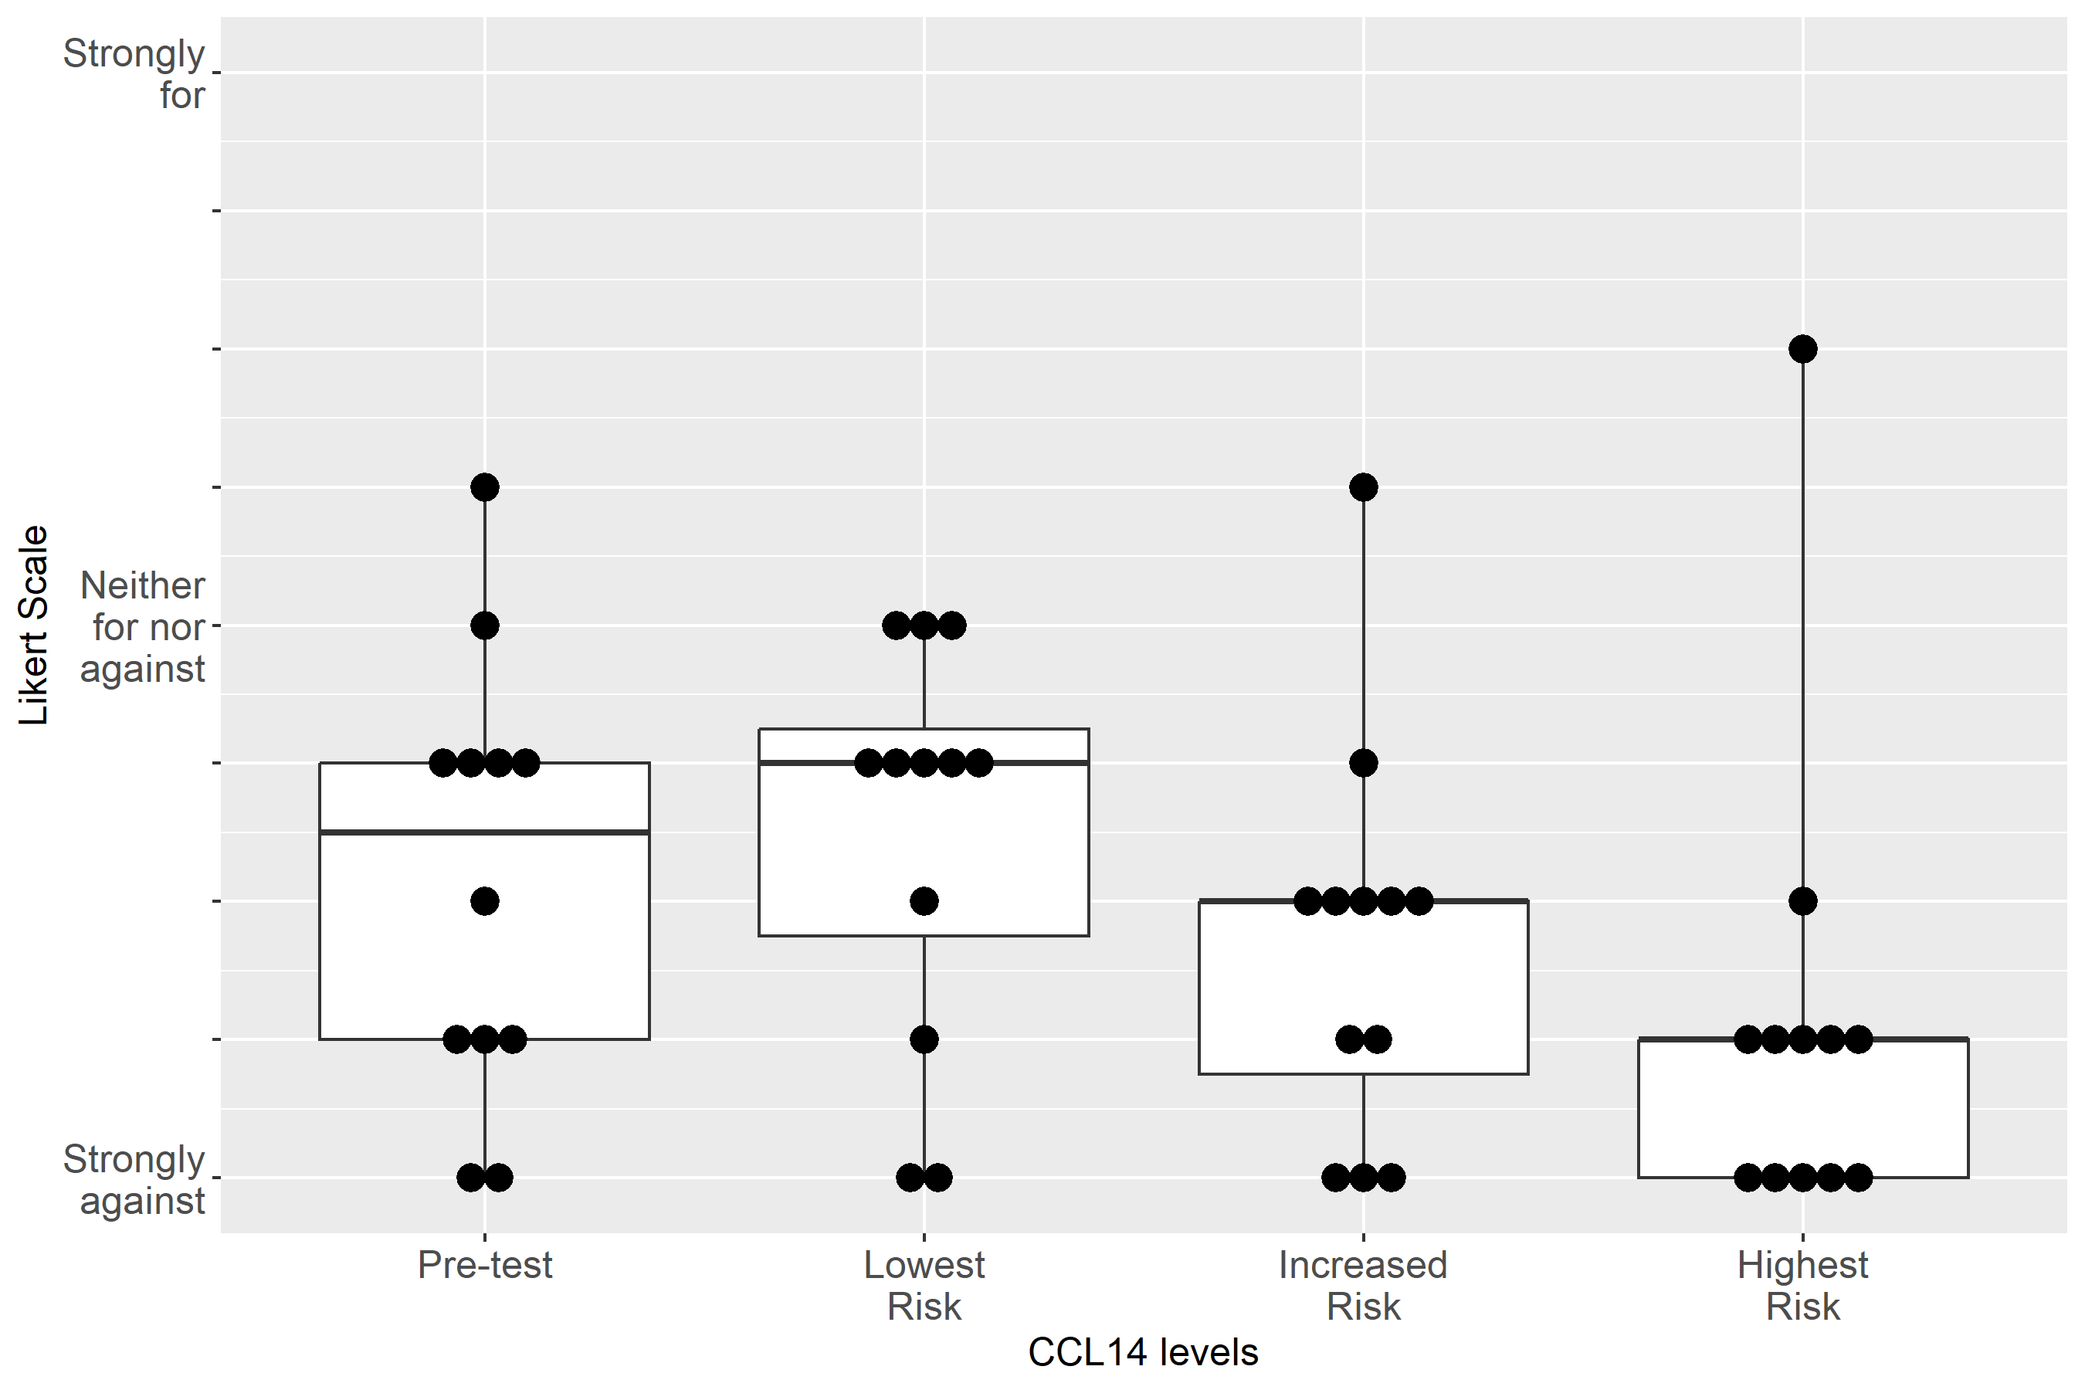

Supplemental Figure S2-48: Case 5, Clinical action: Adjust non-nephrotoxic, renally cleared medication
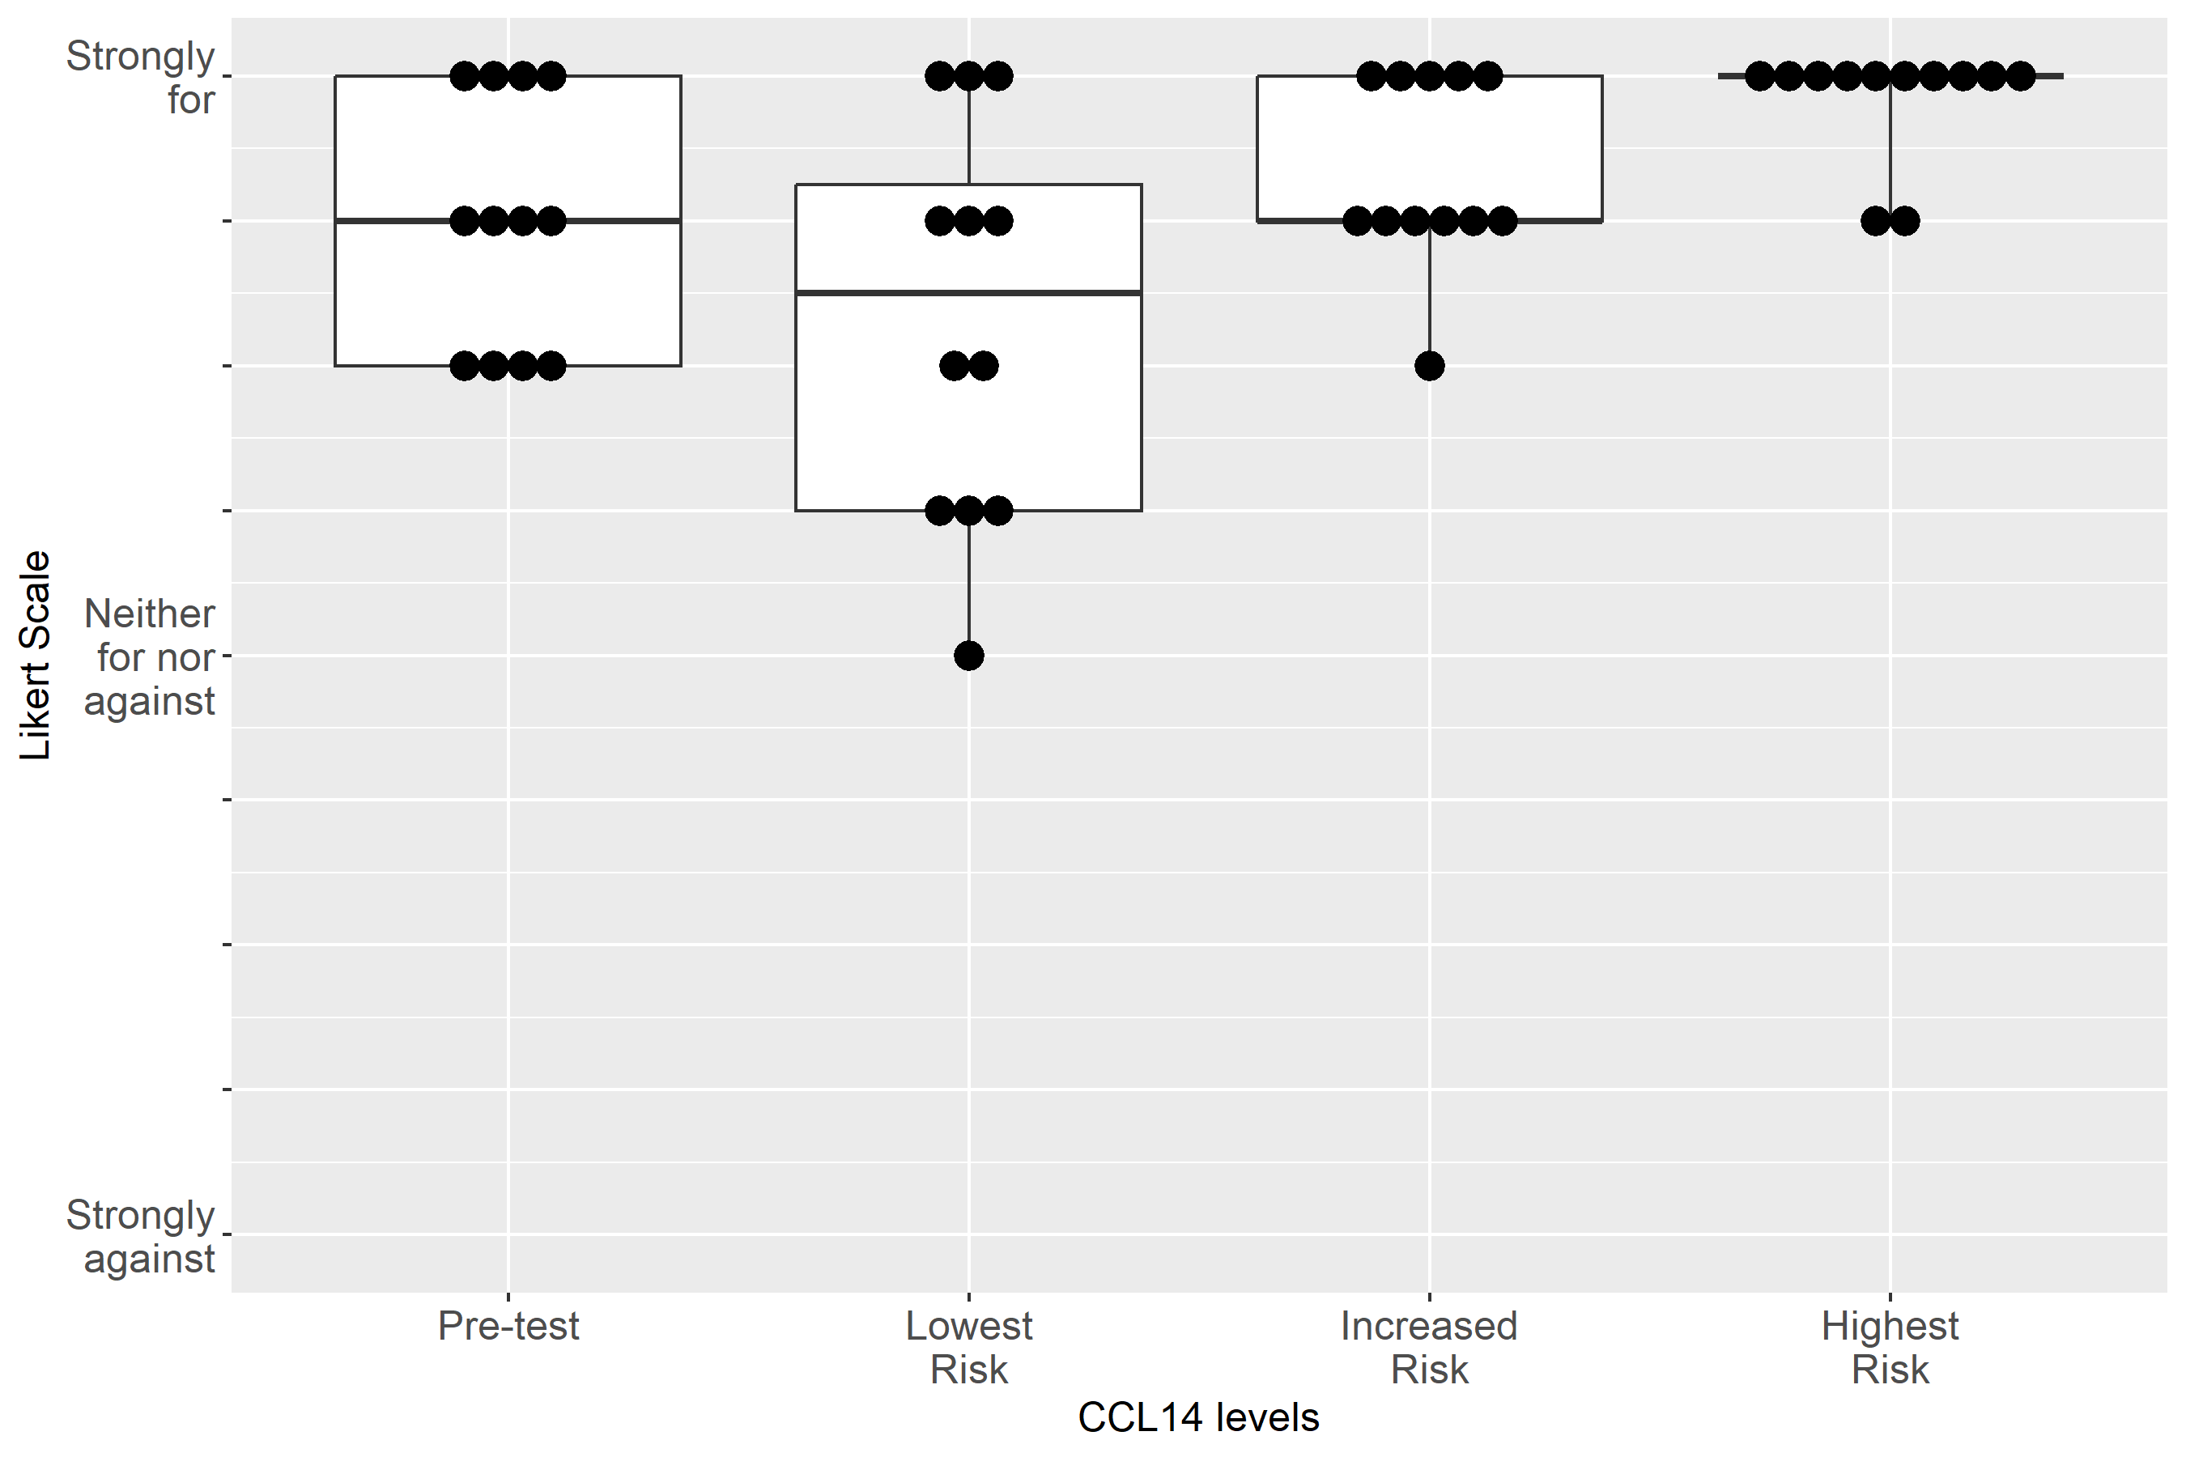

Supplemental Figure S2-49: Case 5, Clinical action: Use functional hemodynamic monitoring
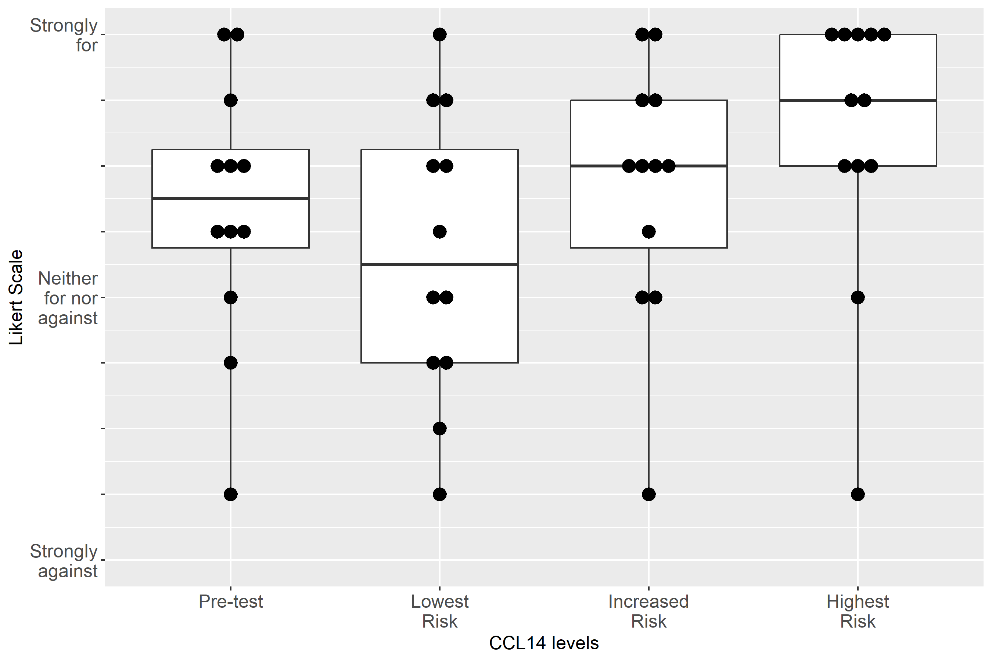

Supplemental Figure S2-50: Case 5, Clinical action: Perform renal ultrasound
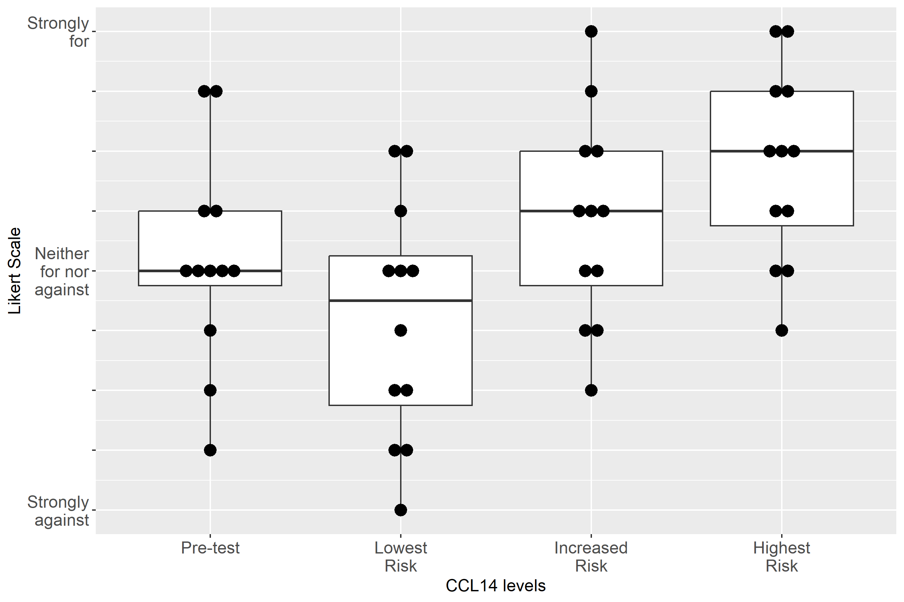

Supplemental Figure S2-51: Case 5, Clinical action: Keep foley catheter, 1-2 hourly Urine Output
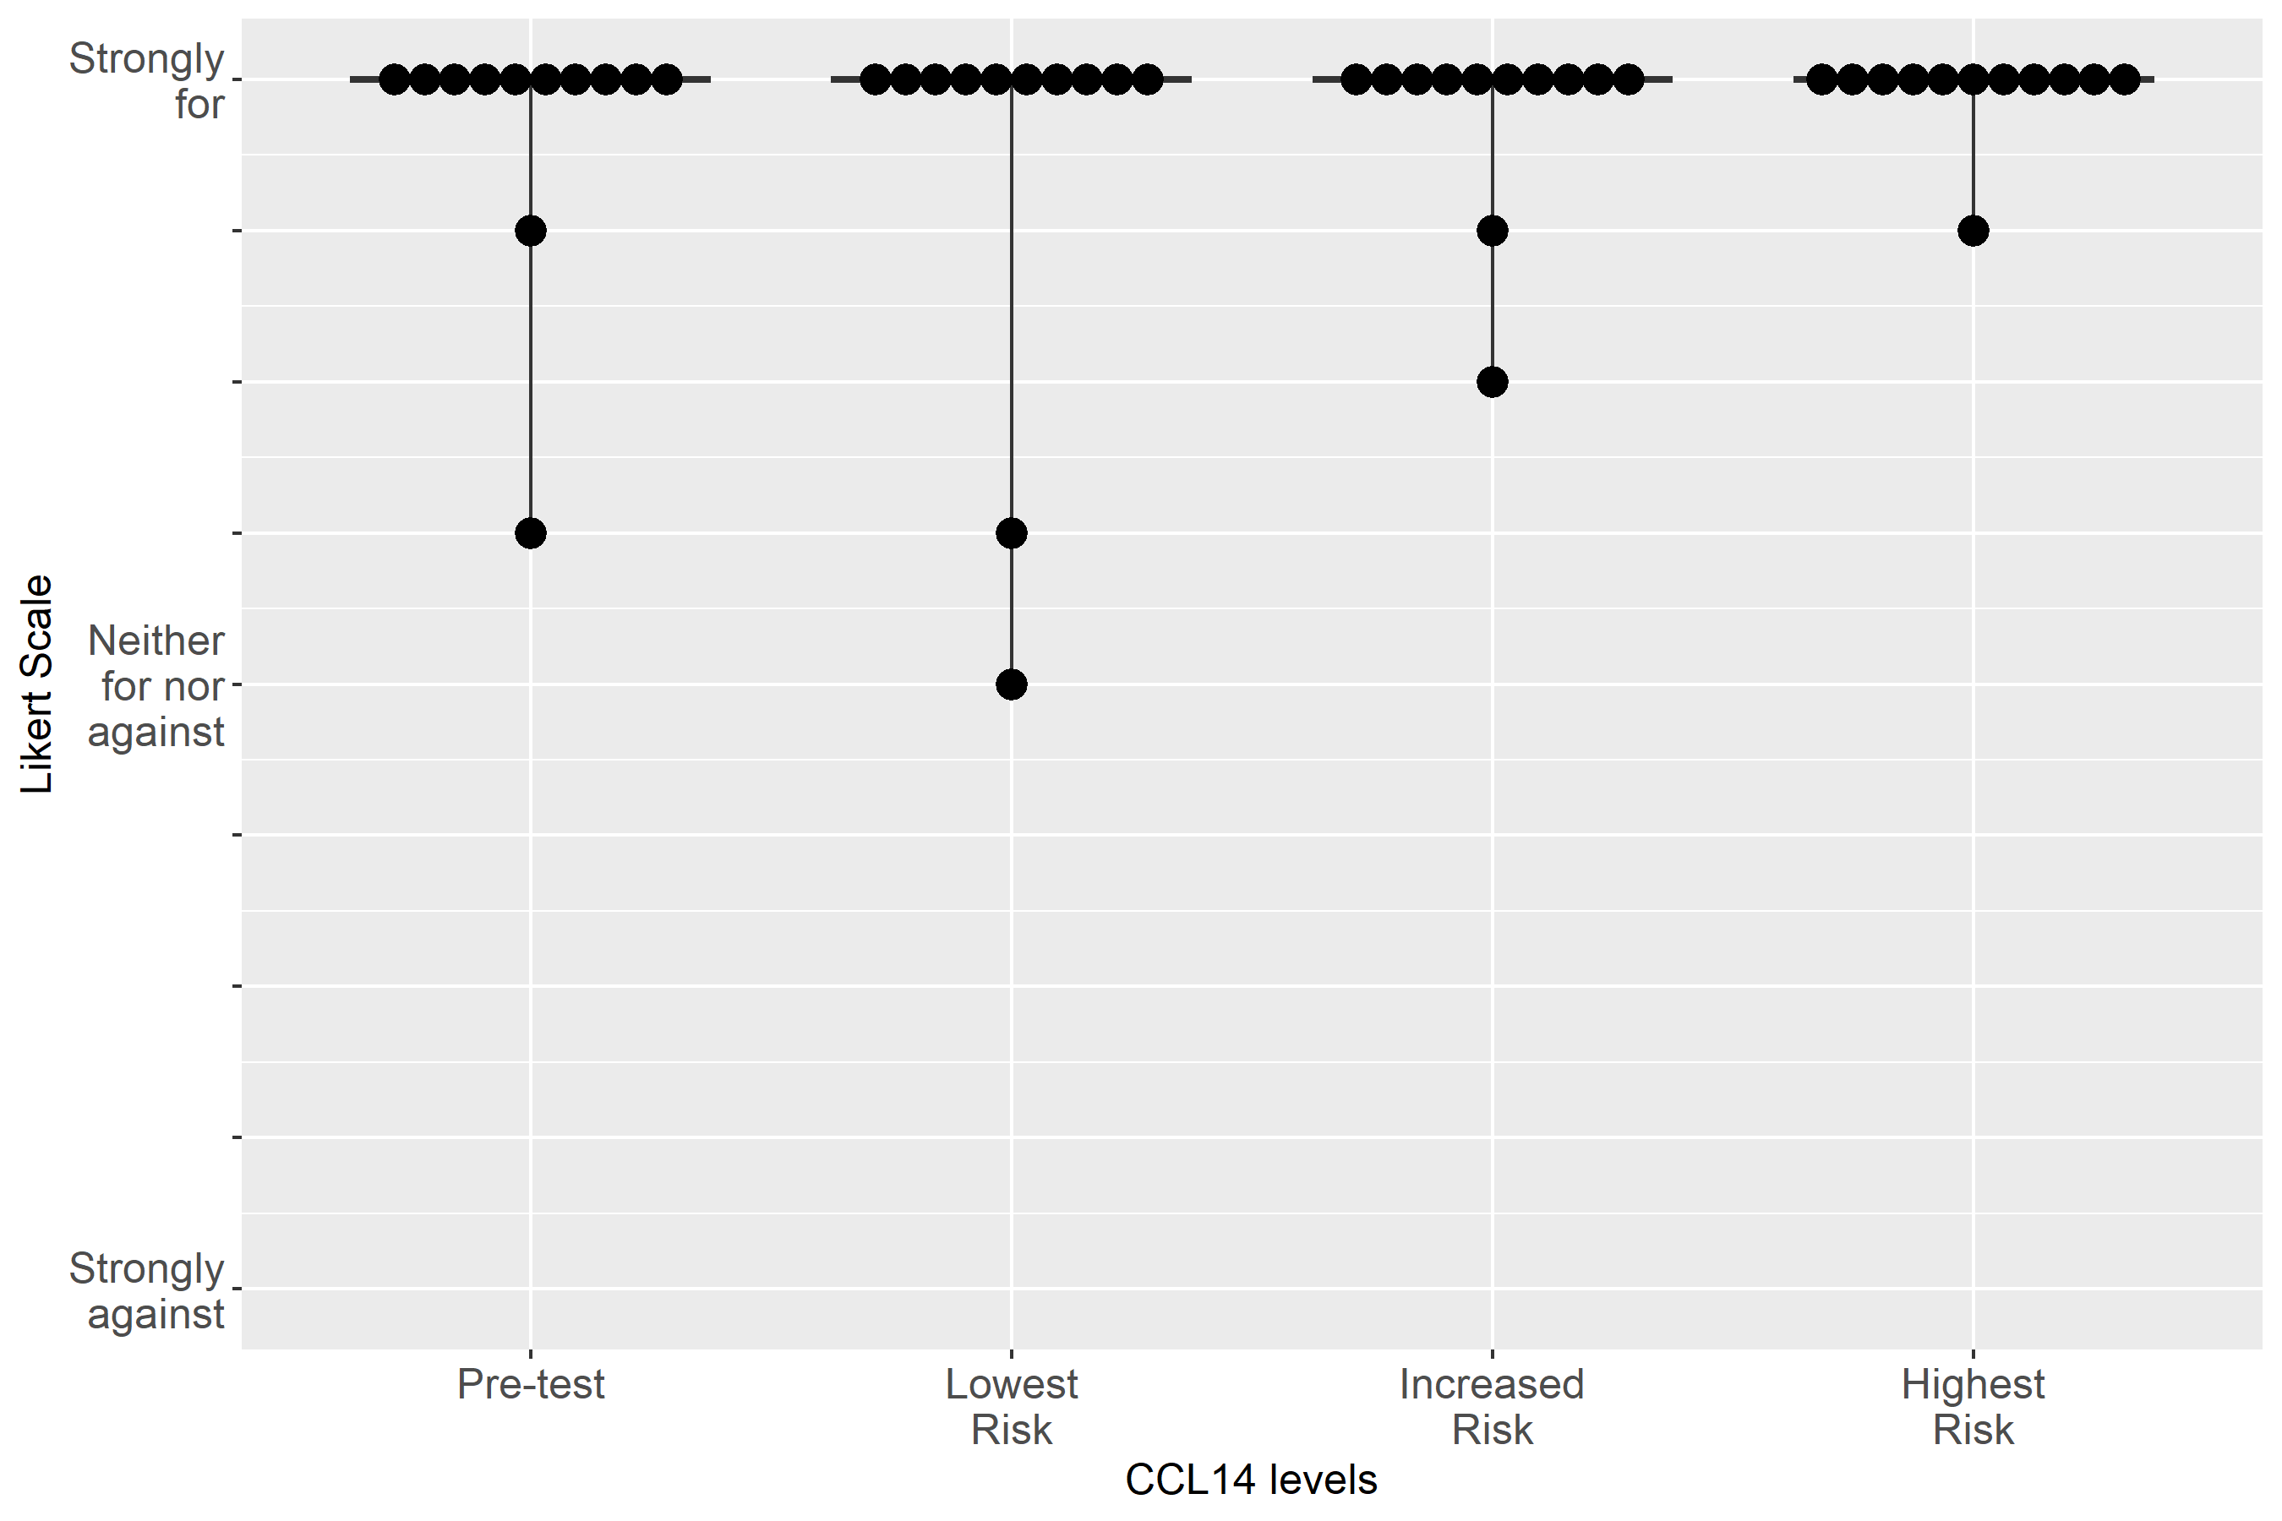

Supplemental Figure S2-52: Case 5, Clinical action: Measure serum creatinine at least daily

Supplemental Figure S2-53: Case 5, Clinical action: Consult nephrology
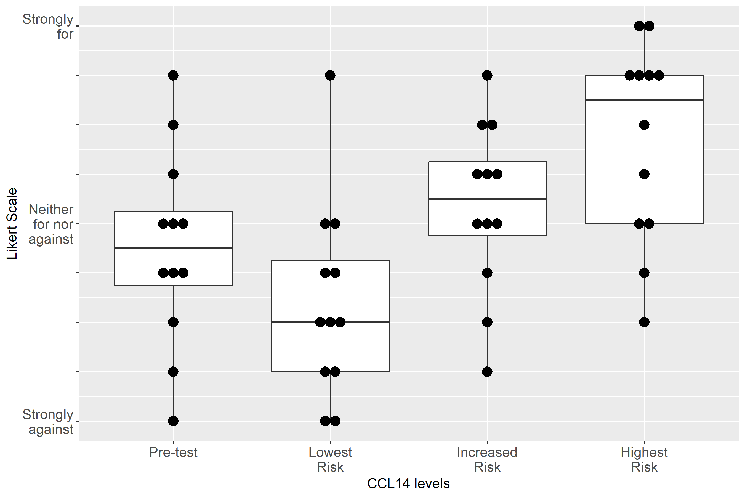

Supplemental Figure S2-54: Case 5, Clinical action: Order CT/angiography
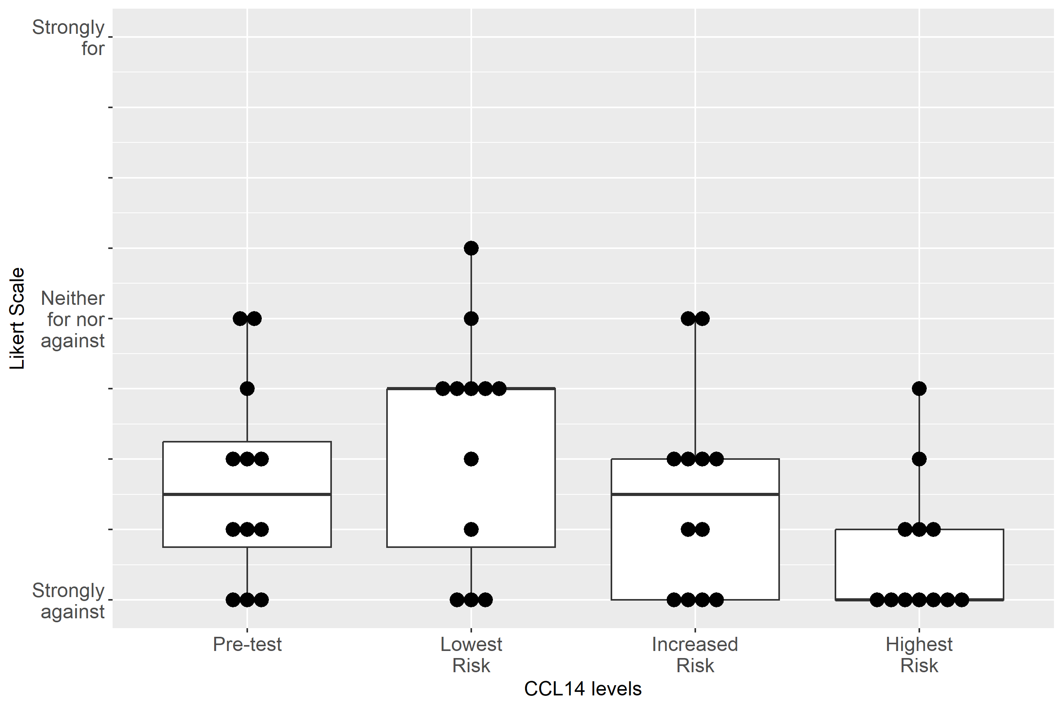

Supplemental Figure S2-55: Case 5, Clinical action: Give fluid
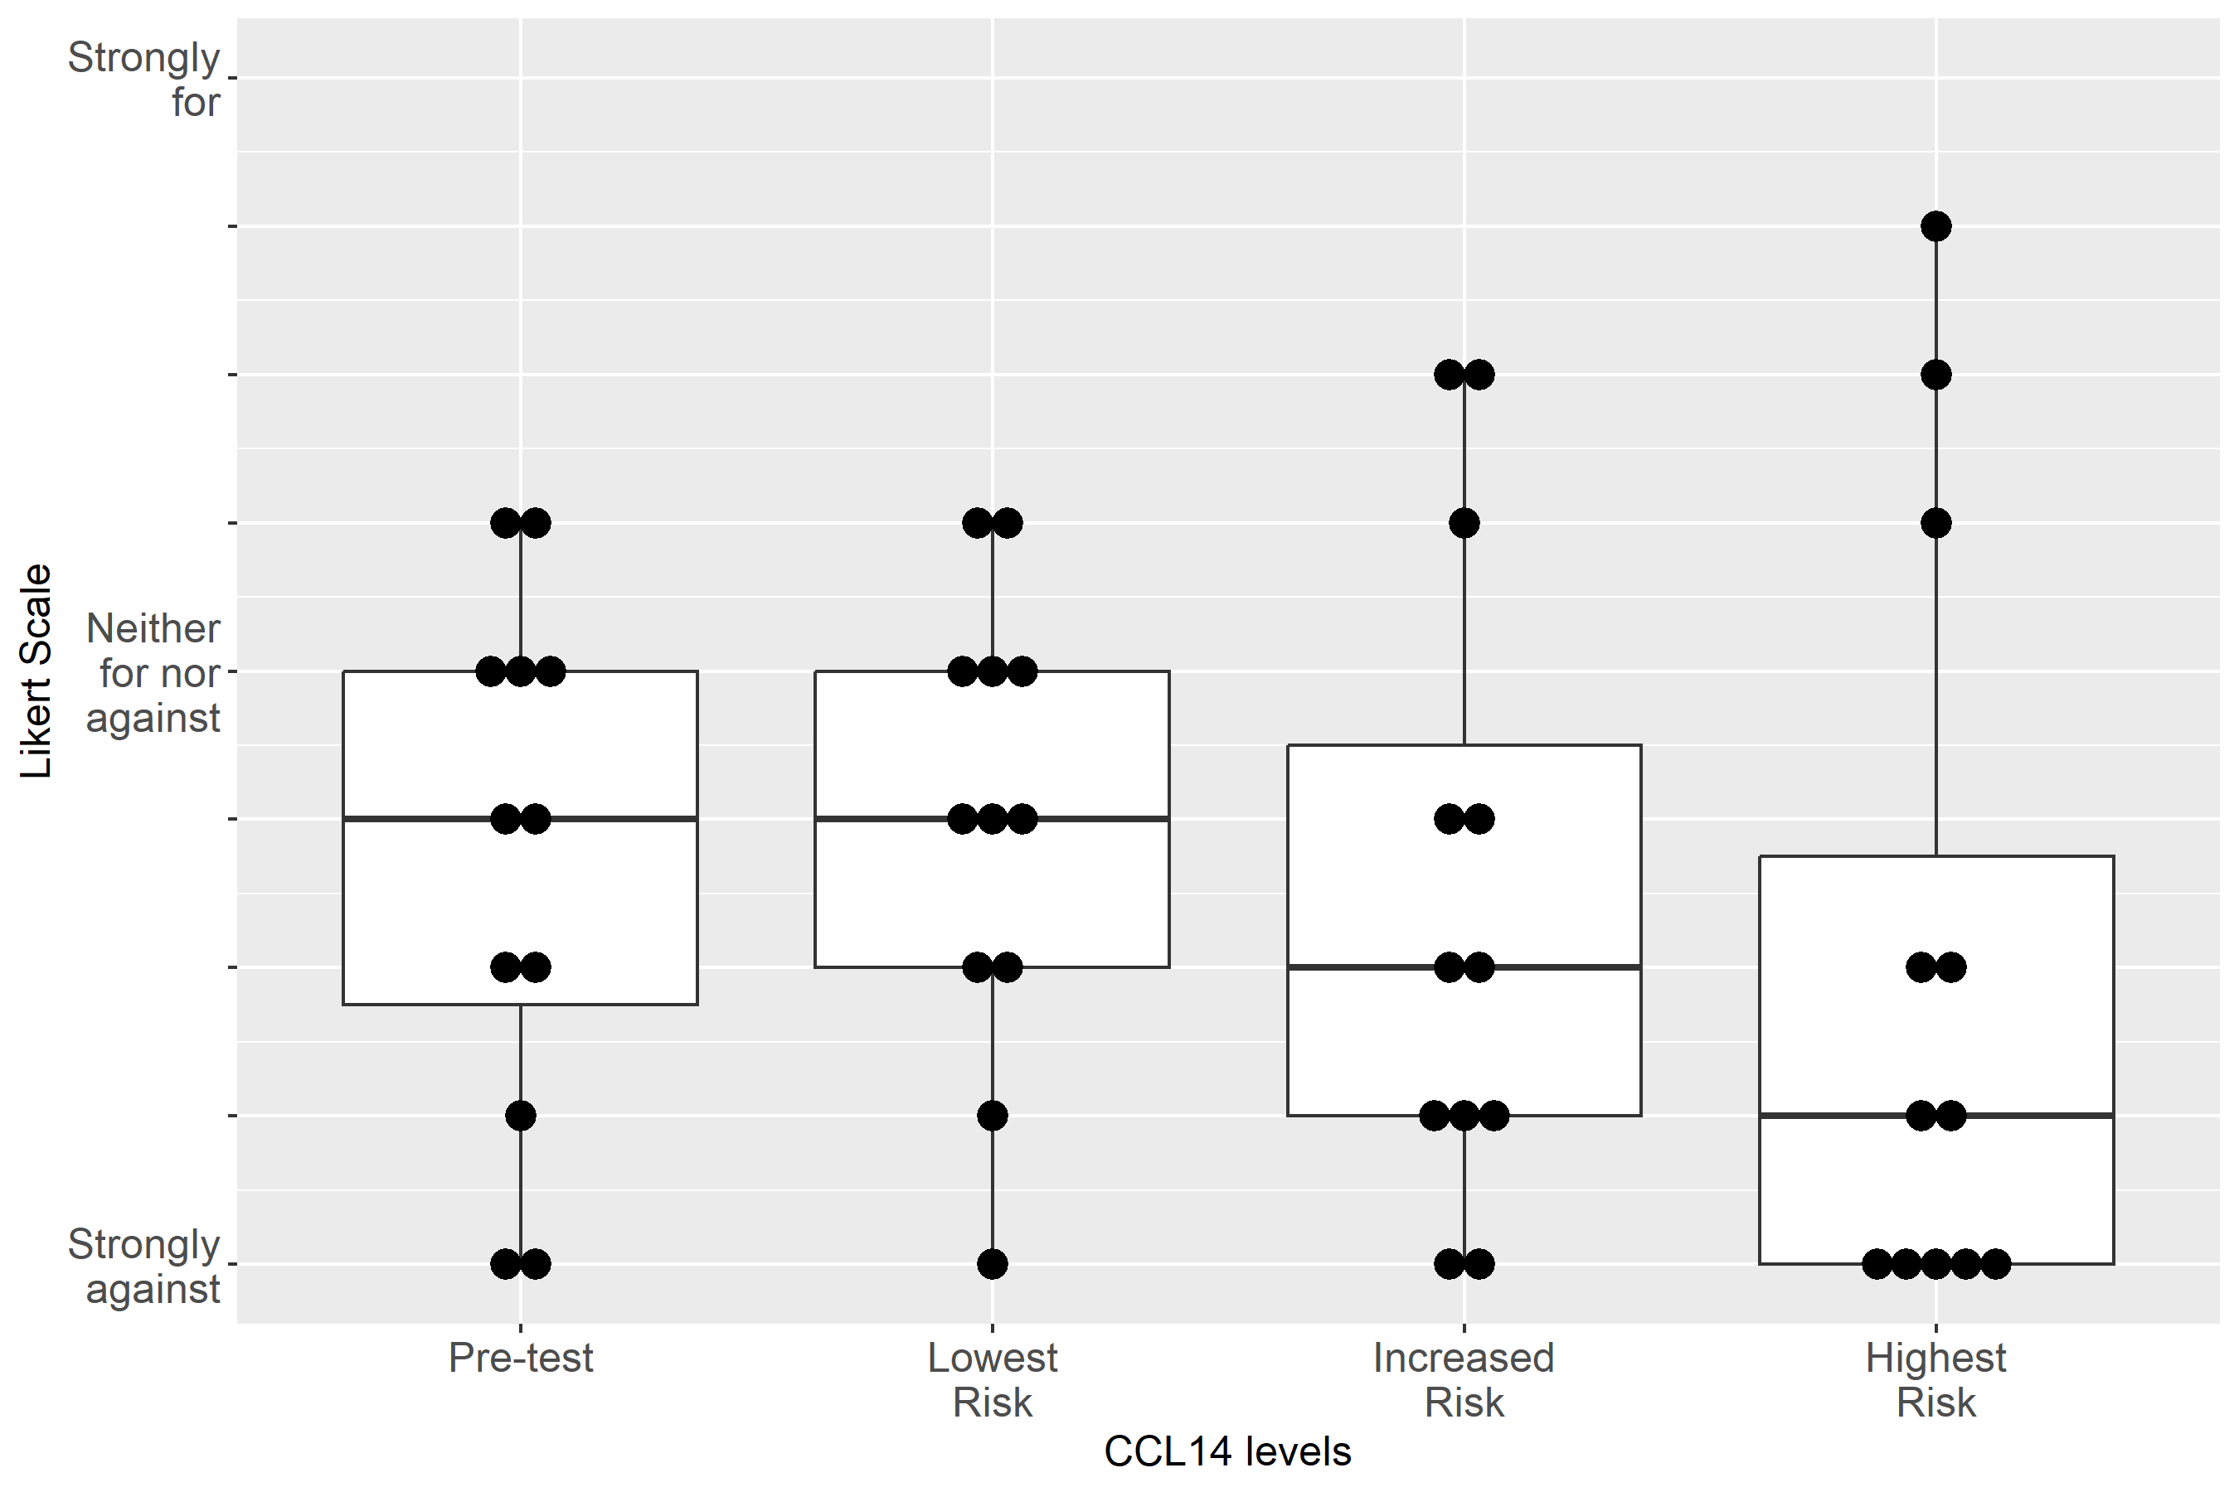

Supplemental Figure S2-56: Case 5, Clinical action: Administer Lasix
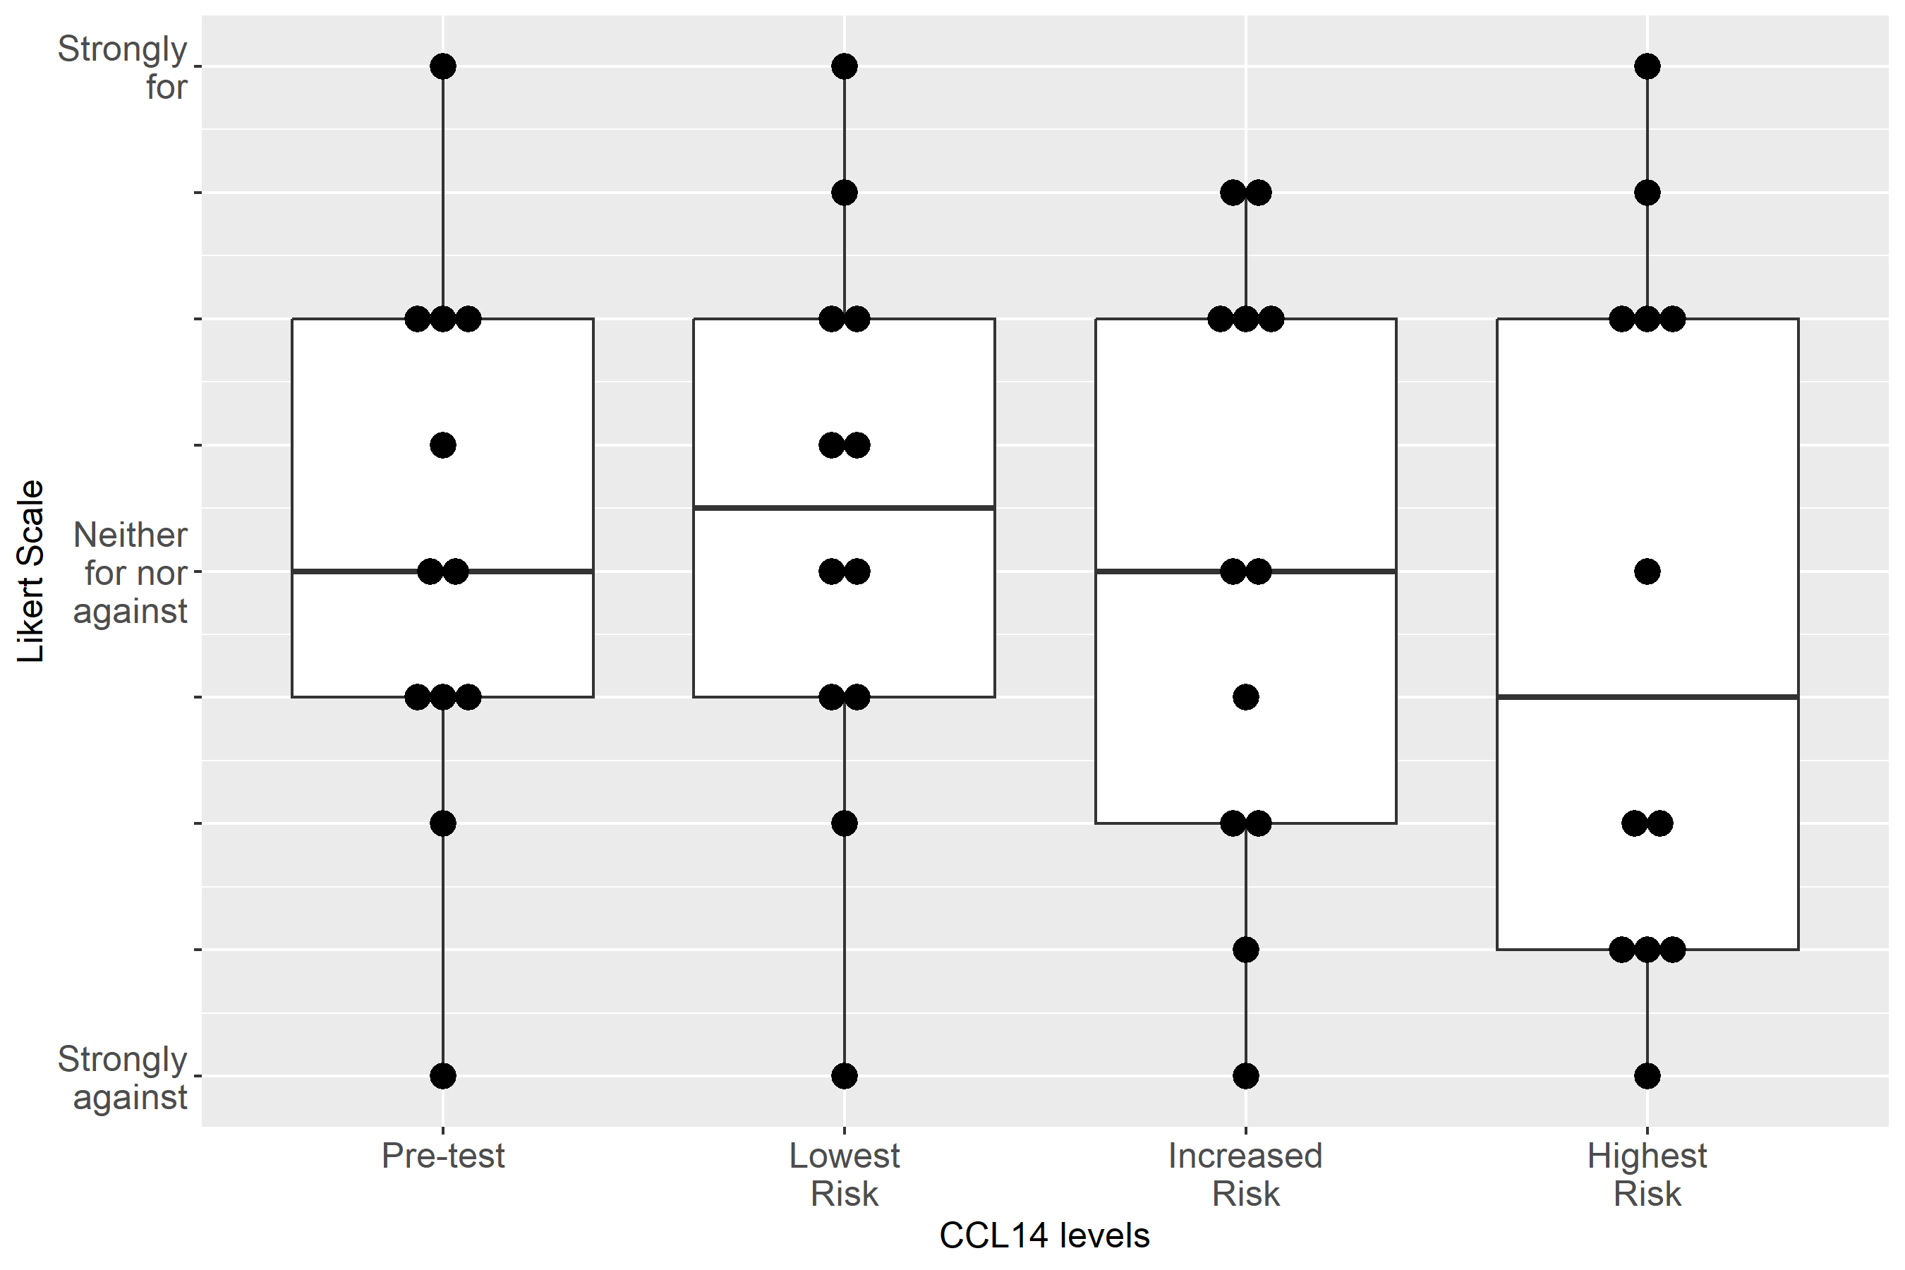

Supplemental Figure S2-57: Case 5, Clinical action: Discuss RRT with patient/family
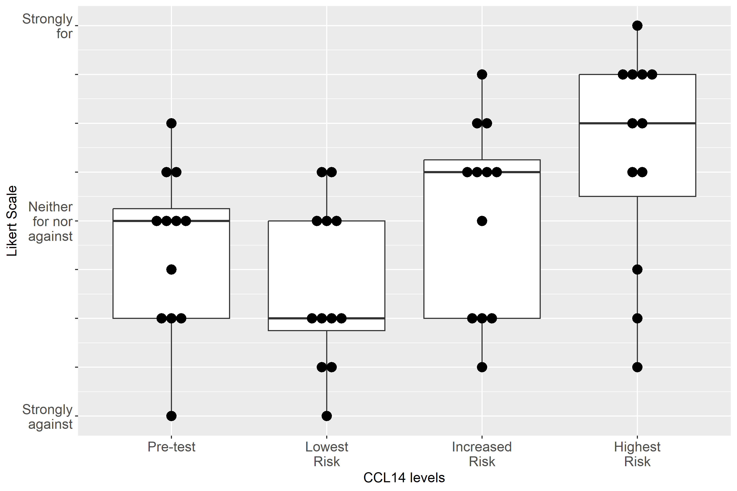

Supplemental Figure S2-58: Case 6, Clinical action: Resume Captopril once the patient is off vasopressors
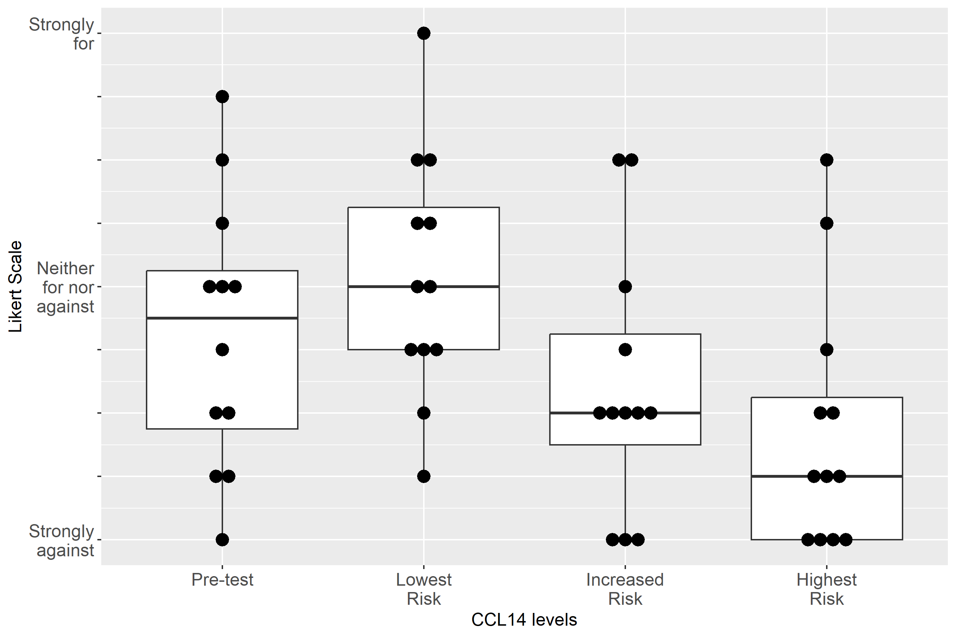

Supplemental Figure S2-59: Case 6, Clinical action: Continue Lasix
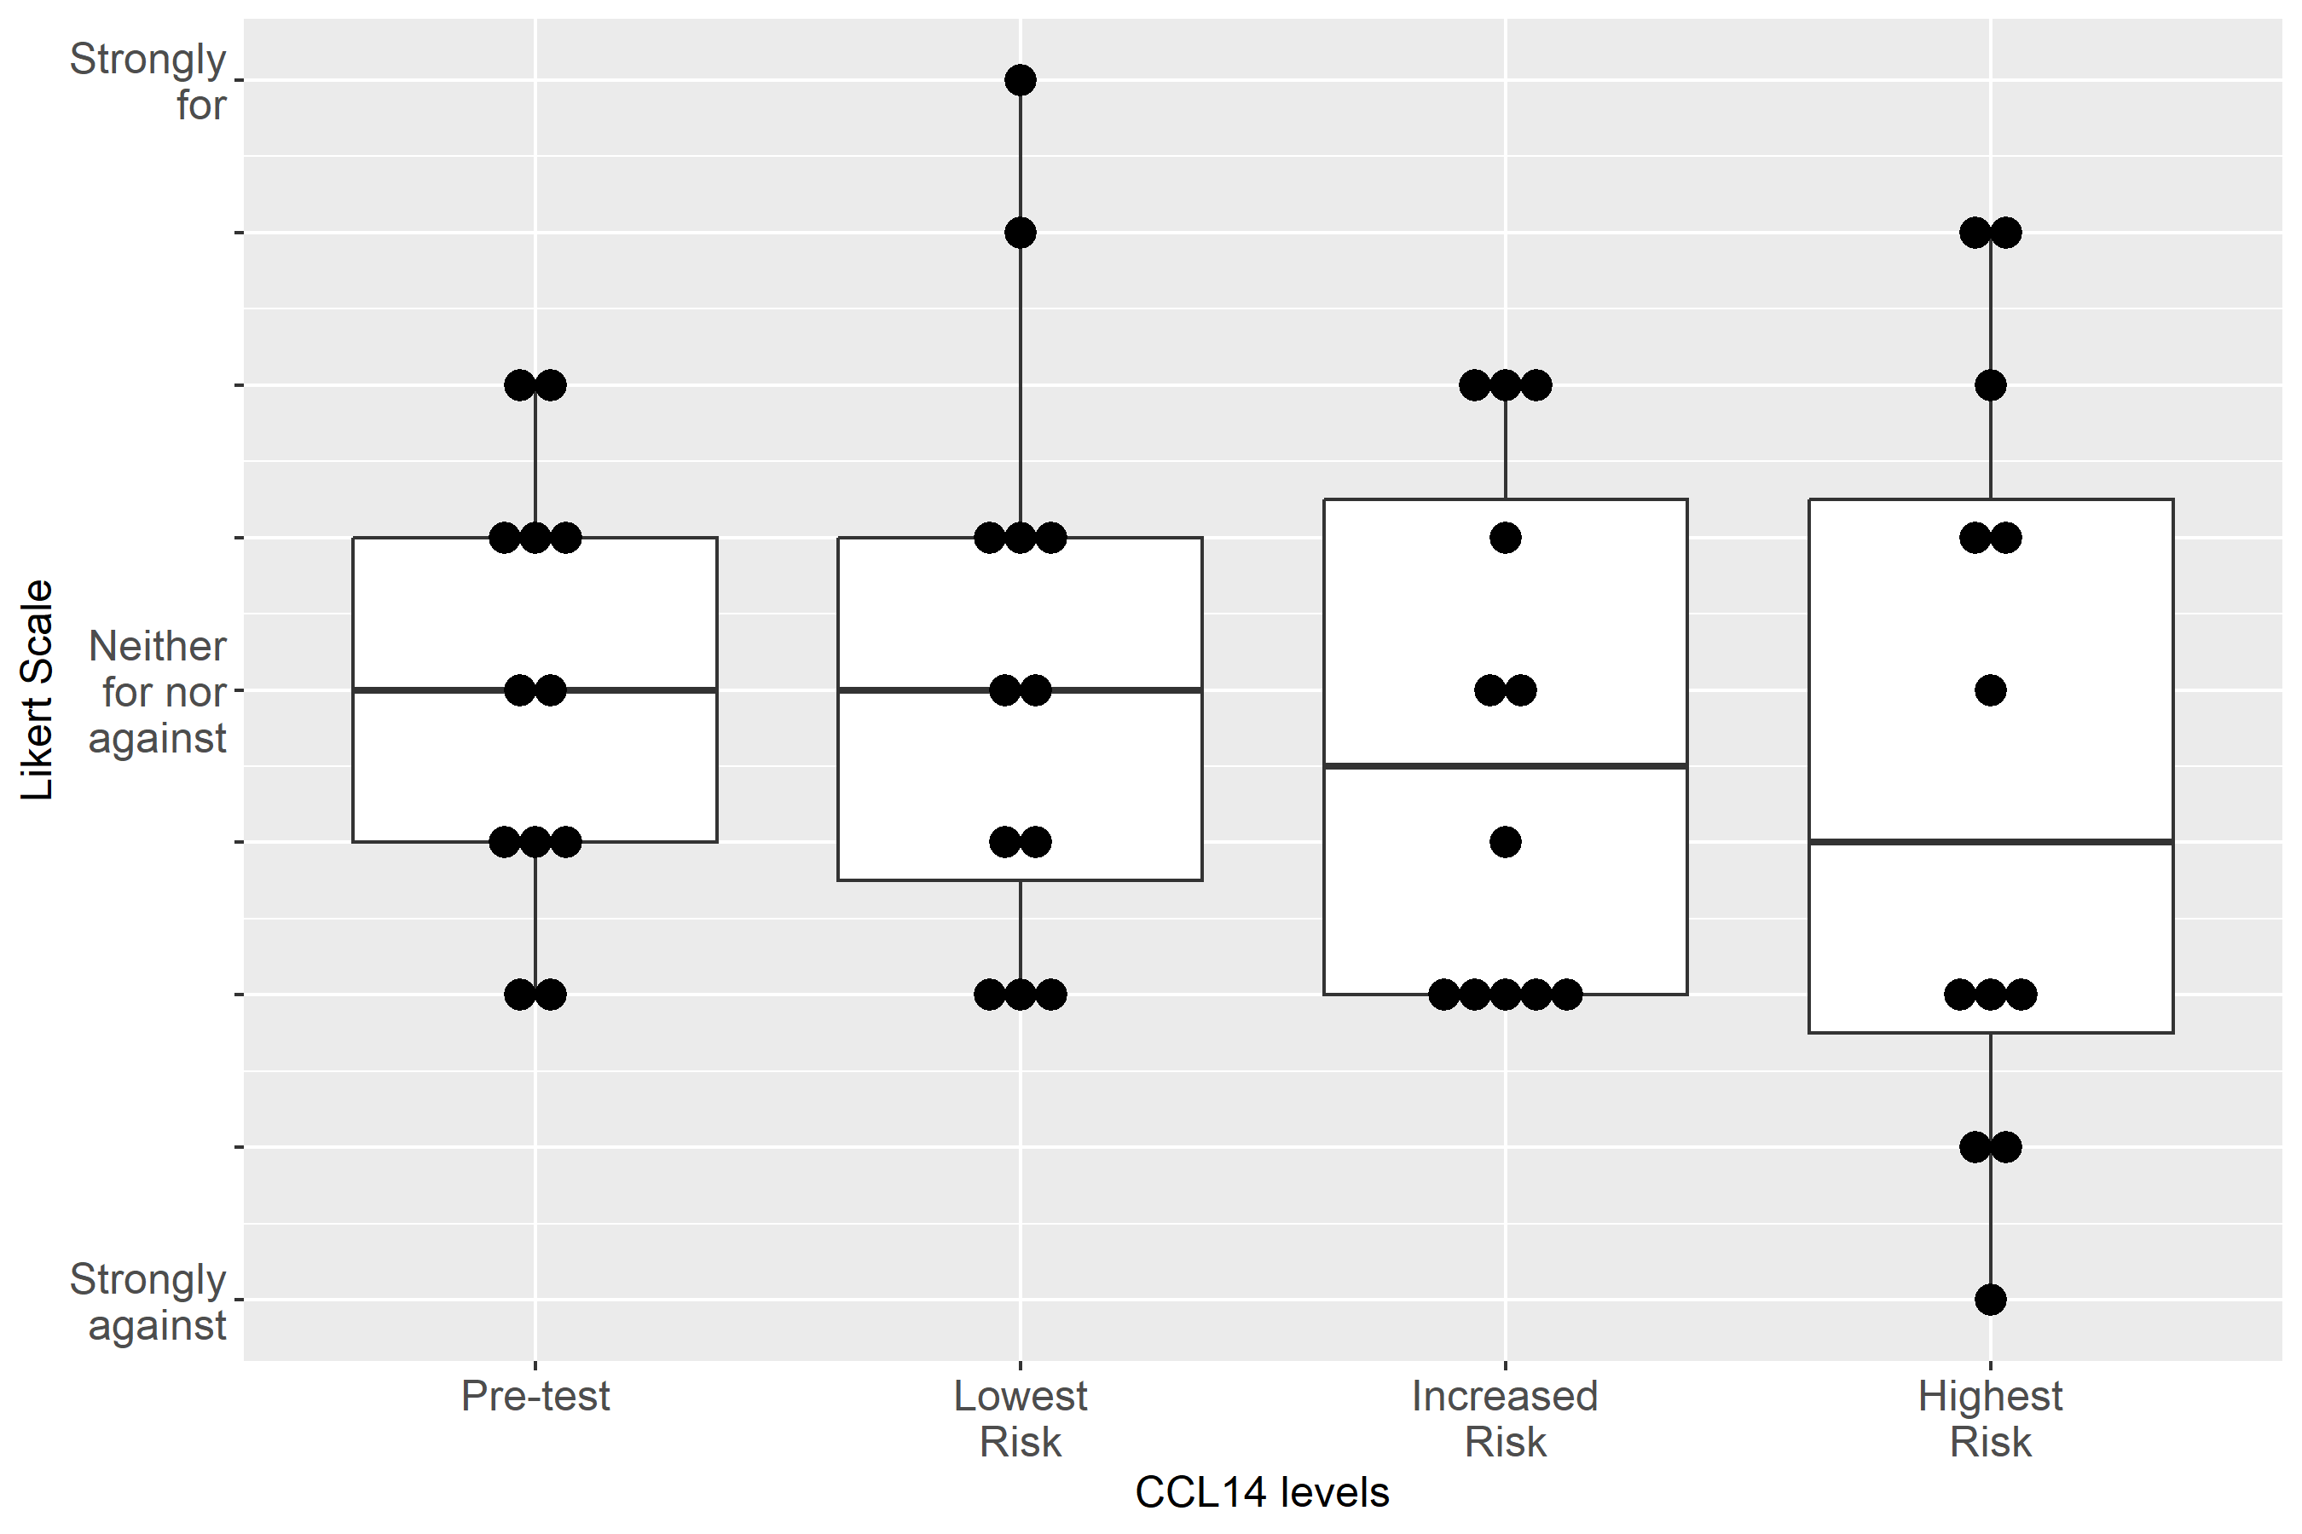

Supplemental Figure S2-60: Case 6, Clinical action: Adjust non-nephrotoxic, renally cleared medication
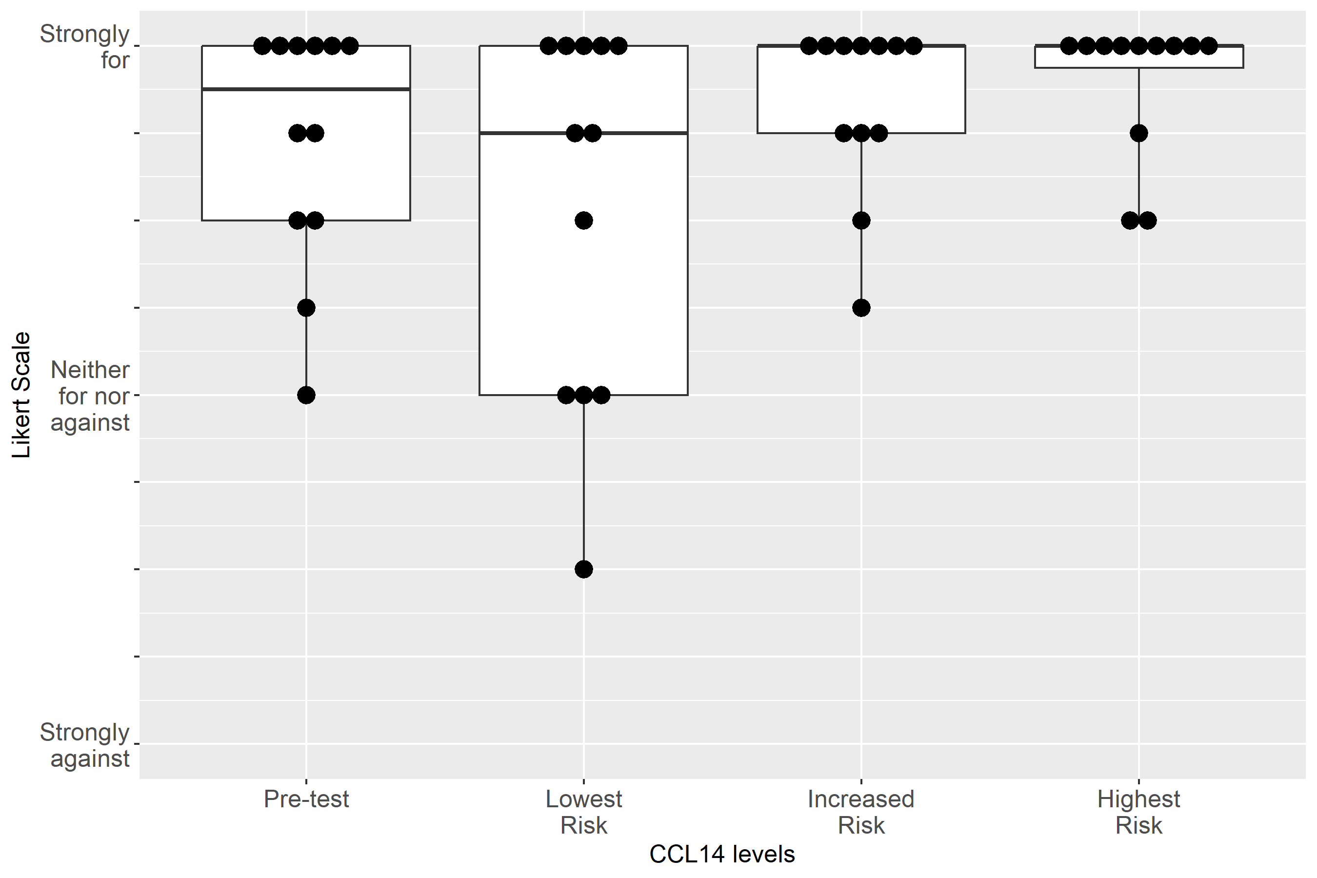

Supplemental Figure S2-61: Case 6, Clinical action: Use functional hemodynamic monitoring
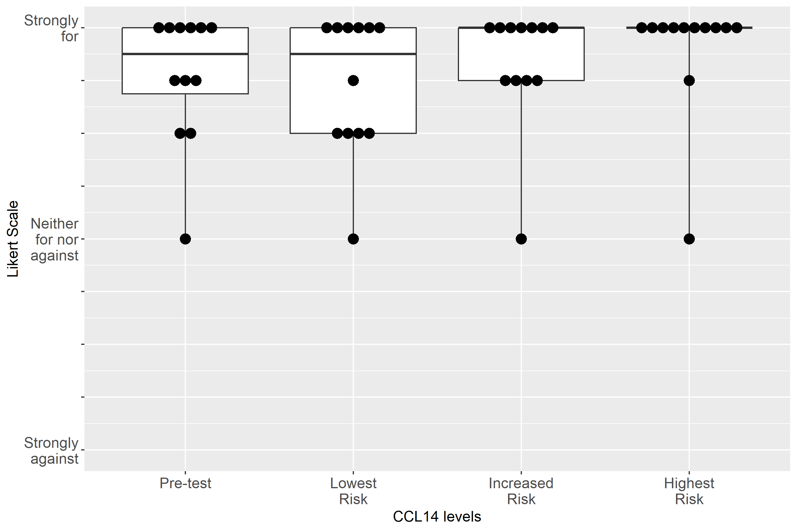

Supplemental Figure S2-62: Case 6, Clinical action: Perform renal ultrasound
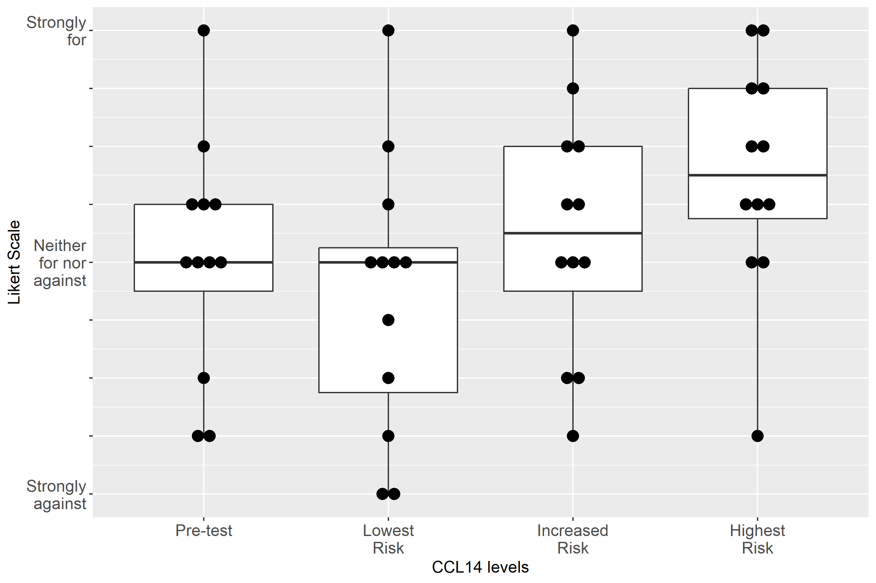

Supplemental Figure S2-63: Case 6, Clinical action: Keep foley catheter, 1-2 hourly Urine Output
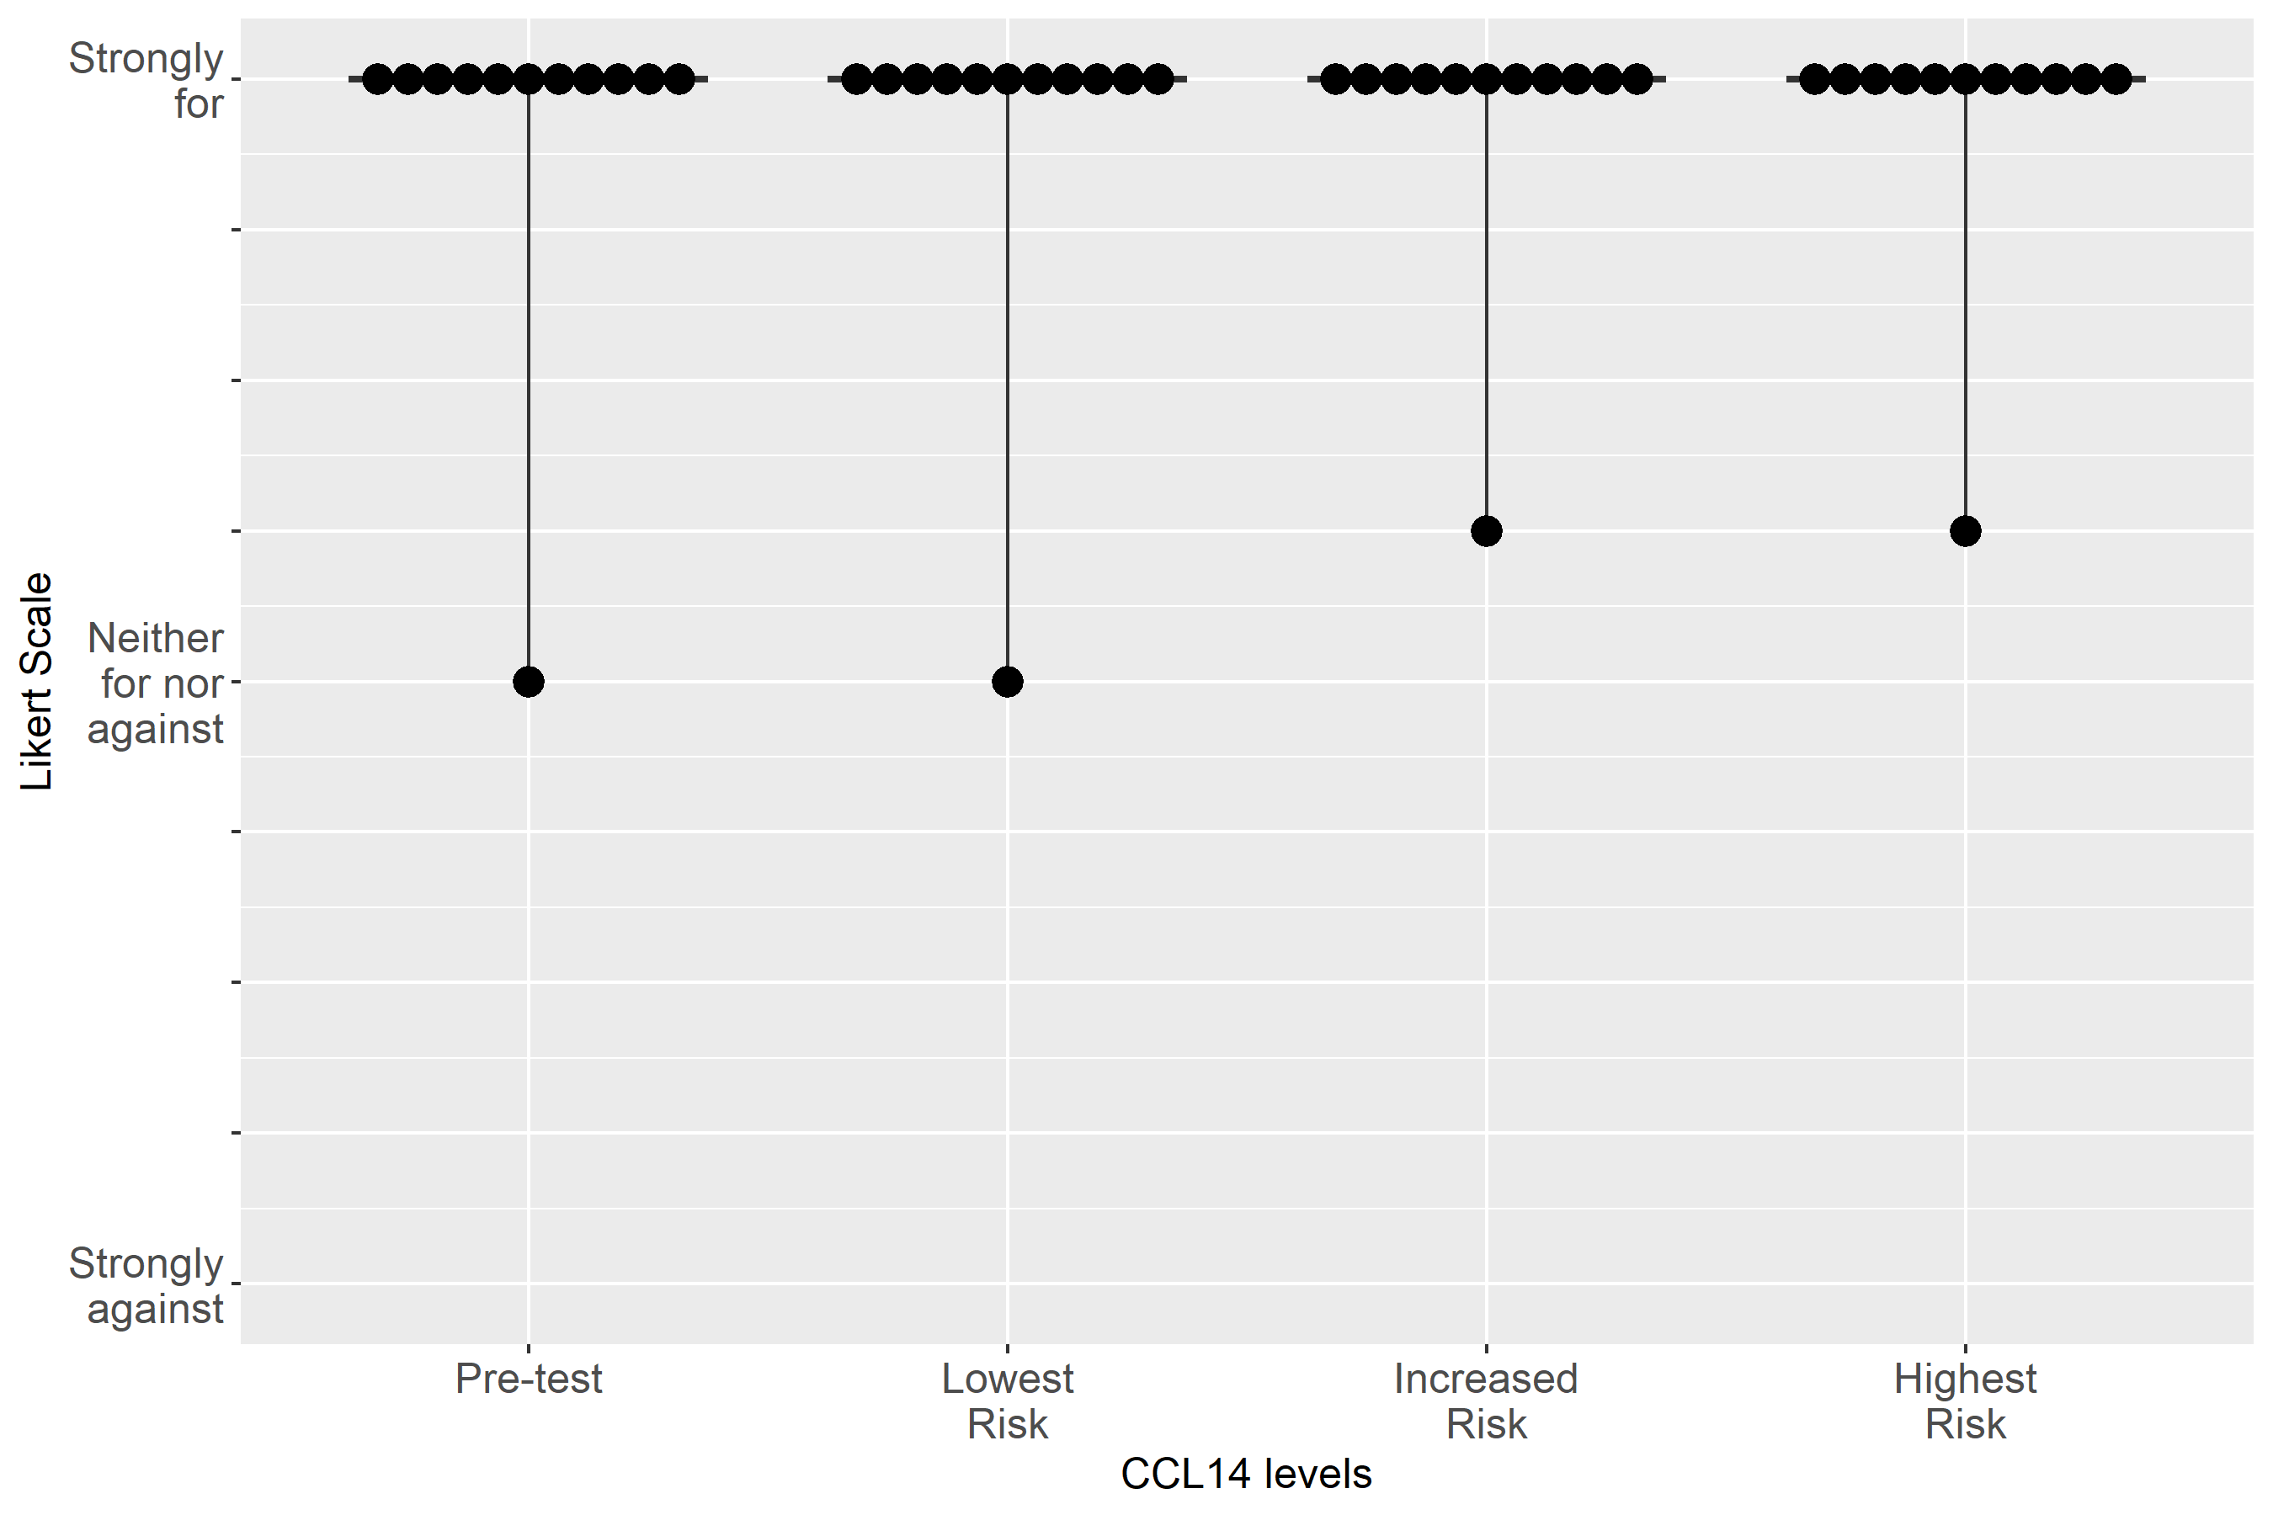

Supplemental Figure S2-64: Case 6, Clinical action: Measure serum creatinine at least daily

Supplemental Figure S2-65: Case 6, Clinical action: Consult nephrology
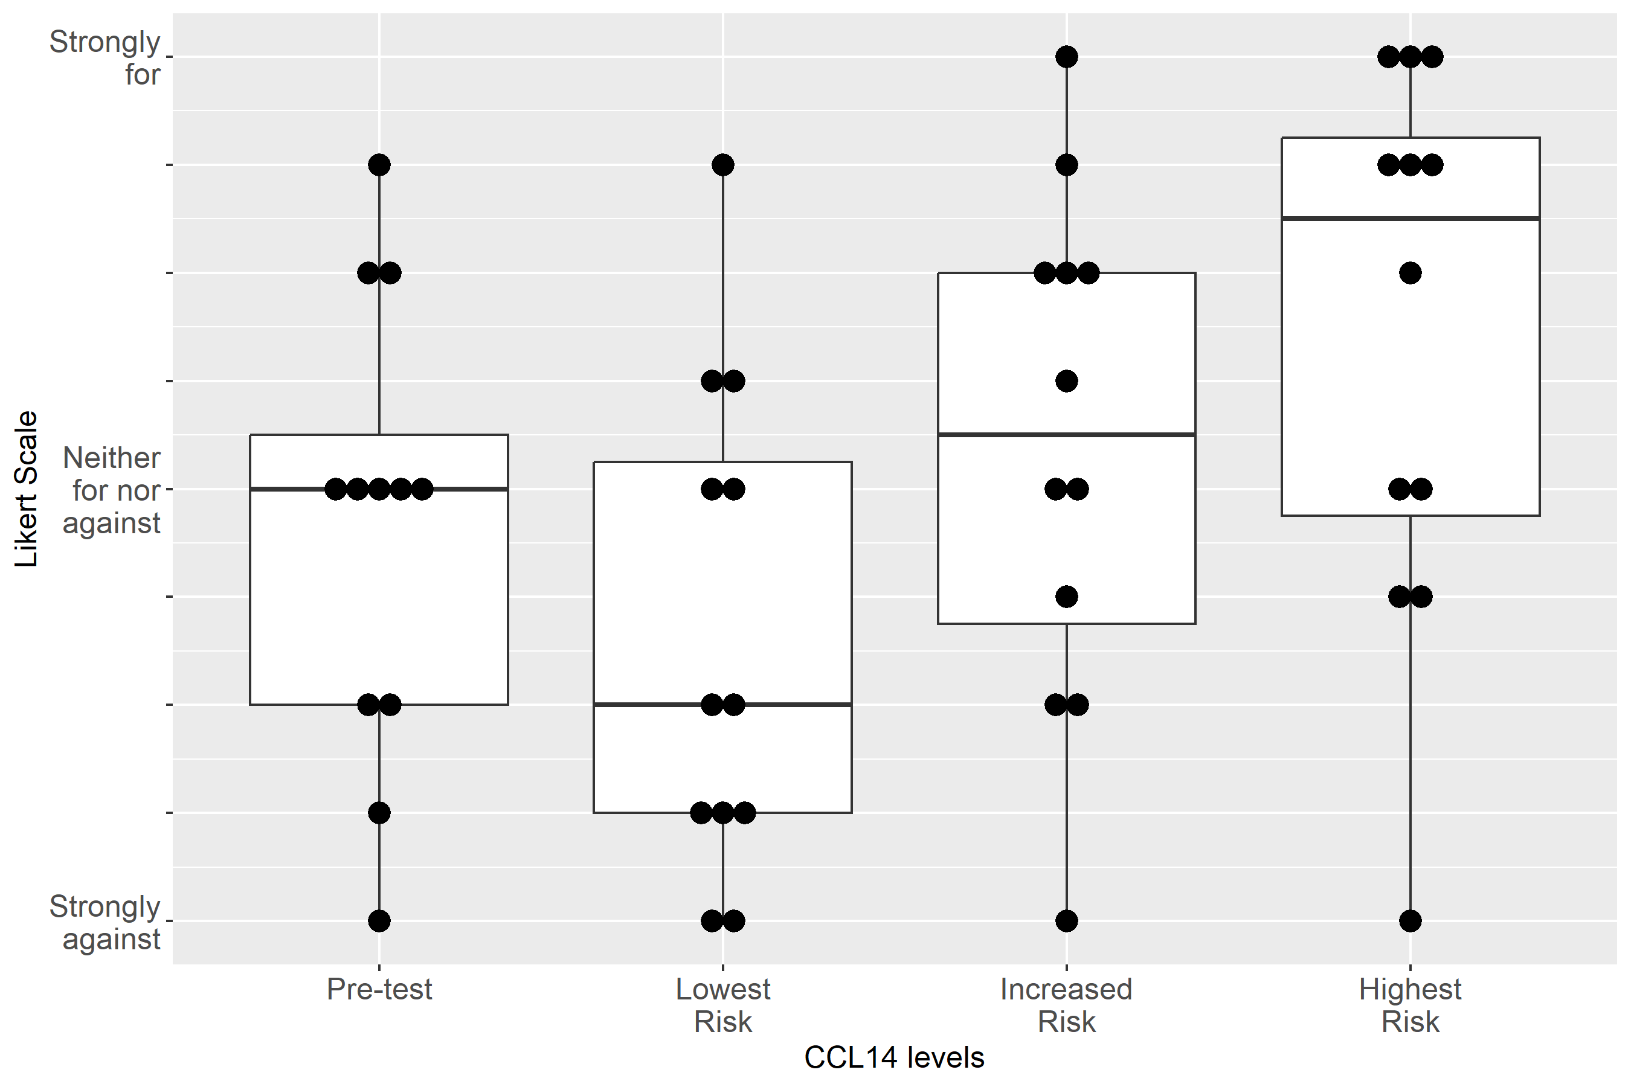

Supplemental Figure S2-66: Case 6, Clinical action: Give fluid
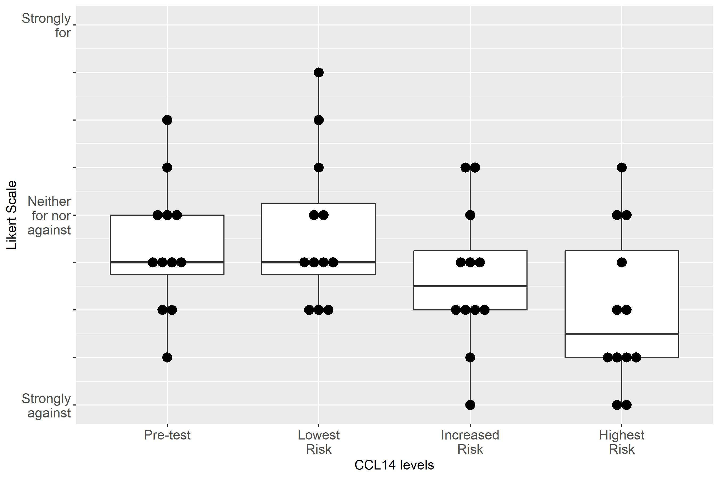

Supplemental Figure S2-67: Case 6, Clinical action: Order CT/angiography
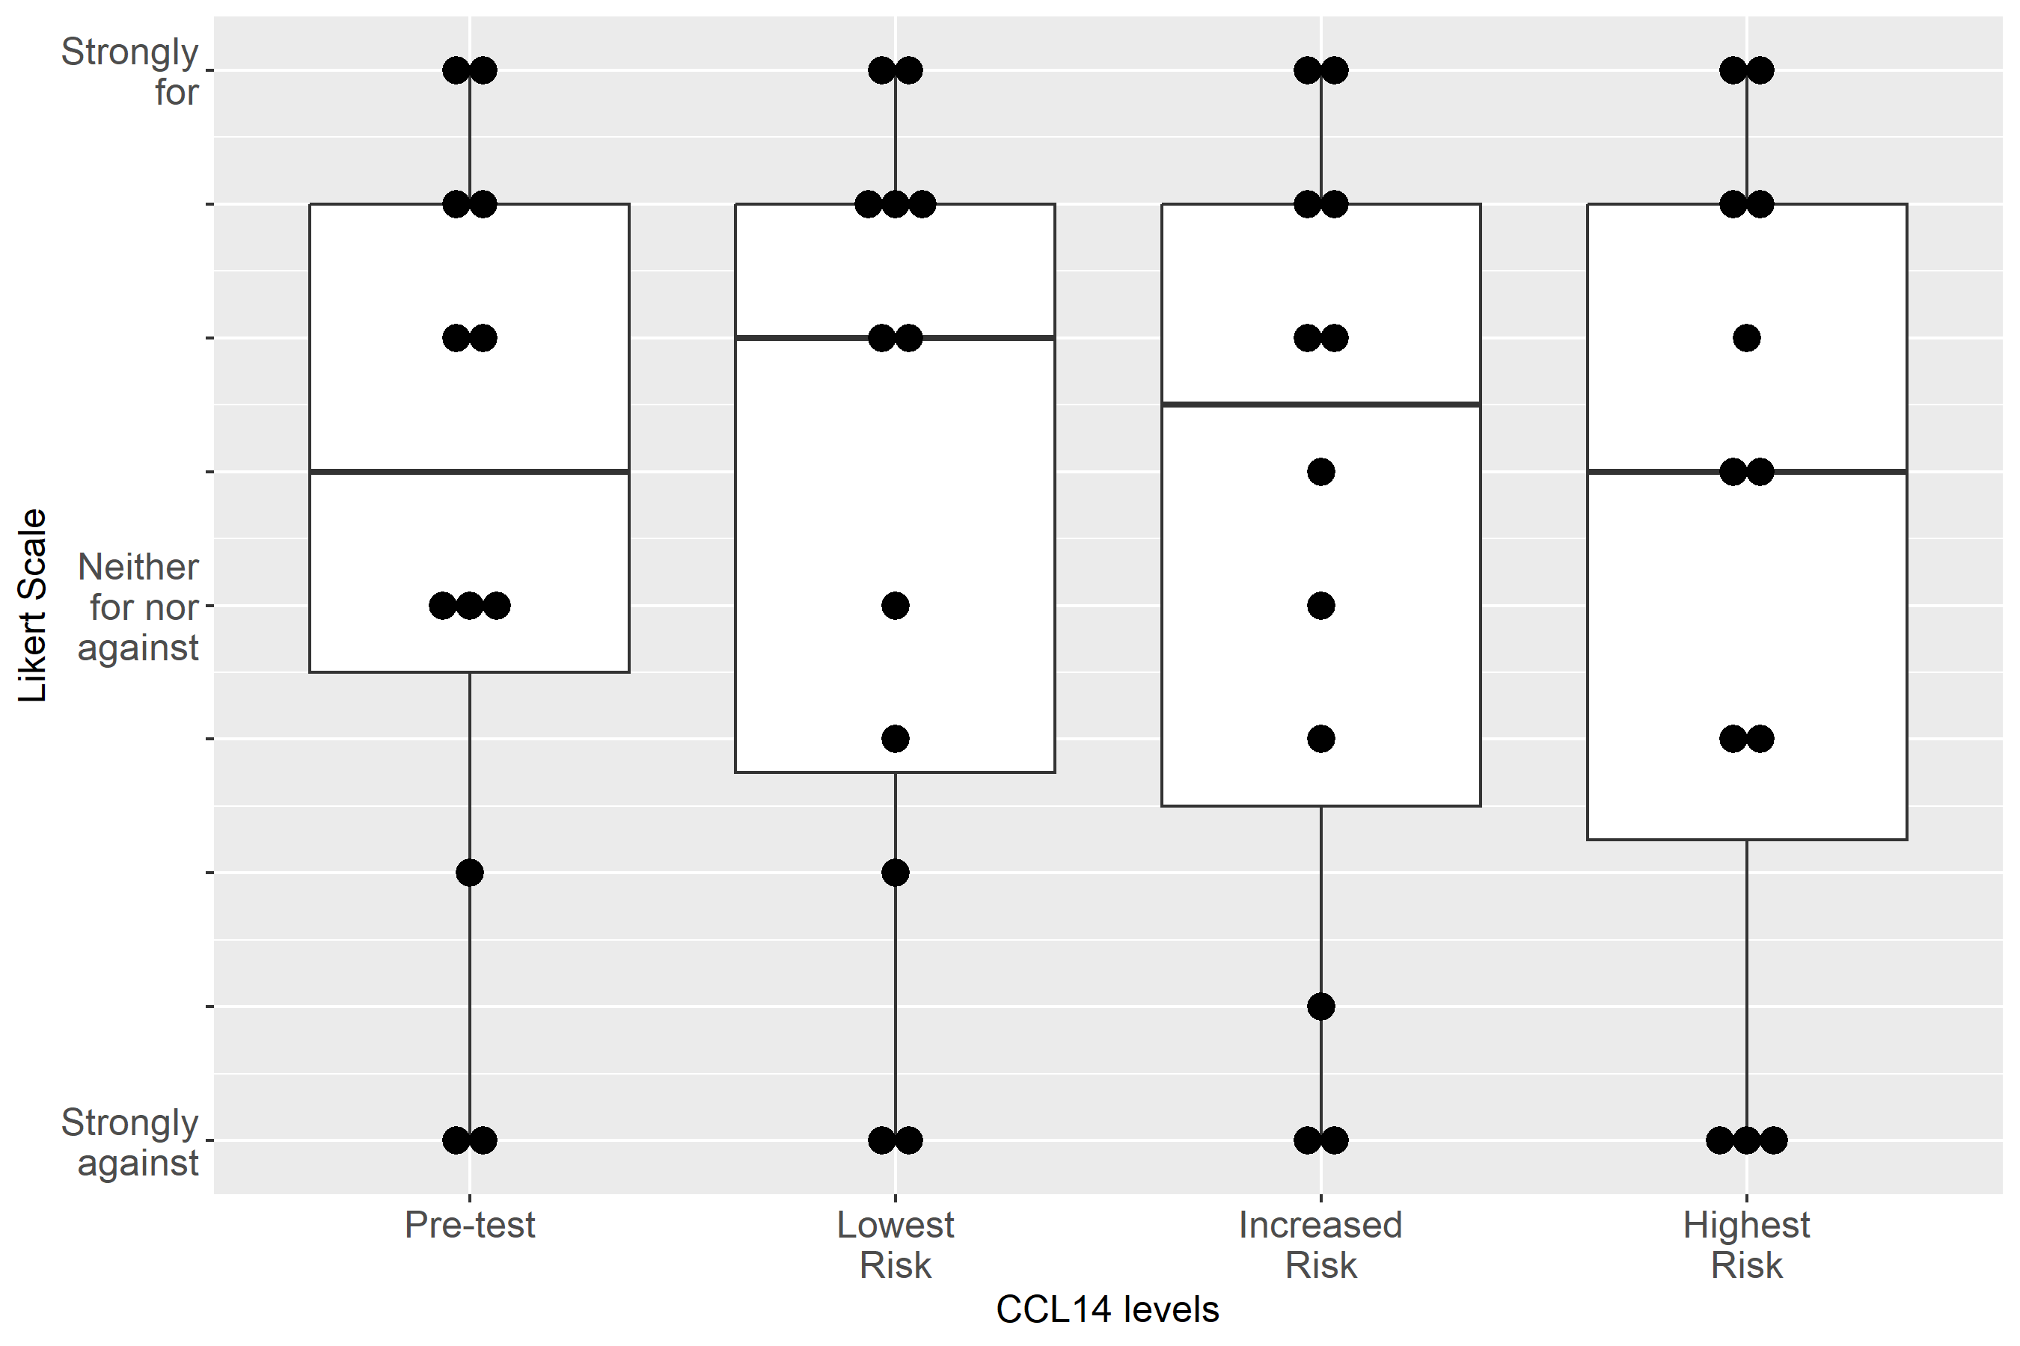

Supplemental Figure S2-68: Case 6, Clinical action: Discuss RRT with patient/family
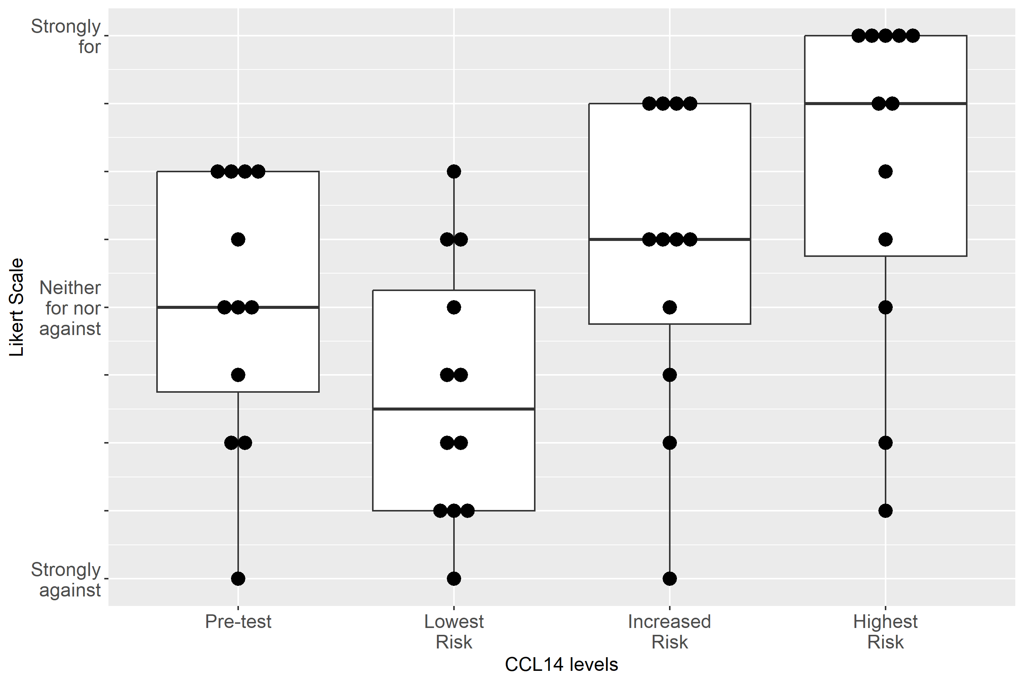
Supplemental Table S1-1. Model coefficients and 95% confidence intervals (CI) from mixed ordinal regression of the secondary hypothesis of clinical specialty and CCL14 influence on expert ratings. The reference for the variables, CCL14 and clinical specialty, were “pre-test” and “nephrologist”, respectively. A positive coefficient indicates tendency towards the “For” rating relative to the reference, while a negative coefficient indicates a tendency towards the “Against” rating relative to the reference. P-values were computed by the likelihood ratio test for the three variables, CCL14, clinical specialty, and their interaction.
Regression term | Regression coefficient (95% CI) | p-value
CCL14 lowest risk | -0.35 (-0.60, -0.10) | <0.001
CCL14 increased risk | 0.43 (0.18, 0.68) | <0.001
CCL14 highest risk | 1.18 (0.92, 1.43) | <0.001
Clinical specialty – Intensivist | 0.27 (-0.07, 0.62) | 0.293
Clinical specialty – Intensivist : CCL14 lowest risk | -0.12 (-0.48, 0.24) | 0.551
Clinical specialty – Intensivist : CCL14 increased risk | -0.13 (-0.49, 0.23) | 0.551
Clinical specialty – Intensivist : CCL14 highest risk | -0.27 (-0.65, 0.10) | 0.551

Supplemental Table S1-2. Model coefficients and 95% confidence intervals (CI) from mixed ordinal regression of the secondary hypothesis of geographic region and CCL14 influence on expert ratings. The reference for the variables, CCL14 and geographic region, were “pre-test” and “North America”, respectively. A positive coefficient indicates tendency towards the “For” rating relative to the reference, while a negative coefficient indicates a tendency towards the “Against” rating relative to the reference. P-values were computed by the likelihood ratio test for the three variables, CCL14, geographic region, and their interaction.
Regression term | Regression coefficient (95% CI) | p-value
CCL14 lowest risk | -0.52 (-0.80, -0.24) | <0.001
CCL14 increased risk | 0.38 (0.11, 0.66) | <0.001
CCL14 highest risk | 1.21 (0.92, 1.50) | <0.001
Geographic region – Europe | -0.11 (-0.46, 0.24) | 0.374
Geographic region – Europe : CCL14 lowest risk | 0.20 (-0.16, 0.57) | 0.095
Geographic region – Europe : CCL14 increased risk | -0.02 (-0.39, 0.34) | 0.095
Geographic region – Europe : CCL14 highest risk | -0.29 (-0.66, 0.09) | 0.095

Supplemental Table S2. Post-hoc pairwise comparison of variance of pre and post-test responses. Difference in variance is calculated relative to pre-test value, i.e., a positive difference indicates a higher variance post vs. pre-test. P-values denote the probability that the difference in variance is zero between pre and post-test and are adjusted for multiple comparisons. P-values in bold are < 0.05. For the comparison of Increased Risk vs. Pre-test, all p-values were > 0.05 (data not shown).
Clinical Recommendation | Lowest Risk vs. Pre-test |  | Highest Risk vs. Pre-test
Clinical Recommendation | Difference in variance (95% CI) | p-value | Difference in variance (95% CI) | p-value
Keep foley catheter, 1-2 hourly Urine Output | 0.40 (0.02 - 0.78) | 0.035 | -0.18 (-0.56 - 0.20) | 0.531
Adjust non-nephrotoxic, renally cleared medication | 0.60 (0.21 - 0.99) | 0.001 | -0.57 (-0.96 - -0.18) | 0.002
Avoid nephrotoxic medications | 0.06 (-0.50 - 0.61) | 0.978 | -0.74 (-1.29 - -0.18) | 0.006
Use functional hemodynamic monitoring | 0.08 (-0.39 - 0.56) | 0.928 | -0.56 (-1.03 - -0.08) | 0.017
Use Furosemide | 0.13 (-0.37 - 0.62) | 0.851 | 0.85 (0.35 - 1.34) | <0.001

