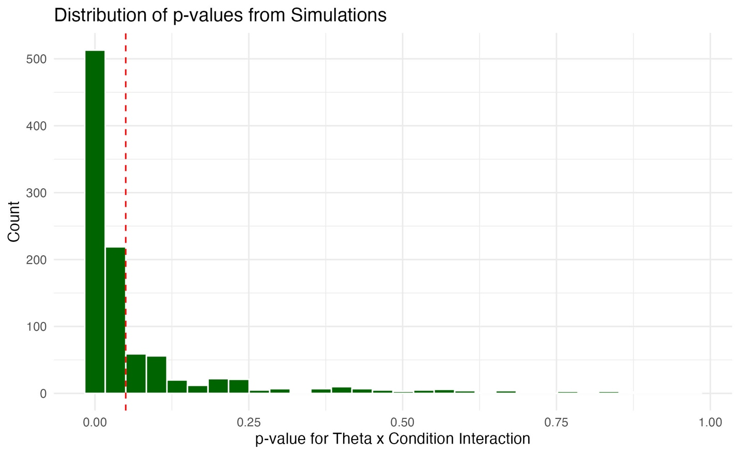
Supplemental Figure 1. Histogram showing the distribution of the p-values of the 1000 simulations. The red vertical dashed line indicates a p-value = 0.05.

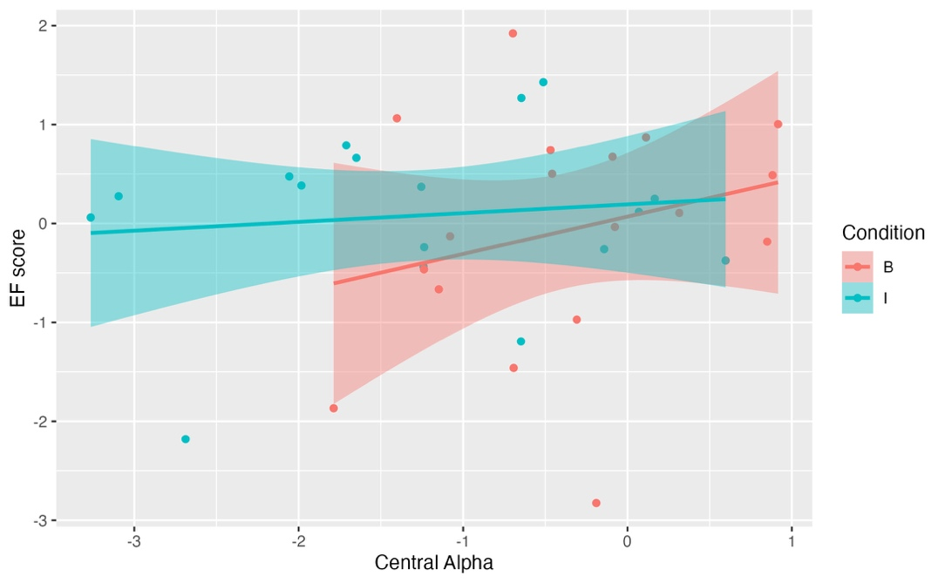
Supplemental Figure 2. A linear model with the main effect and interaction between central alpha and condition, with number of trials as a co-variate and children’s EF score as a dependent variable, found no significant main effects of any of the variables and no significant interactions (all p > .01).

Supplemental Figure 3. A. Statistically significant time-frequency plot during execution for (a) grasp condition and (b) cane-use condition of spectral power relative to baseline. The color towards blue indicate significant suppression of power. Green in images depicts non-significant (p > .05) activity. Power (decibels, dB) is shown by the color bar. B. Topographical maps of mu (6-9Hz) band in 500ms interval during execution for (a) grasp condition and (b) cane-use condition.

