Supplementary figure 1. The morphology of the testicles and accessory testicles

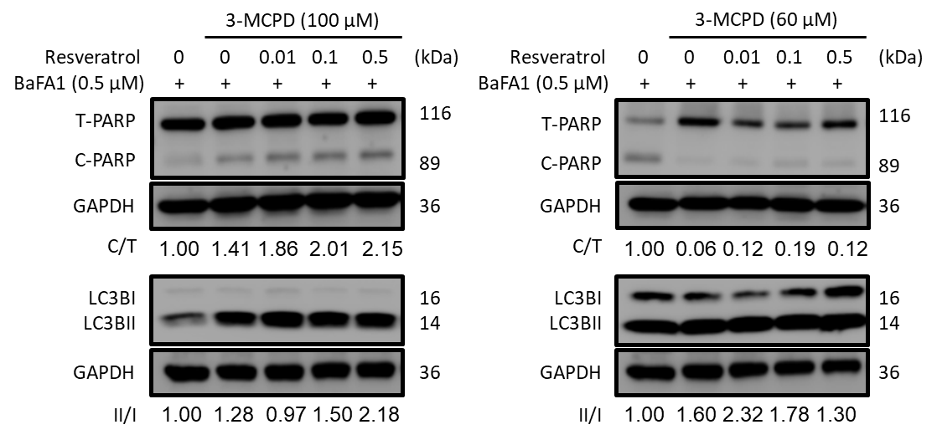
Supplementary figure 2. Impact of lysosome fusion blockade on RSV-mediated alleviation of 3-mcpd-induced male reproductive toxicity
TM3 and TM4 cells were pre-treated with bafilomycin A1 (BaFA1) at a concentration of 0.5 μM for 1.5 hours. Subsequently, cells were exposed to different concentrations of 3-MCPD (100 or 60 μM) and resveratrol (0.01 to 0.5 μM). Protein expression levels were assessed through Western blot analysis to elucidate the impact of BaFA1, 3-MCPD, and resveratrol on cellular responses in TM3 and TM4 cells.

