Table 1. Numbers of study participants in each of the diverse ethnic backgrounds
Ethnic background | Frequency | Percentage
Black | 649 | 30.8
Mixed Race | 212 | 10.0
Indian | 167 | 7.9
White/Caucasian | 1054 | 50.0
Other | 28 | 1.3

Table 2. Level of PUI, as indicated by operationalised JEG-IAT-10 cut-offs
JEG-IAT-10 bracket | Frequency | Percentage
10 - 20: low level of internet use problems | 1621 | 76.8
21 - 40: medium level of internet use problems | 477 | 22.6
41 - 50: high rates of internet use problems such as loss of control, neglect of work, relationships, and other important areas of functioning) | 12 | 0.6

Table 3. Descriptive statistics of COVID-19 related stress, impulsivity and compulsivity
 | IES-R total | S-CIS total | CHI-T total
Mean (SD) | 22.7 (16.8) | 3.1 (2.0) | 26.6 (6.0)
Median | 19 | 3 | 27
Range: Minimum | 0 | 0 | 4
Range: Maximum | 88 | 11 | 45

Table 4. Linear multivariate regression analysis: Model assumptions were met, including absence of notable multi-collinearity*
Variable | Tolerance | VIF | R-Square* | Partial Correlation | Semi-partial Correlation
Age | 0.96 | 1.05 | 0.04 | -0.12 | -0.10
Impulsive symptoms  (S-CIS total) | 0.76 | 1.31 | 0.24 | 0.32 | 0.28
COVID-19 related stress (IES-R total) | 0.81 | 1.23 | 0.19 | 0.22 | 0.19
Compulsive symptoms/traits  (CHI-T total) | 0.82 | 1.22 | 0.18 | 0.11 | 0.09
* The R-square column contains the R-square of the dependent variable (JEG-IAT-10 total) with all other independent variables

Table 5. Partial least squares path modelling for PUI, sexes combined
PATHS* | From | To | Path coefficient | 95% lower | 95% upper | Significant from CI | p-value
Impulsive symptoms PUI level | S-CIS total | JEG-IAT-10 total | 0.35 | 0.31 | 0.40 | yes | <0.01
Compulsive symptoms/traits PUI level | CHIT total | JEG-IAT-10 total | 0.17 | 0.13 | 0.21 | yes | <0.01
COVID-19-related stress PUI level | IES-R total | JEG-IAT-10 total | 0.18 | 0.14 | 0.23 | yes | <0.01
age Impulsive symptoms | age | S-CIS total | -0.22 | -0.26 | -0.19 | yes | <0.01
age Compulsive symptoms/traits | age | CHIT total | -0.19 | -0.23 | -0.15 | yes | <0.01
age COVID-19-related stress | age | IES-R total | -0.08 | -0.12 | -0.04 | yes | <0.01
age PUI level | age | JEG-IAT-10 total | -0.08 | -0.11 | -0.05 | yes | <0.01
* PUI-level, impulsive symptoms, compulsive symptoms/traits, and COVID-10-related stress as indicated by totals on the JEG-IAT-10, S-CIS, CHI-T and IES-R, respectively

Table 6. Application of the SEM model in males and females, respectively
PATH* | Path coefficients:  Females | Path coefficients:  Males | t-value:  Female | t-value:  Male | p-value:  Female | p-value:  Male | Path coefficient differences Female - Male | t-value: Female vs. Male | p-value: Female vs. Male
Impulsive symptoms PUI level | 0.32 | 0.39 | 10.84 | 10.10 | <0.01 | <0,01 | -0.07 | 1.47 | 0.14
Compulsive symptoms/traits PUI level | 0.17 | 0.15 | 6.35 | 4.20 | <0.01 | <0,01 | 0.02 | 0.50 | 0.62
COVID-19-related stress PUI level | 0.21 | 0.21 | 6.83 | 4.99 | <0.01 | <0,01 | 0.00 | 0.01 | 0.99
age Impulsive symptoms | -0.23 | -0.21 | 9.93 | 6.12 | <0.01 | <0,01 | -0.01 | 0.31 | 0.76
age Compulsive symptoms/traits | -0.17 | -0.22 | 7.03 | 6.01 | <0.01 | <0,01 | 0.04 | 0.97 | 0.33
age COVID-19-related stress | -0.09 | -0.08 | 3.37 | 2.12 | <0.01 | 0,03 | -0.01 | 0.32 | 0.75
age PUI level | -0.09 | -0.06 | 4.87 | 2.34 | <0.01 | 0,02 | -0.03 | 0.98 | 0.33
* PUI-level, impulsive symptoms, compulsive symptoms/traits, and COVID-10-related stress as indicated by totals on the JEG-IAT-10, S-CIS, CHI-T and IES-R, respectively

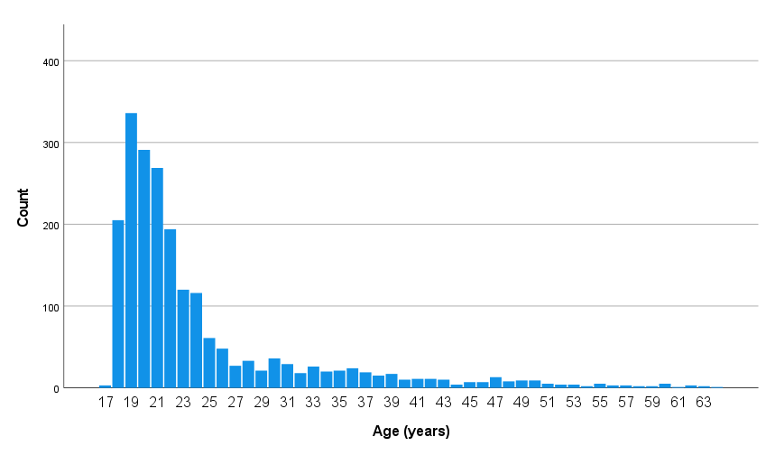
Figure 1. Histogram showing the age distribution of participants

