Supplemental Materials

High and Low Intensity Relationships

Below is a histogram of the intensity z-score for all 1232 social relationships. Relationships to the left of the red line were “low” intensity relationships and relationships above the red line were “high” intensity relationships.
Figure 4

Histogram of The Relationship Intensity Z-Scores

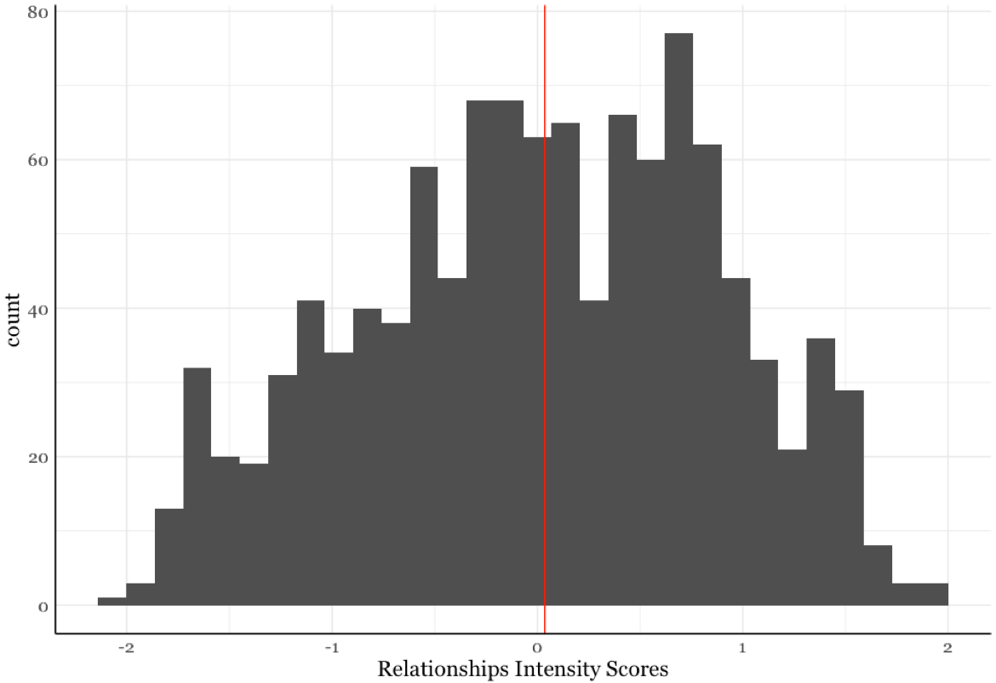
Note. The red line represents the median used to classify relationships as either “low” or “high” intense.

Visual Representations of Diversity Measures

Entropy

Entropy indicates the relative presence of different social categories among the alters in a network and is calculated as follows for a given probability vector of P(X): H(X) = - ∑ P(X) * log2(P(X)) (Drost, 2018). A score of 0 indicates that there is no diversity of categories; all the alters share the same attribute (e.g., all the alters are the same race). A higher entropy scores indicates a greater representation of different categories. See the pictures below for visual representation of Racial Entropy.

Figure 5

Example Network Racial Entropy Values




Network Racial Entropy = 0
Network Racial Entropy = 0.99
Network Racial Entropy = 0

Note. Above are examples networks and their corresponding Network Racial Entropy score. A score of 0 indicates that there is no racial diversity; all the people in the network are the same race.

EI Index

The EI Index is a measure of homophily the child shares with the network and is calculated as follows: (Number of Different Alters – Number of Same Alters)/Network Size (Krackhardt & Stern, 1988). The EI Index ranges from -1 to 1; a score of -1 indicates the entire network is the same as the child on some attribute and a score of 1 would indicate that the entire network is different from the child on some attribute (e.g., if a White child had a network where all the alters were White, they would get a score of -1). See the pictures below for visual representation of Racial EI Index for a White subject.
Figure 6

Example Racial EI Index Values

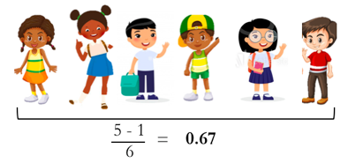
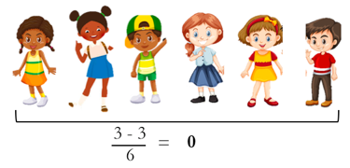
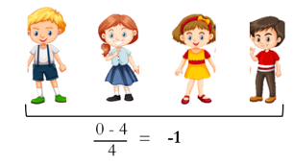


Example Network 2
Example Network 3
Example Network 1

Note. The pictures above show what the Racial EI Index would be if the child was White. A score of -1 means the entire network is the same race as the child.

Network Size, Out-of-home-childcare, and Child Age
In the sample, 167 subjects had out-of-home childcare either through school or daycare (M_{age} = 37.8 months, SD_{age} = 14.8 months) and 112 subjects (M_{age} = 26.3 months, SD_{age} = 11.8 months) did not have out-of-home childcare. This allowed us to explore how the network size changed as a function of childcare experience. For this sample, children who attended school or daycare were significantly older than children who did not attend school or daycare (t(269) = 7.2, p <0.001); therefore, age was included as a control variable in the subsequent analysis.
A linear regression was conducted to test the effects of Age and Out-of-home childcare on Network Size and the regression was significant (R² = 0.39, F(3, 275) = 61.3, p < 0.001; Figure 7). Consistent with the previous finding, there was a main effect of age (ß = 0.02, p < 0.001), but no main effect of Out-of-home childcare (ß = 0.10, p = 0.62), and no significant interaction (ß = 0.006, p = 0.28). Although it is true that children in out-of-home childcare had larger social networks than children without out-of-home childcare (M_{OutofHomeChildcare} = 13 people (5), M_{NoOutofHomeChildcare} = 9 people (5); W = 5031, p < 0.001), when controlling for the effect of Out-of-home childcare on Network Size, child age was the significant predictor.
Post-hoc, Bonferroni corrected correlations were performed to explore if the age trend is present for both children with and without out-of-home childcare. For both groups of children, there was a significant, positive correlation with age (Out-of-home childcare: r = 0.61, p < 0.001; No Out-of-home childcare: r = 0.41, p < 0.001). Regardless of childcare experience, as children got older their networks got larger. Notably, this relationship was weaker for children without out-of-home childcare.

Figure 7

Network Size, Age, and Out-of-Home Childcare Experience

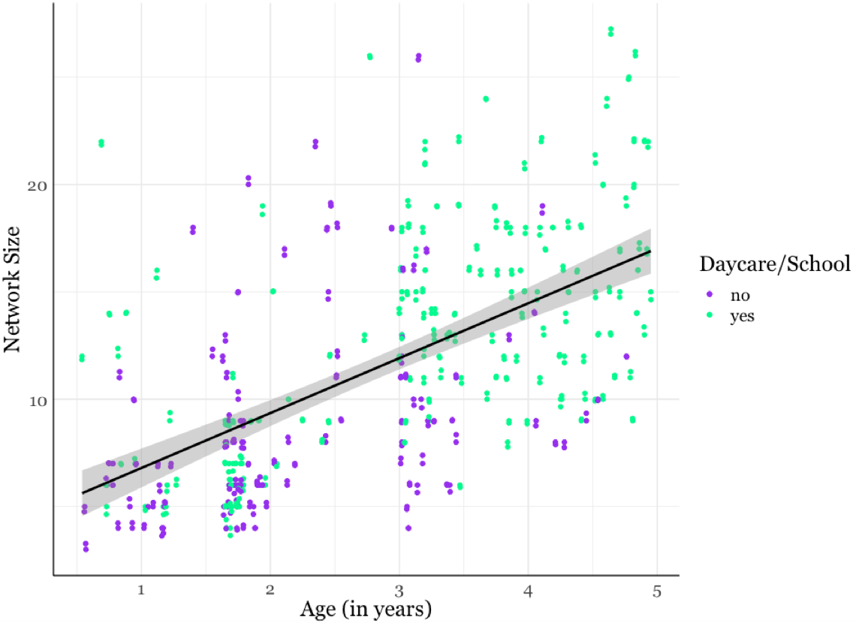

Kin and Intensity Relationships
Below is a table that presents the counts of kin, not kin, high intensity, and low intensity relationships for all 1232 social relationships.
Table 4

2x2 Table Showing Kin and Intense Relationships

 | High Intense Relationships |  | Low Intense Relationships
 | n | % of total | n | % of total
Kin Relationships | 471 | 42% | 212 | 19%
Not Kin Relationships | 90 | 8% | 349 | 31%

Network Variables and Child Age
Below we present the scatterplots between the network variables and child age for completeness. The correlations are reported below, as well as in the manuscript.
Figure 8

Proportion of High and Low Intense Relationships with Age

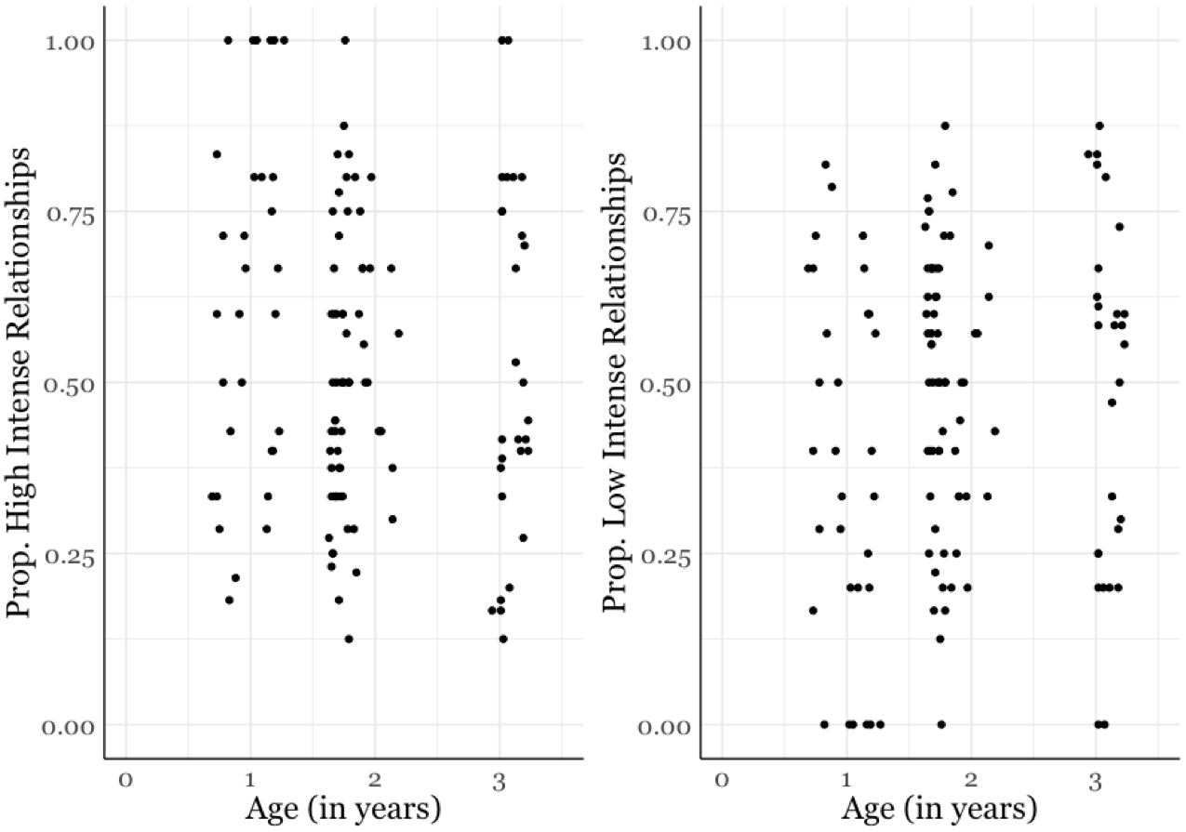

Note. There was no evidence that the proportion of high intense relationships (rho = -0.03, p = 0.72) or proportion of low intense relationships (rho = 0.03, p = 0.72) were correlated with age.

Figure 9

Proportion of Kin Relationships with Age

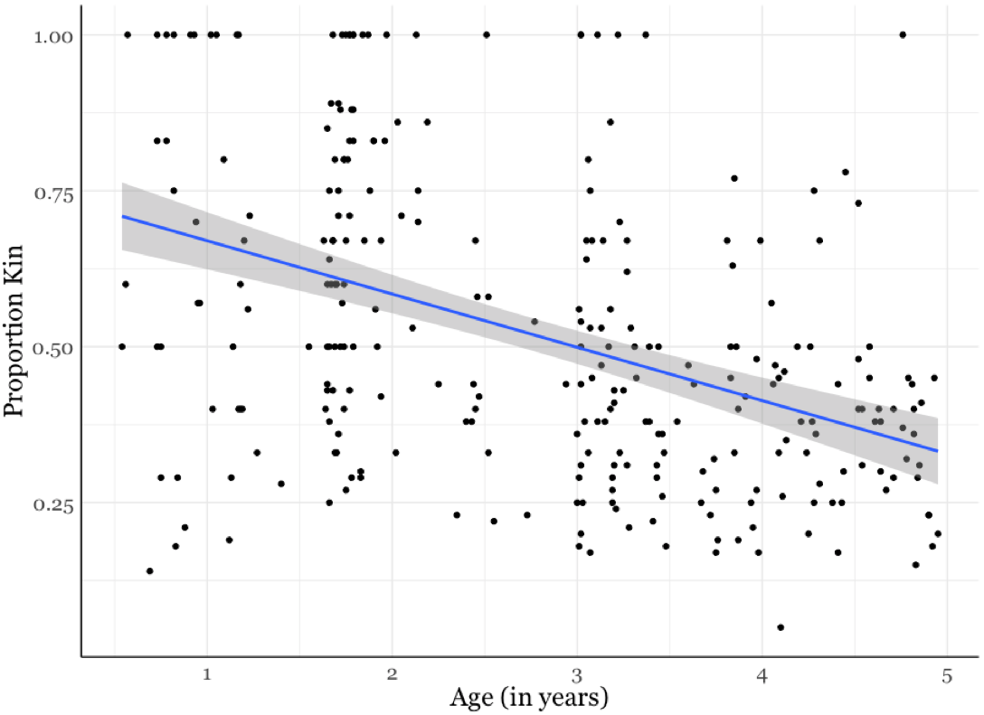
Note. Proportion of kin was correlated with child age (rho = -0.41, p < 0.001).

Figure 10

Proportion of Adult Relationships with Age

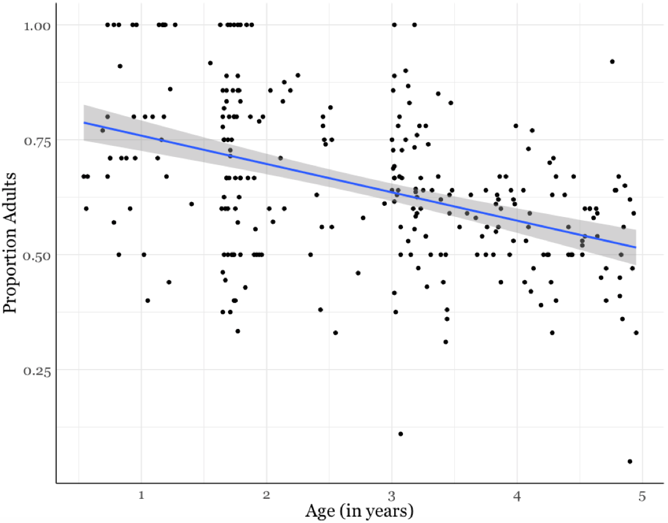
Note. Proportion of adult relationships was correlated with child age (rho = -0.42, p < 0.001).

Figure 11

Network Racial Diversity and Age

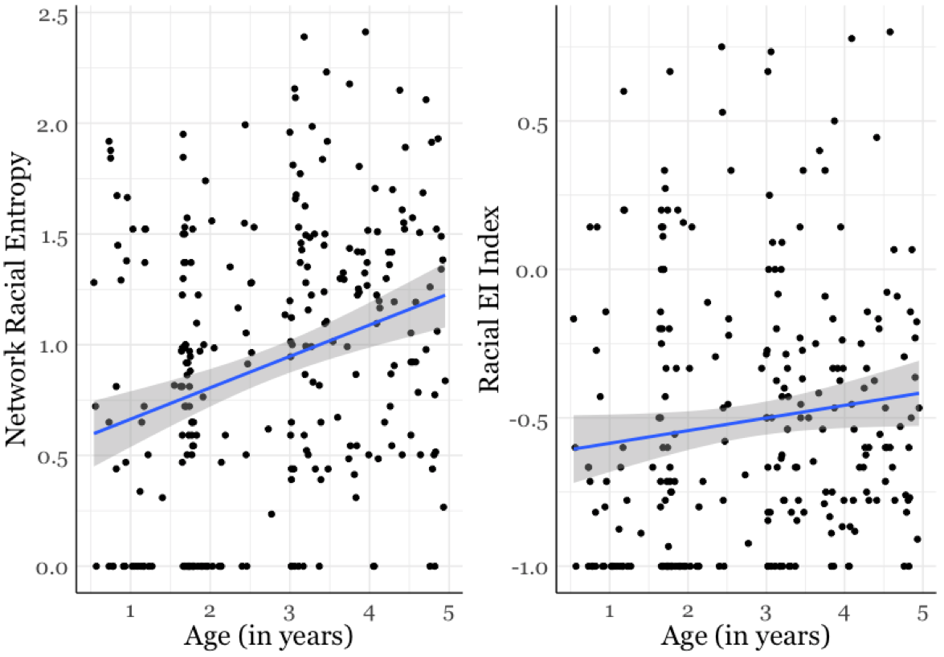

Note. There was a significant positive correlation with age for Network Racial Entropy (rho = 0.25, p <0.001) and for Network Racial EI Index and age (rho = 0.16, p = 0.01).

Figure 12

Network Language Diversity and Age

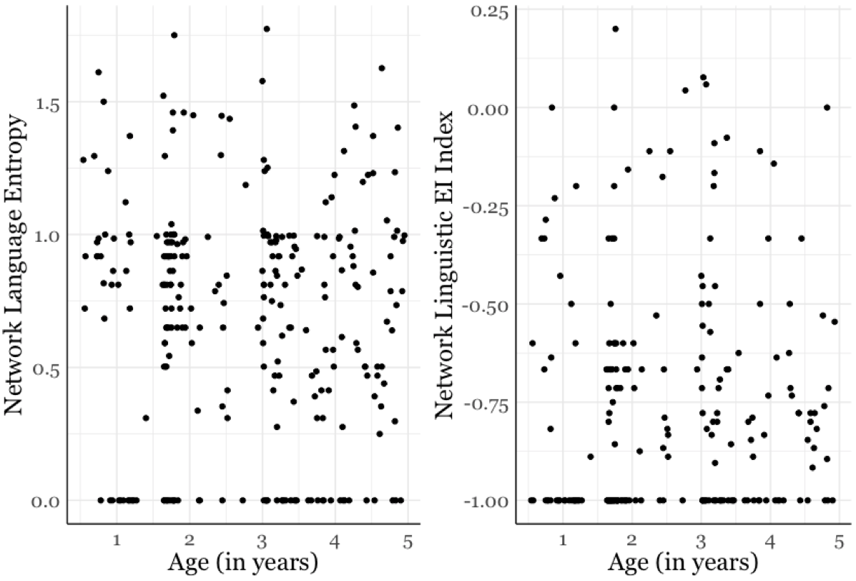

Note. There was no evidence that Network Language Entropy (rho = -0.07, p = 0.29) or Network Linguistic EI Index (rho = 0.09, p = 0.28) was correlated with child age.

Figure 13

Density and Age

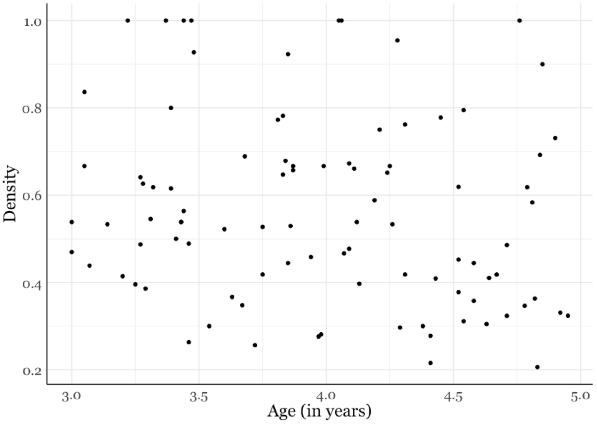

Note. There was no evidence that Density was related to child’s age (rho = -0.19, p = 0.12).

Figure 14

Number of Components, Component Ratio and Age

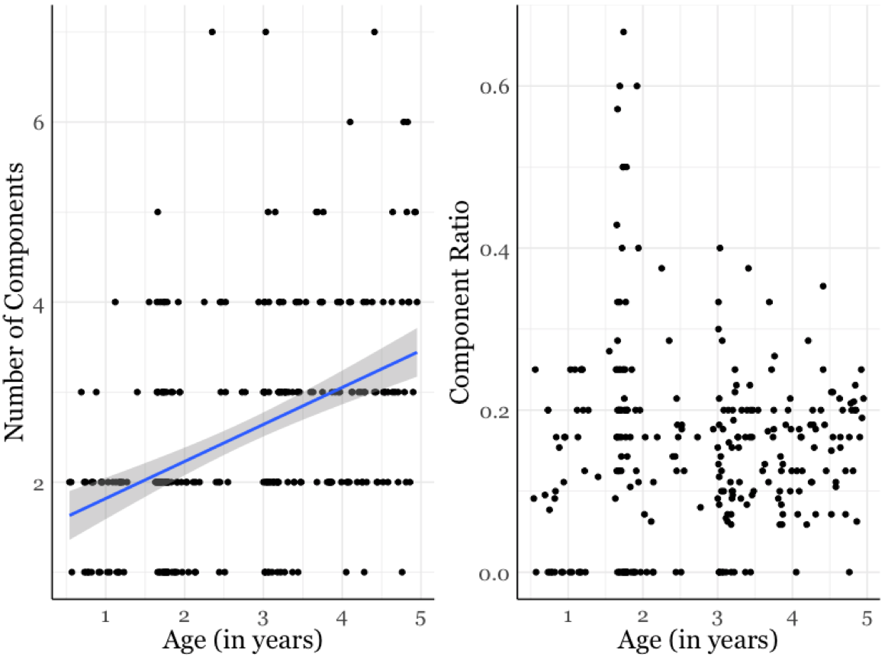

Note. The number of components was positively correlated with age – as children got older the number of components in their network increased (rho = 0.63, p < 0.001). The Component Ratio was not correlated with age; there was no evidence that the fragmentation of children’s networks varied with age (rho = 0.04, p = 0.59).

Diversity in Children’s Social Networks

Entropy and EI Index

Below are the scatterplots for both racial and linguistic entropy and EI Index. Both measures of diversity for both racial and linguistic diversity were highly correlated with each other.

Figure 15

Network Racial Entropy and Racial EI Index

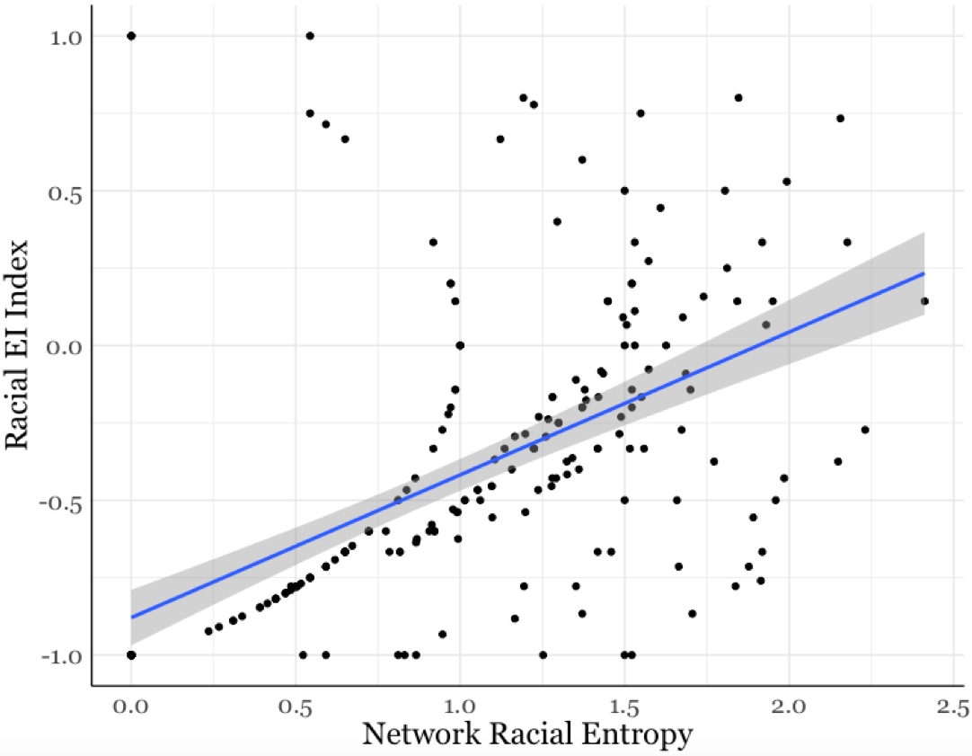
Note. The two measures of network racial diversity were highly correlated with each other (rho = 0.72, p < 0.001).

Figure 16

Network Language Entropy and Linguistic EI Index

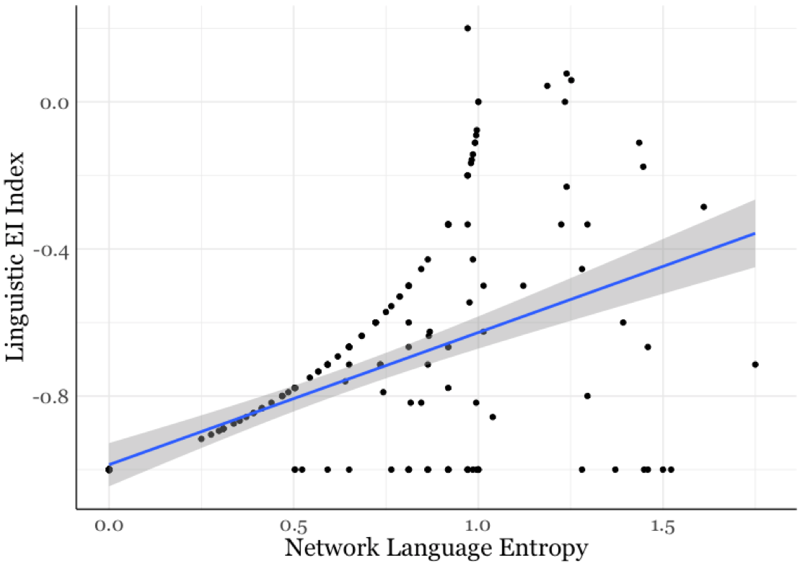

Note. The two measures of network linguistic diversity were highly correlated with each other (rho = 0.50, p < 0.001).

Network Racial Diversity and Network Structure
Below are examples of an Integrated Network and a Segregated Network.
Figure 17

Examples of Integrated and Segregated Networks

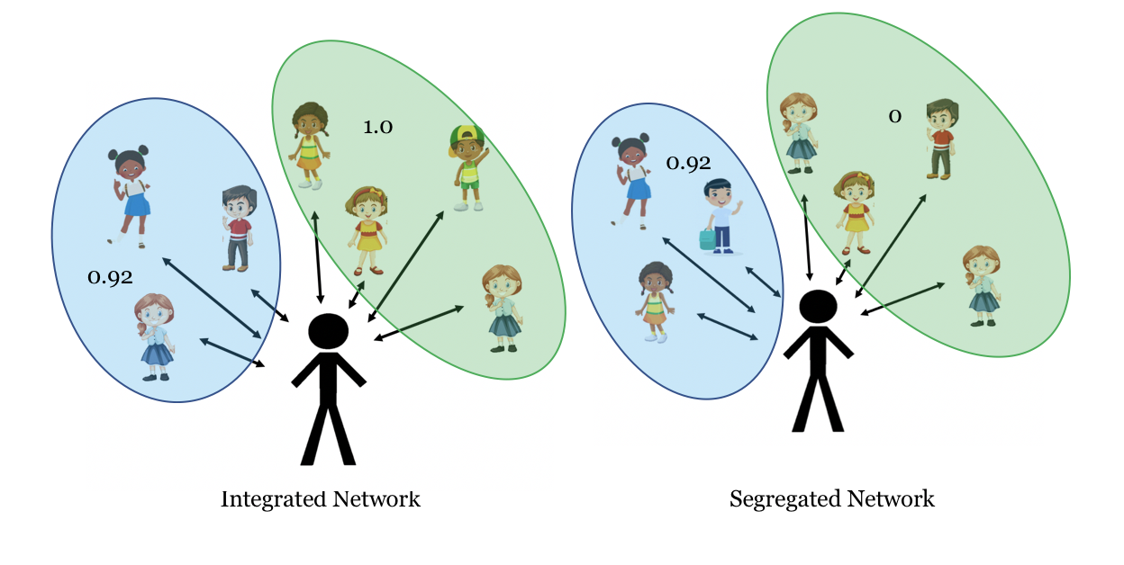
Note. The Integrated Network has 2 components that have non-zero entropy in each component – there are different racial groups represented in each component. The Segregated Network shows that 50% of the components have 0 racial entropy.

