Supplementary Materials for

Modeling suggests that virion production cycles within individual cells is key to understanding acute hepatitis B virus infection kinetics

Atesmachew Hailegiorgis, Yuji Ishida², Nicholson Collier, Michio Imamura, Zhenzhen Shi, Vladimir Reinharz, Masataka Tsuge, Danny Barash, Nobuhiko Hiraga, Hiroshi Yokomichi, Chise Tateno, Jonathan Ozik, Susan L. Uprichard, Kazuaki Chayama*, Harel Dahari*

*Corresponding authors. Emails: Kazuaki Chayama (chayama@hiroshima-u.ac.jp) or Harel Dahari (hdahari@luc.edu )

Table A. Empirical data

Time p.i. | M1 | M2 | M3 | M4 | M5 | M6 | M7
day | HBV genome equivalents (Log)
0.001 | 7.97 | 8.09 | 8.03 | 8.04 | 6.95 | 5.98
0.021 | 7.69 | 7.78 | 7.66 | 7.69 | 6.94 | 5.97
0.042 | 7.49 | 7.63 | 7.36 | 7.47 | 6.65 | 5.77
0.125 |  |  |  |  | 6.04 | 5.10
0.25 | 6.10 | 6.18 | 5.91 | 5.83 | 5.42 | 4.51
0.5 |  |  |  |  | 4.81 | 3.72
1 | 3.77 | 3.82 | 3.79 | 3.73 | 4.51 | BLQ
1.5 |  |  |  |  | 3.60 | BLQ
2 | 3.97 | 3.73 | 3.80 | 3.29 | BLQ | BLQ
3 | 4.09 | 4.01 | 4.00 | 4.07 | BLQ | BLQ
4 | 5.06 | 5.69 | 4.96 | 5.30 | 4.73 | 3.53
5 |  |  |  |  | 5.51 | 4.55
6 | 6.18 | 5.86 | 6.06 | 5.64 | 5.60 | 4.56
7 |  |  |  |  | 5.68 | 4.76 | 4.12
8 | 5.99 | 6.41 | 5.68 | 6.16 | 5.81 | 4.68
9 |  |  |  |  | 5.78 | 4.86
10 | 5.86 | 6.60 | 5.98 | 6.43 | 5.72 | 4.80
12 | 6.40 | 6.92 | 6.29 | 6.87 | 6.09 | 5.29
14 | 6.81 | 7.29 | 6.58 | 6.97 | 6.40 | 5.64 | 4.52
16 |  |  |  |  | 6.75 | 5.95
21 | 7.78 | 8.42 | 7.38 | 8.11 | 7.52 | 6.73 | 5.60
28 | 8.51 | 9.03 | 7.92 | 8.86 | 8.60 | 7.69 | 6.15
35 | 9.20 | 9.35 | 8.67 | 9.16 |  |  | 7.14
42 | 9.18 | 9.28 | 8.94 | 9.24 |  |  | 7.67
49 |  |  |  |  |  |  | 8.52
51 | 9.23 | 9.30 | 9.15 | 9.19
56 |  |  |  |  |  |  | 9.19
63 |  |  |  |  |  |  | 9.19

BLQ, below limit of quantification.
Table B. ABM parameter constrain to fit the empirical data.
Parameter | Source | Unit | Name | Range
$$Ω$$ | Fig. 2 | hr | Eclipse phase | 5-50
P_{st} | Eq. 1 | GE/cell/hr | Virus production at steady state | 2-5
$$γ$$ | Eq. 1 | hr⁻¹ | Steepness of the production curve | 0.1-0.9
$$α$$ | Eq. 1 | hr | Number of cycles to reach 50% of Pst | 10-30
$$δ$$ | Eq. 2 | hr | Initial production cycle length | 15-30
$$ω$$ | Eq. 2 | hr⁻¹ | Decay constant | 0.3-1.0
$$β$$ | Fig. 2 |  | Infection rate constant | 0.01-0.2

GE, HBV genome equivalents.

Table C. Quartile parameter estimates.

Mouse | Ω_{min} | Ω_{max} | P_{st} | γ | α | δ | ω | β
M1 1st Q. | 7.00 | 39.00 | 3.00 | 0.10 | 10.00 | 26.00 | 0.51 | 0.02
M1 Med. | 10.00 | 44.00 | 4.00 | 0.65 | 20.00 | 26.00 | 0.51 | 0.02
M1 3rd Q. | 13.00 | 45.00 | 4.00 | 0.88 | 20.00 | 29.00 | 0.59 | 0.02
M1 Min. | 5.00 | 6.00 | 2.00 | 0.1 | 10.00 | 15.00 | 0.30 | 0.01
M1 Max. | 49.00 | 50.00 | 5.00 | 0.9 | 30.00 | 30.00 | 1.00 | 0.20
M2 1st Q. | 15.00 | 40.00 | 4.00 | 0.62 | 19.00 | 29.00 | 0.80 | 0.02
M2 Med. | 15.00 | 40.00 | 4.00 | 0.79 | 20.00 | 30.00 | 0.80 | 0.02
M2 3rd Q. | 15.00 | 40.00 | 4.00 | 0.88 | 20.00 | 30.00 | 0.80 | 0.02
M2 Min. | 5.00 | 6.00 | 2.00 | 0.1 | 10.00 | 15.00 | 0.30 | 0.01
M2 Max. | 49.00 | 50.00 | 5.00 | 0.9 | 30.00 | 30.00 | 1.00 | 0.20
M3 1st Q. | 13.00 | 48.00 | 2.00 | 0.79 | 11.00 | 30.00 | 0.72 | 0.02
M3 Med. | 13.00 | 48.00 | 2.00 | 0.79 | 11.00 | 30.00 | 0.76 | 0.02
M3 3rd Q. | 15.00 | 49.00 | 2.00 | 0.86 | 14.00 | 30.00 | 0.76 | 0.02
M3 Min. | 5.00 | 6.00 | 2.00 | 0.1 | 10.00 | 15.00 | 0.30 | 0.01
M3 Max. | 49.00 | 50.00 | 5.00 | 0.9 | 30.00 | 30.00 | 1.00 | 0.20
M4 1st Q. | 15.00 | 33.00 | 4.00 | 0.83 | 10.00 | 26.00 | 0.57 | 0.02
M4 Med. | 15.00 | 34.00 | 4.00 | 0.88 | 10.00 | 26.00 | 0.62 | 0.02
M4 3rd Q. | 15.00 | 36.00 | 4.00 | 0.88 | 18.00 | 26.00 | 0.62 | 0.02
M4 Min. | 5.00 | 6.00 | 2.00 | 0.1 | 10.00 | 15.00 | 0.30 | 0.01
M4 Max. | 49.00 | 50.00 | 5.00 | 0.9 | 30.00 | 30.00 | 1.00 | 0.20
M5 1st Q. | 15.00 | 17.00 | 4.00 | 0.22 | 29.00 | 26.00 | 0.49 | 0.04
M5 Med. | 16.00 | 18.00 | 4.00 | 0.22 | 29.00 | 26.00 | 0.50 | 0.04
M5 3rd Q. | 16.00 | 20.00 | 4.00 | 0.22 | 29.00 | 26.00 | 0.50 | 0.04
M5 Min. | 5.00 | 6.00 | 4.00 | 0.1 | 10.00 | 26.00 | 0.30 | 0.01
M5 Max. | 49.00 | 50.00 | 4.00 | 0.9 | 30.00 | 26.00 | 1.00 | 0.20
M6 1st Q. | 10.00 | 28.00 | 4.00 | 0.63 | 17.00 | 29.00 | 0.66 | 0.02
M6 Med. | 10.00 | 28.00 | 4.00 | 0.73 | 17.00 | 29.00 | 0.66 | 0.02
M6 3rd Q. | 10.00 | 29.00 | 4.00 | 0.73 | 17.00 | 29.00 | 0.66 | 0.02
M6 Min. | 5.00 | 6.00 | 4.00 | 0.1 | 10.00 | 15.00 | 0.30 | 0.01
M6 Max. | 49.00 | 50.00 | 4.00 | 0.9 | 30.00 | 30.00 | 1.00 | 0.20
M7 1st Q. | 25.00 | 28.00 | 4.00 | 0.21 | 10.00 | 29.00 | 0.39 | 0.01
M7 Med. | 27.00 | 28.00 | 4.00 | 0.21 | 11.00 | 29.00 | 0.39 | 0.01
M7 3rd Q. | 27.00 | 44.00 | 4.00 | 0.31 | 23.00 | 29.00 | 0.39 | 0.01
M7 Min. | 5.00 | 6.00 | 2.00 | 0.1 | 10.00 | 15.00 | 0.30 | 0.01
M7 Max. | 49.00 | 50.00 | 2.00 | 0.9 | 30.00 | 30.00 | 0.90 | 0.08

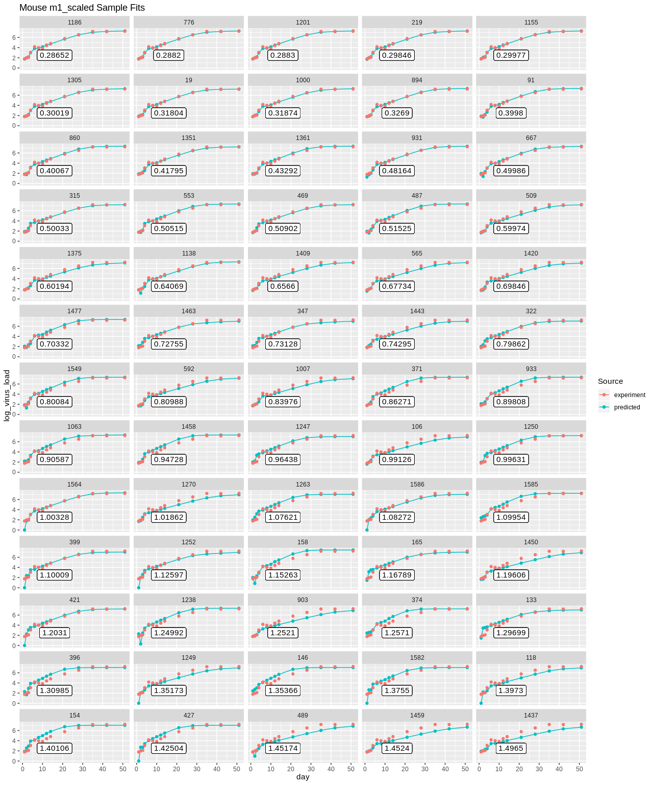
Figure A: Best GA j-score fits for M1. Each row contains j-scores within a range (e.g. 0.2 – 0.3). The first column is the best fit within that range, the last column is the worst fit within that range, and the remaining 3 are randomly sampled from the j-scores within that range.

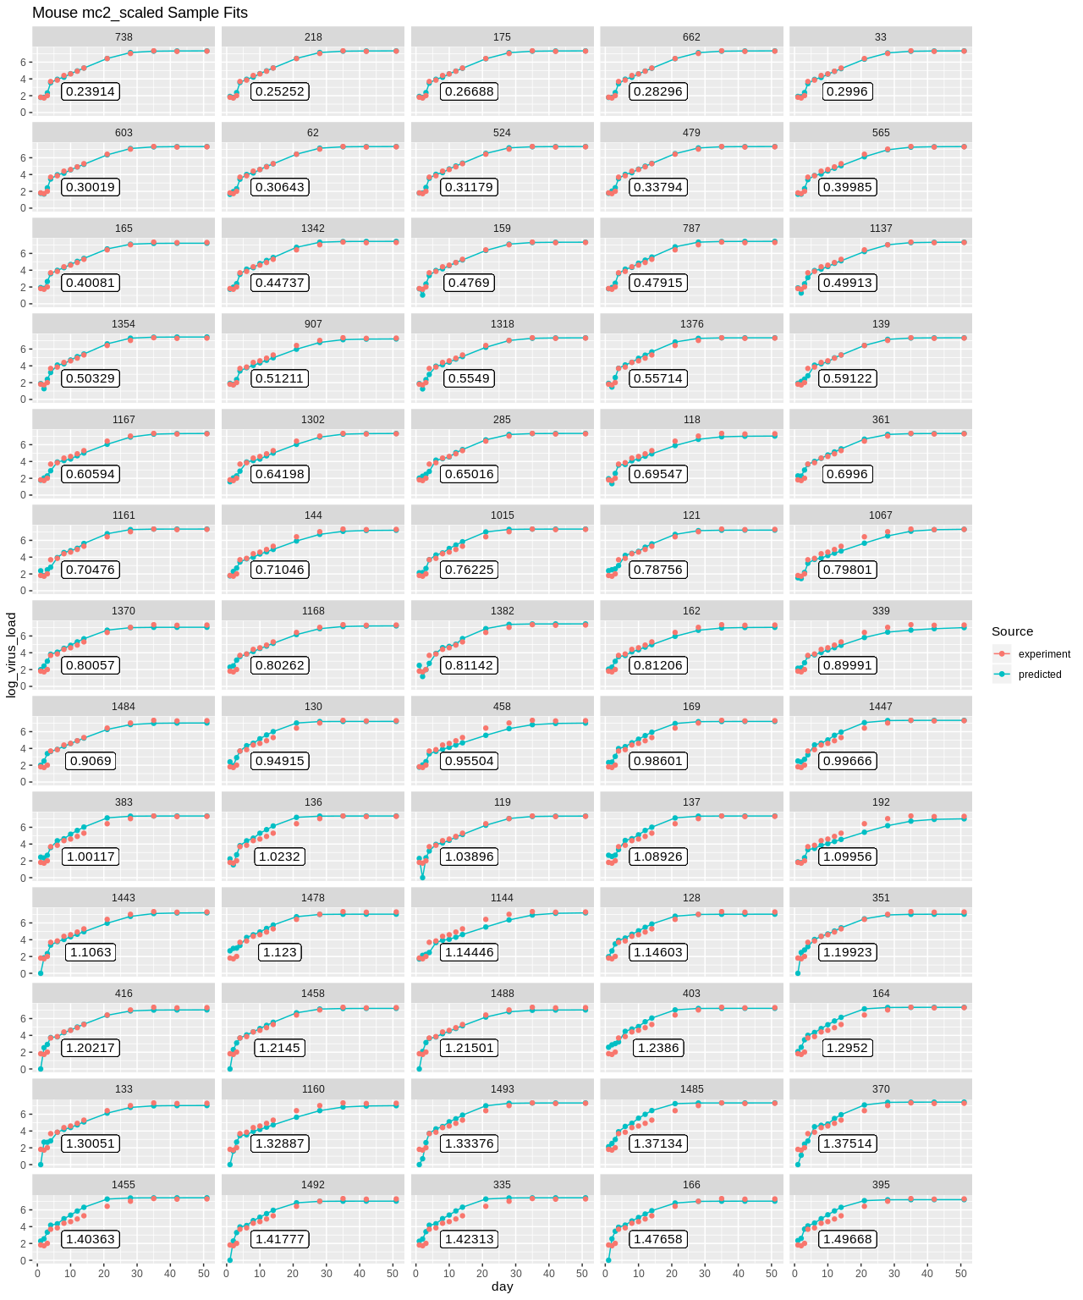 Figure B: Best GA j-score fits for M2. Each row contains j-scores within a range (e.g. 0.2 – 0.3). The first column is the best fit within that range, the last column is the worst fit within that range, and the remaining 3 are randomly sampled from the j-scores within that range.
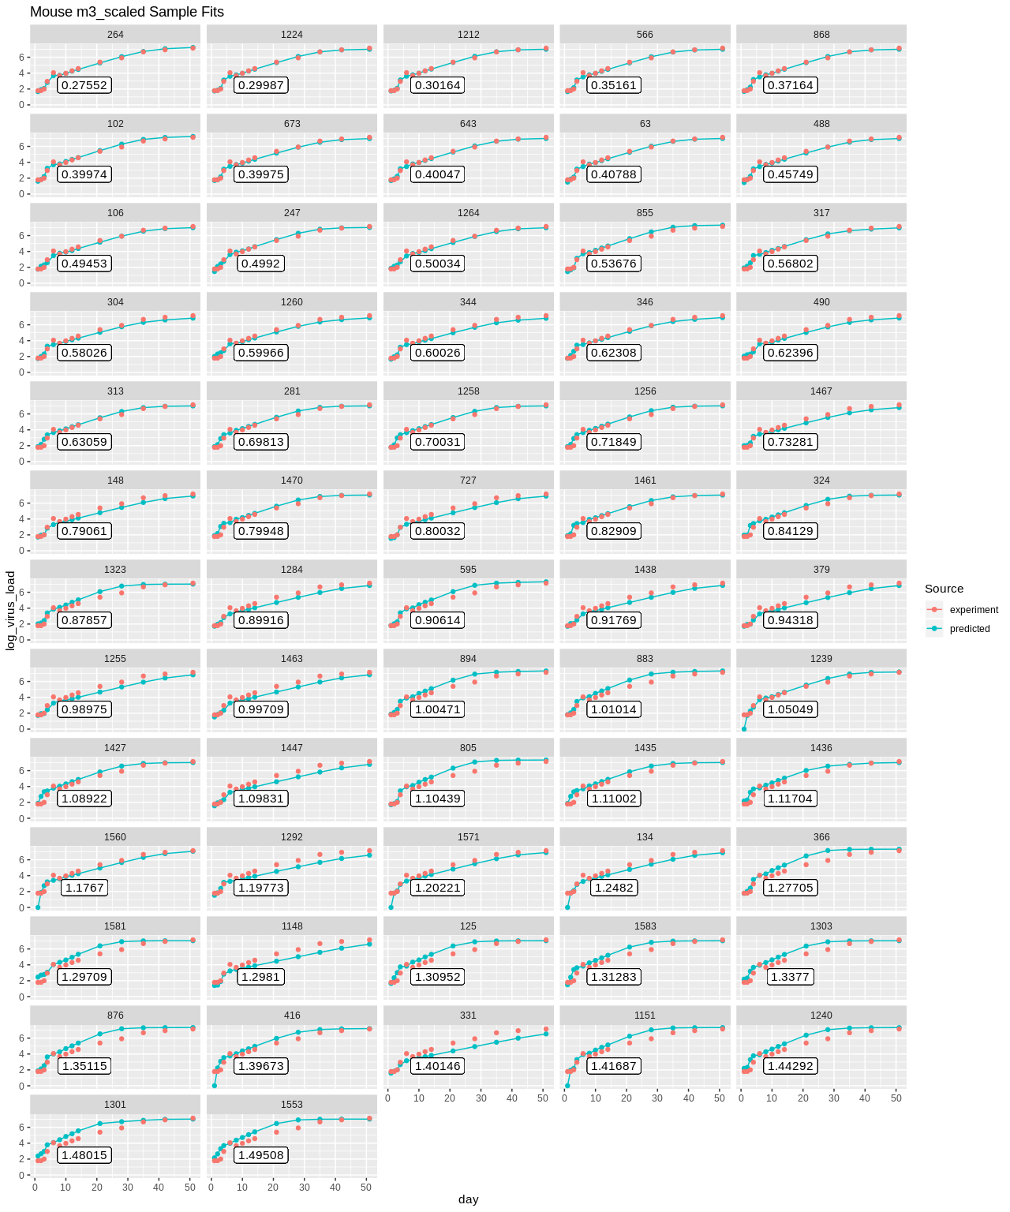
Figure C: Best GA j-score fits for M3. Each row contains j-scores within a range (e.g. 0.2 – 0.4). The first column is the best fit within that range, the last column is the worst fit within that range, and the remaining 3 are randomly sampled from the j-scores within that range.
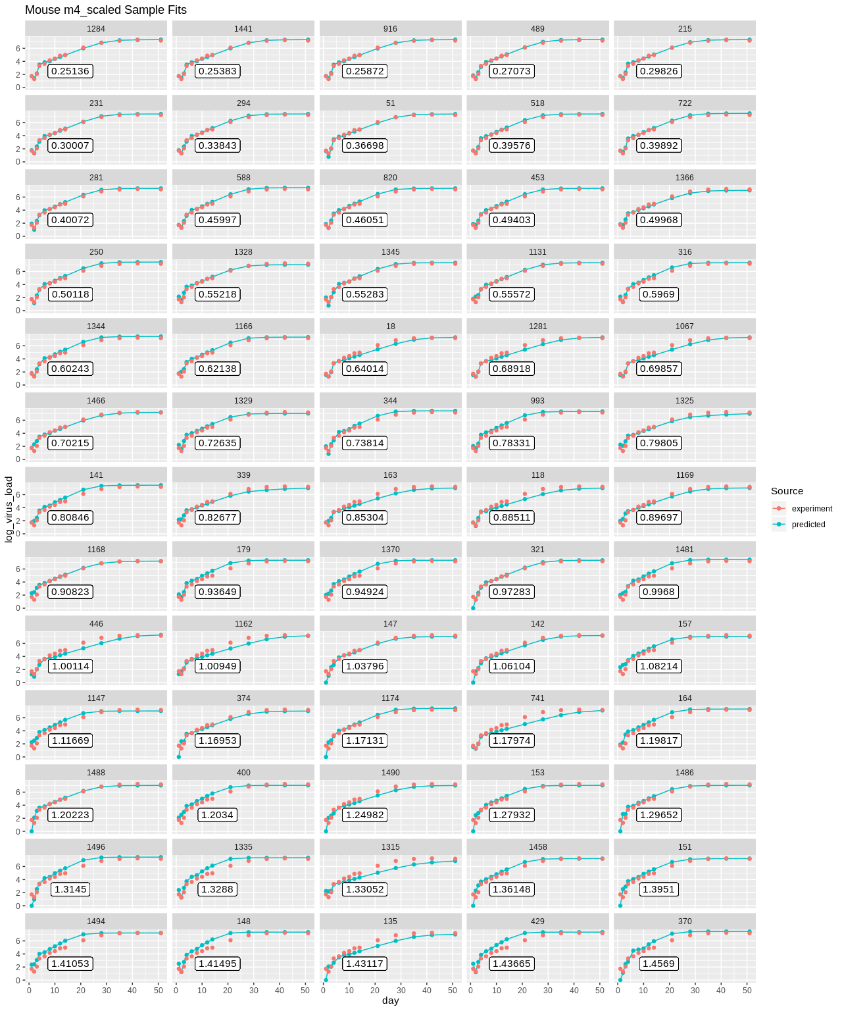
Figure D: Best GA j-score fits for M4. Each row contains j-scores within a range (e.g. 0.2 – 0.3). The first column is the best fit within that range, the last column is the worst fit within that range, and the remaining 3 are randomly sampled from the j-scores within that range.

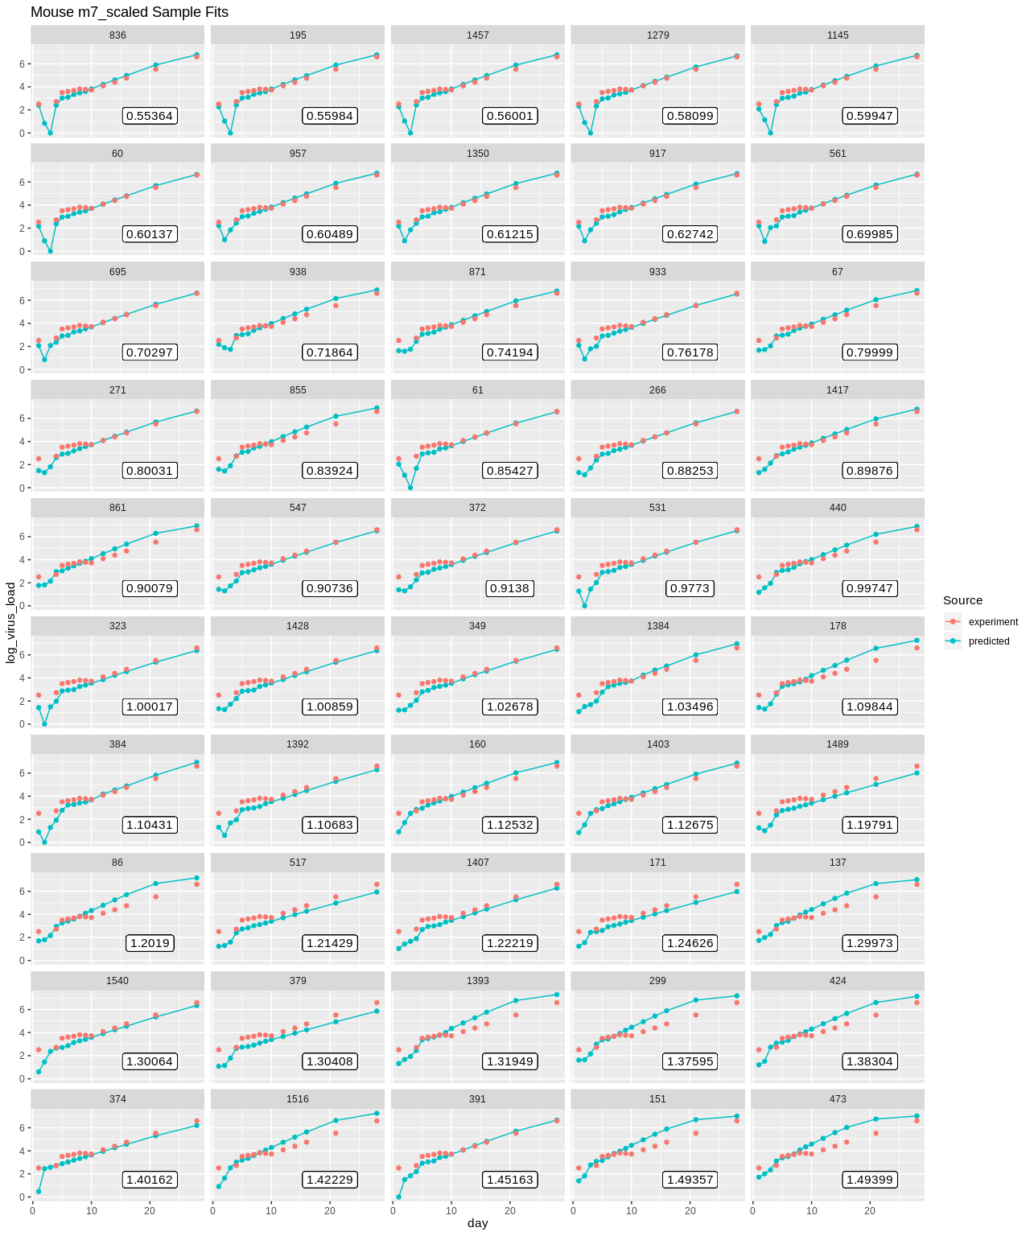
Figure E: Best GA j-score fits for M5. Each row contains j-scores within a range (e.g. 0.5 – 0.6). The first column is the best fit within that range, the last column is the worst fit within that range, and the remaining 3 are randomly sampled from the j-scores within that range.

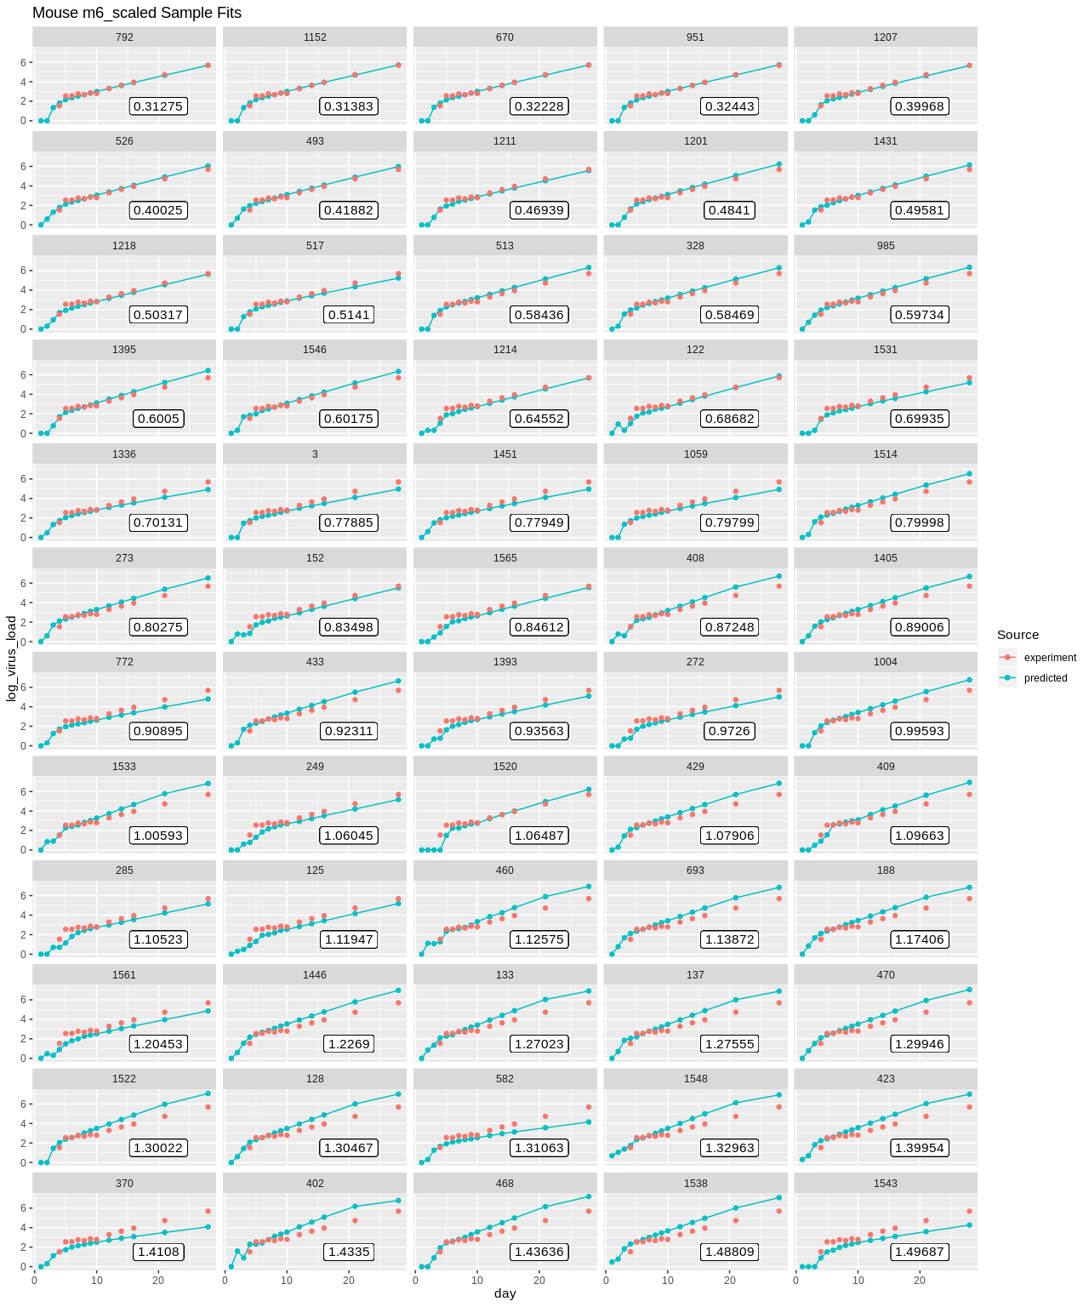
Figure F: Best GA j-score fits for M6. Each row contains j-scores within a range (e.g. 0.3 – 0.4). The first column is the best fit within that range, the last column is the worst fit within that range, and the remaining 3 are randomly sampled from the j-scores within that range.

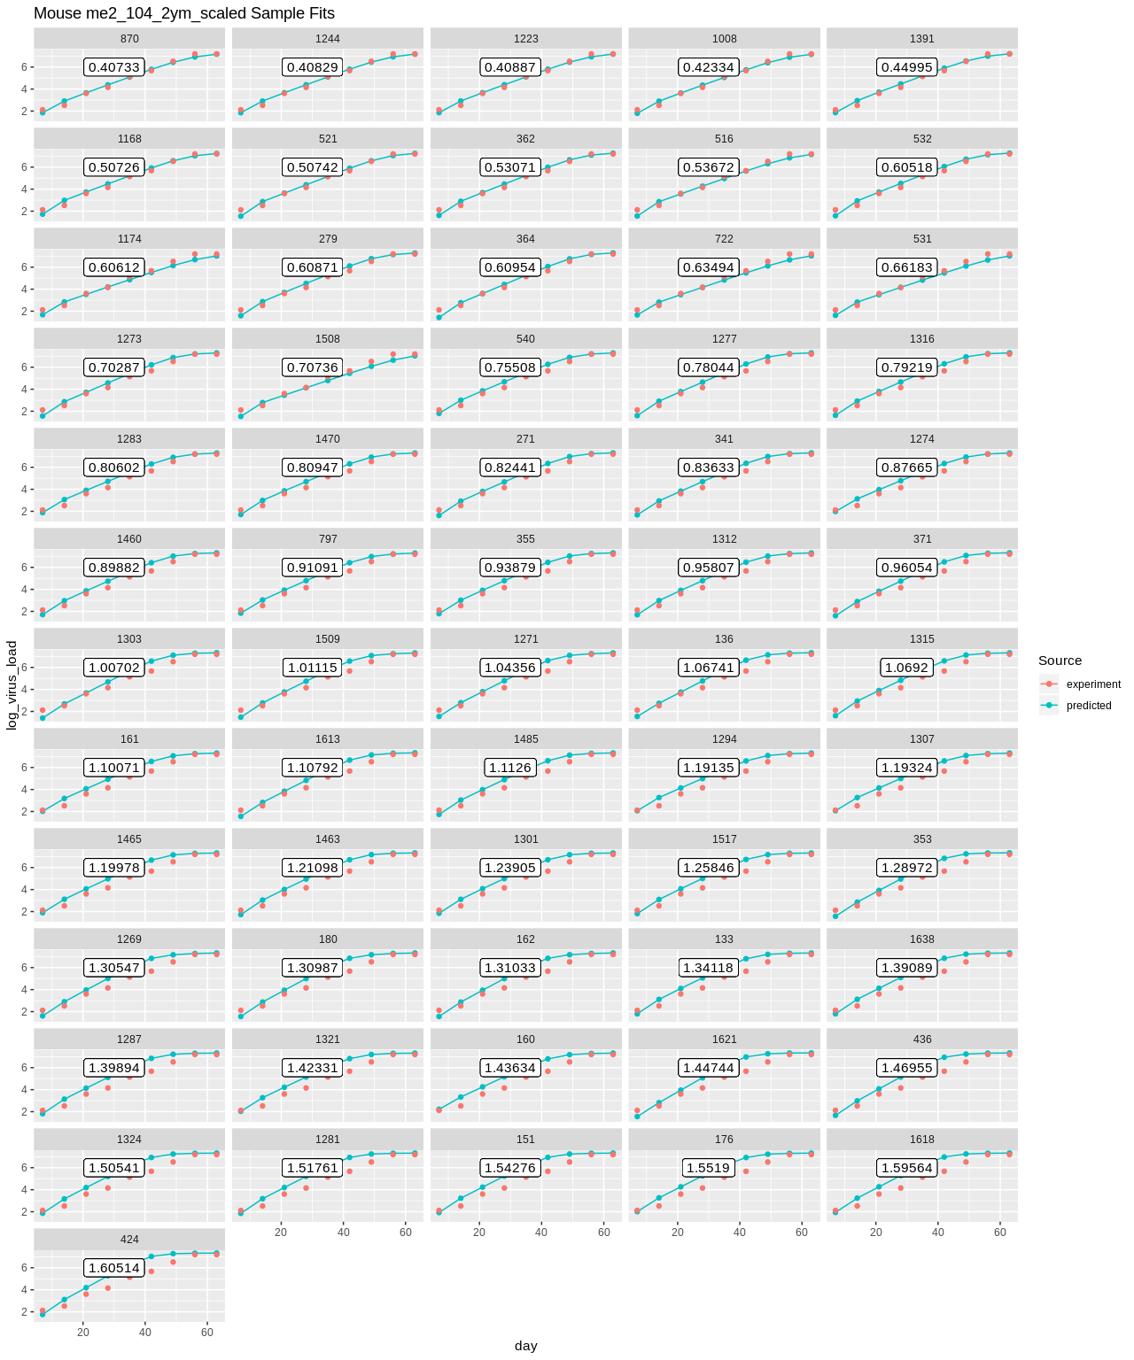
Figure G: Best GA j-score fits for M7. Each row contains j-scores within a range (e.g. 0.4 – 0.6). The first column is the best fit within that range, the last column is the worst fit within that range, and the remaining 3 are randomly sampled from the j-scores within that range.

Figure H. Pair plot for M1.

Figure I. Pair plot for M2

Figure J. Pair plot for M3.

Figure K. Pair plot for M4.

Figure L. Pair plot for M5

Figure M. Pair plot for M6.

Figure N. Pair plot for M7.

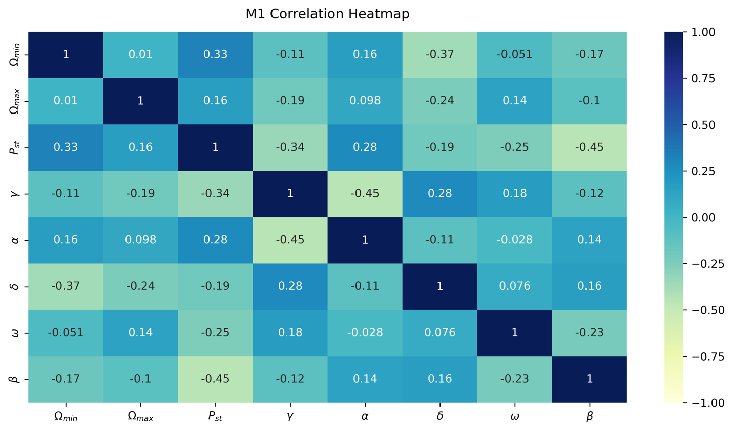

Figure O. Correlation plot for M1.

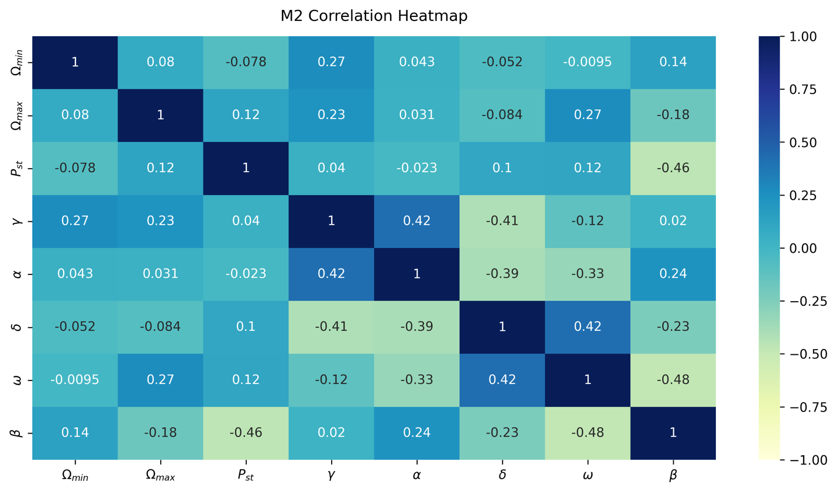

Figure P. Correlation plot for M2.
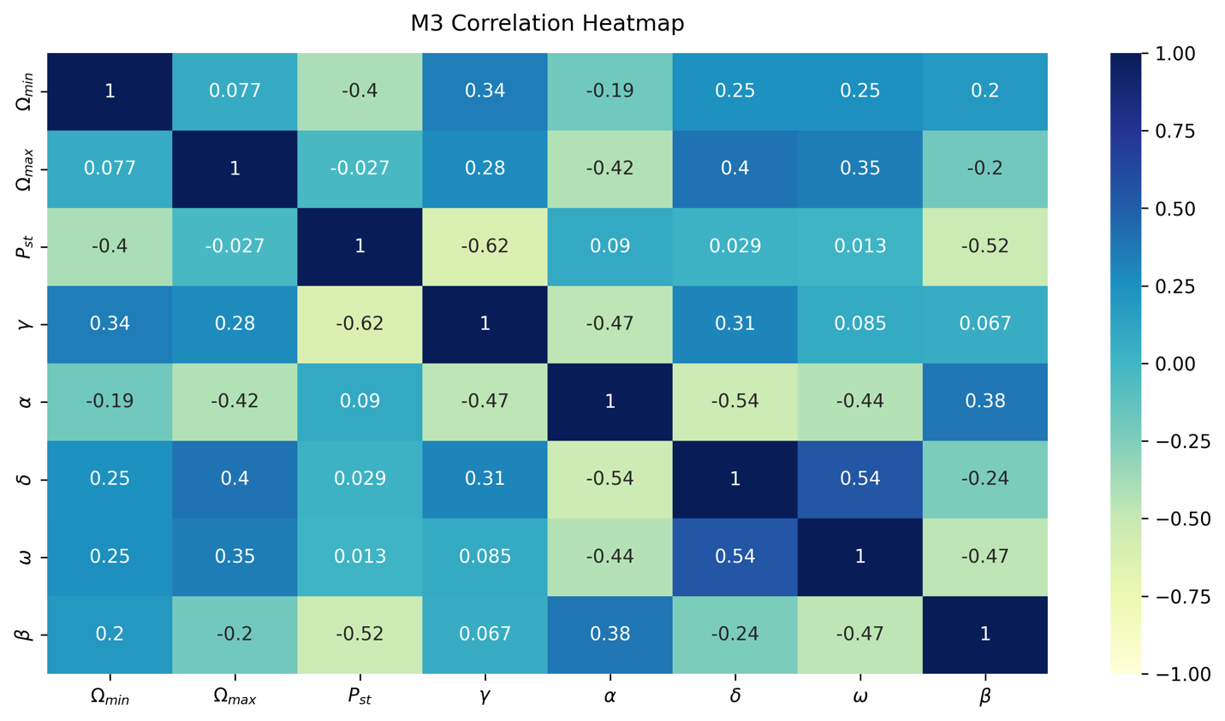
Figure Q. Correlation plot for M3.

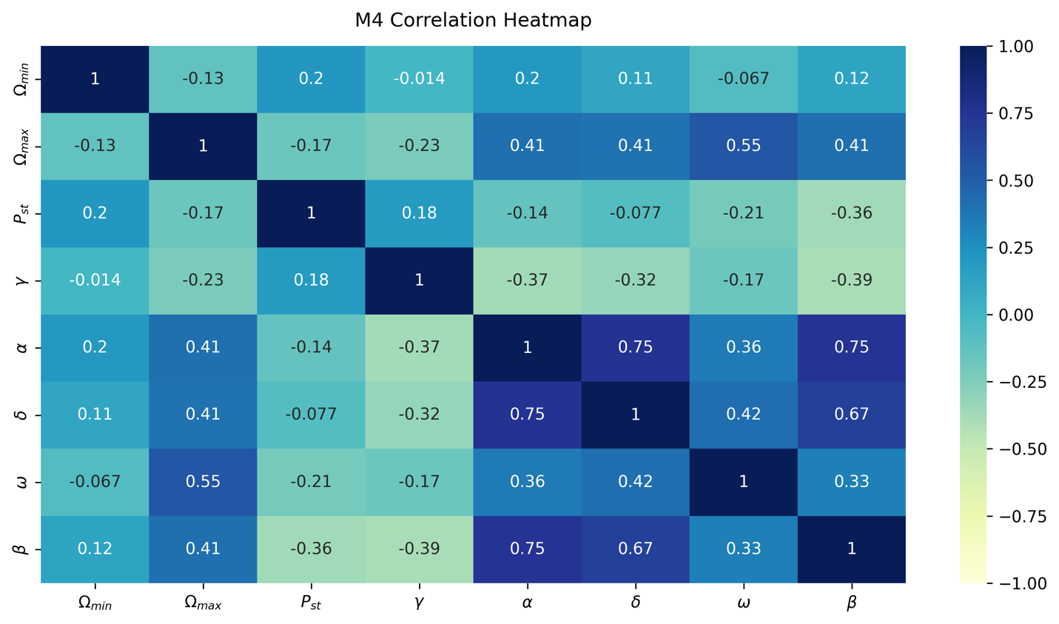

Figure R. Correlation plot for M4.

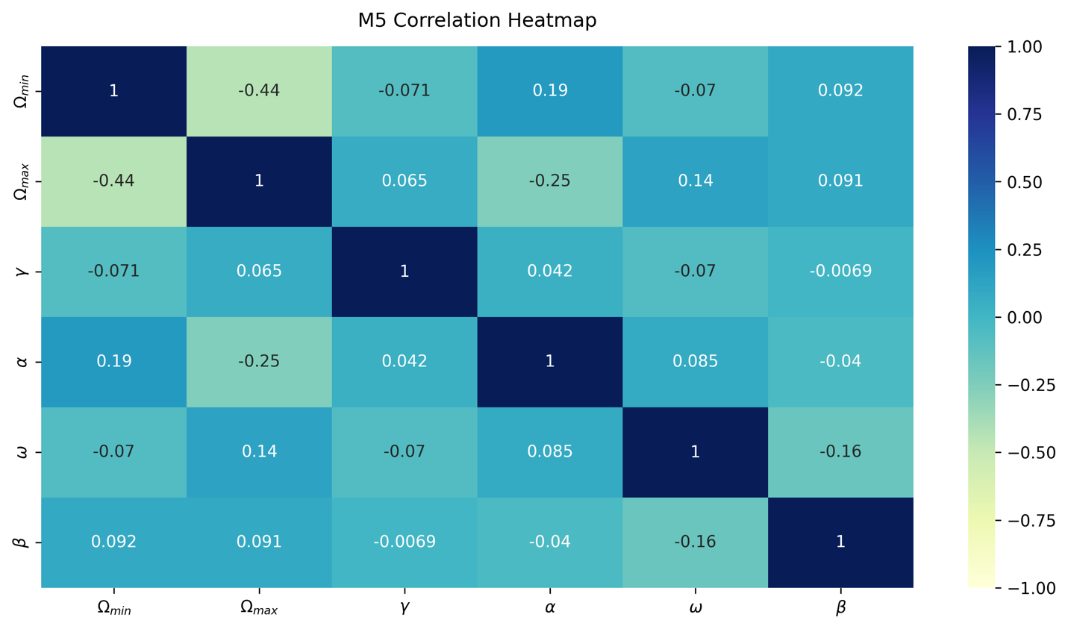

Figure S. Correlation plot for M5.

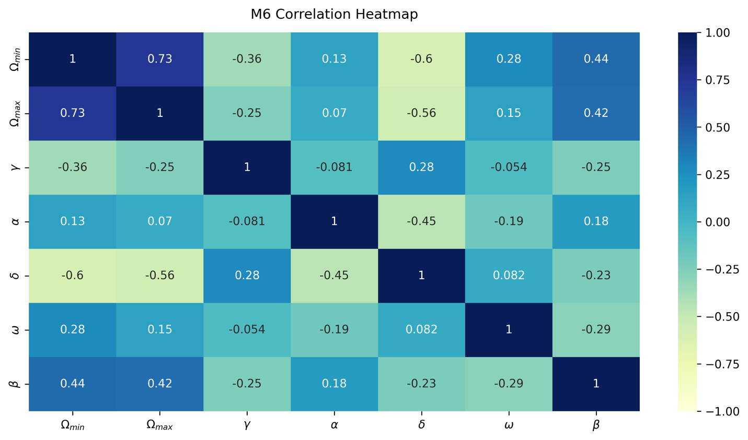

Figure T. Correlation plot for M6.

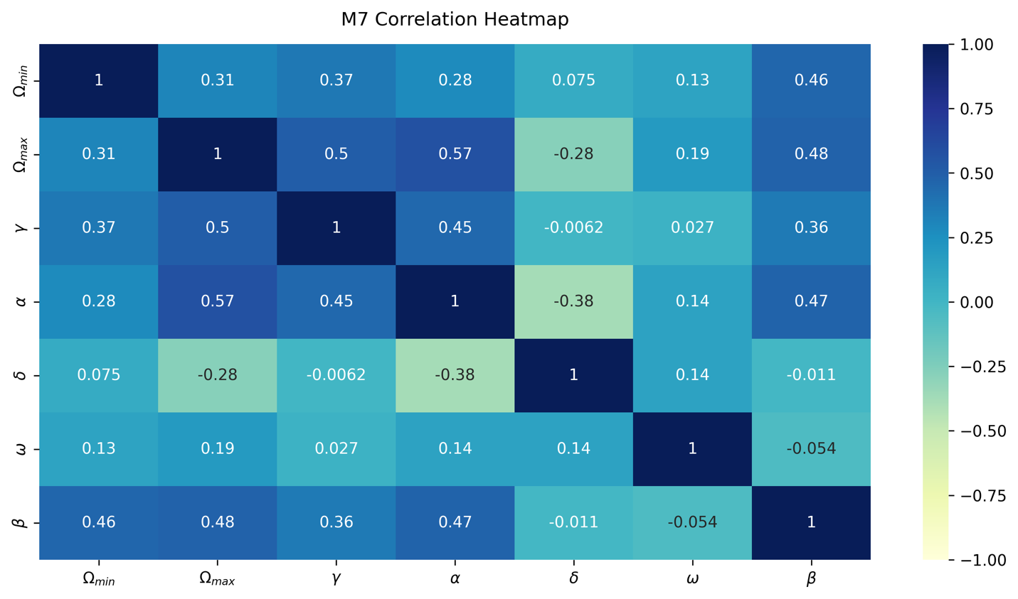
Figure U. Correlation plot for M7.

Figure V. HBV viral production quantum (circles) and viral production cycles in mice 2, 3 and 4 that were inoculated with 10⁸ GE/ml of HBV DNA.

Figure W. Varying the eclipse phase length ($Ω$) and initial production cycle length ($δ$) from time of inoculation until 56 days post. Model simulations from time of inoculation until 56 days post inoculation were run with parameters equal to that estimated for mouse 1 (M1), except for the indicated changes. (A) The parameter range of the eclipse phase was shortened to $Ω$ = [0,5] hr (dashed green line) or extended to $Ω$ =[36-72] hr (dotted red line). (B) The parameter range for the production cycle was reduced to $δ$ =1 hr (i.e., faster production, dashed green line) or increased to $δ$ = 36 hr (i.e., slower production, dotted red line). (C) The short eclipse parameter range of $Ω$ = [0,5] hr was combined with the fast (dashed green line) or slow (dotted red line) production parameter ranges used in (B). (D) same as (C) assuming extended eclipse phase to $Ω$ =[36-72] hr. The model simulations for M1, $Ω$ = [9,48] hr and to $δ$ = 26 hr, is shown for comparison using solid black lines.

