Supplementary Information
Enabling Uniform and Accurate Control of Cycling Pressure for All-Solid-State Batteries
Yu-Ting Chen^{1†}, Jihyun Jang^{2,3†}, Jin An Sam Oh², So-Yeon Ham¹, Hedi Yang⁴, Dong-Ju Lee², Marta Vicencio², Jeong Beom Lee⁵, Darren H. S. Tan², Mehdi Chouchane⁴, Ashley Cronk¹, Min-Sang Song⁵, Yijie Yin¹, Jianting Qian¹, Zheng Chen^{1,2,6,7}*, and Ying Shirley Meng^{1,2,4,6}*

¹ Program of Materials Science and Engineering, University of California San Diego, La Jolla, California 92093, United States
² Department of NanoEngineering, University of California San Diego, La Jolla, California 92093, United States of America
³ Department of Chemistry, Sogang University, 35 Baekbeom-ro, Mapo-Gu, Seoul 04107, Korea
⁴ Pritzker School of Molecular Engineering, The University of Chicago, Chicago, IL 60637, United States
⁵ LG Energy Solution, Ltd., LG Science Park, Magokjungang 10-ro, Gangseo-gu, Seoul 07796, Korea.
⁶ Sustainable Power & Energy Center (SPEC), University of California San Diego, La Jolla, California 92093, United States
⁷ Program of Chemical Engineering, University of California San Diego, La Jolla, California 92093, United States

*zhc199@ucsd.edu, shmeng@uchicago.edu
†Yu-Ting Chen and Jihyun Jang contributed equally to this work.

This PDF file includes
Figure S1 to S15
Table S1 to S2
Note S1 to S2

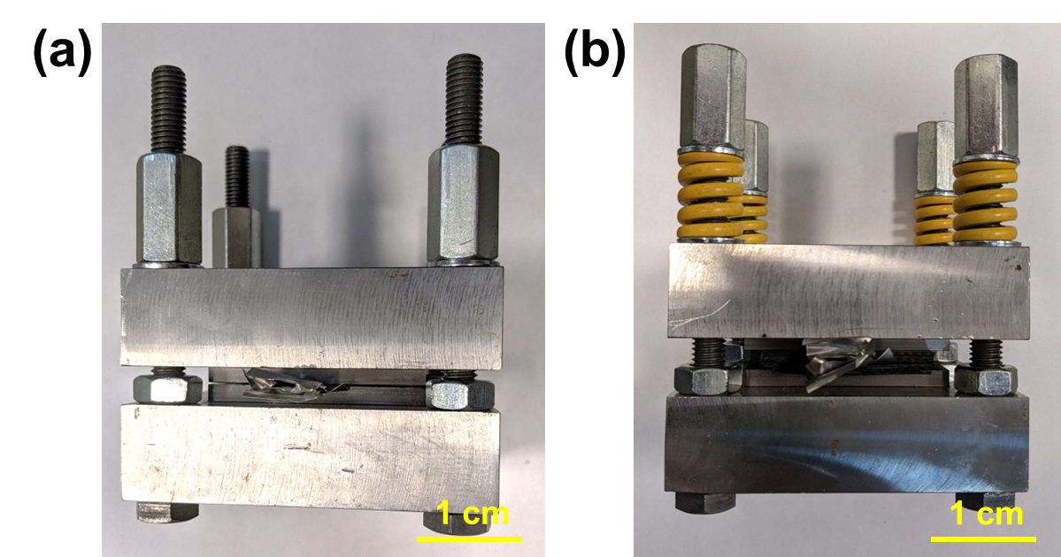
Figure S1. The digital images of (a) a bare UPCH with only bolts and nuts, and (b) an improved UPCH with springs and rubber gaskets.

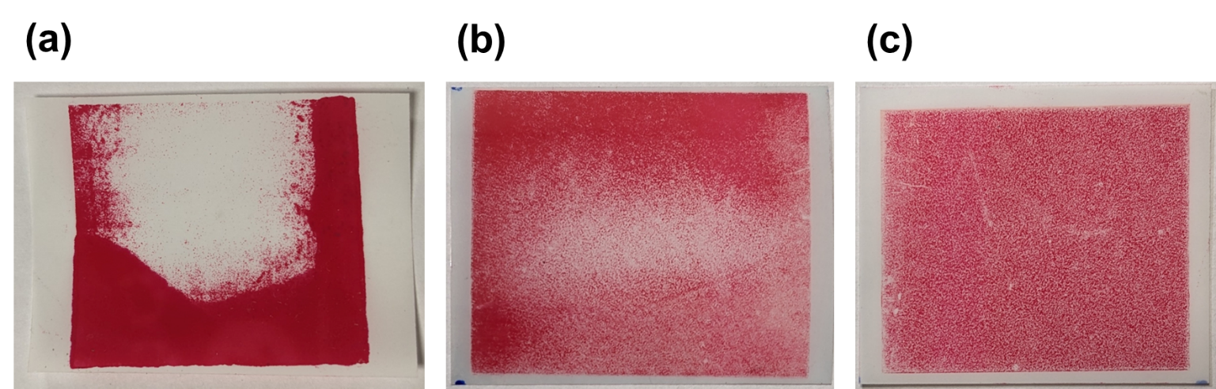
Figure S2. The digital image of pressure paper reflecting the pressure distribution of (a) a bare UPCH with metal surface, (b) an improved UPCH with rubber gaskets and springs, and (c) an IPCH.

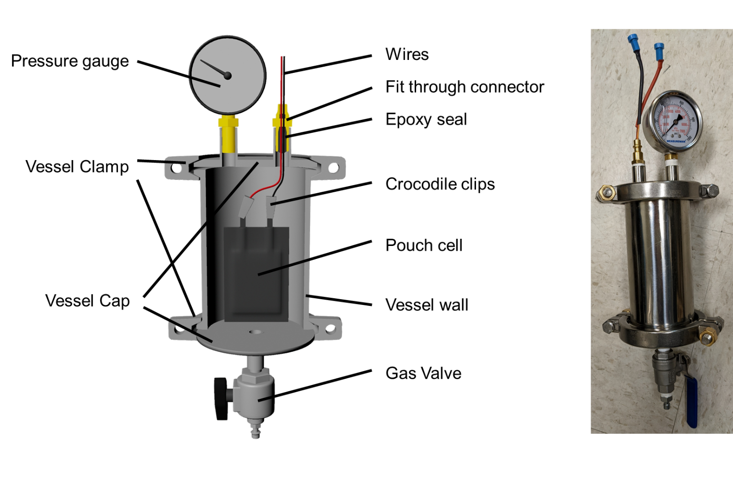
Figure S3. The schematic of the cross-sectional view and the digital image of an IPCH.

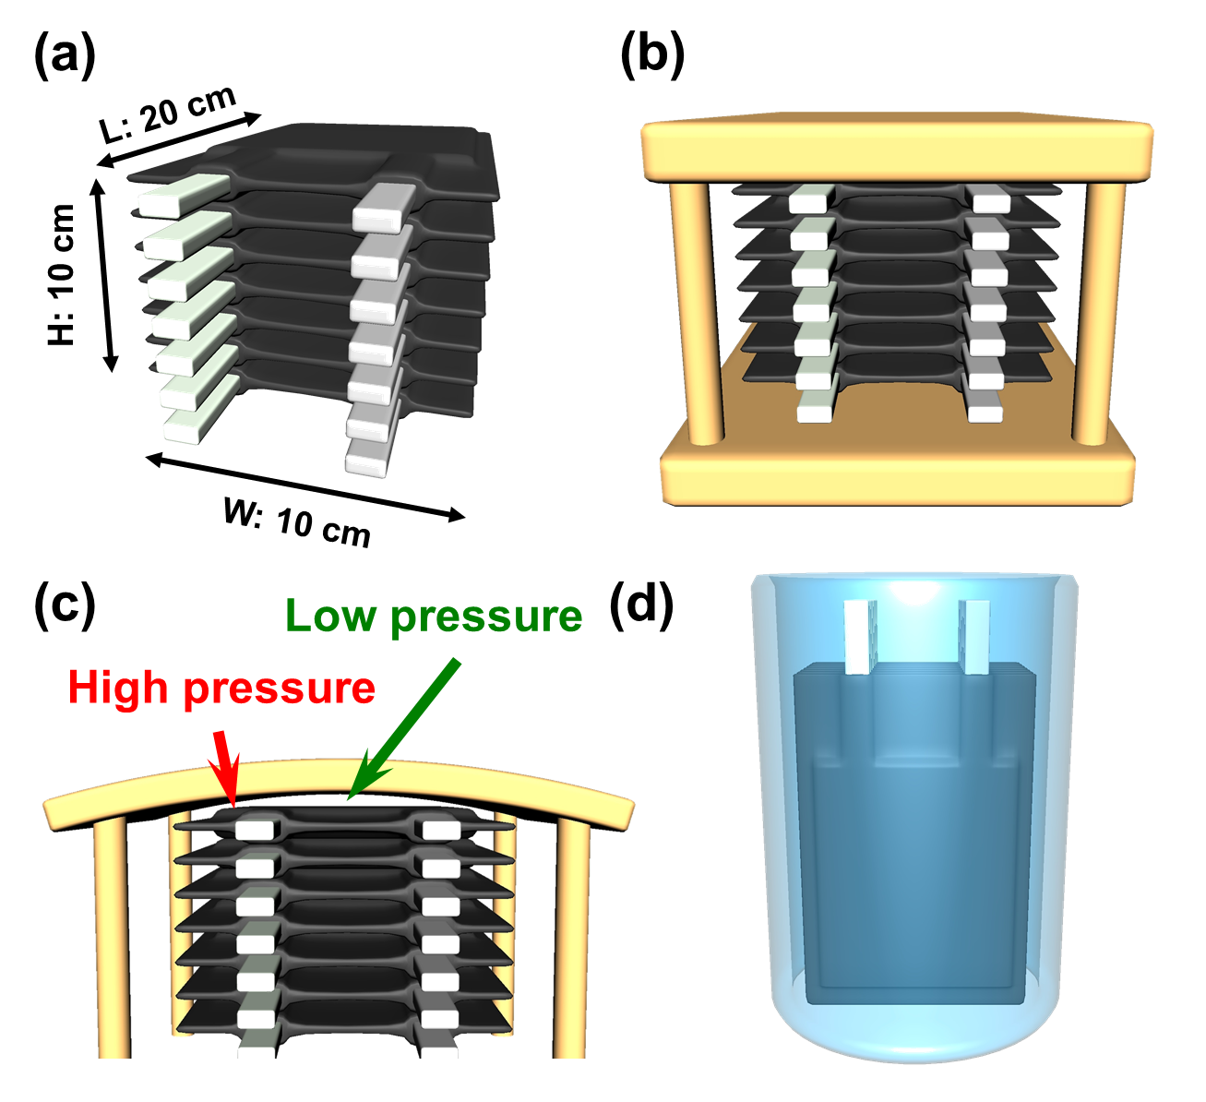
Figure S4. The schematics illustrating (a) a cell stack (the labelled dimension is used for energy density calculation in Figure S5), (b) a cell stack in a cylindrical UPCH, (c) bending of a UPCH plate when its thickness is insufficient, and (d) a cell stack in an IPCH. The dimensions of the cell stack used to calculate the weight of pouch cell holders is 20 × 10 × 10 cm³.

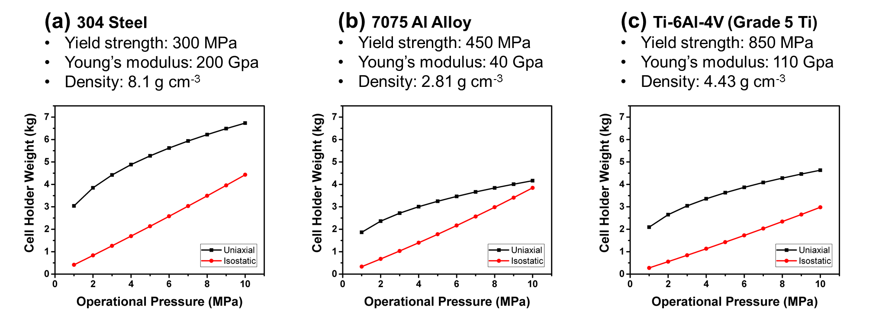
Figure S5. The weight – pressure rating plots of UPCHs and IPCHs. (a) 304 Steel, (b) 7075 Al alloy, and (c) Ti-6Al-4V Ti alloys are selected, as they have different density, yield strength and Young’s modulus.

Note S1. The method of calculating the energy density

To compare the physical weights of UPCHs and IPCHs, a pouch cell stack with dimensions of 20 × 10 × 10 cm³ (Figure S4a) was given and the dimensions of the cell holders were set to accommodate the pouch cell stack.
- Calculation of UPCHs.
- Assumptions
- The holder consists of two rectangular plates and four cylindrical rods to connect the two plates (Figure S4b).
- The dimensions of the plates are 1.1 times larger than the pouch cell stack, i.e., 22 × 11 cm². The length of the cylindrical rods is the height of the pouch cell stack (i.e., 10 cm).
- The total yield strength (only elastic deformation is allowed) of the cylindrical rods is 1.5 times of the total force required to maintain 5 MPa on the pouch cell stack. I.e., a safety coefficient of s = 1.5 is taken.
- The ratio of flexural deflection to the length of the plate is less than 2%, i.e., the deflection should be less than 4 mm on the long edge (20 cm) of the plate. A three-point testing model (Figure S-Note 1) was used to estimate the minimum thickness required for the plates, and the actual required thickness can be slightly less as the pouch cell stack does not apply a point force on the plate.

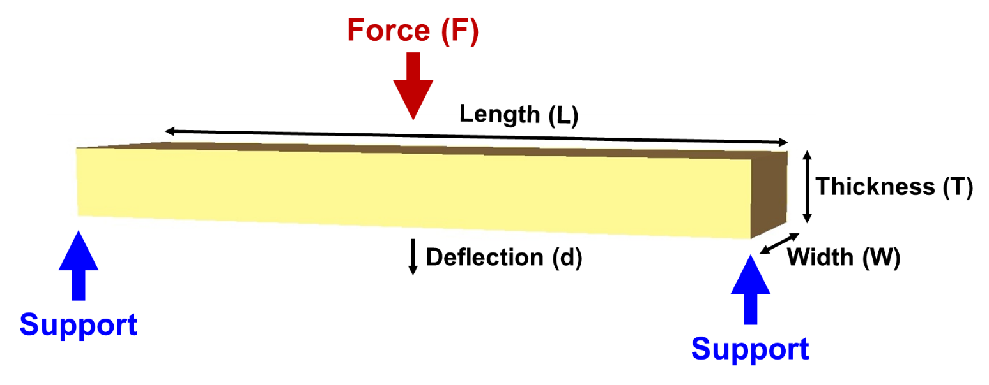
Figure S-Note 1. A schematic figure illustrating a three-point test for a rectangular beam.

To calculate the weight, the dimension requirement of the cell holder needs to be evaluated, namely, the total cross-sectional area of the four cylindrical rods and the thickness of the two plates.
The minimum required total cross-sectional area (A) of the four cylindrical rods can be calculated as follows:
$$A=\frac{PWLS}{σ_{y}}$$
Where P is pressure, W is the width, L is the length of the of the pouch cell stack, σ_{y} is the tensile strength of the cell holder material.
The minimum required plate thickness can be derived using flexural modulus formula.
$$E_{flex}=\frac{L^{3}F}{4WT^{3}d}$$
Rearrange the formula:
$$T=\sqrt[3]{\frac{L^{3}F}{4WE_{flex}d}}=\sqrt[3]{\frac{L^{4}PW}{4WE_{flex}d}}$$
Where E_{flex} is the flexural modulus, F is the exerted force (force required to apply pressure to the pouch cell stacks P × W × L), T is the thickness, and d is the deflection of the plates.
The total weight of a UPCH can be obtained by summing the volumes (V) of its plates and cylindrical rods, and then multipling by its material density.
$$Weight=ρV=ρ\left(2TLW+AL\right)=ρL^{2}W(2\sqrt[3]{\frac{PL}{4E_{flex}d}}+\frac{PS}{σ_{y}})$$

- Calculation of IPCHs.
- Assumptions
- The holder consists of a tube covered with two end plates. The thickness of the tube wall and the two plates are identical (Figure S4d).
- The diameter of the IPCH chamber is 1.05 times of the diagonal length of the stack’s square face, namely, 14.8 cm.
- The yield strength (only elastic deformation is allowed) chamber should stand 5 times the rated pressure (safety coefficient = 5), as the failure of a pressure chamber can be catastrophic, and the fatigue limits of materials are typically less than half of the ultimate tensile strength.
The minimum required wall thickness was estimated with Hoop’s stress with thin-wall assumption. Hoop’s stress value (σ_{θ}) in radial direction was taken, as the value of axial direction is typically smaller.
$$σ_{θ}=\frac{Pr}{T}=\frac{σ_{y}}{5}$$
Where r is the radius of the holder. Rearranging the formula:
$$T=\frac{5Pr}{σ_{y}}$$
The total weight of an IPCH can be obtained by summing the volumes (with thin wall approximation) of its tube wall and end covers, and then multiplying by its material density.
$$Weight=ρV=ρT\left(2πrL+2πr^{2}\right)=2πρ\frac{5Pr}{σ_{y}}(rL+r^{2})$$
The main difference between UPCH and IPCH weight formula is that UPCH has a cube root term (P^{1/3}) involving flexural modulus and a linear term (P¹) related to yield strength, while IPCH only has a linear term related to yield strength. As such, an IPCH is lighter than a UPCH at low pressure ratings but becomes heavier when exceeding a certain pressure rating, depending on the ratio between E_{flex} and σ_{y}. However, as low cycling pressure is requisite for commercial applications, IPCHs still have an advantage over UPCHs.
Three alloys, 304 stainless steel, 7075 Al alloy, and Ti-6Al-4V were selected to estimate the weight of IPCHs and UPCHs and the weight – pressure rating plots are shown in Figure S5. As metal materials selected are isotropic, Young’s modulus (E) was used as E_{flex}. The mechanical values used in the calculation are listed in Table S-Note1. When materials with smaller E-σ_{y} ratios are employed, IPCHs gain more advantage over UPCHs. As such, light and tough materials, such as carbon fiber or glass fiber, are the desirable materials to make IPCHs more competitive.

Table S-Note 1. The mechanical values used in calculating the weight of cell holders.
 | Yield Strength (MPa) | Young's modulus (GPa) | Density
304 SS | 200 MPa | 200 | 8.00 g/cm3
7075 Al | 450 MPa | 40 | 2.81 g/cm3
Ti-6Al-4V | 850MPa | 110 | 4.43 g/cm3

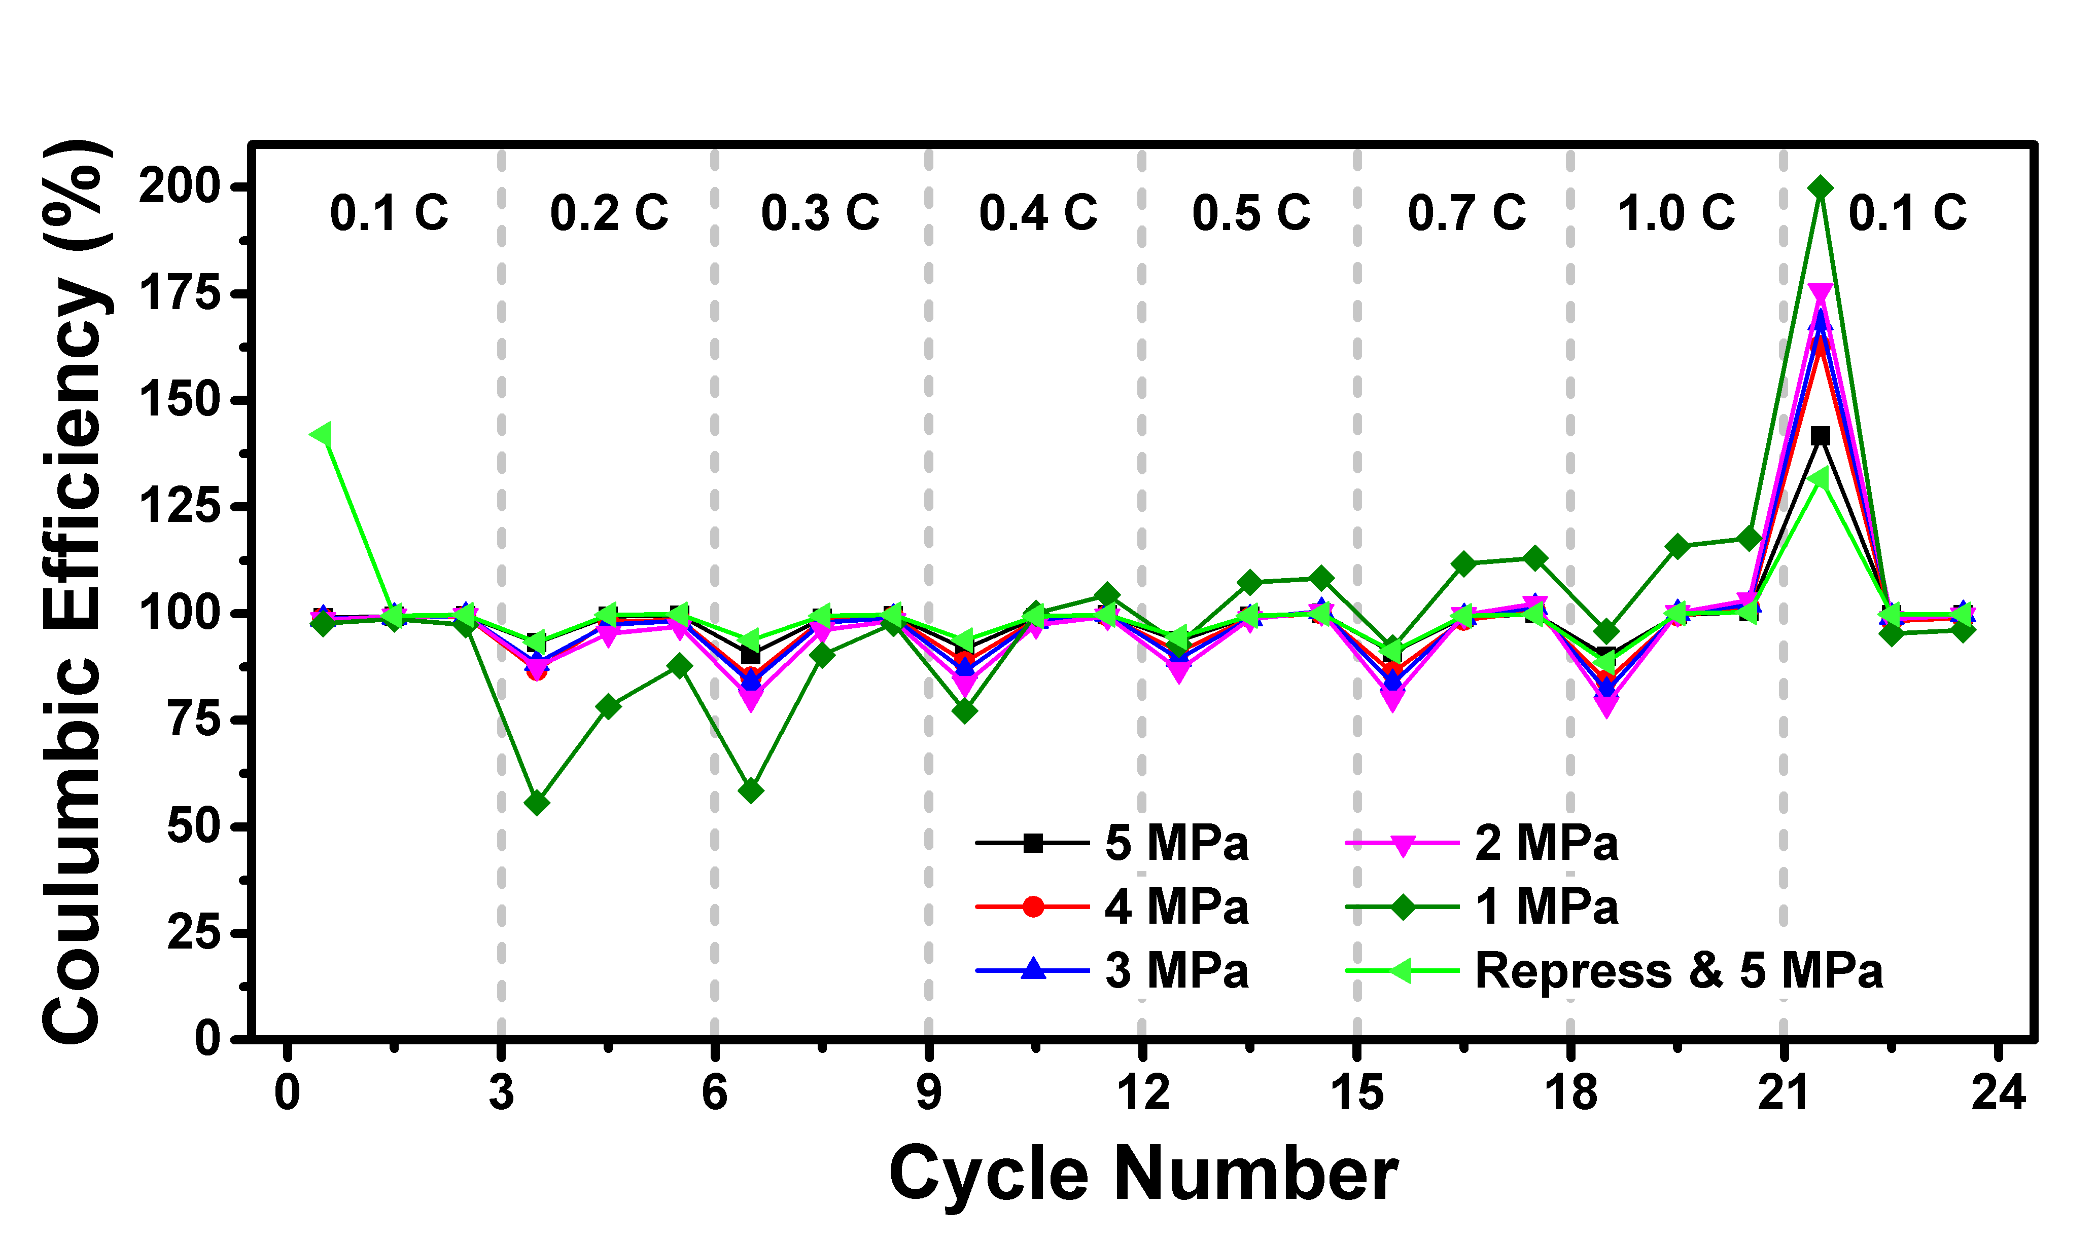
Figure S6. The Coulombic efficiency plots of rate capability tests with cycling pressures from 5 MPa to 1 MPa and the ASSPC after re-calendering

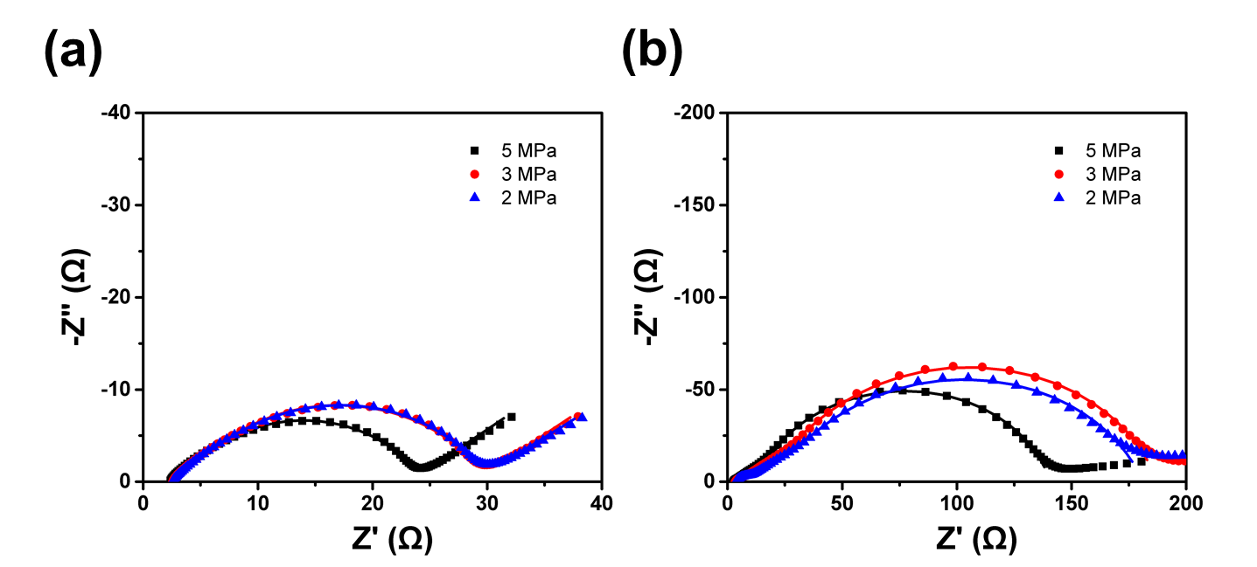
Figure S7. The Nyquist plots of pouch cells fabricated at 500 MPa and cycled at 5 MPa, 3 MPa and 2 MPa using IPCHs. The EIS of the pouch cells were measured in (a) the first and (b) the one hundredth cycle at the state of charge of 50%.

Table S1. The EIS fitted results of ASSPCs presented in Figure 4a.
Cycling Pressure | Cycle Number | Bulk | Interface | Cathode | Anode
5 MPa | 1st | 2.75 | 1.428 | 18.27
5 MPa | 100th | 3.022 | 0.97127 | 76.09 | 12.01
3 MPa | 1st | 2.609 | 2.462 | 23.92
3 MPa | 100th | 3.697 | 2.391 | 160.1 | 21.06
2 MPa | 1st | 2.575 | 3.182 | 23.25
2 MPa | 100th | 4.05 | 4.16 | 151.4 | 21.5

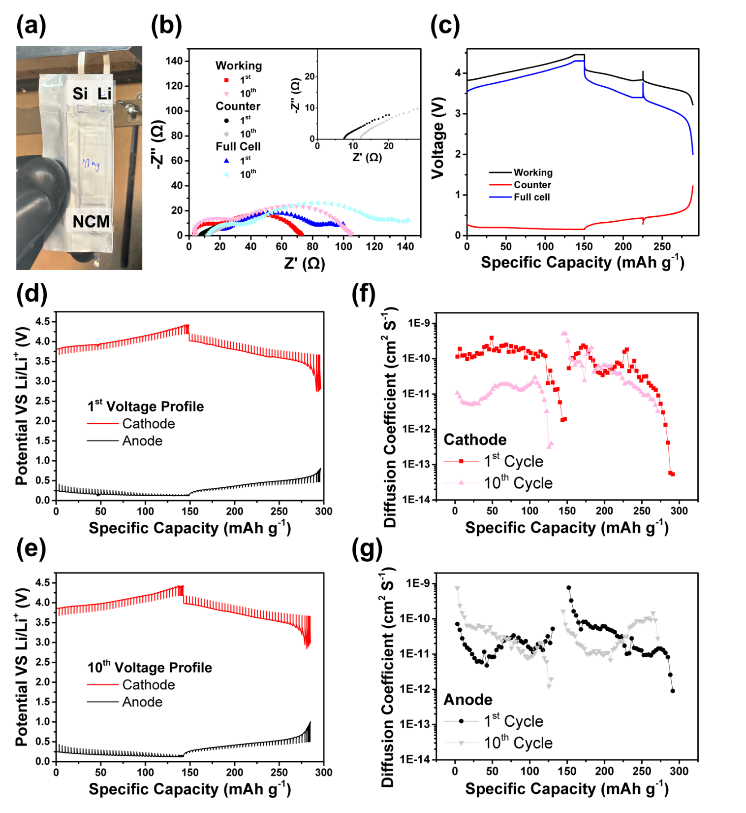
Figure S8. (a) The digital image of a three-electrode ASSPC. (b) The Nyquist plots of cathode – Li (working), anode – Li (counter) and full cell (anode – cathode) EIS at 0% state of charge in 1st and 10th discharge. (c) The voltage profiles of cathode – Li, anode – Li and full cell in the 1st cycle. The voltage spikes were due to the EIS measurement. The GITT voltage profiles of the cathode and the anode after (d) the 1st and (e) the 10th cycle. The Li⁺ diffusion coefficients of (f) the cathode and (g) the anode after the 1st and the 10th cycle.
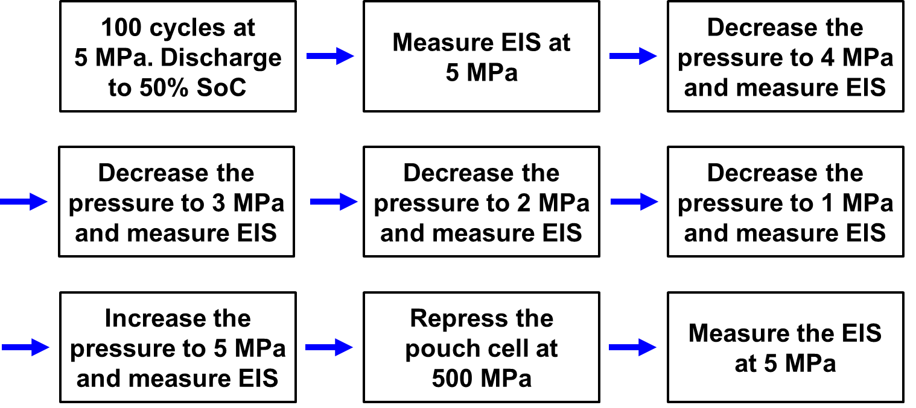
Chart S1. A schematic showing the pressurizing process of Figure 4a.

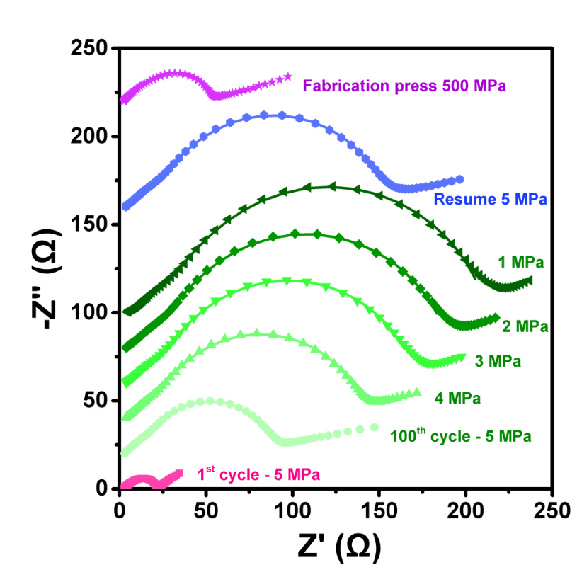
Figure S9. Decreasing the applied pressures ranging from 5 to 1 MPa and then resuming to 5 MPa of a pouch cell cycled at 5 MPa after 100 cycles. After the measurement, a fabrication pressure of 500 MPa was reapplied to the pouch cell and the EIS was measured at 5 MPa.

Table S2. The EIS fitted results of ASSPCs fabricated at 500 MPa and cycled at 5 MPa, 3 MPa and 2 MPa.
ASSPC States | Applied pressure | Bulk | Interface | Cathode | Anode
1st cycle | 5 MPa | 2.75 | 1.428 | 18.27
100th cycle | 5 MPa | 3.022 | 0.97127 | 76.09 | 12.01
100th cycle | 4 MPa | 3.574 | 1.21 | 120 | 18.93
100th cycle | 3 MPa | 3.963 | 1.466 | 144.4 | 22.55
100th cycle | 2 MPa | 4.199 | 1.755 | 160.8 | 24.2
100th cycle | 1 MPa | 4.699 | 2.221 | 175.7 | 30.14
Resume | 5 MPa | 3.758 | 1.321 | 129.5 | 21.86
500 MPa press | 5 MPa | 2.545 | 1.214 | 43.39 | 7.662

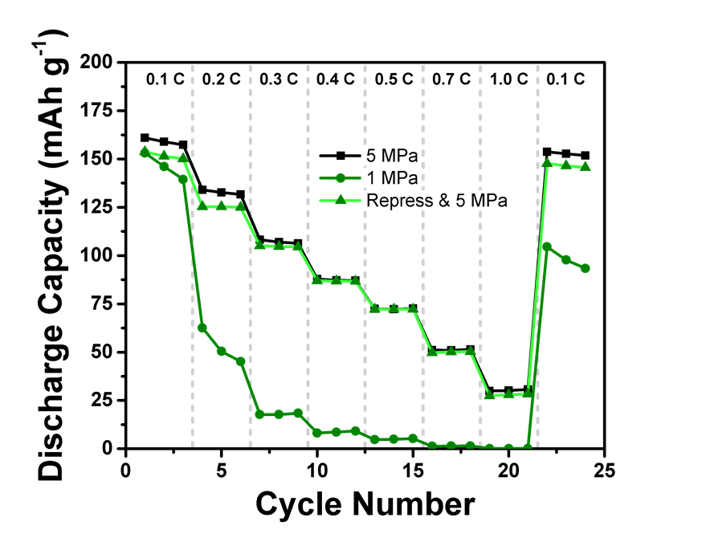
Figure S10. The rate capability test of an ASSPC cycled at 1 MPa, re-pressurized at 500 MPa and then tested again at 5 MPa. A similar rate capability as an ASSPC cycling at 5 MPa from the beginning was obtained.

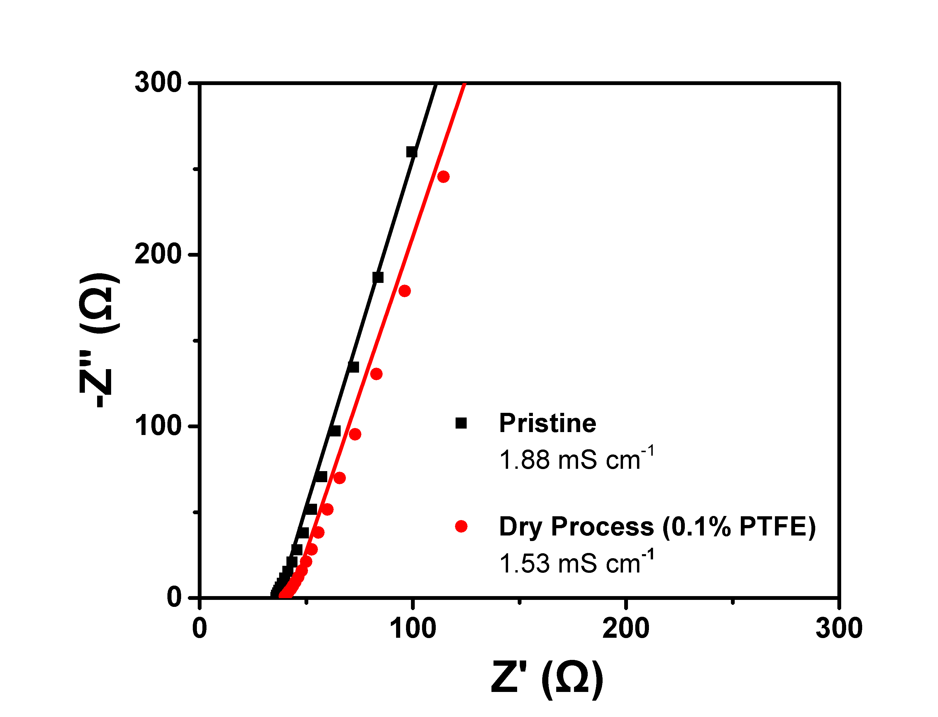
Figure S11. The EIS comparison of pristine LPSCl pellet and dry-processed LPSCl separator containing 0.1% PTFE. The ionic conductivity decreased slightly from 1.88 mS cm⁻¹ to 1.53 mS cm⁻¹ after adding 0.1% PTFE.

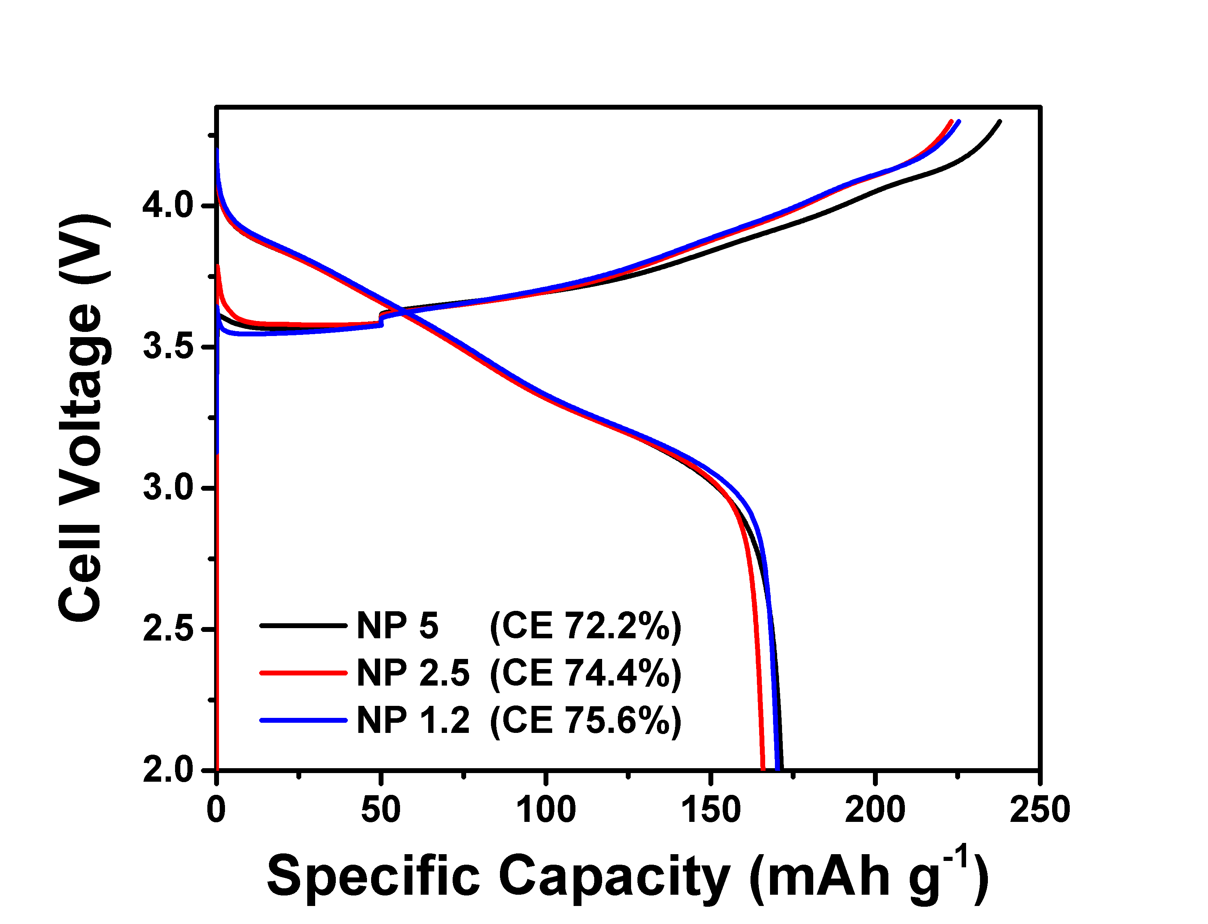
Figure S12. The voltage profiles of the activation cycles of pouch cells with NP ratios of 5, 2.5 and 1.2. As the NP ratio increases from 1.2 to 5, the initial Coulombic efficiency decreases from 75.6% to 72.2%.

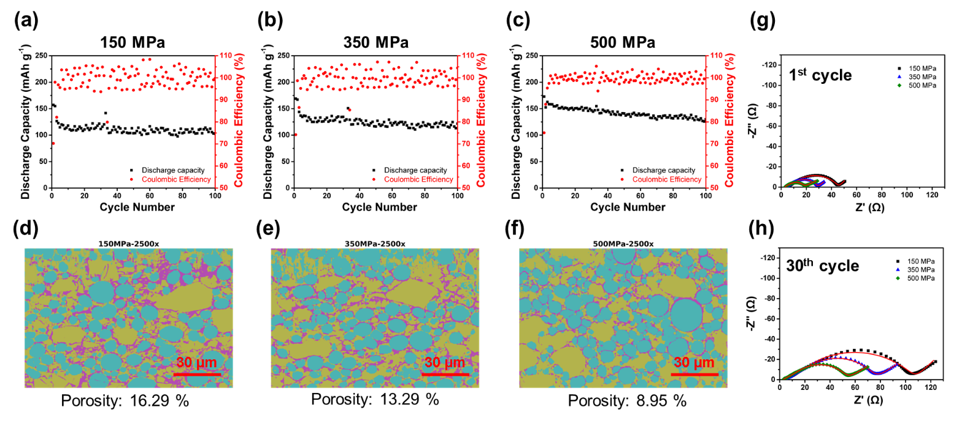
Figure S13. The capacity retention and Coulombic efficiency of pouch cells fabricated using (a) 150 MPa, (b) 350 MPa and (c) 500 MPa. The segmented FIB cross section images and porosities are shown in (d) to (f). The EIS of their (g) 1st cycle and (h) 30th cycle were measured.

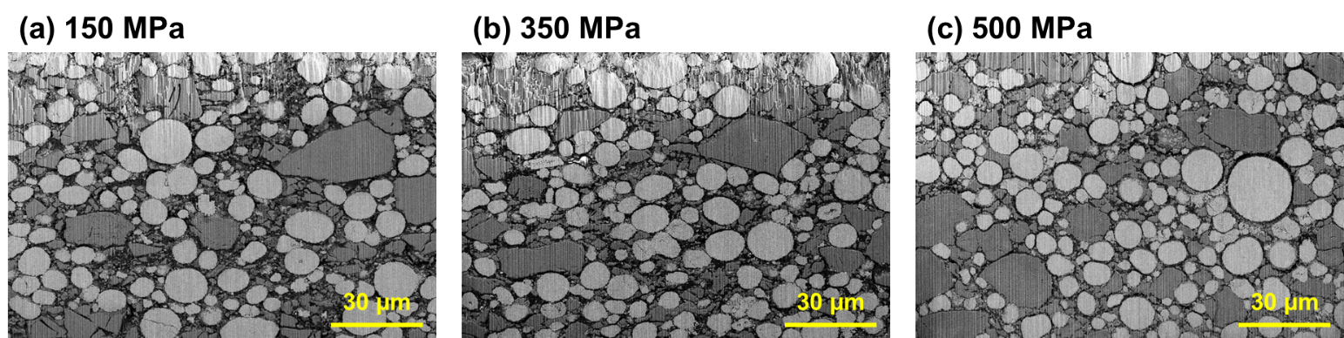
Figure S14. The P-FIB cross section of NCM811 cathode composite calendered at (a) 150 MPa, (b) 350 MPa and (c) 500 MPa.

Note S2.
To understand the effect of calender pressure on the electrochemical performance, ASSPCs calendered at 150, 350 and 500 MPa were cycled and characterized. All cells successfully accomplished 100 cycles (Figure S12a-c). The ASSPCs used in this fabrication study were cycled at ambient temperature, resulting in fluctuated Coulombic efficiency and capacity retention. Higher capacity retention was obtained as the fabrication pressure increased, as it increases interfacial contacts. The P-FIB / SEM cross-sectional images (Figure S13) of the cathode composite calendered at different fabrication pressures were segmented to identify the porosity (Figure S12d-f), and the porosity decreased as the fabrication pressure increased. The EIS after the 1st and 30th cycle also exhibited decreased cell impedance at higher fabrication pressure (Figure S12g-h), explaining the capacity retention results.

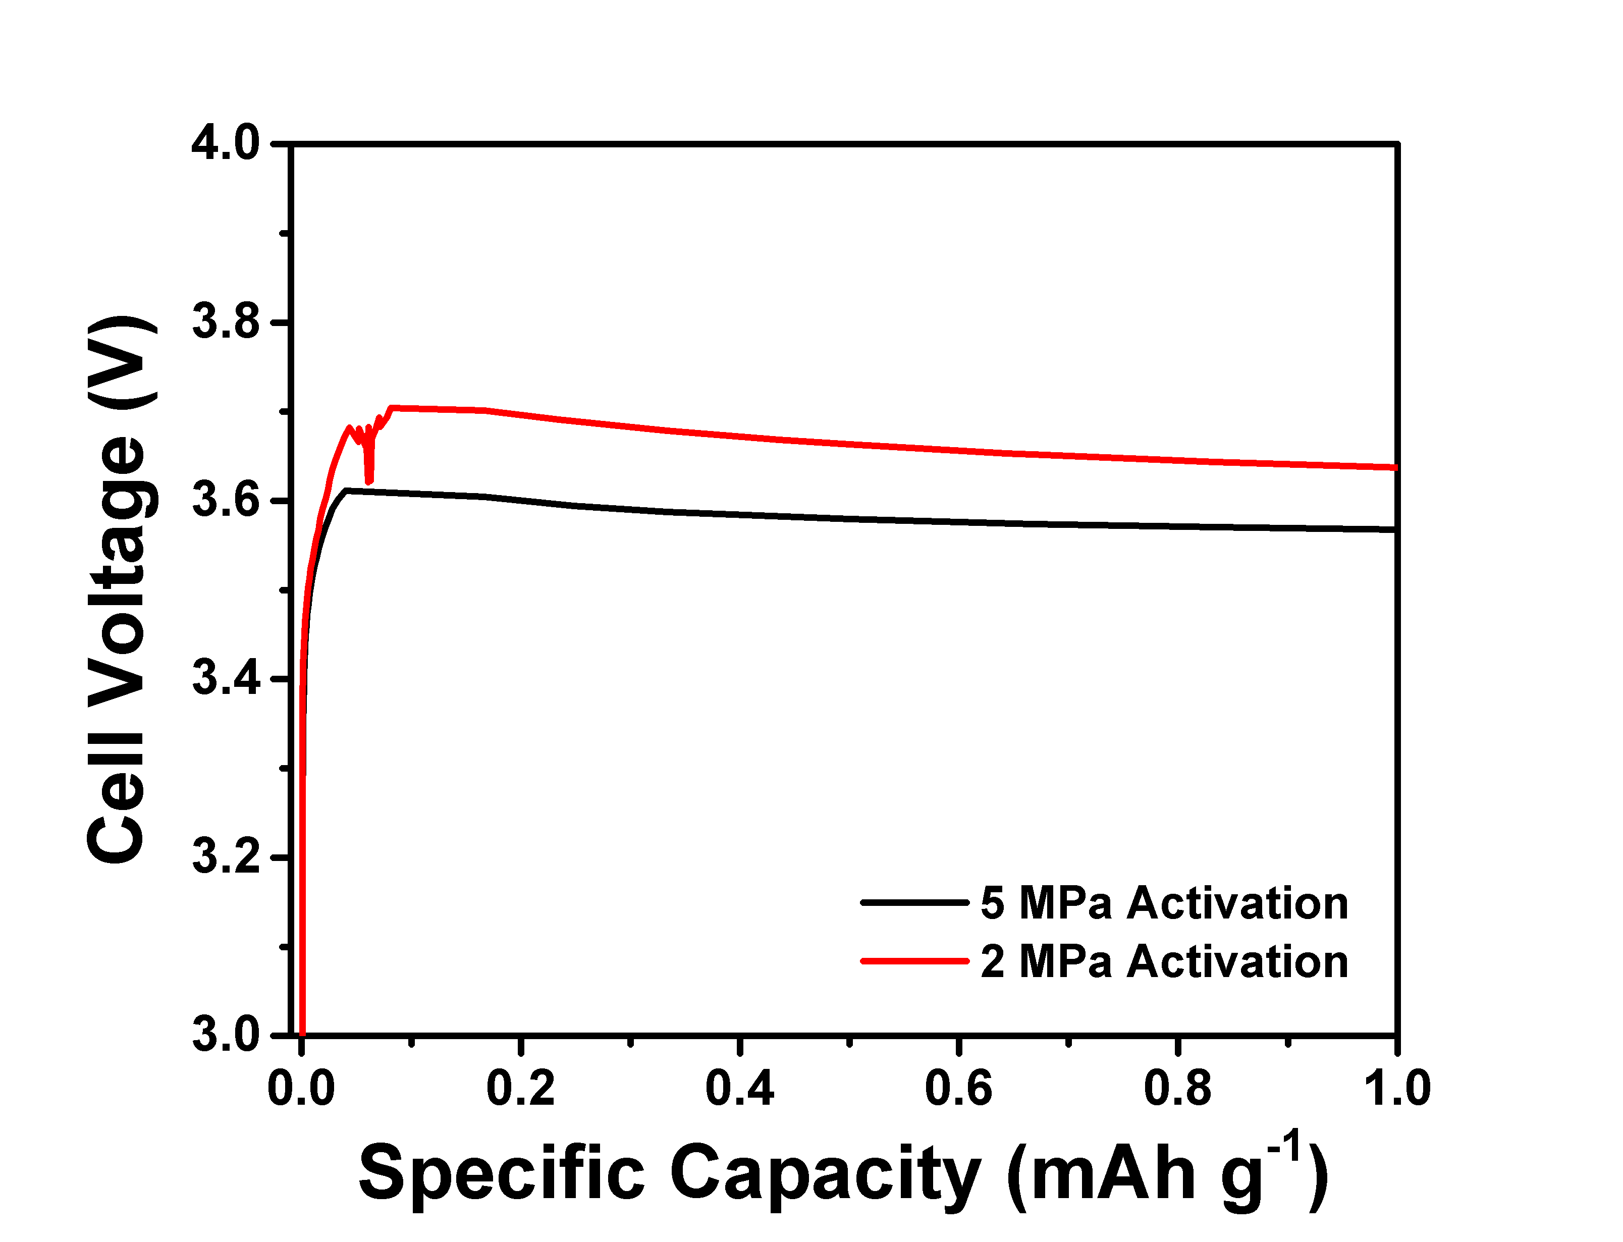
Figure S15. The voltage profiles of ASSPC activated at 5 MPa and 2 MPa isostatic pressure. A larger polarization and voltage spikes were observed when activated at 2 MPa.

