6. Supplementary Materials

Supp. Figure 1. 2019 city-specific charts of heterogeneity in effects on trip length and destination count by SEI quintile.

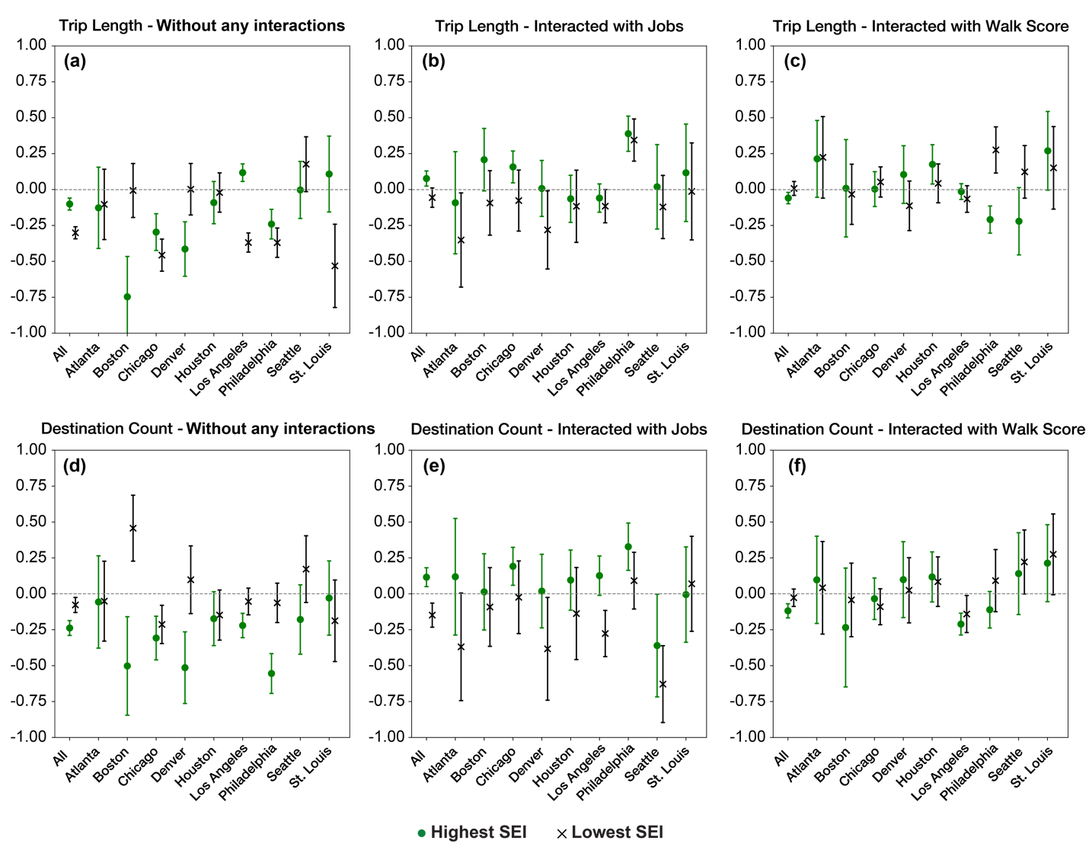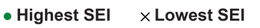
Pct city-wide CBGs visited
Trip length

